聖公會呂明才中學
S.K.H. Lui Ming Choi Secondary School
S2 單元四：AI 進階與倫理深化｜教師筆記
S2 Unit 4: Advanced AI and Deepening of AI Ethics | Teacher Notes
本堂物資表 Materials List（教師版）
請預早一星期準備所需物資；標示「課室現有」之項目請預先清點。
品名 Item | 數量（每組） Quantity (per group) | 大約成本 Est. cost | 安全注意 Safety notes
個案資料及工作紙 | 每人 1 份 | 影印約每份 HK$0.4 | 個案內容涉及騙案，提醒學生只作課堂討論，不模仿。
白板／投影（展示辯論規則及計時） | 課室現有 | HK$0 | 不適用
計時器（老師手機） | 1 部 | HK$0 | 課堂期間只作計時用途。
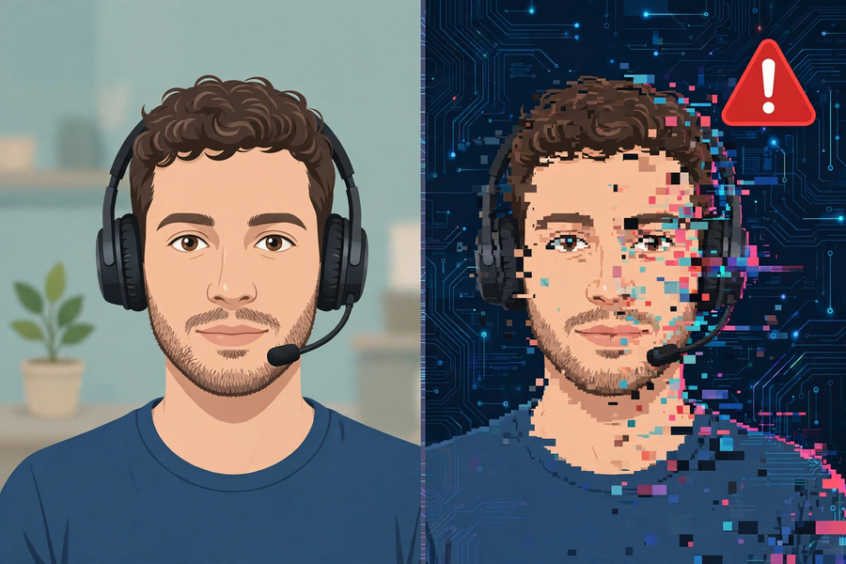
第 18 堂｜AI 倫理個案研討：deepfake 騙案與 AI 招聘偏見
Lesson 18 | AI Ethics Case Study: Deepfake Fraud and AI Hiring Bias
姓名 Name：＿＿＿＿ 班別 Class：＿＿＿＿ 學號 No.：＿＿＿＿ 日期 Date：＿＿＿＿

本教師筆記包含：學生筆記全部題目參考答案、家課參考答案、附加思考題、建議教導方向及常見迷思。
These teacher notes contain: suggested answers to all student-notes questions, homework answers, extra thinking questions, teaching guidance and common misconceptions.
甲部：學生筆記參考答案
Part A: Student Notes — Suggested Answers
簡單問答題
- 2024 年初香港：職員被偽冒財務總監的電郵誘入視像會議，會議中人全屬 deepfake 偽造；職員分 15 次轉帳合共 2 億港元，一星期後才識破。
Early 2024, Hong Kong: an employee was lured by a fake CFO email into a video conference where everyone was a deepfake; the employee transferred HK$200 million in 15 transactions, exposed a week later.
- 某科技公司 2014 年起用十年履歷訓練 AI 招聘系統；2015 年發現系統對女性求職者系統性評低分，原因是訓練履歷大多來自男性；公司最終放棄系統。
A tech company trained an AI hiring system from 2014 on ten years of resumes; in 2015 it found systematic lower scores for female applicants because most training resumes came from men; the company scrapped the system.
- 誰受影響？是否公平（為甚麼）？誰應負責（為甚麼）？
Who is affected? Is it fair (why)? Who should be responsible (why)?
- 訓練用的履歷大多來自男性，系統從中學會了「男性較優勝」的規律，並把這種規律套用到所有求職者身上。
Most training resumes came from men, so the system learnt the pattern that "men are preferable" and applied it to all applicants.
思考題（參考答案）
- 反駁：AI 的「公平」建基於訓練資料；個案二證明，若資料本身有性別偏見，AI 只會複製甚至放大偏見，結果比人類評審更不公平，因為它把偏見包裝成「客觀分數」。
Rebuttal: AI's "fairness" rests on training data; Case 2 proves that if the data is gender-biased, AI merely copies or amplifies the bias — worse than human review, because it disguises bias as an "objective score".
- 評分指引：不設標準答案；重點看理由是否具體、能否引用個案事實。示例立場：「技術本身是中立的工具，問題在用的人——個案一的騙徒才是作惡者。」或「技術不是中立的，個案二的系統在設計上已經內建了偏見。」兩種立場皆可接受，只要有理據。
Marking guide: no standard answer; assess whether reasons are concrete and cite case facts. Example: "The technology is a neutral tool; the wrongdoers are its users — the Case 1 scammers." Or: "The technology is not neutral; the Case 2 system had bias built into its design." Both acceptable with reasoning.
三問分析表參考答案
個案一
- 誰受影響：受騙的職員及公司（損失 2 億港元）、被冒充身份的財務總監及同事。
Who is affected: the deceived employee and company (HK$200 million lost); the impersonated CFO and colleagues.
- 是否公平：不公平，這是詐騙犯罪；受害人是被精心偽造的影像誤導，並非疏忽。
Is it fair: no — this is fraud; the victim was misled by carefully faked media, not by carelessness.
- 誰應負責：騙徒負主要責任；同時提醒企業需建立轉帳覆核程序（如雙人確認）。
Who is responsible: the fraudsters bear primary responsibility; companies are also reminded to build transfer-verification procedures (e.g. dual confirmation).
個案二
- 誰受影響：女性求職者（被系統性評低分，失去公平機會）。
Who is affected: female applicants (systematically scored lower, denied fair chances).
- 是否公平：不公平，因為評分標準與工作能力無關，而是與性別相關。
Is it fair: no, because the scoring criteria were linked to gender, not job competence.
- 誰應負責：採用未經偏見檢測系統的企業及設計者。
Who is responsible: the company that deployed a system never tested for bias, and its designers.
小測驗答案
Q1 答案 Answer：A
Deepfake 是人工智能生成的合成媒體。
Deepfake is AI-generated synthetic media.
Q2 答案 Answer：B
訓練履歷大多來自男性，系統學會了有偏差的規律。
Most training resumes came from men; the system learnt a biased pattern.
Q3 答案 Answer：D
三問是：誰受影響、是否公平、誰應負責。
The three questions are: who is affected, is it fair, who is responsible.
Q4 答案 Answer：B
AI 從人類資料中學習；資料有偏見，AI 只會複製甚至放大。
AI learns from human data; biased data means AI copies or amplifies the bias.
Q5 答案 Answer：A
主要責任在使用 deepfake 行騙的騙徒。
Primary responsibility lies with the fraudsters.
- 參考答案：受影響者——女性求職者。不公平——評分與工作能力無關，只與性別相關。責任——採用未經偏見檢測系統的企業及設計者。
Sample answer: Affected — female applicants. Unfair — scoring was tied to gender, not competence. Responsible — the company deploying an untested-for-bias system and its designers.
- 評分指引：立場本身不設對錯；須有明確立場＋至少一個理由＋引用個案事實，方為滿分。
Marking guide: the stance itself is not right or wrong; full marks need a clear stance + at least one reason + cited case facts.
乙部：家課參考答案
Part B: Homework — Suggested Answers
Q1 答案 Answer：B
有偏差的訓練資料令 AI 複製甚至放大偏見。
Biased training data causes AI to copy or amplify bias.
Q2 答案 Answer：B
辯論立場必須有理據支持。
Debate positions must be evidence-backed.
- 評分要點：例子須真實近期並註明出處及日期；100 字內須有事件經過＋個人看法＋三問一句分析。例子如 AI 生成假新聞、AI 面試評分爭議等，言之成理即可。
Marking points: the example must be real, recent, with source and date cited; within 100 words cover what happened + personal view + one-sentence three-question analysis. Examples like AI-generated fake news or AI interview scoring disputes are fine if reasoned.
- 參考答案：視乎例子而定；引導學生具體說明，例如「責任主要在設計者，因為系統在推出前沒有做偏見測試」。
Sample answer: depends on the example; guide students to be specific, e.g. "responsibility lies mainly with the designers, because the system was launched without bias testing."
丙部：附加思考題
Part C: Extra Thinking Questions
Q1. 如果將來求職時要面對 AI 面試官，你會做甚麼準備？你認為 AI 面試可能有甚麼偏見風險？
If you face an AI interviewer when job-hunting in future, how would you prepare? What bias risks might AI interviews carry?
Q2. 有人提議「用 AI 來審查 AI 的決定」。你認為這個做法能解決偏見問題嗎？為甚麼？
Someone suggests "using AI to review AI's decisions". Do you think this solves the bias problem? Why?
參考答案：1. 準備：了解評分準則、保持自然表達；風險：口音、樣貌、背景可能影響評分，而這些與能力無關。2. 未必能解決：如果審查的 AI 用同類有偏差的資料訓練，只會複製同一偏見；關鍵仍是資料與人類監督。
Suggested answers: 1. Prepare by understanding the scoring criteria and expressing yourself naturally; risks: accent, appearance or background may affect scores though unrelated to competence. 2. Not necessarily: if the reviewing AI is trained on similarly biased data, it copies the same bias; data quality and human oversight remain the key.
丁部：建議教導方向
Part D: Teaching Guidance
- 課前可搜尋近期 deepfake 騙案新聞作課堂例子，但一律以口述及文字描述呈現，不提供任何連結。
Before the lesson you may search recent deepfake fraud news as examples, but present them only orally and in writing — no links.
- 辯論前先訂立規則，確保氣氛理性；教師擔任主席時保持中立，不預設「正確答案」。
Set debate rules beforehand for a rational atmosphere; chair neutrally without presuming a "correct answer".
- 把個案二扣連第 15 堂的「垃圾進，垃圾出」與資料偏差，讓學生看到同一概念在真實世界的後果。
Link Case 2 to Lesson 15's "garbage in, garbage out" and data bias, showing students the real-world consequences of the same concept.
戊部：常見迷思
Part E: Common Misconceptions
- 迷思：「AI 沒有感情，所以最公平。」正解：AI 從人類資料中學習，若資料本身有偏見，AI 只會複製甚至放大偏見，個案二正是例子。
Myth: "AI has no feelings, so it is the fairest." Correction: AI learns from human data; if the data is biased, AI merely copies or amplifies the bias — Case 2 is exactly such an example.
- 迷思：「技術無罪」等於「無人需要負責。」正解：要區分技術、設計者、使用者三層責任。
Myth: "Technology is blameless" means "no one is responsible." Correction: distinguish three layers — technology, designers, users.

