聖公會呂明才中學
S.K.H. Lui Ming Choi Secondary School
S2 單元四：AI 進階與倫理深化｜家課
S2 Unit 4: Advanced AI and Deepening of AI Ethics | Homework
第 19 堂｜AI 與社會：工作會被取代嗎？
Lesson 19 | AI and Society: Will Jobs Be Replaced?
姓名 Name：＿＿＿＿ 班別 Class：＿＿＿＿ 學號 No.：＿＿＿＿ 日期 Date：＿＿＿＿

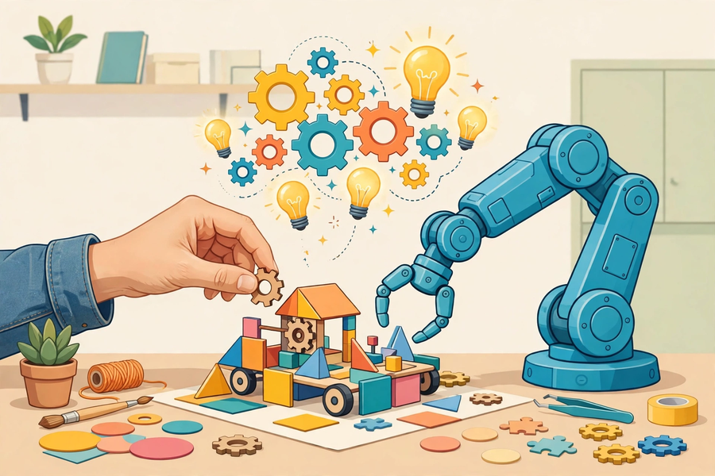
第一部分：選擇題
Part 1: Multiple Choice
Q1. 以下哪個說法是常見迷思？
Which of the following is a common misconception?
A. 「讀不好書才會被 AI 取代」
"Only poor students get replaced by AI"
B. 重複性高的工作較易被自動化
Highly repetitive work is more easily automated
C. 同理心是 AI 難以取代的能力
Empathy is hard for AI to replace
D. 科技會創造新的工種
Technology creates new kinds of jobs
Q2. 為甚麼高學歷但重複性高的工作（如部分文書處理）同樣面對自動化？
Why does highly educated but repetitive work (e.g. some clerical work) also face automation?
A. 因為學歷不重要
Because qualifications do not matter
B. 因為關鍵在工作性質（重複、規則明確）而非學歷
Because what matters is the nature of the work (repetitive, rule-based), not qualifications
C. 因為 AI 喜歡取代高學歷的人
Because AI likes replacing highly educated people
D. 因為這類工作人工太高
Because such jobs pay too much
第二部分：問答題
Part 2: Short Questions
Q1. 【訪問，約 150 字】訪問一位家人：他的工作內容是甚麼？他認為 AI 會如何影響他的工作（帶來幫助還是威脅）？以約 150 字記錄訪問結果及你的感想。
[Interview, about 150 words] Interview a family member: What does their job involve? How do they think AI will affect their work (help or threat)? Record the outcome and your reflections in about 150 words.
Q2. 承上題：根據本堂所學，你會建議這位家人學會哪一項「與 AI 協作」的新技能？為甚麼？
Following on: based on this lesson, which new "collaborating with AI" skill would you suggest this family member learn? Why?

