聖公會呂明才中學
S.K.H. Lui Ming Choi Secondary School
S2 單元四：AI 進階與倫理深化｜學生筆記
S2 Unit 4: Advanced AI and Deepening of AI Ethics | Student Notes
第 19 堂｜AI 與社會：工作會被取代嗎？
Lesson 19 | AI and Society: Will Jobs Be Replaced?
姓名 Name：＿＿＿＿ 班別 Class：＿＿＿＿ 學號 No.：＿＿＿＿ 日期 Date：＿＿＿＿
本堂物資表 Materials List
以下為本堂分組活動所需物資（每組一份）。請在老師派發時核對。
品名 Item | 數量（每組） Quantity (per group) | 安全注意 Safety notes
工作紙「AI 與職業分析表」及「我的未來技能清單」 | 每人 1 份 | 不適用
投影（展示 6 種職業列表） | 課室現有 | 不適用
職業抽籤卡 | 每組 1 張（老師預先印製，可重用） | 不適用

一、課程內容理論
1. Course Content
- 1. 較易被自動化的工作特徵。三類：第一，重複性高（每天做同樣的事）；第二，規則明確（有固定流程可循）；第三，以資料處理為主（輸入資料、輸出結果）。符合這三類的工作，AI 最容易代勞。
Characteristics of jobs more easily automated. Three types: (1) highly repetitive (doing the same things daily); (2) rule-based (fixed procedures to follow); (3) mainly data-processing (data in, results out). Jobs matching these are easiest for AI to take over.
- 2. AI 難以取代的人類能力。創意（想出全新的點子）、同理心（理解並回應他人的感受）、複雜判斷（在資訊不完整、沒有標準答案時做決定），以及需要人際信任的工作，都是 AI 難以取代的。
Human capabilities AI struggles to replace. Creativity (coming up with brand-new ideas), empathy (understanding and responding to others' feelings), complex judgement (deciding with incomplete information and no standard answer), and work built on human trust are all hard for AI to replace.
- 3. 歷史告訴我們：科技改變工作，而非消滅工作。歷史上每一次技術變革（例如電腦普及）都令部分工種消失，但同時創造新的工種。重點不是恐慌，而是適應：學會與新科技共事。
History tells us: technology transforms jobs rather than eliminating them. Every past technological shift (e.g. the spread of computers) removed some roles while creating new ones. The point is not panic but adaptation: learning to work alongside new technology.
- 4. 思維轉換：與 AI 協作，而非與 AI 競爭。未來最有價值的人，不是「比 AI 更快」的人，而是「懂得指揮 AI、審核 AI、為 AI 的輸出負責」的人。回想第 15、16 堂：AI 會出錯，需要人審核——人仍是關鍵。
Mindset shift: collaborate with AI, not compete against it. The most valuable people in future will not be those "faster than AI", but those who can direct AI, review AI output and take responsibility for it. Recall Lessons 15–16: AI makes mistakes and needs human review — humans remain the key.
- 5. 生涯規劃的基本概念。選擇未來方向時，要同時考慮三樣：興趣（你喜歡甚麼）、能力（你擅長甚麼）、職業要求（社會需要甚麼）。及早思考自己想成為怎樣的人，現在就可以開始培養相關技能。
Basic concepts of life planning. When choosing a future direction, consider three things together: interests (what you enjoy), abilities (what you are good at), and occupational requirements (what society needs). Think early about the person you want to become, and start building the relevant skills now.
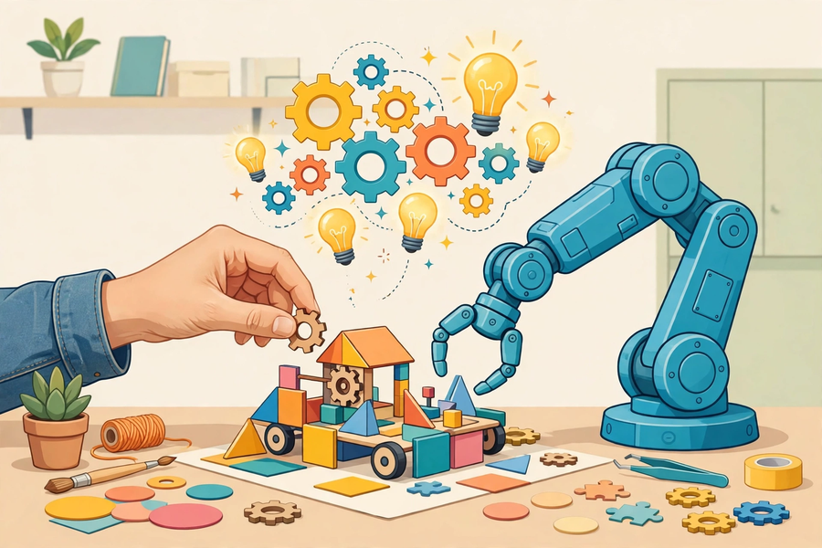
二、例子
2. Examples
- 課堂投票活動。老師展示多個職業，請全班投票估計每個職業被 AI 取代的可能性（高／中／低），先不給「標準答案」；講解後再請大家修正看法，對比前後差異。
Class voting activity. The teacher shows several occupations; the class votes on how likely each is to be replaced by AI (high / medium / low) — with no "standard answers" given first. After the explanation, students revise their views and compare the before-and-after difference.
- 職業分析示例：司機。AI 能代勞的部分：長途固定路線駕駛。AI 做不到的部分：處理突發路況、與乘客溝通。從業員要學的新技能：車隊監控與調度。
Occupation analysis example: driver. Parts AI can take over: long-haul fixed-route driving. Parts AI cannot do: handling sudden road conditions, communicating with passengers. New skills workers need: fleet monitoring and dispatch.
- 職業分析示例：社工。AI 能代勞的部分：整理個案資料、預約安排。AI 做不到的部分：建立信任關係、理解服務對象的複雜情緒。從業員要學的新技能：運用 AI 工具提升行政效率，把時間留給面談。
Occupation analysis example: social worker. Parts AI can take over: organising case files, scheduling appointments. Parts AI cannot do: building trust, understanding clients' complex emotions. New skills: using AI tools to boost admin efficiency, freeing time for face-to-face work.
三、簡單問答題
3. Quick Questions
Q1. 列出三類較易被 AI 取代的工作特徵。
List three characteristics of jobs more easily replaced by AI.
Q2. 說出兩種 AI 難以取代的人類能力，並各舉一個例子。
Name two human capabilities AI struggles to replace, with one example each.
Q3. 為甚麼說「與 AI 協作」比「與 AI 競爭」是更好的思維？
Why is "collaborating with AI" a better mindset than "competing against AI"?
Q4. 生涯規劃要同時考慮哪三樣東西？
What three things must life planning consider together?
四、思考題
4. Thinking Questions
Q1. 有人說：「讀不好書的人才會被 AI 取代。」請反駁這個說法。
Someone says: "Only poor students get replaced by AI." Refute this statement.
Q2. 會計文員和廚師，哪一個較易被 AI 取代？試從工作特徵分析。
Which is more easily replaced by AI: an accounts clerk or a chef? Analyse using job characteristics.
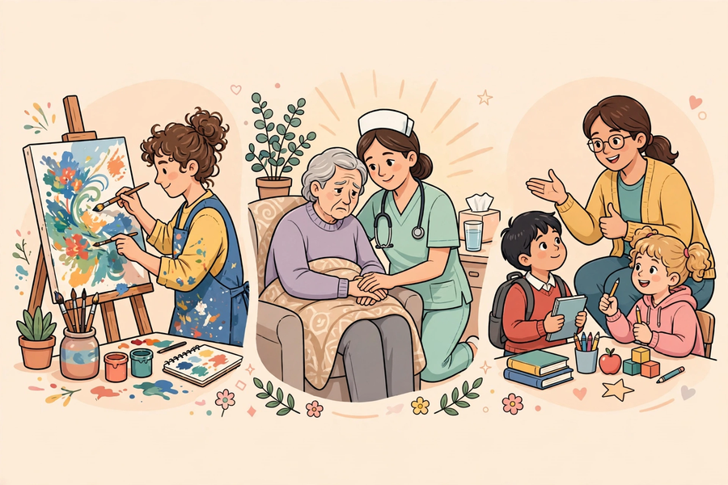
五、分組活動：AI 與職業分析表
5. Group Task: AI and Occupations Analysis
- 小組抽籤獲分配一個職業（例如：速遞員、社工、廚師、會計文員、攝影師、醫生），深入分析並完成下表。
Each group draws one occupation (e.g. courier, social worker, chef, accounts clerk, photographer, doctor), analyses it in depth and completes the table below.
- 完成後，每人獨立填寫「我的未來技能清單」。
Afterwards, each student independently completes "My Future Skills List".
職業分析表（每組填寫一份）
項目 Item | 內容 Content
職業名稱 Occupation
AI 能代勞的部分 Parts AI can take over
AI 做不到的部分 Parts AI cannot do
從業員需要學會的新技能 New skills needed

我的未來技能清單（每人獨立填寫） My Future Skills List (individual)
項目 Item | 內容 Content
我的興趣 My interests
我的強項 My strengths
我想培養的技能一 Skill 1
我想培養的技能二 Skill 2
我想培養的技能三 Skill 3（與 AI 協作相關 related to collaborating with AI）

六、總結
6. Summary
- 易被自動化：重複性高、規則明確、以資料處理為主。
Easily automated: highly repetitive, rule-based, mainly data-processing.
- 難被取代：創意、同理心、複雜判斷、人際信任。
Hard to replace: creativity, empathy, complex judgement, human trust.
- 科技改變工作而非消滅工作；重點是適應，與 AI 協作。
Technology transforms rather than eliminates jobs; the key is to adapt and collaborate with AI.
- 生涯規劃：興趣＋能力＋職業要求，及早培養未來技能。
Life planning: interests + abilities + occupational requirements; build future skills early.
七、小測驗
7. Quiz
Q1. 以下哪類工作最易被 AI 自動化？
Which type of work is most easily automated by AI?
A. 每天重複輸入資料、按固定流程處理的工作
Daily repetitive data entry following fixed procedures
B. 需要安慰傷心病人的工作
Work requiring comforting distressed patients
C. 需要發明全新產品的工作
Work requiring inventing brand-new products
D. 需要在資訊不完整時做決定的工作
Work requiring decisions with incomplete information
Q2. 以下哪項是 AI 難以取代的人類能力？
Which is a human capability AI struggles to replace?
A. 快速複製貼上
Fast copy-and-paste
B. 同理心
Empathy
C. 24 小時不休息工作
Working 24 hours without rest
D. 背誦大量資料
Memorising large amounts of data
Q3. 關於科技與就業的歷史，以下哪個說法正確？
About technology and employment in history, which statement is correct?
A. 科技每次都令所有工作消失
Technology has always eliminated all jobs
B. 科技多次改變而非消滅就業，同時創造新工種
Technology has repeatedly transformed rather than eliminated employment, while creating new roles
C. 歷史上科技從未影響就業
Technology has never affected employment in history
D. 只有 AI 會影響就業
Only AI affects employment
Q4. 未來最有價值的人是怎樣的？
What will the most valuable people in future be like?
A. 計算速度比 AI 更快的人
People who calculate faster than AI
B. 懂得指揮 AI、審核 AI 輸出並為其負責的人
People who can direct AI, review its output and take responsibility for it
C. 完全不用 AI 的人
People who never use AI at all
D. 甚麼都不學的人
People who learn nothing
Q5. 生涯規劃要同時考慮哪三樣？
What three things must life planning consider together?
A. 興趣、能力、職業要求
Interests, abilities, occupational requirements
B. 身高、體重、血型
Height, weight, blood type
C. 運氣、星座、生肖
Luck, star sign, Chinese zodiac
D. 零用錢、遊戲、假期
Pocket money, games, holidays
Q1. 會計文員的工作被認為較易自動化，社工則較難。試用「工作特徵」解釋這個判斷。
An accounts clerk's work is considered more easily automated than a social worker's. Explain this judgement using "job characteristics".
Q2. 寫出三項你想培養的未來技能，其中至少一項與「與 AI 協作」相關，並說明每項的具體內容。
Write down three future skills you wish to develop, at least one related to "collaborating with AI", and state concretely what each involves.

