聖公會呂明才中學
S.K.H. Lui Ming Choi Secondary School
S2 單元四：AI 進階與倫理深化｜教師筆記
S2 Unit 4: Advanced AI and Deepening of AI Ethics | Teacher Notes
本堂物資表 Materials List（教師版）
請預早一星期準備所需物資；標示「課室現有」之項目請預先清點。
品名 Item | 數量（每組） Quantity (per group) | 大約成本 Est. cost | 安全注意 Safety notes
工作紙「AI 與職業分析表」及「我的未來技能清單」 | 每人 1 份 | 影印約每份 HK$0.4 | 不適用
投影（展示 6 種職業列表） | 課室現有 | HK$0 | 不適用
職業抽籤卡 | 每組 1 張（老師預先印製，可重用） | 影印約 HK$2 | 不適用
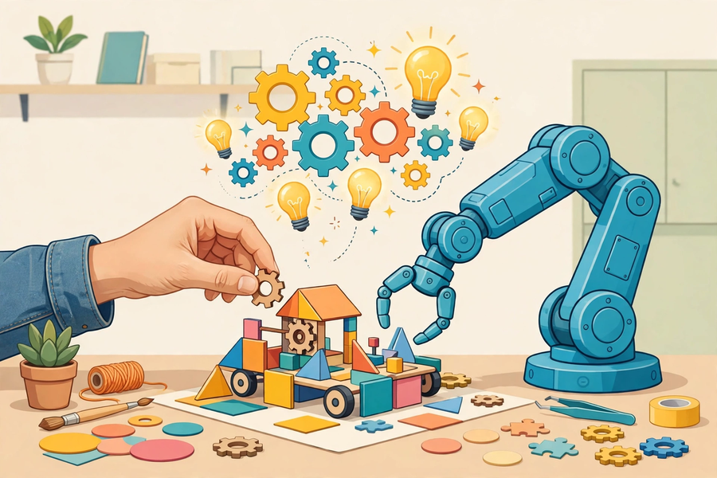
第 19 堂｜AI 與社會：工作會被取代嗎？
Lesson 19 | AI and Society: Will Jobs Be Replaced?
姓名 Name：＿＿＿＿ 班別 Class：＿＿＿＿ 學號 No.：＿＿＿＿ 日期 Date：＿＿＿＿

本教師筆記包含：學生筆記全部題目參考答案、家課參考答案、附加思考題、建議教導方向及常見迷思。
These teacher notes contain: suggested answers to all student-notes questions, homework answers, extra thinking questions, teaching guidance and common misconceptions.
甲部：學生筆記參考答案
Part A: Student Notes — Suggested Answers
簡單問答題
- 重複性高、規則明確、以資料處理為主。
Highly repetitive, rule-based, mainly data-processing.
- 示例：創意——廣告創作人想出全新宣傳概念；同理心——輔導員安慰受困擾的學生。
Examples: creativity — an advertiser inventing a new campaign concept; empathy — a counsellor comforting a distressed student.
- 因為與 AI 比速度和記憶力，人必輸無疑；但指揮、審核 AI 並為其輸出負責，是 AI 做不到的，這才是人的價值所在。
Because humans will surely lose to AI in speed and memory; but directing AI, reviewing its output and taking responsibility for it is what AI cannot do — that is where human value lies.
- 興趣、能力、職業要求。
Interests, abilities, occupational requirements.
思考題（參考答案）
- 反駁：關鍵在工作性質而非學歷。高學歷但重複性高的工作（如部分文書處理、翻譯初稿）同樣面對自動化；相反，學歷要求不高但需要人際互動和臨場判斷的工作（如水電維修）較難被取代。
Rebuttal: what matters is the nature of the work, not qualifications. Highly educated but repetitive work (e.g. some clerical work, first-draft translation) also faces automation; conversely, work needing human interaction and on-the-spot judgement (e.g. plumbing repairs) is harder to replace despite lower qualification requirements.
- 會計文員較易被取代：工作重複性高、規則明確、以資料處理為主。廚師較難：需要創意（研發新菜式）、臨場判斷（火候調味）、感官經驗，AI 難以複製。
The accounts clerk is more easily replaced: repetitive, rule-based, data-processing work. The chef is harder: creativity (new dishes), on-the-spot judgement (heat and seasoning), sensory experience — hard for AI to replicate.
小測驗答案
Q1 答案 Answer：A
重複、固定流程的工作最易被自動化。
Repetitive, fixed-procedure work is most easily automated.
Q2 答案 Answer：B
同理心是 AI 難以取代的人類能力。
Empathy is hard for AI to replace.
Q3 答案 Answer：B
科技多次改變而非消滅就業，同時創造新工種。
Technology has repeatedly transformed rather than eliminated employment, creating new roles.
Q4 答案 Answer：B
懂得指揮 AI、審核輸出並負責的人最有價值。
Those who direct AI, review output and take responsibility are most valuable.
Q5 答案 Answer：A
興趣、能力、職業要求三者兼顧。
Interests, abilities and occupational requirements together.
- 參考答案：會計文員的工作重複性高、規則明確、以資料處理為主，符合三類易自動化特徵；社工需要建立信任、理解複雜情緒，屬 AI 難以取代的人際能力。
Sample answer: accounts work is repetitive, rule-based and data-processing — matching all three easily-automated traits; social work needs trust-building and understanding complex emotions — hard-to-replace human capabilities.
- 評分指引：三項技能須具體（如「學會用試算表函數」而非「學好電腦」）；至少一項與 AI 協作相關（如用 AI 輔助學習並核實內容）；與自身興趣／強項有扣連更佳。
Marking guide: skills must be concrete (e.g. "learn spreadsheet functions", not "learn computers"); at least one related to collaborating with AI (e.g. using AI to aid study while verifying content); linking to personal interests/strengths is better.
乙部：家課參考答案
Part B: Homework — Suggested Answers
Q1 答案 Answer：A
「讀不好書才會被 AI 取代」是迷思，關鍵在工作性質。
"Only poor students get replaced by AI" is a myth; what matters is the nature of the work.
Q2 答案 Answer：B
關鍵在工作性質（重複、規則明確）而非學歷。
What matters is the nature of the work (repetitive, rule-based), not qualifications.
- 評分要點：訪問內容須具體（工作內容＋家人對 AI 影響的看法）；感想須扣連本堂所學，而非空泛。
Marking points: the interview must be concrete (job content + the family member's view of AI's impact); reflections must link to this lesson, not be vague.
- 參考答案示例：建議家人學會「用 AI 起草文件初稿再人工審核」，因為文書工作重複性高，AI 可代勞初稿，人專注審核和判斷，效率更高。
Sample answer: suggest the family member learn "drafting documents with AI then reviewing them", because clerical work is repetitive — AI handles first drafts while the human focuses on review and judgement, raising efficiency.
丙部：附加思考題
Part C: Extra Thinking Questions
Q1. 承接第 18 堂：如果 AI 面試官有偏見，求職者可以怎樣保障自己？社會又應該有甚麼規管？
Following Lesson 18: if an AI interviewer is biased, how can applicants protect themselves? What regulation should society have?
Q2. 有人說「AI 只會取代『工作』，不會取代『職業』」。你怎樣理解這句話？
Someone says "AI only replaces 'tasks', not 'professions'". How do you understand this?
參考答案：1. 求職者：要求知道評分準則、要求人類覆核；社會：要求招聘 AI 通過偏見檢測、保留申訴機制。2. 理解示例：司機的「駕駛」工作可被代勞，但「運輸服務」這個職業仍在，只是內容改變——人轉做監控、調度、服務。
Suggested answers: 1. Applicants: ask for the scoring criteria and human review; society: require hiring AIs to pass bias tests and keep an appeal mechanism. 2. Example: a driver's "driving" task can be automated, but the "transport service" profession remains with changed content — humans move to monitoring, dispatch and service.
丁部：建議教導方向
Part D: Teaching Guidance
- 投票環節先不給「標準答案」，留待講解後再請學生修正看法，對比前後差異最能呈現學習成效。
Do not give "standard answers" during the vote; ask students to revise views after the explanation — the before-and-after contrast best shows learning.
- 小組抽籤職業宜涵蓋不同性質（速遞員、社工、廚師、會計文員、攝影師、醫生），以呈現多元圖像。
Drawn occupations should cover diverse natures (courier, social worker, chef, accounts clerk, photographer, doctor) for a varied picture.
- 避免製造恐慌：強調「改變而非消滅」，並把焦點放在「我可以學甚麼新技能」。
Avoid creating panic: stress "transformed, not eliminated" and focus on "what new skills can I learn".
戊部：常見迷思
Part E: Common Misconceptions
- 迷思：「讀不好書才會被 AI 取代。」正解：高學歷但重複性高的工作同樣面對自動化，關鍵在工作性質而非學歷。
Myth: "Only poor students get replaced by AI." Correction: highly educated but repetitive work also faces automation — what matters is the nature of the work, not qualifications.
- 迷思：「所有工作都會消失。」正解：歷史上科技多次改變而非消滅就業，重點是適應。
Myth: "All jobs will disappear." Correction: technology has repeatedly transformed rather than eliminated employment; adaptation is the key.

