聖公會呂明才中學
S.K.H. Lui Ming Choi Secondary School
S2 單元四：AI 進階與倫理深化｜家課
S2 Unit 4: Advanced AI and Deepening of AI Ethics | Homework
第 20 堂｜網絡安全進階：識別釣魚電郵與密碼管理實務
Lesson 20 | Advanced Cyber Security: Spotting Phishing Emails and Password Management
姓名 Name：＿＿＿＿ 班別 Class：＿＿＿＿ 學號 No.：＿＿＿＿ 日期 Date：＿＿＿＿

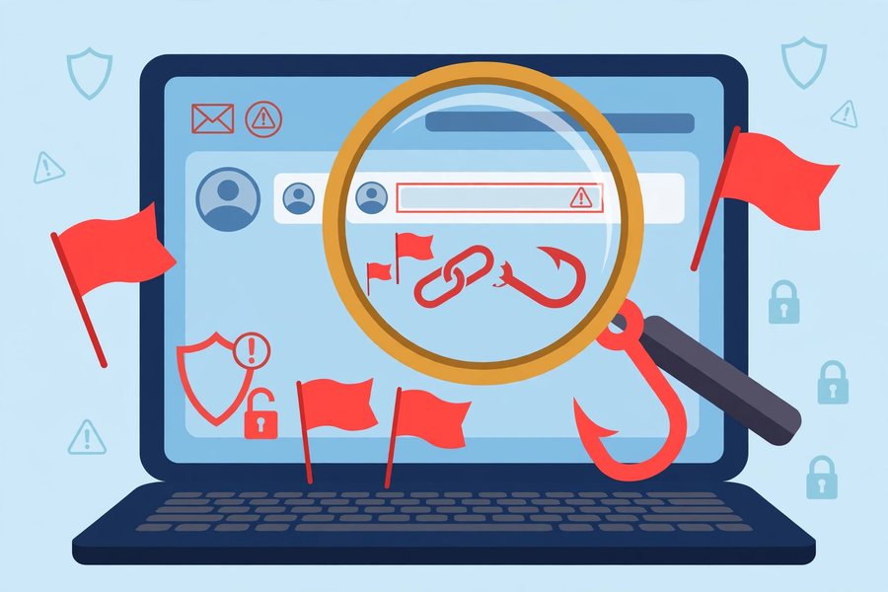
第一部分：選擇題
Part 1: Multiple Choice
Q1. 「社交工程」是指甚麼？
What does "social engineering" mean?
A. 騙徒針對「人」而非電腦，利用人的心理弱點行騙
Fraudsters target "people" not computers, exploiting human psychological weaknesses
B. 工程師的社交活動
Engineers' social activities
C. 在社交平台做工程
Doing engineering on social platforms
D. 一種新的程式語言
A new programming language
Q2. 以下哪個附件最可疑？
Which attachment is the most suspicious?
A. 老師在課堂上派發的功課指引.pdf
The homework guide.pdf distributed by the teacher in class
B. 陌生電郵附帶的「獎品領取.exe」
"prize-claim.exe" attached to a stranger's email
C. 學校內聯網下載的測驗時間表.pdf
The test timetable.pdf downloaded from the school intranet
D. 自己拍的照片.jpg
A photo.jpg you took yourself
第二部分：問答題
Part 2: Short Questions
Q1. 【改善計劃，約 80 字】回家檢查自己（或經家人同意下，家人的）一個網上帳戶的密碼習慣，對照課堂三原則寫出約 80 字的改善計劃。注意：切勿在功課中寫出任何真實密碼，只寫習慣及改善方法。
[Improvement plan, about 80 words] At home, review the password habits of one of your own online accounts (or, with permission, a family member's). Write an improvement plan of about 80 words against the three principles taught in class. Note: never write any real password in the homework — describe habits and improvements only.
Q2. 如果你收到一封自稱學校發出的電郵，要求你點擊連結並輸入密碼，你會怎樣做？寫出三個具體步驟。
If you received an email claiming to be from the school, asking you to click a link and enter your password, what would you do? Write three concrete steps.
⚠ 注意：切勿在功課中寫出任何真實密碼，只寫習慣及改善方法。
⚠ Note: never write any real password in your homework — describe habits and improvements only.

