聖公會呂明才中學
S.K.H. Lui Ming Choi Secondary School
S2 單元四：AI 進階與倫理深化｜學生筆記
S2 Unit 4: Advanced AI and Deepening of AI Ethics | Student Notes
第 20 堂｜網絡安全進階：識別釣魚電郵與密碼管理實務
Lesson 20 | Advanced Cyber Security: Spotting Phishing Emails and Password Management
姓名 Name：＿＿＿＿ 班別 Class：＿＿＿＿ 學號 No.：＿＿＿＿ 日期 Date：＿＿＿＿
本堂物資表 Materials List
以下為本堂分組活動所需物資（每組一份）。請在老師派發時核對。
品名 Item | 數量（每組） Quantity (per group) | 安全注意 Safety notes
工作紙「釣魚電郵偵測練習」及「密碼自查表」 | 每人 1 份 | 提醒學生切勿在功課或工作紙上寫出真實密碼。
小組挑戰用示例電郵卡 | 每組 1 套（老師預先印製，可重用） | 示例均為仿真教材，不可作其他用途。
投影（展示示例電郵） | 課室現有 | 不適用

一、課程內容理論
1. Course Content
- 1. 甚麼是「社交工程」？騙徒針對的往往不是電腦，而是「人」。他們利用人的好奇、恐懼和貪心，誘使你自己交出資料或點擊惡意連結。識破騙局，關鍵在看穿「人的弱點被利用了」。
What is "social engineering"? Fraudsters often target "people", not computers. They exploit human curiosity, fear and greed to trick you into handing over data or clicking malicious links. To see through a scam, spot how "human weakness is being exploited".
- 2. 釣魚電郵的五個特徵。第一，可疑寄件人：地址古怪或與自稱身份不符。第二，製造緊急語氣：「24 小時內不處理，帳戶將被停用！」第三，奇怪連結：連結文字與實際網址不符。第四，附件陷阱：來歷不明的附件，尤其是可執行檔。第五，索取個人資料：要求你輸入密碼、信用卡號等。
Five hallmarks of phishing emails. (1) Suspicious sender: a strange address that does not match the claimed identity. (2) Manufactured urgency: "Your account will be suspended if you don't act within 24 hours!" (3) Strange links: the link text does not match the real URL. (4) Attachment traps: attachments from unknown sources, especially executable files. (5) Requests for personal data: asking you to enter passwords, credit card numbers, etc.
- 3. 檢查連結的實務技巧。把滑鼠懸停在連結上（不要點擊），看真正的網址；仔細核對域名拼法——騙徒常用只差一個字母的域名（例如把 microsoft 寫成 micorsoft）；有懷疑就不要點，直接到官方網站或問老師。
Practical link-checking skills. Hover over a link (do not click) to see the real URL; check the domain spelling carefully — scammers often use domains differing by one letter (e.g. "micorsoft" instead of "microsoft"). When in doubt, do not click: go to the official website directly or ask a teacher.
- 4. 密碼管理的三個原則。第一，夠長：至少 12 個字元，愈長愈難破解。第二，獨特：不要用生日、電話號碼、名字等容易猜到的資料。第三，不同網站用不同密碼：一個網站外洩，不會連累其他帳戶。
Three principles of password management. (1) Long: at least 12 characters — longer is harder to crack. (2) Unique: avoid guessable information like birthdays, phone numbers or names. (3) Different passwords for different sites: a leak at one site will not compromise your other accounts.
- 5. 易記又安全的方法：把三個不相關的詞語串連起來（例如「藍天_單車_圖書館」），再加數字或符號。這種「口令短語」既長又好記，比「P@ssw0rd」這類看似複雜其實常見的密碼更安全。也可以考慮使用密碼管理工具幫你記住不同的密碼。
A memorable yet secure method: join three unrelated words (e.g. "blue-sky_bicycle_library") and add numbers or symbols. Such a "passphrase" is long and memorable — safer than seemingly complex but common passwords like "P@ssw0rd". You may also use a password manager to remember different passwords for you.
- 6. 最重要的自保原則：懷疑就停手。收到可疑電郵或訊息時，停手、不要點擊、向老師或家長求助。記住：任何人（包括自稱老師或客服的人）都不應向你索取密碼。
The most important self-protection principle: when in doubt, stop. On receiving a suspicious email or message, stop, do not click, and seek help from a teacher or parent. Remember: no one — including anyone claiming to be a teacher or customer service — should ask for your password.
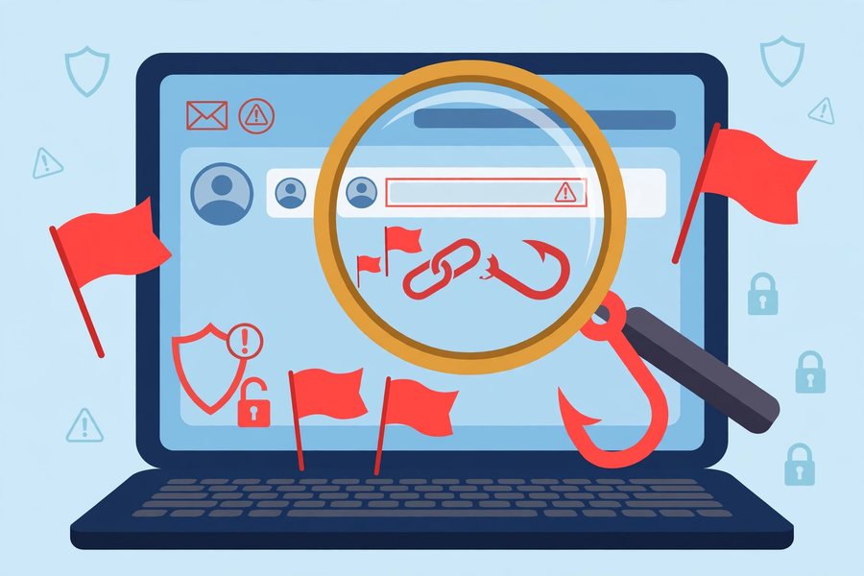
二、例子：三封示例電郵
2. Examples: Three Sample Emails
注意：以下全為老師預備的仿真教材，並非真實電郵。
Note: the following are all simulated teaching materials prepared by the teacher, not real emails.
- 示例電郵 A（假）：寄件人 support@micorsoft-support.com（注意：micorsoft 多了一個字母 o，真正的微軟域名是 microsoft）。內容：「你的帳戶出現異常，請在 24 小時內點擊以下連結驗證，否則帳戶將被停用。」特徵：可疑寄件人＋緊急語氣＋奇怪連結。
Sample email A (phishing): sender support@micorsoft-support.com (note: "micorsoft" has an extra "o"; the real Microsoft domain is "microsoft"). Content: "Your account shows unusual activity. Click the link below to verify within 24 hours or your account will be suspended." Hallmarks: suspicious sender + urgent tone + strange link.
- 示例電郵 B（真）：寄件人為學校官方電郵地址（以本校實際域名為準，內容無索取任何個人資料）。內容：「下週測驗時間表已上載到學校內聯網，請同學查閱。」特徵：寄件人可信、內容正常、沒有索取資料、沒有緊急威嚇。
Sample email B (genuine): sender is the school's official email address (use the school's actual domain; the content requests no personal data). Content: "Next week's test timetable has been uploaded to the school intranet. Please check." Hallmarks: trustworthy sender, normal content, no data requests, no urgent threats.
- 示例電郵 C（假）：附件名為「成績單.exe」的可執行檔，內容：「你的成績有誤，請立即開啟附件核對，並回覆你的學生編號及密碼。」特徵：附件陷阱＋緊急語氣＋索取個人資料。注意：.exe 是可執行檔，開啟可能中毒。
Sample email C (phishing): an attachment named "report-card.exe" (an executable file) with content: "There is an error in your grades. Open the attachment immediately and reply with your student number and password." Hallmarks: attachment trap + urgent tone + request for personal data. Note: .exe files are executables — opening one may infect your device.
三、簡單問答題
3. Quick Questions
Q1. 列出釣魚電郵的五個特徵。
List the five hallmarks of phishing emails.
Q2. 收到可疑連結時，應該怎樣檢查？（寫出兩個具體做法）
How should you check a suspicious link? (Give two concrete steps.)
Q3. 說出設定安全密碼的三個原則。
State the three principles of secure passwords.
Q4. 為甚麼「不同網站用不同密碼」很重要？
Why is it important to use different passwords for different sites?
四、思考題
4. Thinking Questions
Q1. 有同學說：「電郵有大公司的標誌，一定是真的。」請反駁這個說法。
A classmate says: "The email has a big company's logo, so it must be genuine." Refute this.
Q2. 騙徒為甚麼喜歡在釣魚電郵中製造緊急語氣（例如「24 小時內不處理就停用帳戶」）？這利用了人的甚麼心理？
Why do scammers like manufacturing urgency in phishing emails (e.g. "act within 24 hours or your account will be suspended")? What human psychology does this exploit?
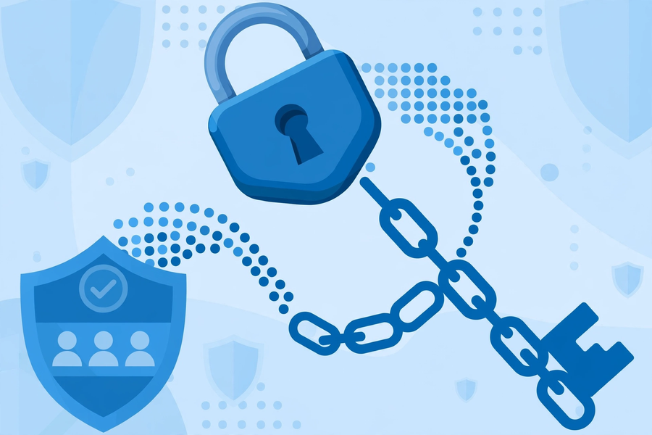
五、分組活動：釣魚電郵偵測練習
5. Group Task: Phishing Email Detection Practice
- 小組挑戰：老師會展示多封示例電郵（真假混合），各組即場判斷真偽，並圈出發現的特徵（可疑寄件人／緊急語氣／奇怪連結／附件陷阱／索取個人資料），寫下判斷理由。
Group challenge: the teacher will show several sample emails (a mix of genuine and phishing). Each group judges them on the spot, circles the hallmarks found (suspicious sender / urgent tone / strange link / attachment trap / request for personal data), and writes down the reasons.
- 注意：所有示例電郵均為老師預備的仿真教材，切勿使用真實釣魚電郵作教材；全程謹記「懷疑就停手、問老師」。
Note: all sample emails are simulated materials prepared by the teacher; never use real phishing emails as teaching materials. Throughout, remember: "When in doubt, stop and ask the teacher".
偵測練習表（每組一份）
電郵 Email | 真／假 Genuine / Phishing | 圈出發現的特徵 Circled hallmarks | 判斷理由 Reasons
A
B
C

密碼自查表（每人一份） Password Self-Check (individual)
自查問題 Self-check question | 是 Yes | 否 No
我的密碼有否使用生日或電話號碼？Does my password use my birthday or phone number? | ☐ | ☐
我是否在不同網站使用同一個密碼？Do I use the same password across sites? | ☐ | ☐
我有否告訴過別人我的密碼？Have I ever told anyone my password? | ☐ | ☐

六、總結
6. Summary
- 釣魚電郵五特徵：可疑寄件人、緊急語氣、奇怪連結、附件陷阱、索取個人資料。
Five phishing hallmarks: suspicious sender, urgent tone, strange links, attachment traps, requests for personal data.
- 檢查連結：懸停看網址、核對域名拼法；有懷疑就不要點。
Check links: hover to view the URL, verify domain spelling; when in doubt, do not click.
- 密碼三原則：夠長（至少 12 個字元）、獨特、不同網站不同密碼。
Three password principles: long (at least 12 characters), unique, different per site.
- 自保原則：懷疑就停手，問老師或家長；任何人不應向你索取密碼。
Self-protection: when in doubt, stop and ask a teacher or parent; no one should ask for your password.
- 課後可到 cyberhub.hk 的學生培訓免費網上課程持續進修：https://cyberhub.hk/tc/student-training
For further self-study, visit cyberhub.hk's free online student training: https://cyberhub.hk/tc/student-training
七、小測驗
7. Quiz
Q1. 以下哪一項不是釣魚電郵的特徵？
Which of the following is NOT a hallmark of phishing emails?
A. 可疑的寄件人地址
A suspicious sender address
B. 製造緊急語氣
Manufactured urgency
C. 索取個人資料
Requests for personal data
D. 寄件人是學校官方地址且內容正常
Sender is the school's official address with normal content
Q2. 收到可疑連結，正確的做法是？
On receiving a suspicious link, the correct action is?
A. 立即點擊看看
Click it immediately to see
B. 懸停看真正網址、核對域名拼法，有懷疑就不要點
Hover to view the real URL, check domain spelling; do not click when in doubt
C. 轉發給所有朋友
Forward it to all friends
D. 把連結抄下來貼到功課上
Copy the link into your homework
Q3. 關於安全密碼，以下哪個說法正確？
About secure passwords, which statement is correct?
A. 用生日做密碼最方便
Using your birthday as the password is most convenient
B. 所有網站用同一個密碼最省事
Using one password for all sites is most convenient
C. 夠長、獨特、不同網站用不同密碼
Long, unique, different passwords for different sites
D. 把密碼告訴好朋友幫忙記住
Tell your password to a good friend to help remember it
Q4. 以下哪個密碼最安全？
Which password is the most secure?
A. 123456
123456
B. password
password
C. 藍天_單車_圖書館_2026
blue-sky_bicycle_library_2026
D. 我的電話號碼
My phone number
Q5. 有人自稱客服向你索取密碼，你應該？
Someone claiming to be customer service asks for your password. You should?
A. 立即提供
Provide it immediately
B. 拒絕並告訴老師或家長
Refuse and tell a teacher or parent
C. 只提供一半
Provide only half of it
D. 問他要不要其他帳戶的密碼
Ask if they want other accounts' passwords too
Q1. 示例電郵 A 的寄件人是 support@micorsoft-support.com。指出它為假電郵的兩個證據。
Sample email A's sender is support@micorsoft-support.com. Point out two pieces of evidence that it is phishing.
Q2. 你的朋友在三個網站都用同一個密碼「生日＋名字」。寫出這做法的兩個風險，並給他一個具體改善建議。
Your friend uses the same password "birthday + name" on three websites. State two risks of this practice and give one concrete improvement suggestion.

