聖公會呂明才中學
S.K.H. Lui Ming Choi Secondary School
S2 單元四：AI 進階與倫理深化｜教師筆記
S2 Unit 4: Advanced AI and Deepening of AI Ethics | Teacher Notes
本堂物資表 Materials List（教師版）
請預早一星期準備所需物資；標示「課室現有」之項目請預先清點。
品名 Item | 數量（每組） Quantity (per group) | 大約成本 Est. cost | 安全注意 Safety notes
工作紙「釣魚電郵偵測練習」及「密碼自查表」 | 每人 1 份 | 影印約每份 HK$0.4 | 提醒學生切勿在功課或工作紙上寫出真實密碼。
小組挑戰用示例電郵卡 | 每組 1 套（老師預先印製，可重用） | 卡紙及影印約 HK$10 | 示例均為仿真教材，不可作其他用途。
投影（展示示例電郵） | 課室現有 | HK$0 | 不適用
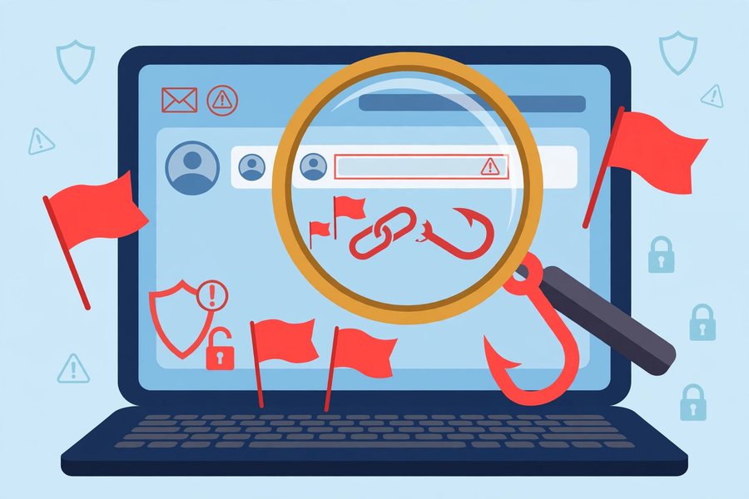
第 20 堂｜網絡安全進階：識別釣魚電郵與密碼管理實務
Lesson 20 | Advanced Cyber Security: Spotting Phishing Emails and Password Management
姓名 Name：＿＿＿＿ 班別 Class：＿＿＿＿ 學號 No.：＿＿＿＿ 日期 Date：＿＿＿＿

本教師筆記包含：學生筆記全部題目參考答案、家課參考答案、附加思考題、建議教導方向及常見迷思。
These teacher notes contain: suggested answers to all student-notes questions, homework answers, extra thinking questions, teaching guidance and common misconceptions.
甲部：學生筆記參考答案
Part A: Student Notes — Suggested Answers
簡單問答題
- 可疑寄件人、製造緊急語氣、奇怪連結、附件陷阱、索取個人資料。
Suspicious sender, manufactured urgency, strange links, attachment traps, requests for personal data.
- 把滑鼠懸停在連結上看真正網址（不要點擊）；仔細核對域名拼法。
Hover over the link to see the real URL (do not click); check the domain spelling carefully.
- 夠長（至少 12 個字元）、獨特、不同網站用不同密碼。
Long (at least 12 characters), unique, different passwords for different sites.
- 因為一旦其中一個網站資料外洩，騙徒會用同一組帳號密碼去試其他網站；不同密碼可把損失局限在一個帳戶。
Because if one site leaks data, scammers will try the same credentials on other sites; different passwords confine the damage to one account.
思考題（參考答案）
- 反駁：標誌極易偽造，複製貼上一秒就完成；判斷真偽必須核對寄件人地址及連結域名，而不是看標誌。
Rebuttal: logos are trivially easy to forge — copy and paste takes a second; verify the sender address and link domain, not the logo.
- 因為緊急語氣令人恐慌，恐慌時人會停止思考、急於按指示行動，正中騙徒下懷；這利用了人的「恐懼」心理。
Because urgency creates panic, and panicking people stop thinking and rush to follow instructions — exactly what scammers want; it exploits human "fear".
三封示例電郵判斷（參考答案）
- A 為假：寄件人域名 micorsoft-support.com 多了一個字母 o；內容製造緊急語氣並附奇怪連結。
A is phishing: the sender domain "micorsoft-support.com" has an extra "o"; the content manufactures urgency with a strange link.
- B 為真：學校官方域名（請老師按本校實際域名修改示例），內容正常，無索取資料。
B is genuine: the school's official domain (teachers: replace with the school's actual domain), normal content, no data requests.
- C 為假：附件為 .exe 可執行檔（附件陷阱），加上緊急語氣及索取學生編號和密碼。
C is phishing: the .exe executable attachment is a trap, plus urgent tone and a request for student number and password.
小測驗答案
Q1 答案 Answer：D
學校官方地址＋正常內容是真電郵的特徵，不是釣魚特徵。
The school's official address with normal content marks a genuine email, not phishing.
Q2 答案 Answer：B
懸停看網址、核對域名，有懷疑就不要點。
Hover to view the URL, check the domain; do not click when in doubt.
Q3 答案 Answer：C
夠長、獨特、不同網站不同密碼。
Long, unique, different passwords for different sites.
Q4 答案 Answer：C
三個不相關詞語加數字又長又好記，最安全。
Three unrelated words plus numbers — long and memorable, the most secure.
Q5 答案 Answer：B
拒絕並告訴老師或家長；任何人不應索取你的密碼。
Refuse and tell a teacher or parent; no one should ask for your password.
- 參考答案：證據一——寄件人域名「micorsoft」拼錯，真正的微軟是「microsoft」；證據二——內容製造緊急語氣（24 小時內不驗證就停用帳戶），屬典型釣魚特徵。
Sample answer: Evidence 1 — the sender domain "micorsoft" is misspelt; the real Microsoft is "microsoft". Evidence 2 — the content manufactures urgency ("verify within 24 hours or be suspended"), a classic phishing trait.
- 參考答案：風險一——其中一個網站外洩，騙徒會用同一密碼試其他網站；風險二——生日加名字極易被猜中。改善建議：改用三個不相關詞語串連的口令短語，且每個網站不同。
Sample answer: Risk 1 — if one site leaks, scammers will try the same password elsewhere. Risk 2 — birthday plus name is easily guessed. Suggestion: switch to a passphrase of three unrelated words, different per site.
乙部：家課參考答案
Part B: Homework — Suggested Answers
Q1 答案 Answer：A
社交工程是針對「人」的心理弱點行騙。
Social engineering targets human psychological weaknesses.
Q2 答案 Answer：B
陌生電郵的 .exe 附件最可疑。
A .exe attachment from a stranger's email is the most suspicious.
- 評分要點：須對照三原則（夠長、獨特、不同網站不同密碼）提出具體改善方法；全文約 80 字；如發現學生寫出真實密碼，須即時提醒並扣分，教導切勿在任何功課或網上寫出真實密碼。
Marking points: must propose concrete improvements against the three principles; about 80 words; if a student writes a real password, remind them immediately, deduct marks, and teach never to write real passwords in homework or online.
- 參考答案：第一步——停手，不要點擊連結；第二步——核對寄件人地址是否真是學校官方域名；第三步——直接向老師或家長求助查證。即使真是學校電郵，也應到官方網站登入而非經電郵連結。
Sample answer: Step 1 — stop, do not click the link. Step 2 — check whether the sender address is truly the school's official domain. Step 3 — ask a teacher or parent to verify. Even if genuinely from the school, log in via the official website, not the email link.
丙部：附加思考題
Part C: Extra Thinking Questions
Q1. 除了電郵，騙徒還會用甚麼渠道進行社交工程？（提示：電話、短訊、社交媒體）試舉一個例子並說明防範方法。
Besides email, what other channels do scammers use for social engineering? (Hint: phone calls, SMS, social media.) Give one example and a prevention method.
Q2. 為甚麼「懷疑就停手」比「學會分辨每一種騙術」更實用？
Why is "when in doubt, stop" more practical than "learning to identify every scam"?
參考答案：1. 示例：假冒速遞短訊附釣魚連結；防範：不要點短訊連結，直接到官方應用程式查件。2. 因為騙術不斷翻新，不可能學完所有招式；「停手＋求助」這個原則以不變應萬變。
Suggested answers: 1. Example: fake courier SMS with a phishing link; prevention: do not tap SMS links — check parcels in the official app. 2. Because scams keep evolving and no one can learn them all; "stop + seek help" is a timeless principle.
丁部：建議教導方向
Part D: Teaching Guidance
- 所有示例電郵均為老師預備的仿真教材，切勿使用真實釣魚電郵作教材；課堂上不斷重申「懷疑就停手、問老師」。
All sample emails are simulated materials prepared by the teacher; never use real phishing emails. Repeat throughout: "When in doubt, stop and ask the teacher".
- 小組挑戰的示例宜真假混合，避免學生猜規律；可即場加一兩封老師臨時設計的示例。
Mix genuine and phishing samples in the group challenge so students cannot guess by pattern; you may add one or two impromptu samples.
- 課堂尾聲介紹 cyberhub.hk 學生培訓免費網上課程（網址已核實：https://cyberhub.hk/tc/student-training），鼓勵學生課後持續進修。
Close by introducing cyberhub.hk's free online student training (verified URL: https://cyberhub.hk/tc/student-training) and encourage further self-study.
戊部：常見迷思
Part E: Common Misconceptions
- 迷思：「有大公司標誌就不會是假。」正解：標誌極易偽造，必須核對寄件人地址及連結域名。
Myth: "A big company's logo means it cannot be fake." Correction: logos are easily forged — always verify the sender address and link domain.
- 迷思：「密碼愈複雜愈好，愈長反而難記。」正解：可用「三個不相關詞語串連」等易記又安全的方法，並介紹密碼管理工具。
Myth: "The more complex the password the better; long ones are hard to remember." Correction: memorable-yet-secure methods like joining three unrelated words work, plus password managers.

