創科班 Little Makers Class｜單元三：編程思維（不插電） Little Makers Class | Unit 3: Computational Thinking (Unplugged)
第 14 堂：Debug 大作戰——紙上程式找錯＋改良迷宮指令 Lesson 14: Debugging Challenge — Find the Bugs on Paper + Improve the Maze Instructions
姓名 Name：＿＿＿＿ 班別 Class：＿＿＿＿ 學號 No.：＿＿＿＿ 日期 Date：＿＿＿＿
本堂物資表 Materials List
以下為本堂分組活動所需物資（每組一份）。請在老師派發時核對。
品名 Item | 數量（每組） Quantity (per group) | 安全注意 Safety notes
「紙上程式找錯」工作紙 "Find the bugs on paper" worksheet | 每人 1 張 1 per student | 無 None
「改良我的迷宮指令」工作紙 "Improve my maze instructions" worksheet | 每人 1 張 1 per student | 無 None
第 11 堂迷宮指令（學生自備） Lesson 11 maze instructions (students' own) | 每人 1 份 1 per student | 無 None
原子筆／紅筆（圈出錯處用） Ballpoint / red pens (for circling bugs) | 每人 1 支 1 per student | 無 None

一、本課目標
1. Learning objectives
完成本課後，你能夠：
By the end of this lesson, you will be able to:
- 說出除錯三步法（重現問題、追蹤執行、逐段測試）； ／ state the three debugging steps (reproduce the problem, trace the execution, test section by section);
- 在一份紙上程式中找出最少兩個預設錯誤，並說明每個錯誤的成因； ／ find at least two planted bugs in a paper program and explain the cause of each;
- 運用除錯思維改良第 11 堂的迷宮指令，並指出具體改了什麼、為什麼改。 ／ improve your Lesson 11 maze instructions with debugging thinking, stating exactly what was changed and why.

二、理論：什麼是除錯？
2. Theory: what is debugging?
程式或指令中的錯誤稱為 bug（蟲），找出並修正錯誤的過程稱為 debug（除蟲／除錯）。
An error in a program or set of instructions is called a bug; the process of finding and fixing it is called debugging.
出錯是學習編程的正常部分。重點不是「一次寫對」，而是有系統地找出原因——胡亂整段重寫，往往比有系統的除錯更慢。
Making mistakes is a normal part of learning programming. The point is not to “get it right first time” but to find the cause systematically — blindly rewriting everything is usually slower than systematic debugging.

除錯三步法
The three debugging steps
- 重現問題（Reproduce）：把出錯的情況再做一次，確認錯誤在哪裡出現、在哪一步發生。 ／ Reproduce: make the error happen again to confirm where and at which step it occurs.
- 追蹤執行（Trace）：假裝自己是電腦，逐行跟著指令走，記下每一步之後的位置和狀態，找出第一步出錯的地方。 ／ Trace: pretend to be the computer and follow the instructions line by line, noting the position after each step, to find the first step that goes wrong.
- 逐段測試（Test section by section）：把指令分段檢查，逐段確認沒有問題，逐步縮小出錯的範圍。 ／ Test section by section: check the instructions in sections to narrow down where the bug is.

常見的錯誤類型
Common bug types
- 次序錯誤：步驟的先後調亂了（例如先前行、後轉彎，正確應是先轉彎、後前行）； ／ Wrong order: steps in the wrong sequence (e.g. moving before turning, when it should be turn-then-move);
- 遺漏步驟：少寫了關鍵的一步（例如轉彎後忘記寫「向前行」）； ／ Missing step: a key step is left out (e.g. forgetting “move forward” after turning);
- 含糊用詞：用詞不清楚，執行者無法判斷（例如「行前少少」——少少是多遠？）； ／ Vague wording: unclear words the executor cannot judge (e.g. “move a little” — how far is “a little”?);
- 多餘步驟：寫了不需要的步驟（例如起點已面向正確方向，卻多寫了一次轉彎）。 ／ Redundant step: an unnecessary step (e.g. turning when already facing the right way).


三、例子：追蹤執行找錯
3. Example: tracing to find a bug
以下是一組有錯的迷宮指令（起點 (0,0)，起步面向右方 →，終點 (2,3)；黑色格為牆）。我們用「追蹤執行」逐行檢查：
The following maze instructions contain a bug (start (0,0) facing right →, goal (2,3); black squares are walls). Let us trace line by line:
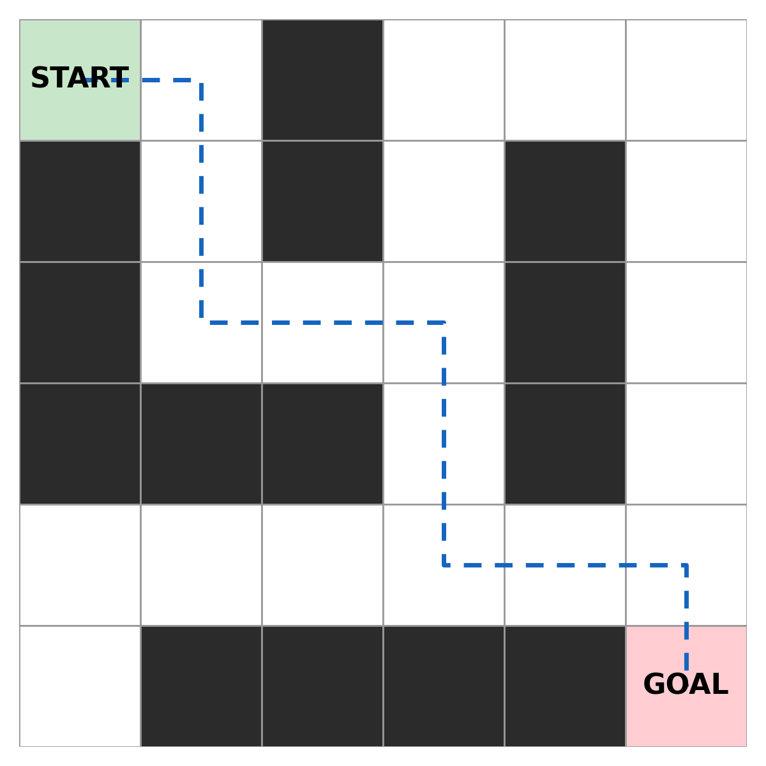
- 向前行一格； ／ Move forward one square;
- 向右轉； ／ Turn right;
- 向前行兩格； ／ Move forward two squares;
- 向右轉； ／ Turn right;
- 向前行一格。 ／ Move forward one square.
步驟  Step | 指令  Instruction | 執行後位置／面向  Position / facing after | 正常？  OK?
1 | 向前行一格 | (0,1) 面向右 | ✓
2 | 向右轉 | (0,1) 面向下 | ✓
3 | 向前行兩格 | (2,1) 面向下 | ✓
4 | 向右轉 | (2,1) 面向左 | ✗ 錯！應向左轉才面向右方
5 | 向前行一格 | 撞牆！(2,0) 是牆壁 | ✗

找到錯處：第 4 步方向錯誤，應為「向左轉」。修正後重新追蹤，第 5 步便能順利走到 (2,2)。這就是「重現 → 追蹤 → 修正 → 再測試」的除錯循環。
Bug found: step 4 turns the wrong way — it should be “turn left”. After fixing, re-trace: step 5 now reaches (2,2) safely. This is the debug loop: reproduce → trace → fix → test again.

四、紙上程式找錯
4. Find the bugs on paper
以下三段指令各有 2–3 個預設錯誤。請用追蹤執行法逐行檢查，圈出錯處並寫下成因。迷宮圖見上（起點 START 綠格，終點 GOAL 紅格）。
Each of the three instruction sets below contains 2–3 planted bugs. Trace line by line, circle each bug and write its cause. (Maze map above: green START, red GOAL.)

（甲）起點 (0,0)，起步面向下 ↓，終點 (2,3)
(A) Start (0,0) facing down ↓, goal (2,3)
- 向左轉； ／ Turn left;
- 向前行一格； ／ Move forward one square;
- 向左轉； ／ Turn left;
- 向前行一格； ／ Move forward one square;
- 向左轉； ／ Turn left;
- 向左轉； ／ Turn left;
- 向前行兩格。 ／ Move forward two squares.
步驟  Step | 執行後位置／面向  Position / facing after | 正常？問題在哪？  OK? What is wrong?
1
2
3
4
5
6
7

（乙）起點 (4,0)，起步面向右 →，終點 (5,5)
(B) Start (4,0) facing right →, goal (5,5)
- 向前行一格； ／ Move forward one square;
- 行前少少； ／ Move a little forward;
- 向前行三格； ／ Move forward three squares;
- 向前行一格； ／ Move forward one square;
- 向右轉。 ／ Turn right.
步驟  Step | 執行後位置／面向  Position / facing after | 正常？問題在哪？  OK? What is wrong?
1
2
3
4
5

（丙）起點 (2,1)，起步面向右 →，終點 (2,3)
(C) Start (2,1) facing right →, goal (2,3)
- 向右轉； ／ Turn right;
- 向左轉； ／ Turn left;
- 向前行兩格。 ／ Move forward two squares.
步驟  Step | 執行後位置／面向  Position / facing after | 正常？問題在哪？  OK? What is wrong?
1
2
3

五、簡單問答題
5. Quick questions
- 除錯三步法是什麼？ ／ What are the three debugging steps?
- 「追蹤執行」是什麼意思？ ／ What does “tracing the execution” mean?
- 常見的錯誤類型有哪四種？ ／ What are the four common bug types?
- 找到錯處卻說不清成因，應該怎樣做？ ／ You found a bug but cannot explain its cause — what should you do?
- 為什麼有系統的除錯比整段重寫更快？ ／ Why is systematic debugging faster than rewriting everything?

六、思考題
6. Thinking question
有人 debug 時喜歡把整段指令刪掉重寫。你會給他什麼建議？為什麼？
Some people like to delete the whole instruction set and rewrite it when debugging. What advice would you give them? Why?
你的看法：＿＿＿＿＿＿＿＿＿＿＿＿＿＿＿＿＿＿＿＿＿＿＿＿＿＿＿＿＿＿＿＿
Your view:
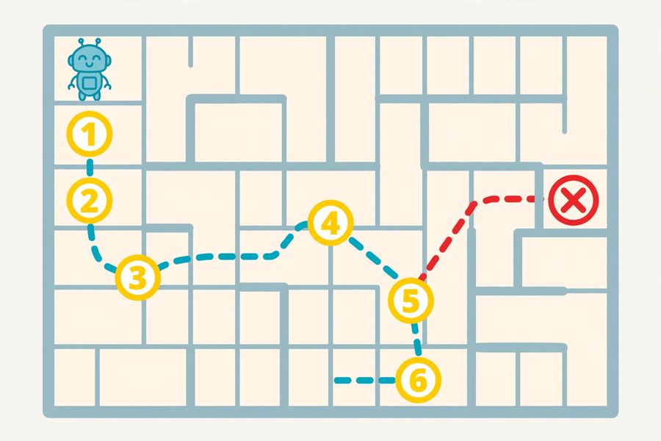

七、分組題：改良我的迷宮指令
7. Group activity: improve my maze instructions
取出第 11 堂的迷宮指令，完成以下三項任務：
Take out your Lesson 11 maze instructions and complete these three tasks:
- 用除錯三步法把原版指令重審一次； ／ Review the original instructions with the three debugging steps;
- 最少作出兩處具體改良，填寫對照表； ／ Make at least two concrete improvements and fill in the comparison table;
- 把其中一組改寫成「長者版」（字體較大、用詞淺白、每步只有一個動作）。 ／ Rewrite one set as an “elderly-friendly version” (larger writing, plain wording, one action per step).

改良對照表
Improvement comparison table
原版指令  Original | 發現的問題  Problem found | 改良後指令  Improved | 為什麼這樣改  Why

長者版指令寫作區
Elderly-friendly version
1. ＿＿＿＿＿＿＿＿＿＿＿＿＿＿＿＿＿＿＿＿＿＿
2. ＿＿＿＿＿＿＿＿＿＿＿＿＿＿＿＿＿＿＿＿＿＿
3. ＿＿＿＿＿＿＿＿＿＿＿＿＿＿＿＿＿＿＿＿＿＿
4. ＿＿＿＿＿＿＿＿＿＿＿＿＿＿＿＿＿＿＿＿＿＿
5. ＿＿＿＿＿＿＿＿＿＿＿＿＿＿＿＿＿＿＿＿＿＿
6. ＿＿＿＿＿＿＿＿＿＿＿＿＿＿＿＿＿＿＿＿＿＿

八、正能量／關愛連結
8. Positivity and caring connection
為長者改寫指令時，你考慮了讀者的什麼需要？這和寫給同學看的指令有什麼不同？
When rewriting instructions for the elderly, whose needs did you consider? How is this different from instructions written for classmates?
＿＿＿＿＿＿＿＿＿＿＿＿＿＿＿＿＿＿＿＿＿＿＿＿＿＿＿＿＿＿＿＿＿＿＿＿

九、單元回顧
9. Unit review
本單元四堂的主線：
The thread running through this unit’s four lessons:
- 第 11 堂：演算法——解決問題的明確步驟（精確性、序列）； ／ Lesson 11: Algorithms — clear steps for solving problems (precision, sequencing);
- 第 12 堂：二進制——電腦的語言（逢二進一）； ／ Lesson 12: Binary — the language of computers (carry when reaching two);
- 第 13 堂：效率——演算法有快慢之分（二分搜尋每次排除一半）； ／ Lesson 13: Efficiency — algorithms can be fast or slow (binary search halves each time);
- 第 14 堂：除錯——有系統地找出並修正錯誤（重現、追蹤、逐段測試）。 ／ Lesson 14: Debugging — systematically finding and fixing errors (reproduce, trace, test).

十、總結
10. Summary
- 出錯是正常的；有系統的除錯比重寫更快。 ／ Mistakes are normal; systematic debugging beats rewriting.
- 除錯三步法：重現問題、追蹤執行、逐段測試。 ／ Three steps: reproduce, trace, test section by section.
- 常見錯誤：次序錯誤、遺漏步驟、含糊用詞、多餘步驟。 ／ Common bugs: wrong order, missing steps, vague wording, redundant steps.
- 好的指令往往經過多次修訂；為長者改寫要考慮讀者的能力。 ／ Good instructions go through many revisions; writing for the elderly means considering the reader’s abilities.

十一、小測驗
11. Quiz
- （選擇題）除錯三步法的正確次序是：
A. 追蹤 → 重現 → 測試 B. 重現 → 追蹤 → 逐段測試 C. 測試 → 重現 → 追蹤 D. 重寫 → 重現 → 追蹤 ／ (MC) The correct order of the three debugging steps is: A. trace → reproduce → test B. reproduce → trace → test section by section C. test → reproduce → trace D. rewrite → reproduce → trace
- （選擇題）「追蹤執行」是指：
A. 用跑步追著電腦 B. 假裝自己是電腦，逐行跟著指令走 C. 把錯處全部刪掉 D. 問老師要答案 ／ (MC) “Tracing the execution” means: A. chasing the computer on foot B. pretending to be the computer and following instructions line by line C. deleting all the bugs D. asking the teacher for the answer
- （判斷題）Debug 就是把整段指令刪掉重寫。（正確／錯誤） ／ (True/False) Debugging means deleting the whole instruction set and rewriting it. (True / False)
- 下面這組指令有一處錯誤（起點 (0,0)，起步面向右 →，終點 (0,1)）。請圈出錯處並說明成因。
1. 向右轉 2. 向前行一格
錯處：＿＿＿＿＿＿＿＿ 成因：＿＿＿＿＿＿＿＿ ／ There is one bug below (start (0,0) facing right →, goal (0,1)). Circle it and explain the cause.
1. Turn right 2. Move forward one square
Bug: ____ Cause: ____
- 寫出除錯三步法，並用一句話解釋每一步。 ／ Write the three debugging steps and explain each in one sentence.

