聖公會呂明才中學 S.K.H. Lui Ming Choi Secondary School
創科班 Little Makers Class
第 17 堂｜AI 生成作品
Lesson 17 | Creating with Generative AI
教師筆記（內含全部答案）
Teacher's Notes (with all answers)
本文件包含學生筆記全文、小測驗及家課的全部答案，僅供教師參考，請勿派發給學生。
This document contains the full student notes and all quiz/homework answers. For teachers only; do not distribute to students.
本堂物資表 Materials List（教師版）
請預早一星期準備所需物資；標示「課室現有」之項目請預先清點。
品名 Item | 數量（每組） Quantity (per group) | 大約成本 Est. cost | 安全注意 Safety notes
共用平板／手提電腦 Shared tablets / laptops | 2–3 部（全班輪用） 2–3 for the class | 學校現有，$0 School-owned, $0 | 使用前檢查電量；操作時不飲食。 Check battery; no food or drink during use.
彩色列印（海報成品） Colour printing (finished posters） | 每組 1 張 1 per group | 約 HK$3／張 Approx. HK$3 each | 列印機運作時高溫，由老師操作，學生勿觸碰。 Printer gets hot; teacher operates only.
藍牙喇叭 Bluetooth speaker | 1 個 1 | 學校現有，$0 School-owned, $0 | 音量適中，免影響鄰班。 Keep volume moderate.
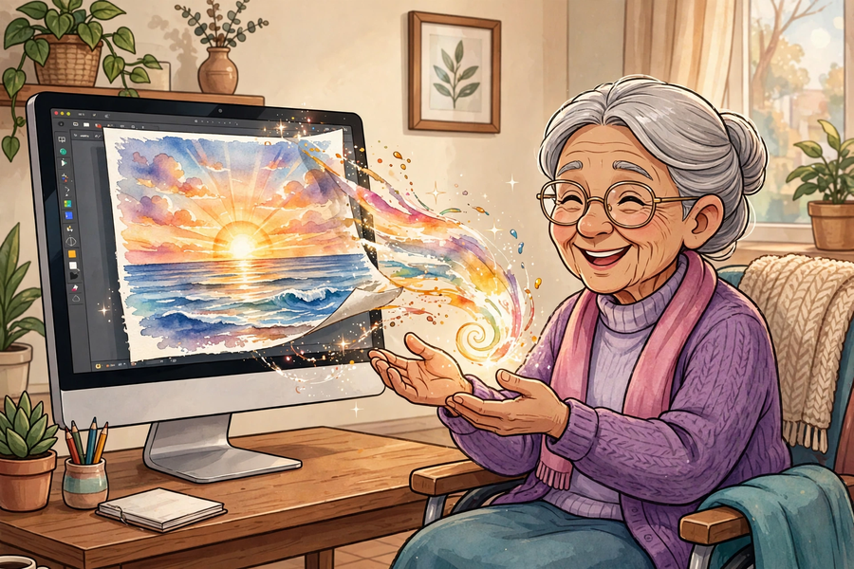
一、學生筆記內容（含答案） Student Notes Content (with answers)
主題：AI 生圖＋AI 音樂：為院舍長者製作正能量圖文／音樂作品
Theme: AI image + AI music generation: producing positive artworks for elderly home residents
姓名 Name：______________ 班別 Class：______ 學號 No.：______ 日期 Date：____________
一、學習目標 Learning Objectives
1. 能用一句話解釋生成式 AI：按文字描述產生全新內容的人工智能。
1. Explain generative AI in one sentence: AI that produces brand-new content from text descriptions.
2. 能與組員合作，完成一件關愛主題的作品（圖文海報或短音樂）。
2. Collaborate to complete one caring-themed artwork (illustrated poster or short music piece).
3. 能在作品中清楚表達正能量訊息。
3. Express a clear positive message in the work.
4. 能說出使用生成式 AI 的兩項注意：註明 AI 生成、不上傳他人私人相片。
4. Name two precautions: label AI-generated content and do not upload others' private photos.
二、課程內容 Key Concepts
1. 什麼是生成式 AI？生成式 AI（Generative AI）是能夠按文字描述，產生全新內容（圖像、音樂、文字等）的人工智能。與只會回答問題或分類的 AI 不同，它會「創作」。
1. What is generative AI? Generative AI is AI that produces brand-new content (images, music, text, etc.) from text descriptions. Unlike AI that only answers or classifies, it "creates".
2. 它怎樣做到？它從大量圖像、音樂中學習規律，再按你的文字描述組合出新的作品。作品是新的，但風格和元素來自它學過的數據。
2. How does it work? It learns patterns from huge numbers of images and music pieces, then combines them into new works according to your text description. The work is new, but its style and elements come from the data it learnt.
3. 使用三不：①不透露個人私隱——不在提示中輸入姓名、電話、學校；②不上傳他人相片——嚴禁上傳學生或他人的真實相片作生成素材；③註明 AI 生成——作品要標明由 AI 協助製作，不冒充真人作品。
3. Three don'ts: 1. No private data — no names, phone numbers or schools in prompts; 2. No uploading others' photos — strictly no real photos of students or others as generation material; 3. Label AI-generated content — mark works as AI-assisted; never pass them off as human works.
4. 誠信：AI 做的作品不可以當作自己親手創作來交功課；引用或使用 AI 作品時必須註明出處。
4. Integrity: AI-made works must not be submitted as your own hand-made work; always declare the source when quoting or using AI works.
5. AI 是工具，溫度來自人的心意：作品的關愛和溫度，來自分組同學為長者著想的心意，而不是 AI 本身。
5. AI is a tool; the warmth comes from people: the care in your work comes from your group's thoughtfulness for the elderly, not from the AI itself.
三、生活例子 Examples
1. 老師展示：兩張 AI 生成的「長者笑臉」圖，說明 AI 按文字描述拼出新圖。
1. Teacher demo: two AI-generated cheerful images, showing how AI composes new images from text descriptions.
2. 圖文海報組：用 AI 生成圖像，再由組員撰寫口號和祝福語。
2. Poster groups: generate images with AI, then write slogans and blessings yourselves.
3. 音樂組：用 AI 生成短音樂，或改編生日歌歌詞送給長者。
3. Music groups: generate short music with AI, or adapt birthday-song lyrics for the elderly.
4. 好的標示示例：「本作品圖像由 AI 生成，口號由本組同學撰寫。」
4. Good labelling example: "Images in this work were AI-generated; slogans were written by our group."
四、簡單問答 Quick Q&A
Q1. 用一句話解釋什麼是生成式 AI。
Q1. Explain generative AI in one sentence.
答案：按文字描述產生全新內容的人工智能。
Answer: AI that produces brand-new content from text descriptions.
Q2. 為什麼不能上傳同學的相片來生成圖片？
Q2. Why must you not upload a classmate's photo to generate images?
答案：因為涉及他人私隱和肖像權，未經同意不可使用。
Answer: Because it concerns others' privacy and portrait rights; never use them without consent.
Q3. 用 AI 生成的作品，應該怎樣標示？
Q3. How should AI-generated works be labelled?
答案：註明由 AI 生成，不冒充真人作品。
Answer: Label them as AI-generated; never pass them off as human works.
Q4. AI 生成的圖文可以用來交美術功課當自己畫嗎？為什麼？
Q4. Can AI-generated pictures be submitted as your own art homework? Why?
答案：不可以；必須註明出處，誠信為上。
Answer: No; the source must be declared — integrity first.
五、思考題 Thinking Questions
Q1. 有人說「AI 生圖就是抄襲」，你怎樣看？
Q1. Some say "AI image generation is plagiarism". What do you think?
答案：AI 從大量圖像學習規律再組合，與人學畫再創作有相似之處；重點是使用時註明 AI 生成，尊重原創，不冒充真人作品。
Answer: AI learns patterns from many images and recombines them, similar in some ways to humans learning to draw before creating. The key is to label AI-generated works, respect originality, and not pass them off as human works.
Q2. 要把作品送給院舍長者，除了漂亮的圖，你們還可以怎樣令作品更有心意？
Q2. Besides pretty pictures, how else can you make the work more heartfelt for elderly home residents?
答案：參考：手寫祝福語、按長者喜好選主題、附上小組的問候、字體放大方便閱讀。
Answer: Suggested: hand-written blessings, themes the elderly enjoy, a greeting from the group, enlarged text for easy reading.
六、分組活動 Group Activity
每組選定作品形式（圖文海報／音樂），組內分工：寫提示、操作裝置、記錄、匯報。輪流使用共用裝置（每組約八至十分鐘），完成初稿後組內潤飾（修改提示並至少再生成一次），填寫下表。
Each group chooses a format (illustrated poster / music) and assigns roles: prompt writer, device operator, recorder, presenter. Take turns using the shared devices (8–10 minutes each); refine after the first draft (revise the prompt and regenerate at least once), and complete the table below.
三不重溫：不透露私隱、不上傳他人相片、註明 AI 生成。
Recap of the three don'ts: no private data, no others' photos, label AI-generated content.
主題  Theme | 對象  Audience | 所用提示  Prompt used | 修改次數及內容  Revisions | 成品描述  Final work description
七、總結 Summary
1. 生成式 AI：輸入文字描述，輸出全新圖像／音樂／文字。
1. Generative AI: text description in, brand-new images/music/text out.
2. 使用三不：不透露私隱、不上傳他人相片、註明 AI 生成。
2. Three don'ts: no private data, no others' photos, label AI-generated content.
3. AI 是工具，溫度來自人的心意；誠信為上，註明出處。
3. AI is a tool; warmth comes from people. Integrity first: declare the source.
八、小測驗 Mini Quiz
1. 生成式 AI 的特點是：
1. A feature of generative AI is:
A. 只會回答問題
A. It only answers questions
B. 按文字描述產生全新內容
B. It produces brand-new content from text descriptions
C. 只能做數學運算
C. It only does maths
D. 必須配合機械臂使用
D. It must be used with a robotic arm
答案：B。生成式 AI 的定義就是按文字描述產生全新內容。
Answer: B. Generative AI is defined by producing brand-new content from text descriptions.
2. 使用生成式 AI 時，正確的做法是：
2. The correct practice when using generative AI is:
A. 上傳朋友的相片來生成圖片
A. Upload a friend's photo to generate pictures
B. 把 AI 作品當作自己親手創作交功課
B. Submit AI works as your own hand-made homework
C. 在作品註明由 AI 生成
C. Label the work as AI-generated
D. 在提示中輸入自己的全名和學校
D. Enter your full name and school in the prompt
答案：C。註明 AI 生成是誠信的基本要求；上傳他人相片和輸入私隱都是禁止的。
Answer: C. Labelling AI-generated content is basic integrity; uploading others' photos and entering private data are forbidden.
Q1. 寫出使用生成式 AI 的「三不」。
Q1. Write the "three don'ts" of using generative AI.
答案：不透露個人私隱、不上傳他人相片、註明 AI 生成。
Answer: No private data, no uploading others' photos, label AI-generated content.
Q2. 你的小組想為院舍長者製作一張圖文海報，寫一條包含提示四要素（角色、任務、對象、格式）的提示。
Q2. Your group will make an illustrated poster for elderly home residents. Write a prompt covering the four elements (role, task, audience, format).
答案：合理且包含四要素即可，例如：「你是一位海報設計師（角色），為院舍長者設計一張正能量圖文海報（任務），對象是八十歲左右、視力較差的長者（對象）。要求：大字標題、一句祝福口號、溫暖色調圖像（格式）。」
Answer: Any reasonable prompt covering all four elements, e.g.: "You are a poster designer (role). Design a positive illustrated poster for elderly home residents (task), for residents around 80 with weaker eyesight (audience). Requirements: large headline, one blessing slogan, warm-toned image (format)."
二、家課答案 Homework Answers
甲部：選擇題
Section A: Multiple Choice
1. 以下哪一項是生成式 AI 的例子？
1. Which is an example of generative AI?
A. 計算機
A. Calculator
B. 按文字描述生成圖像的 AI 工具
B. An AI tool generating images from text descriptions
C. 微波爐
C. Microwave oven
D. 交通燈
D. Traffic lights
答案：B。只有按文字描述生成全新圖像的工具符合生成式 AI 的定義。
Answer: B. Only a tool generating brand-new images from text descriptions fits the definition.
2. 使用生成式 AI 時不應該：
2. When using generative AI, you should NOT:
A. 註明作品由 AI 生成
A. Label works as AI-generated
B. 上傳同學的真實相片作素材
B. Upload a classmate's real photo as material
C. 反覆修改提示
C. Revise prompts repeatedly
D. 與組員分工合作
D. Divide work with groupmates
答案：B。嚴禁上傳學生或他人的真實相片。
Answer: B. Uploading real photos of students or others is strictly forbidden.
3. 「AI 是工具，溫度來自人的心意」這句話的意思是：
3. What does "AI is a tool; the warmth comes from people" mean?
A. AI 沒有用
A. AI is useless
B. 作品的關愛來自人的心意，AI 只是工具
B. The care in the work comes from people's hearts; AI is just a tool
C. 人不需要用 AI
C. People need not use AI
D. AI 比人更有溫度
D. AI is warmer than people
答案：B。關愛和溫度來自分組同學的心意，AI 只是實現想法的工具。
Answer: B. Care and warmth come from the group's hearts; AI is just the tool that realises the idea.
4. 把 AI 生成的圖當作自己親手畫的交功課，這是：
4. Submitting an AI-generated picture as your own hand-drawn homework is:
A. 有創意的做法
A. Creative
B. 誠信問題，必須註明出處
B. An integrity issue; the source must be declared
C. 老師一定不會發現
C. Something the teacher will never notice
D. 值得鼓勵
D. Worth encouraging
答案：B。冒充真人作品違反誠信，必須註明 AI 生成。
Answer: B. Passing it off as a human work breaches integrity; AI generation must be declared.
5. 為院舍長者製作作品時，最重要的考慮是：
5. The most important consideration when making works for elderly home residents is:
A. 作品要複雜
A. The work must be complex
B. 訊息正面、長者看得明白
B. A positive message the elderly can understand
C. 用愈多 AI 功能愈好
C. Using as many AI features as possible
D. 愈快完成愈好
D. Finishing as fast as possible
答案：B。關愛主題和正面訊息才是作品的核心價值。
Answer: B. The caring theme and positive message are the core value of the work.
乙部：問答題（參考答案）
Section B: Short Questions (suggested answers)
Q1. 為小組的作品寫一段五十至八十字的介紹：對象是誰、想帶給長者什麼正能量訊息。
Q1. Write a 50–80 word introduction to your group's work: who it is for and what positive message it carries for the elderly.
答案：對象清楚 2 分，正能量訊息具體 3 分；字數大致相符。
Answer: 2 marks for a clear audience; 3 for a specific positive message; roughly within word count.
Q2. 解釋為什麼使用 AI 生成作品時必須註明「由 AI 生成」。
Q2. Explain why AI-generated works must be labelled as such.
答案：因為不註明就是冒充真人作品，違反誠信；註明出處是尊重原創、對觀眾負責的做法。
Answer: Because omitting the label passes the work off as human-made, breaching integrity; declaring the source respects originality and is responsible to the audience.
Q3. 舉出一個你在本堂學到的、保護他人私隱的具體做法，並解釋原因。
Q3. Give one specific practice you learnt today for protecting others' privacy, and explain why.
答案：參考：不上傳他人真實相片作生成素材，因為涉及肖像權和私隱，未經同意不可使用。
Answer: Suggested: never upload others' real photos as generation material, because it concerns portrait rights and privacy and must not be used without consent.
三、附加思考題 Extra Thinking Questions
Q1. 如果 AI 生成的圖中出現了不恰當的內容，你應該怎樣處理？
Q1. What should you do if the AI generates inappropriate content?
答案：立即停止使用並告訴老師；不要傳播或儲存；檢查提示是否恰當。
Answer: Stop using it immediately and tell the teacher; do not spread or keep it; check whether the prompt was appropriate.
Q2. 試想一個可以用生成式 AI 幫助弱勢社群的新點子。
Q2. Think of a new idea for helping the underprivileged with generative AI.
答案：開放式；例子：為視障人士生成圖像的語音描述；為長者生成大字版健康資訊單張。
Answer: Open-ended; e.g. generating spoken descriptions of images for the visually impaired; large-print health leaflets for the elderly.
四、建議教導方向 Suggested Teaching Focus
1. 音樂生成可能需時較長，宜安排音樂組先使用裝置。
1. Music generation can be slow — let music groups use the devices first.
2. 列印海報需預留時間，可安排下堂派發或張貼；列印機運作時高溫，由老師操作。
2. Allow time for printing posters; the hot printer must be operated by the teacher only.
3. 嚴禁上傳學生或他人真實相片作生成素材；不輸入姓名、學校等個人資料。
3. Strictly no uploading real photos of students or others; no personal data such as names or schools.
4. 總結時強調：AI 是工具，溫度來自人的心意；使用 AI 生成作品要註明出處、尊重原創。
4. Close by stressing: AI is a tool and warmth comes from people; declare sources and respect originality.
五、常見迷思 Common Misconceptions
1. 「AI 生圖是抄襲」——引導思考：AI 學習圖案再組合，與人學畫再創作有何異同；重點是註明 AI 生成。
1. "AI images are plagiarism" — discuss: how is AI learning patterns and recombining like or unlike humans learning to draw before creating? The key point is labelling AI generation.
2. 「AI 做的就可以當自己作品交功課」——必須註明出處，誠信為上。
2. "AI-made work can be submitted as my own" — the source must be declared; integrity first.

