聖公會呂明才中學 S.K.H. Lui Ming Choi Secondary School
創科班 Little Makers Class
第 18 堂｜教電腦認東西
Lesson 18 | Teaching Computers to Recognise Things
學生筆記
Student Notes
主題：Teachable Machine 影像辨識：剪刀石頭布識別＋數據偏見實驗
Theme: Image recognition with Teachable Machine: rock-paper-scissors recognition + data bias experiment
姓名 Name：______________ 班別 Class：______ 學號 No.：______ 日期 Date：____________
本堂物資表 Materials List
以下為本堂分組活動所需物資（每組一份）。請在老師派發時核對。
品名 Item | 數量（每組） Quantity (per group) | 安全注意 Safety notes
共用手提電腦／平板（具鏡頭） Shared laptops / tablets (with camera) | 2–3 部（全班輪用） 2–3 for the class | 鏡頭勿直射強光；課後蓋上鏡頭（如有鏡頭貼）。 Avoid pointing cameras at strong light; cover cameras afterwards if covers exist.
工作紙 Worksheets | 每組 1 張 1 per group | —
Teachable Machine 網站 Teachable Machine website | 老師預先在示範電腦開啟 Pre-opened by teacher | 網址：https://teachablemachine.withgoogle.com/（本文件唯一網址，由老師開啟，免學生輸入錯誤）。 URL: https://teachablemachine.withgoogle.com/ (the only URL in this document; opened by the teacher).
一、學習目標 Learning Objectives
1. 能按序說出機器學習流程：收集數據、訓練、測試。
1. State the machine learning workflow in order: collect data, train, test.
2. 能親手完成一次影像分類模型的訓練（剪刀／石頭／布三類）。
2. Personally complete one image-classifier training (three classes: scissors, rock, paper).
3. 能解釋模型認錯的原因與數據有關（樣本不足或太單一）。
3. Explain that recognition errors relate to data (too few or too uniform samples).
4. 能舉出一個數據偏見的例子。
4. Give one example of data bias.
二、課程內容 Key Concepts
1. 本堂親手「教電腦」：用 Teachable Machine 建立影像分類模型，不用寫程式也能訓練 AI。網址：https://teachablemachine.withgoogle.com/（老師會預先開啟）。
1. Today you will literally "teach" a computer: build an image classifier with Teachable Machine — no coding needed. URL: https://teachablemachine.withgoogle.com/ (the teacher will open it in advance).
2. Teachable Machine 是什麼？它是 Google 推出的免費網上工具，讓任何人都能快速建立機器學習模型（影像、聲音、姿勢分類），操作簡單。它可以在你的裝置本機運作，鏡頭影像不會離開你的電腦。
2. What is Teachable Machine? It is a free web tool from Google that lets anyone quickly build machine learning models (image, sound and pose classification) with simple steps. It can run entirely on your device, so webcam images never leave your computer.
3. 訓練四步：①開設三個類別（剪刀／石頭／布）；②每類按住按鈕拍約三十張樣本（轉換角度、轉換手，背景盡量簡潔）；③按「訓練」（約需十秒）；④用新姿勢測試。
3. Four training steps: 1. Create three classes (scissors / rock / paper); 2. Hold the button to capture about 30 samples per class (vary angles and hands; keep backgrounds simple); 3. Click "Train" (about ten seconds); 4. Test with new poses.
4. 為什麼會認錯？多數是數據問題：樣本太少（例如只拍五張）→ 模型不穩定；樣本太單一（例如只用右手、只在光猛課室拍攝）→ 換個情況就認錯。
4. Why do errors happen? Mostly a data problem: too few samples (e.g. only five) → unstable model; too uniform samples (e.g. right hand only, bright classroom only) → fails in new situations.
5. 數據偏見：訓練數據有偏差，AI 就會學到偏差。例如只用右手訓練、用左手測試，模型就會認錯。
5. Data bias: biased training data teaches the AI the bias. E.g. training with the right hand only, then testing with the left, makes the model fail.
6. 真實世界也有例子：國際研究曾發現，某些人臉辨識系統對部分膚色的準確度較低，原因正是訓練數據不夠多元。科技並非中立——人選擇用什麼數據，會影響 AI 的判斷。
6. Real-world example: international research has found some face-recognition systems less accurate for certain skin tones, because the training data was not diverse enough. Technology is not neutral — human choices about data shape AI's judgements.

三、生活例子 Examples
1. 課堂偏見實驗：只用右手訓練 → 用左手測試 → 全班看著模型認錯。
1. Class bias experiment: train with the right hand only → test with the left → the class watches the model fail.
2. 只在光猛課室訓練 → 到昏暗走廊測試 → 認錯（數據太單一）。
2. Train in a bright classroom only → test in a dim corridor → errors (data too uniform).
3. 預測討論：如果每類只拍五張樣本，會發生什麼？（模型不穩定，時對時錯。）
3. Prediction: what if only five samples per class? (Unstable model — sometimes right, sometimes wrong.)
四、簡單問答 Quick Q&A
Q1. Teachable Machine 是什麼？
Q1. What is Teachable Machine?
Q2. 訓練影像分類模型的三步是什麼？
Q2. What are the three steps of training an image classifier?
Q3. 每類拍多少張樣本較合適？拍攝時要注意什麼？
Q3. How many samples per class are suitable? What should you watch for when capturing?
Q4. 只用右手訓練、用左手測試會怎樣？為什麼？
Q4. What happens when you train with the right hand only and test with the left? Why?
Q5. 什麼是數據偏見？
Q5. What is data bias?
五、思考題 Thinking Questions
Q1. 有人說「相拍得愈多一定愈準」，你同意嗎？為什麼？
Q1. Some say "more photos always means more accurate". Do you agree? Why?
Q2. 如果你是工程師，要訓練一個分辨「校服／便服」的模型，你會怎樣收集數據才算公平？
Q2. As an engineer training a "school uniform / casual wear" classifier, how would you collect data fairly?
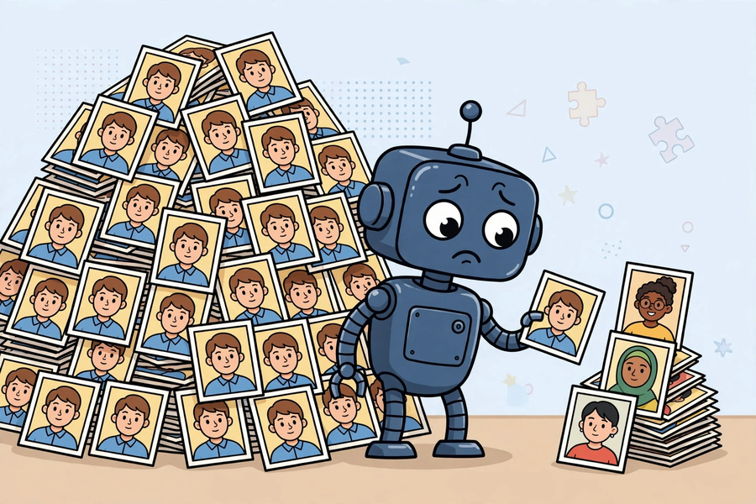
六、分組活動 Group Activity
2–3 部具鏡頭裝置全班輪用，每組約六至八分鐘。每組重建一次剪刀／石頭／布模型並測試；輪候組在工作紙記錄預測與觀察，填寫下表。
2–3 camera devices shared by the class, about 6–8 minutes per group. Each group rebuilds and tests a scissors/rock/paper model; waiting groups log predictions and observations in the table below.
類別  Class | 樣本數  Samples | 測試十次：對／錯  Test x10: right/wrong | 認錯例子  Misclassified examples | 我估計的原因  My guessed cause
七、總結 Summary
1. 親手經歷完整流程：收集數據 → 訓練 → 測試。
1. Hands-on full cycle: collect data → train → test.
2. 數據的質和量決定 AI 的表現：多元比單純多更重要。
2. Data quality and quantity decide AI performance: diversity matters more than sheer amount.
3. 數據偏見：有偏見的數據 → 有偏見的 AI。
3. Data bias: biased data → biased AI.
4. 電腦不是在「思考」，只是在比對圖案特徵。
4. The computer is not "thinking"; it only matches visual features.
八、小測驗 Mini Quiz
（請作答，不用查閱筆記。老師會講解答案。）
(Answer without referring to your notes. The teacher will go through the answers.)
1. Teachable Machine 是什麼？
1. What is Teachable Machine?
A. Google 的免費機器學習入門工具
A. Google's free machine-learning starter tool
B. 一部真實的機器
B. A real machine
C. 剪刀石頭布遊戲
C. A rock-paper-scissors game
D. 相機應用程式
D. A camera app
2. 訓練影像分類模型時，較好的做法是：
2. The better practice when training an image classifier is:
A. 每類只拍一張
A. One sample per class
B. 每類拍約三十張，並轉換角度和手
B. About thirty samples per class, varying angles and hands
C. 只用同一隻手拍攝全部樣本
C. All samples with the same hand
D. 背景愈雜亂愈好
D. The messier the background the better
Q1. 寫出課堂中模型認錯的一個具體例子，並用「數據」解釋原因。
Q1. Describe one concrete misclassification from today's lesson and explain the cause in terms of data.
Q2. 什麼是數據偏見？舉一個例子。
Q2. What is data bias? Give an example.

