聖公會呂明才中學 S.K.H. Lui Ming Choi Secondary School
創科班 Little Makers Class
第 19 堂｜AI 倫理（一）：真假難分
Lesson 19 | AI Ethics (1): Hard to Tell True from False
家課
Homework
姓名 Name：______________ 班別 Class：______ 學號 No.：______ 日期 Date：____________
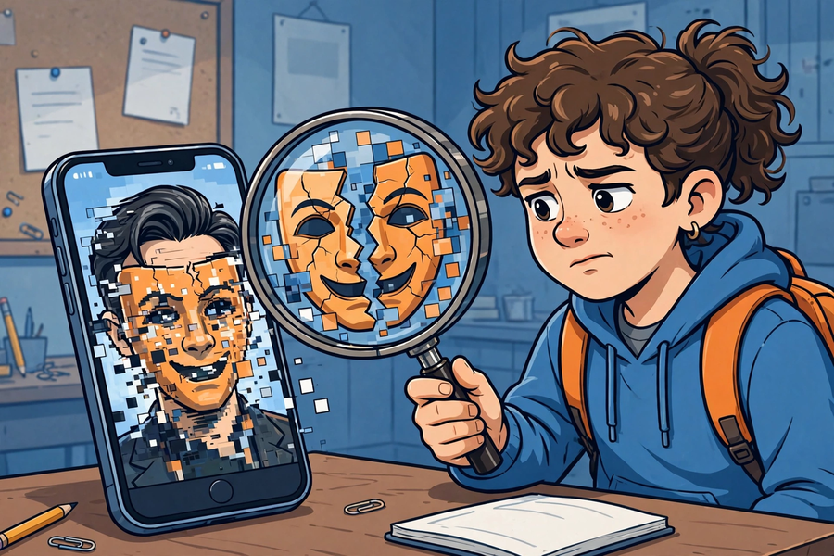
甲部：選擇題（每題 2 分，共 10 分）
Section A: Multiple Choice (2 marks each, 10 marks total)
1. 以下哪一項是 deepfake？
1. Which of the following is a deepfake?
A. 真實的新聞相片
A. A genuine news photo
B. 用 AI 換臉偽造的影片
B. An AI face-swap faked video
C. 手機原相機拍的照片
C. A photo from the phone camera
D. 課本插圖
D. A textbook illustration
2. 「查來源」是指：
2. "Check the source" means:
A. 看看是誰發的、是否官方
A. See who sent it and whether it's official
B. 看看訊息有多長
B. See how long the message is
C. 看看有多少人轉發
C. See how many people forwarded it
D. 看看用什麼手機發的
D. See what phone sent it
3. AI 幻覺的意思是：
3. AI hallucination means:
A. AI 會做夢
A. AI dreams
B. AI 自信地編造不實答案
B. AI confidently fabricates false answers
C. AI 眼花了
C. AI's eyes are blurry
D. AI 壞了
D. AI is broken
4. 以下哪個查證做法正確？
4. Which verification practice is correct?
A. 只看標題就轉發
A. Forward after reading only the headline
B. 找多個可靠來源核對
B. Cross-check with multiple reliable sources
C. 誰說都信
C. Believe whoever says it
D. 愈驚人愈可信
D. The more shocking, the more credible
5. 「先查證，後轉發」的原因是：
5. The reason for "verify before forwarding" is:
A. 轉發很花時間
A. Forwarding takes time
B. 避免散播假訊息，盡資訊責任
B. Avoid spreading misinformation; fulfil information responsibility
C. 顯得自己很聰明
C. To look smart
D. 沒有原因
D. No reason
乙部：問答題（共 15 分）
Section B: Short Questions (15 marks total)
1. 在家人通訊群組找一則轉發訊息，用查證三步驗證，寫下訊息內容、查證過程與結論；如發現可疑，寫下你會怎樣提醒家人（切勿轉發）。（10 分）
1. Find one forwarded message in a family chat group. Verify it with the three steps; record the message, the process and the conclusion. If it is suspicious, write how you would alert your family (do not forward it). (10 marks)
2. 解釋為什麼「有圖有影片」不一定代表訊息是真的。（2 分）
2. Explain why "having photos and videos" does not guarantee a message is true. (2 marks)
3. 老師問 AI「本校上星期二午膳吃了什麼」，AI 一本正經地答了出來。這個答案可信嗎？為什麼？（3 分）
3. The teacher asked AI "What did the school have for lunch last Tuesday?" and AI answered confidently. Is the answer trustworthy? Why? (3 marks)
— 完 End —

