聖公會呂明才中學 S.K.H. Lui Ming Choi Secondary School
創科班 Little Makers Class
第 19 堂｜AI 倫理（一）：真假難分
Lesson 19 | AI Ethics (1): Hard to Tell True from False
學生筆記
Student Notes
主題：Deepfake 與假資訊例子＋查證練習、AI 幻覺
Theme: Deepfake and misinformation examples + verification practice; AI hallucination
姓名 Name：______________ 班別 Class：______ 學號 No.：______ 日期 Date：____________
本堂物資表 Materials List
以下為本堂分組活動所需物資（每組一份）。請在老師派發時核對。
品名 Item | 數量（每組） Quantity (per group) | 安全注意 Safety notes
可疑訊息卡 Suspicious message cards | 每組 1 套（3 張） 1 set (3 cards) per group | 內容由老師預先審查，確保適齡。 Content pre-screened by the teacher for age-appropriateness.
查證清單卡 Verification checklist cards | 每人 1 張 1 per student | —
投影機 Projector | 1 套 1 set | —
一、學習目標 Learning Objectives
1. 能說出 deepfake 的定義：用 AI 偽造的逼真影像或聲音。
1. Define deepfake: realistic images or audio faked with AI.
2. 能列出至少三個查證方法。
2. List at least three verification methods.
3. 能在小組練習中判斷可疑訊息並說出理由。
3. Judge suspicious messages in group practice and give reasons.
4. 能解釋「AI 幻覺」：AI 會自信地編造不實答案。
4. Explain "AI hallucination": AI confidently fabricates false answers.
二、課程內容 Key Concepts
1. 眼見不一定為實。Deepfake（深偽技術）是指用 AI 偽造的逼真影像或聲音，例如換臉影片、模仿某人聲音的錄音。國際上曾有騙徒利用 AI 模仿聲音進行詐騙的個案。
1. Seeing is not always believing. Deepfake is realistic images or audio faked with AI, e.g. face-swap videos or voice-cloning recordings. There have been international cases of fraudsters using AI-cloned voices in scams.
2. AI 假資訊常見手法：①以假亂真的圖片（AI 生成圖冒充新聞相片）；②斷章取義的標題（標題與內容不符）；③假冒名人發言（名人根本沒說過的話）。
2. Common AI-misinformation tactics: 1. Deceptively real images (AI-generated pictures passed off as news photos); 2. Clickbait headlines taken out of context; 3. Fake celebrity quotes (words the person never said).
3. 查證三步：①停一停——太驚人、太令人憤怒的訊息，先別轉發；②查來源——誰發的？是官方帳號嗎？有沒有署名？；③找多個來源——有沒有其他可靠媒體報導同一件事？
3. Three verification steps: 1. Pause — for shocking or enraging messages, don't forward yet; 2. Check the source — who sent it? Is it an official account? Is it signed?; 3. Find multiple sources — have other reliable outlets reported the same thing?
4. AI 幻覺：AI 是按機率推測下一個字來生成答案的，它不會查證事實。所以當它不知道答案時，也會一本正經地編造一個看似合理的答案。問 AI 功課答案時，必須再查證。
4. AI hallucination: AI generates answers by predicting the most likely next words; it does not check facts. So when it does not know the answer, it still confidently fabricates a plausible-sounding one. Always verify AI answers about homework.
5. 金句：「先查證，後轉發。」這是每個人的資訊責任。
5. Motto: "Verify before forwarding." This is everyone's information responsibility.
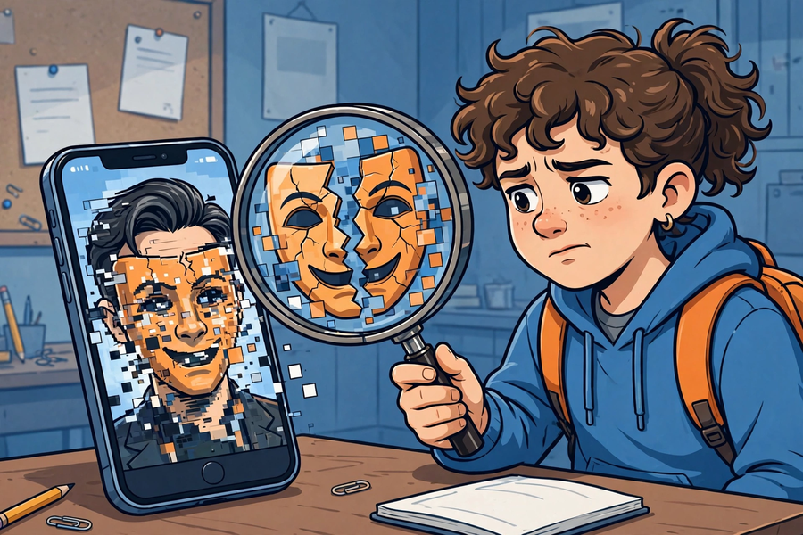
三、生活例子 Examples
1. 可疑訊息卡一：「某明星代言神奇藥水，飲了百病全消！」→ 可疑（查無官方來源，明星代言多為假冒）。
1. Card 1: "A celebrity endorses a miracle potion that cures everything!" → Suspicious (no official source; celebrity endorsements are often faked).
2. 可疑訊息卡二：「學校明天停課！」（無來源截圖）→ 假（與官方公布不符，應查學校官方渠道）。
2. Card 2: "School is suspended tomorrow!" (unsourced screenshot) → False (contradicts official announcements; check official school channels).
3. 可疑訊息卡三：「長者中心免費量血壓活動，歡迎參加（附中心電話）。」→ 較可信（有具體聯絡方式，可致電核實）。
3. Card 3: "Free blood-pressure checks at the elderly centre, all welcome (centre phone number attached)." → More credible (verifiable by phone).
4. 課堂示範：老師問 AI 一條它不可能知道的問題（如本校上星期二午膳吃了什麼），展示 AI 一本正經編出答案。
4. Class demo: the teacher asks AI an unknowable question (e.g. what the school had for lunch last Tuesday) and shows it fabricating a confident answer.
四、簡單問答 Quick Q&A
Q1. 什麼是 deepfake？
Q1. What is deepfake?
Q2. 查證三步是什麼？
Q2. What are the three verification steps?
Q3. 為什麼 AI 會一本正經地說出錯誤答案？
Q3. Why does AI confidently state wrong answers?
Q4. 收到家人轉發的驚人訊息，第一步該做什麼？
Q4. You receive a shocking forwarded message from family. What is the first step?
五、思考題 Thinking Questions
Q1. 有人說「有圖有片一定真」，你怎樣反駁？
Q1. Some say "photos and videos can't lie". How do you counter that?
Q2. 如果你發現家人轉發了假訊息，你會怎樣溫和地提醒他們？
Q2. If you find family members forwarding false messages, how would you gently alert them?
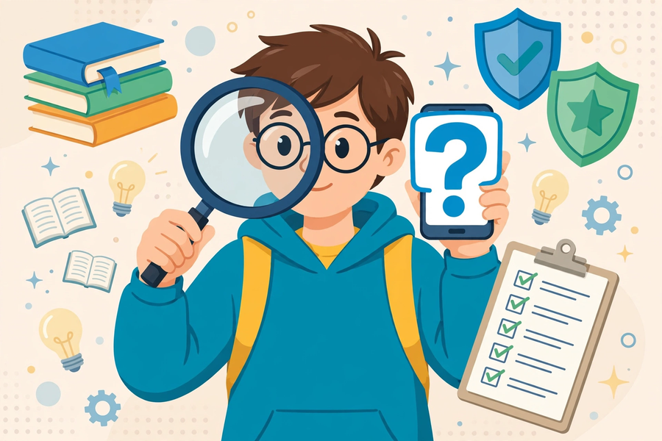
六、分組活動 Group Activity
每組獲發三則可疑訊息卡，小組討論並判斷每則是「可信／可疑／假」，寫下理由和所用查證方法，填寫下表。
Each group gets three suspicious message cards. Discuss and judge each as "credible / suspicious / false", write reasons and the verification methods used, and complete the table below.
訊息內容  Message | 判斷（可信／可疑／假）  Judgement | 理由  Reason | 所用查證方法  Verification method used
七、總結 Summary
1. Deepfake ＝ AI 偽造的影像／聲音；眼見不一定為實。
1. Deepfake = AI-faked images/audio; seeing is not always believing.
2. 查證三步：停一停、查來源、找多個來源。
2. Three verification steps: pause, check the source, find multiple sources.
3. AI 幻覺：AI 會自信地編造答案；問 AI 也要查證。
3. AI hallucination: AI confidently fabricates answers; verify AI answers too.
4. 金句：先查證，後轉發。
4. Motto: verify before forwarding.
八、小測驗 Mini Quiz
（請作答，不用查閱筆記。老師會講解答案。）
(Answer without referring to your notes. The teacher will go through the answers.)
1. Deepfake 是指：
1. Deepfake refers to:
A. 深度睡眠
A. Deep sleep
B. 用 AI 偽造的逼真影像或聲音
B. Realistic images or audio faked with AI
C. 深海拍攝技術
C. Deep-sea filming
D. 一本教科書
D. A textbook
2. 收到一則令人震驚的轉發訊息，第一步應該：
2. You receive a shocking forwarded message. The first step is:
A. 立刻轉發給所有朋友
A. Forward it to all friends at once
B. 停一停，先查來源
B. Pause and check the source first
C. 直接相信
C. Believe it directly
D. 刪除通訊程式
D. Delete the messaging app
Q1. 寫出查證三步。
Q1. Write the three verification steps.
Q2. 用一句話解釋什麼是「AI 幻覺」。
Q2. Explain "AI hallucination" in one sentence.

