聖公會呂明才中學 S.K.H. Lui Ming Choi Secondary School
創科班 Little Makers Class
第 19 堂｜AI 倫理（一）：真假難分
Lesson 19 | AI Ethics (1): Hard to Tell True from False
教師筆記（內含全部答案）
Teacher's Notes (with all answers)
本文件包含學生筆記全文、小測驗及家課的全部答案，僅供教師參考，請勿派發給學生。
This document contains the full student notes and all quiz/homework answers. For teachers only; do not distribute to students.
本堂物資表 Materials List（教師版）
請預早一星期準備所需物資；標示「課室現有」之項目請預先清點。
品名 Item | 數量（每組） Quantity (per group) | 大約成本 Est. cost | 安全注意 Safety notes
可疑訊息卡 Suspicious message cards | 每組 1 套（3 張） 1 set (3 cards) per group | 約 HK$3 Approx. HK$3 | 內容由老師預先審查，確保適齡。 Content pre-screened by the teacher for age-appropriateness.
查證清單卡 Verification checklist cards | 每人 1 張 1 per student | 約 HK$4（全班） Approx. HK$4 | —
投影機 Projector | 1 套 1 set | 學校現有，$0 School-owned, $0 | —
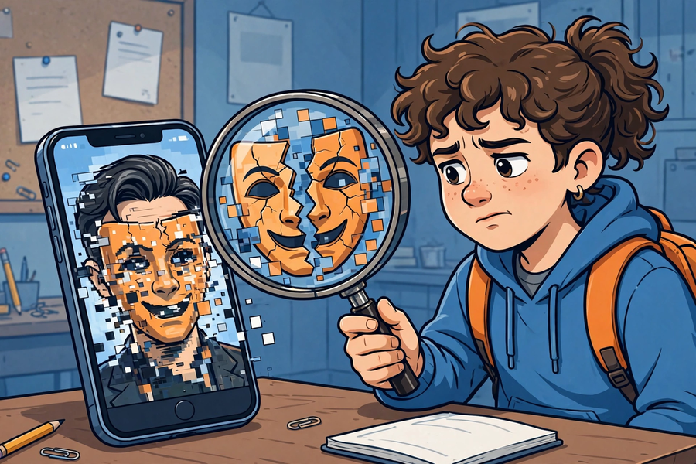
一、學生筆記內容（含答案） Student Notes Content (with answers)
主題：Deepfake 與假資訊例子＋查證練習、AI 幻覺
Theme: Deepfake and misinformation examples + verification practice; AI hallucination
姓名 Name：______________ 班別 Class：______ 學號 No.：______ 日期 Date：____________
一、學習目標 Learning Objectives
1. 能說出 deepfake 的定義：用 AI 偽造的逼真影像或聲音。
1. Define deepfake: realistic images or audio faked with AI.
2. 能列出至少三個查證方法。
2. List at least three verification methods.
3. 能在小組練習中判斷可疑訊息並說出理由。
3. Judge suspicious messages in group practice and give reasons.
4. 能解釋「AI 幻覺」：AI 會自信地編造不實答案。
4. Explain "AI hallucination": AI confidently fabricates false answers.
二、課程內容 Key Concepts
1. 眼見不一定為實。Deepfake（深偽技術）是指用 AI 偽造的逼真影像或聲音，例如換臉影片、模仿某人聲音的錄音。國際上曾有騙徒利用 AI 模仿聲音進行詐騙的個案。
1. Seeing is not always believing. Deepfake is realistic images or audio faked with AI, e.g. face-swap videos or voice-cloning recordings. There have been international cases of fraudsters using AI-cloned voices in scams.
2. AI 假資訊常見手法：①以假亂真的圖片（AI 生成圖冒充新聞相片）；②斷章取義的標題（標題與內容不符）；③假冒名人發言（名人根本沒說過的話）。
2. Common AI-misinformation tactics: 1. Deceptively real images (AI-generated pictures passed off as news photos); 2. Clickbait headlines taken out of context; 3. Fake celebrity quotes (words the person never said).
3. 查證三步：①停一停——太驚人、太令人憤怒的訊息，先別轉發；②查來源——誰發的？是官方帳號嗎？有沒有署名？；③找多個來源——有沒有其他可靠媒體報導同一件事？
3. Three verification steps: 1. Pause — for shocking or enraging messages, don't forward yet; 2. Check the source — who sent it? Is it an official account? Is it signed?; 3. Find multiple sources — have other reliable outlets reported the same thing?
4. AI 幻覺：AI 是按機率推測下一個字來生成答案的，它不會查證事實。所以當它不知道答案時，也會一本正經地編造一個看似合理的答案。問 AI 功課答案時，必須再查證。
4. AI hallucination: AI generates answers by predicting the most likely next words; it does not check facts. So when it does not know the answer, it still confidently fabricates a plausible-sounding one. Always verify AI answers about homework.
5. 金句：「先查證，後轉發。」這是每個人的資訊責任。
5. Motto: "Verify before forwarding." This is everyone's information responsibility.
三、生活例子 Examples
1. 可疑訊息卡一：「某明星代言神奇藥水，飲了百病全消！」→ 可疑（查無官方來源，明星代言多為假冒）。
1. Card 1: "A celebrity endorses a miracle potion that cures everything!" → Suspicious (no official source; celebrity endorsements are often faked).
2. 可疑訊息卡二：「學校明天停課！」（無來源截圖）→ 假（與官方公布不符，應查學校官方渠道）。
2. Card 2: "School is suspended tomorrow!" (unsourced screenshot) → False (contradicts official announcements; check official school channels).
3. 可疑訊息卡三：「長者中心免費量血壓活動，歡迎參加（附中心電話）。」→ 較可信（有具體聯絡方式，可致電核實）。
3. Card 3: "Free blood-pressure checks at the elderly centre, all welcome (centre phone number attached)." → More credible (verifiable by phone).
4. 課堂示範：老師問 AI 一條它不可能知道的問題（如本校上星期二午膳吃了什麼），展示 AI 一本正經編出答案。
4. Class demo: the teacher asks AI an unknowable question (e.g. what the school had for lunch last Tuesday) and shows it fabricating a confident answer.
四、簡單問答 Quick Q&A
Q1. 什麼是 deepfake？
Q1. What is deepfake?
答案：用 AI 偽造的逼真影像或聲音。
Answer: Realistic images or audio faked with AI.
Q2. 查證三步是什麼？
Q2. What are the three verification steps?
答案：停一停、查來源、找多個來源。
Answer: Pause, check the source, find multiple sources.
Q3. 為什麼 AI 會一本正經地說出錯誤答案？
Q3. Why does AI confidently state wrong answers?
答案：AI 按機率推測下一個字生成答案，不會查證事實；不知道時也會編造。
Answer: AI generates answers by predicting likely next words and does not check facts; it fabricates when it does not know.
Q4. 收到家人轉發的驚人訊息，第一步該做什麼？
Q4. You receive a shocking forwarded message from family. What is the first step?
答案：停一停，先別轉發。
Answer: Pause — don't forward it yet.
五、思考題 Thinking Questions
Q1. 有人說「有圖有片一定真」，你怎樣反駁？
Q1. Some say "photos and videos can't lie". How do you counter that?
答案：Deepfake 正是偽造逼真影像和聲音的技術；圖片影片也可以被剪接或配上假標題，所以必須查證。
Answer: Deepfakes are exactly technology for faking realistic images and audio; photos and videos can also be edited or given false captions, so verification is a must.
Q2. 如果你發現家人轉發了假訊息，你會怎樣溫和地提醒他們？
Q2. If you find family members forwarding false messages, how would you gently alert them?
答案：參考：先肯定家人的好意，再分享查證結果和可靠來源，建議以後先查證後轉發。
Answer: Suggested: acknowledge their good intention first, then share your verification findings and reliable sources, and suggest verifying before forwarding in future.
六、分組活動 Group Activity
每組獲發三則可疑訊息卡，小組討論並判斷每則是「可信／可疑／假」，寫下理由和所用查證方法，填寫下表。
Each group gets three suspicious message cards. Discuss and judge each as "credible / suspicious / false", write reasons and the verification methods used, and complete the table below.
訊息內容  Message | 判斷（可信／可疑／假）  Judgement | 理由  Reason | 所用查證方法  Verification method used
七、總結 Summary
1. Deepfake ＝ AI 偽造的影像／聲音；眼見不一定為實。
1. Deepfake = AI-faked images/audio; seeing is not always believing.
2. 查證三步：停一停、查來源、找多個來源。
2. Three verification steps: pause, check the source, find multiple sources.
3. AI 幻覺：AI 會自信地編造答案；問 AI 也要查證。
3. AI hallucination: AI confidently fabricates answers; verify AI answers too.
4. 金句：先查證，後轉發。
4. Motto: verify before forwarding.
八、小測驗 Mini Quiz
1. Deepfake 是指：
1. Deepfake refers to:
A. 深度睡眠
A. Deep sleep
B. 用 AI 偽造的逼真影像或聲音
B. Realistic images or audio faked with AI
C. 深海拍攝技術
C. Deep-sea filming
D. 一本教科書
D. A textbook
答案：B。Deepfake 就是用 AI 偽造的逼真影像或聲音。
Answer: B. Deepfake is realistic images or audio faked with AI.
2. 收到一則令人震驚的轉發訊息，第一步應該：
2. You receive a shocking forwarded message. The first step is:
A. 立刻轉發給所有朋友
A. Forward it to all friends at once
B. 停一停，先查來源
B. Pause and check the source first
C. 直接相信
C. Believe it directly
D. 刪除通訊程式
D. Delete the messaging app
答案：B。查證三步的第一步是「停一停」。
Answer: B. The first of the three verification steps is "pause".
Q1. 寫出查證三步。
Q1. Write the three verification steps.
答案：停一停、查來源、找多個來源。
Answer: Pause, check the source, find multiple sources.
Q2. 用一句話解釋什麼是「AI 幻覺」。
Q2. Explain "AI hallucination" in one sentence.
答案：AI 不知道答案時也會自信地編造不實答案。（意思相近即可）
Answer: AI confidently fabricates false answers even when it does not know the answer. (Equivalent wording accepted.)
二、家課答案 Homework Answers
甲部：選擇題
Section A: Multiple Choice
1. 以下哪一項是 deepfake？
1. Which of the following is a deepfake?
A. 真實的新聞相片
A. A genuine news photo
B. 用 AI 換臉偽造的影片
B. An AI face-swap faked video
C. 手機原相機拍的照片
C. A photo from the phone camera
D. 課本插圖
D. A textbook illustration
答案：B。用 AI 換臉偽造的影片符合 deepfake 的定義。
Answer: B. An AI face-swap faked video fits the definition of deepfake.
2. 「查來源」是指：
2. "Check the source" means:
A. 看看是誰發的、是否官方
A. See who sent it and whether it's official
B. 看看訊息有多長
B. See how long the message is
C. 看看有多少人轉發
C. See how many people forwarded it
D. 看看用什麼手機發的
D. See what phone sent it
答案：A。查來源就是核實發佈者身份和可信度。
Answer: A. Checking the source means verifying who published it and their credibility.
3. AI 幻覺的意思是：
3. AI hallucination means:
A. AI 會做夢
A. AI dreams
B. AI 自信地編造不實答案
B. AI confidently fabricates false answers
C. AI 眼花了
C. AI's eyes are blurry
D. AI 壞了
D. AI is broken
答案：B。AI 按機率生成答案，不查證事實，會編造看似合理的答案。
Answer: B. AI generates answers probabilistically without checking facts, fabricating plausible-sounding ones.
4. 以下哪個查證做法正確？
4. Which verification practice is correct?
A. 只看標題就轉發
A. Forward after reading only the headline
B. 找多個可靠來源核對
B. Cross-check with multiple reliable sources
C. 誰說都信
C. Believe whoever says it
D. 愈驚人愈可信
D. The more shocking, the more credible
答案：B。找多個來源是查證三步的第三步。
Answer: B. Finding multiple sources is the third verification step.
5. 「先查證，後轉發」的原因是：
5. The reason for "verify before forwarding" is:
A. 轉發很花時間
A. Forwarding takes time
B. 避免散播假訊息，盡資訊責任
B. Avoid spreading misinformation; fulfil information responsibility
C. 顯得自己很聰明
C. To look smart
D. 沒有原因
D. No reason
答案：B。轉發前查證，是每個人的資訊責任。
Answer: B. Verifying before forwarding is everyone's information responsibility.
乙部：問答題（參考答案）
Section B: Short Questions (suggested answers)
Q1. 在家人通訊群組找一則轉發訊息，用查證三步驗證，寫下訊息內容、查證過程與結論；如發現可疑，寫下你會怎樣提醒家人（切勿轉發）。
Q1. Find one forwarded message in a family chat group. Verify it with the three steps; record the message, the process and the conclusion. If it is suspicious, write how you would alert your family (do not forward it).
答案：訊息內容 2 分；查證過程（用上三步）4 分；結論 2 分；提醒家人的做法合理 2 分。
Answer: 2 marks for the message; 4 for the verification process (using the three steps); 2 for the conclusion; 2 for a reasonable way to alert family.
Q2. 解釋為什麼「有圖有影片」不一定代表訊息是真的。
Q2. Explain why "having photos and videos" does not guarantee a message is true.
答案：因為 deepfake 可以偽造逼真的影像和聲音；圖片影片也可被剪接或配上假標題。
Answer: Because deepfakes can forge realistic images and audio; photos and videos can also be edited or given false captions.
Q3. 老師問 AI「本校上星期二午膳吃了什麼」，AI 一本正經地答了出來。這個答案可信嗎？為什麼？
Q3. The teacher asked AI "What did the school have for lunch last Tuesday?" and AI answered confidently. Is the answer trustworthy? Why?
答案：不可信（1 分）；因為這是 AI 幻覺——AI 不知道答案時也會按機率編造看似合理的答案，它沒有查證事實（2 分）。
Answer: Not trustworthy (1 mark); this is AI hallucination — when AI does not know, it still probabilistically fabricates a plausible answer without checking facts (2 marks).
三、附加思考題 Extra Thinking Questions
Q1. 為什麼假訊息通常寫得很驚人或很令人憤怒？
Q1. Why are false messages usually written to be shocking or enraging?
答案：因為要利用情緒令人失去冷靜判斷，急於轉發；所以查證第一步是「停一停」。
Answer: Because they exploit emotions to bypass calm judgement and trigger hasty forwarding; hence the first verification step is "pause".
Q2. 除了三步查證，你還想到什麼查證方法？
Q2. Besides the three steps, what other verification methods can you think of?
答案：參考：用圖片反向搜尋、向老師或家長求助、查官方網站或可信媒體。
Answer: Suggested: reverse image search, asking teachers or parents, checking official websites or trusted media.
四、建議教導方向 Suggested Teaching Focus
1. 所有例子必須適齡，避免血腥、驚嚇或政治敏感內容；訊息卡答案預先備妥。
1. All examples must be age-appropriate — avoid gore, horror or politically sensitive content; prepare the message-card answer keys in advance.
2. 討論時引導學生講「理由」，而不只猜對錯；理由合理比答對更重要。
2. Guide students to give "reasons", not just guesses; reasonable reasoning matters more than correct answers.
3. AI 幻覺示範要即場進行，效果最震撼：問一條 AI 不可能知道的問題。
3. Demo AI hallucination live for maximum impact: ask a question the AI cannot possibly know.
4. 總結時派發查證清單卡，囑咐貼在書桌當眼處，把習慣帶回家。
4. Hand out verification checklist cards at the close and ask students to stick them visibly on their desks, taking the habit home.
五、常見迷思 Common Misconceptions
1. 「AI 都說是真就是真」——AI 也會錯，還會一本正經地編造。
1. "If AI says it's true, it's true" — AI also errs, and fabricates confidently.
2. 「有圖有片一定真」——deepfake 正是針對這種心態而出現的。
2. "Photos and videos can't lie" — deepfakes exploit exactly this mindset.
3. 「查證很麻煩」——三步熟習後只需約一分鐘。
3. "Verification is troublesome" — the three steps take about a minute once familiar.

