聖公會呂明才中學 S.K.H. Lui Ming Choi Secondary School
創科班 Little Makers Class
第 20 堂｜AI 倫理（二）：偏見與私隱
Lesson 20 | AI Ethics (2): Bias and Privacy
學生筆記
Student Notes
主題：為何 AI 會歧視、我的資料很值錢、網絡安全（銜接 HKIRC 網絡安全學生培訓）
Theme: Why AI can discriminate; my data is valuable; cyber security (linking to HKIRC student cyber security training)
姓名 Name：______________ 班別 Class：______ 學號 No.：______ 日期 Date：____________
本堂物資表 Materials List
以下為本堂分組活動所需物資（每組一份）。請在老師派發時核對。
品名 Item | 數量（每組） Quantity (per group) | 安全注意 Safety notes
情境卡 Scenario cards | 每組 1 套（6 張） 1 set (6 cards) per group | —
承諾卡 Pledge cards | 每人 1 張 1 per student | —
投影機 Projector | 1 套 1 set | —
一、學習目標 Learning Objectives
1. 能用一句話解釋演算法偏見：AI 學了有偏見的數據，就會做出有偏見的判斷。
1. Explain algorithmic bias in one sentence: AI trained on biased data makes biased judgements.
2. 能舉出至少一個 AI 偏見的例子。
2. Give at least one example of AI bias.
3. 能列出至少四個保護個人私隱的方法。
3. List at least four ways to protect personal privacy.
4. 能說出遇到網絡安全問題時的基本應對。
4. State basic responses to cyber security issues.
二、課程內容 Key Concepts
1. AI 會歧視人嗎？會——如果它學的數據有偏見。演算法偏見：AI 學了有偏見的數據，就會做出有偏見的判斷。問題不在電腦，在數據。
1. Can AI discriminate? Yes — if its training data is biased. Algorithmic bias: AI trained on biased data makes biased judgements. The problem is not the computer; it is the data.
2. 真實個案（國際傳媒曾報導）：某大型科技公司曾用 AI 篩選求職履歷，但訓練數據大多來自男性員工的履歷，結果 AI 學會了較少推薦女性求職者。數據不公平，AI 的判斷就不公平。
2. Real case (reported by international media): a large tech company once used AI to screen job applications, but the training data came mostly from male employees' CVs, so the AI learnt to recommend fewer female candidates. Unfair data → unfair AI judgements.
3. 我的資料很值錢：數據是 AI 的糧食，AI 公司想要大量數據來訓練模型。你的相片、位置、喜好，都是有價值的數據。
3. My data is valuable: data is the food of AI, and AI companies want huge amounts of it to train models. Your photos, location and preferences are all valuable data.
4. 私隱自保四招：①不隨便上傳個人相片；②關閉不必要的定位權限；③設定強密碼並保密（可用句子首字母加數字組成易記又難猜的密碼）；④不亂點不明連結。
4. Four privacy self-protection tips: 1. Don't upload personal photos casually; 2. Turn off unnecessary location permissions; 3. Set strong passwords and keep them secret (use first letters of a sentence plus numbers — memorable yet hard to guess); 4. Don't click unknown links.
5. 遇到網絡安全問題（如收到可疑訊息、陌生人索取相片）：不亂點、不回覆，並立即告訴信任的成人（老師或家長）。
5. When facing cyber security issues (e.g. suspicious messages, strangers asking for photos): don't click, don't reply, and tell a trusted adult (teacher or parent) immediately.
6. 免費自學資源：HKIRC「網絡安全學生培訓」免費網上課程，內容包括保護私隱、保護設備、識別釣魚攻擊，適合中學生自學。網址：https://cyberhub.hk/tc/student-training
6. Free self-study resource: HKIRC's free online "Student Cyber Security Training" covers protecting privacy, protecting devices and spotting phishing attacks — suitable for secondary students. URL: https://cyberhub.hk/tc/student-training
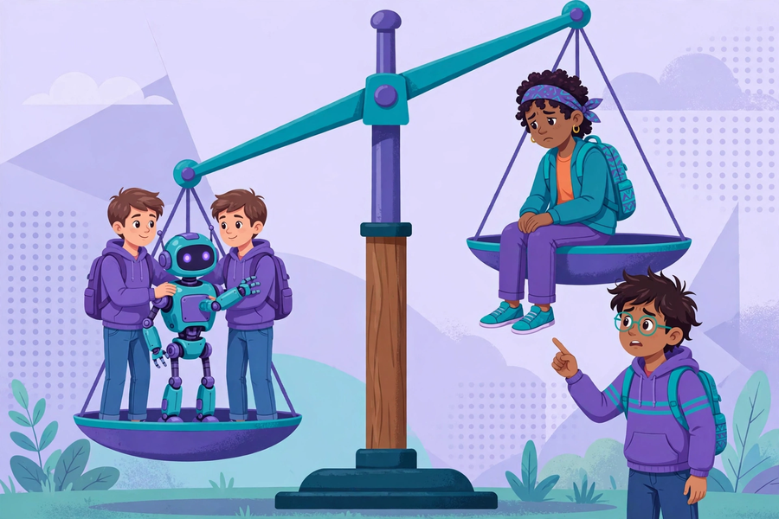
三、生活例子 Examples
1. 情境一：上傳學生證相片換禮物 → 不安全（證件資料可被冒用）。
1. Scenario 1: Uploading your student-card photo for gifts → Unsafe (ID data can be misused).
2. 情境二：遊戲要求開啟定位權限 → 不安全（行蹤可能外洩）。
2. Scenario 2: A game requests location permission → Unsafe (your whereabouts may leak).
3. 情境三：收到「學校」短訊叫點擊連結交費 → 不安全（應先向老師核實）。
3. Scenario 3: A "school" SMS asks you to click a link to pay → Unsafe (verify with a teacher first).
4. 情境四：用生日日期做密碼 → 不安全（太易被猜中）。
4. Scenario 4: Using your birthday as a password → Unsafe (too easy to guess).
5. 情境五：把功課相片分享到班群 → 大致安全（沒有個人敏感資料）。
5. Scenario 5: Sharing homework photos in the class group → Generally safe (no sensitive personal data).
6. 情境六：陌生人私訊索取你的相片 → 不安全（立即告訴信任的成人）。
6. Scenario 6: A stranger messages asking for your photos → Unsafe (tell a trusted adult immediately).
四、簡單問答 Quick Q&A
Q1. 用一句話解釋什麼是演算法偏見。
Q1. Explain algorithmic bias in one sentence.
Q2. 為什麼 AI 公司想要你的資料？
Q2. Why do AI companies want your data?
Q3. 寫出私隱自保四招。
Q3. Write the four privacy self-protection tips.
Q4. 在網上遇到陌生人索取你的相片，應該怎樣做？
Q4. A stranger online asks for your photos. What should you do?
五、思考題 Thinking Questions
Q1. 「AI 是電腦，電腦最公平」——你同意嗎？為什麼？
Q1. "AI is a computer, and computers are the fairest." Do you agree? Why?
Q2. 「我沒有什麼見不得人，所以私隱不重要」——你怎樣回應？
Q2. "I have nothing to hide, so privacy doesn't matter." How do you respond?
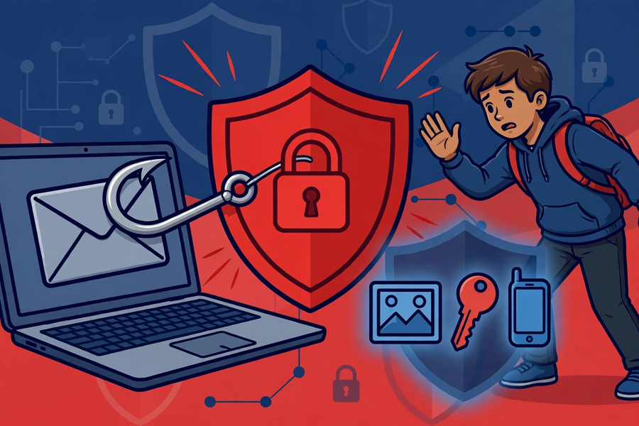
六、分組活動 Group Activity
每組獲發六張情境卡，小組討論每則情境是「安全／不安全」，寫下理由，填寫下表，然後派代表分享。
Each group gets six scenario cards. Discuss whether each is "safe / unsafe", write reasons, complete the table below, then share with the class.
情境  Scenario | 安全／不安全  Safe / Unsafe | 理由  Reason
七、總結 Summary
1. 演算法偏見：有偏見的數據 → 有偏見的 AI；科技並非中立。
1. Algorithmic bias: biased data → biased AI; technology is not neutral.
2. 我的資料很值錢；私隱自保四招要記牢。
2. My data is valuable; remember the four privacy tips.
3. 遇到網絡安全問題：不亂點，告訴信任的成人。
3. Cyber security issues: don't click randomly; tell a trusted adult.
4. 免費自學：HKIRC 網絡安全學生培訓（https://cyberhub.hk/tc/student-training）。
4. Free self-study: HKIRC Student Cyber Security Training (https://cyberhub.hk/tc/student-training).
5. 承諾卡：寫一句「我會……」，貼在課室正能量牆。
5. Pledge card: write one "I will…" statement for the classroom positivity wall.
八、小測驗 Mini Quiz
（請作答，不用查閱筆記。老師會講解答案。）
(Answer without referring to your notes. The teacher will go through the answers.)
1. 演算法偏見的成因是：
1. The cause of algorithmic bias is:
A. 電腦壞了
A. The computer is broken
B. 訓練數據有偏差
B. Biased training data
C. 學生太懶
C. Students are lazy
D. 沒有插電源
D. Not plugged in
2. 以下哪一項是保護私隱的正確做法？
2. Which is a correct privacy-protection practice?
A. 用生日日期做密碼
A. Using your birthday as a password
B. 隨便上傳學生證相片
B. Uploading your student-card photo casually
C. 關閉不必要的定位權限
C. Turning off unnecessary location permissions
D. 亂點不明連結
D. Clicking unknown links
Q1. 用一句話解釋演算法偏見。
Q1. Explain algorithmic bias in one sentence.
Q2. 寫出四個保護個人私隱的方法。
Q2. Write four ways to protect personal privacy.

