聖公會呂明才中學 S.K.H. Lui Ming Choi Secondary School
創科班 Little Makers Class ｜ S1 Unit 5：關愛 Project（關愛創科專題）
第 22 堂：設計
Lesson 22: Design and Planning
姓名 Name：＿＿＿＿ 班別 Class：＿＿＿＿ 學號 No.：＿＿＿＿ 日期 Date (DD-MM-YYYY)：＿＿＿＿

家課
Homework
得分 Score：＿＿＿＿ / 20 （請把答案寫清楚，問答題須寫出完整句子。）
Write your answers clearly.
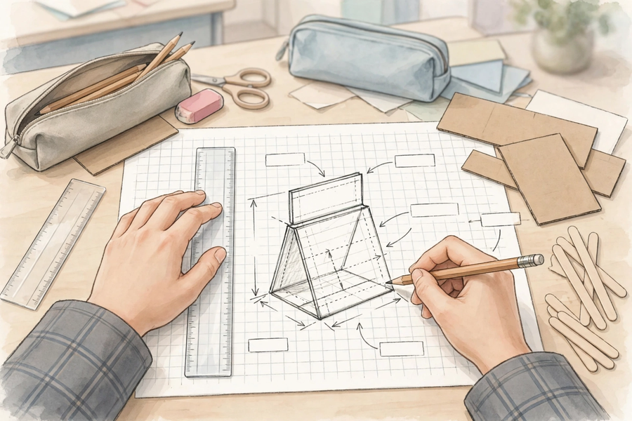
一、甲部：選擇題
Section A: Multiple Choice
1. 以下哪一份設計圖最合格？
Which of the following design sketches is the most satisfactory?
A. 只有漂亮圖畫，沒有尺寸和材料
A pretty picture with no dimensions or materials
B. 有外形、標明尺寸和材料，簡潔清晰
Shows the shape with dimensions and materials labelled, simple and clear
C. 只寫了一段文字描述
Only a paragraph of written description
D. 畫得很美，但看不出各部分大小
Beautifully drawn, but part sizes cannot be told
2. 製作計劃表不包括以下哪一欄？
Which column is NOT part of the production plan?
A. 步驟
Step
B. 負責人
Person in charge
C. 所需材料
Materials needed
D. 組員的身高
Members’ heights
3. 分工時，以下哪種做法最恰當？
Which of the following is the most appropriate way to allocate tasks?
A. 全部工作交給組長
Give all the work to the leader
B. 按組員長處分配，每人有明確任務，兩部分都有人負責
Allocate by members’ strengths, everyone with a clear task, both parts covered
C. 只做實物部分，AI 部分不理
Do only the physical part and ignore the AI part
D. 抽籤決定，抽中才做
Draw lots – only those drawn do the work
4. 小組發現設計需要的材料太貴，以下哪個應變方法最合理？
The group finds a designed material too expensive. Which response is most sensible?
A. 照原設計做，超支也沒關係
Build as designed regardless of overspending
B. 改用較便宜的代用材料，並更新設計圖
Switch to a cheaper substitute and update the sketch
C. 放棄整個專題
Give up the whole project
D. 偷用別組的材料
Secretly use another group’s materials
5. 為什麼製作前要做可行性檢查？
Why run a feasibility check before making?
A. 為了填滿工作紙
To fill up the worksheet
B. 及早發現材料、能力或時間上的問題，避免做到一半才發現做不到
To spot problems with materials, ability or time early, instead of discovering them halfway
C. 因為老師要求寫三條問題
Because the teacher asked for three questions
D. 為了讓設計圖更好看
To make the sketch prettier
二、乙部：問答題
Section B: Short Questions
1. 寫出設計圖三要素，並各用一句話說明其作用。（3 分）
Write down the three elements of a design sketch and explain each one’s purpose in one sentence. (3 marks)
＿＿＿＿＿＿＿＿＿＿＿＿＿＿＿＿＿＿＿＿＿＿＿＿＿＿＿＿＿＿＿＿＿＿
＿＿＿＿＿＿＿＿＿＿＿＿＿＿＿＿＿＿＿＿＿＿＿＿＿＿＿＿＿＿＿＿＿＿
＿＿＿＿＿＿＿＿＿＿＿＿＿＿＿＿＿＿＿＿＿＿＿＿＿＿＿＿＿＿＿＿＿＿
＿＿＿＿＿＿＿＿＿＿＿＿＿＿＿＿＿＿＿＿＿＿＿＿＿＿＿＿＿＿＿＿＿＿
2. 為以下製作寫出五個按先後次序排列的步驟：製作一個卡紙反光提示牌。（2 分）
Write five production steps in sequential order for making a cardboard reflective warning sign. (2 marks)
＿＿＿＿＿＿＿＿＿＿＿＿＿＿＿＿＿＿＿＿＿＿＿＿＿＿＿＿＿＿＿＿＿＿
＿＿＿＿＿＿＿＿＿＿＿＿＿＿＿＿＿＿＿＿＿＿＿＿＿＿＿＿＿＿＿＿＿＿
＿＿＿＿＿＿＿＿＿＿＿＿＿＿＿＿＿＿＿＿＿＿＿＿＿＿＿＿＿＿＿＿＿＿
＿＿＿＿＿＿＿＿＿＿＿＿＿＿＿＿＿＿＿＿＿＿＿＿＿＿＿＿＿＿＿＿＿＿
3. 你的小組有四人，請為「實物部分」和「AI 生成部分」各寫一個具體分工例子。（2 分）
Your group has four members. Give one specific task example for the ‘physical part’ and one for the ‘AI-generated part’. (2 marks)
＿＿＿＿＿＿＿＿＿＿＿＿＿＿＿＿＿＿＿＿＿＿＿＿＿＿＿＿＿＿＿＿＿＿
＿＿＿＿＿＿＿＿＿＿＿＿＿＿＿＿＿＿＿＿＿＿＿＿＿＿＿＿＿＿＿＿＿＿
＿＿＿＿＿＿＿＿＿＿＿＿＿＿＿＿＿＿＿＿＿＿＿＿＿＿＿＿＿＿＿＿＿＿
＿＿＿＿＿＿＿＿＿＿＿＿＿＿＿＿＿＿＿＿＿＿＿＿＿＿＿＿＿＿＿＿＿＿
三、延伸任務
3. Extension Task
延伸任務：按分工表完成設計圖的修訂，並列出實物部分所需的材料清單（品名、數量），估算總成本，下一堂帶回課室作製作參考。
Extension task: Revise the design sketch according to the task allocation; list the materials needed for the physical part (item name, quantity) and estimate the total cost. Bring it to the next lesson as a reference for making.

