聖公會呂明才中學 S.K.H. Lui Ming Choi Secondary School
創科班 Little Makers Class ｜ S1 Unit 5：關愛 Project（關愛創科專題）
第 22 堂：設計
Lesson 22: Design and Planning
姓名 Name：＿＿＿＿ 班別 Class：＿＿＿＿ 學號 No.：＿＿＿＿ 日期 Date (DD-MM-YYYY)：＿＿＿＿
本堂物資表 Materials List
以下為本堂分組活動所需物資（每組一份）。請在老師派發時核對。
品名 Item | 數量（每組） Quantity (per group) | 安全注意 Safety notes
方格紙（A3） | 每組兩張 | —
鉛筆、擦膠、間尺 | 每組一套 | 間尺邊緣勿作嬉戲用途
顏色筆／馬克筆 | 每組一套 | 用後蓋好筆蓋，保持通風
製作計劃表＋分工表（A4） | 每組各一張 | —

學生筆記
Student Notes
一、學習目標
1. Learning Objectives
- 1. 學生能繪製一份設計圖，並標註主要尺寸與使用材料。
Students can draw a design sketch with main dimensions and materials labelled.
- 2. 學生能寫出按先後次序排列的製作步驟（至少五步）。
Students can write production steps in sequential order (at least five steps).
- 3. 學生能完成分工表，清楚列明每位組員負責實物部分或 AI 生成部分的具體工作。
Students can complete a task-allocation table clearly stating each member’s responsibility in the physical part or the AI-generated part.
二、課程內容
2. Lesson Content
甲、設計圖三要素
A. The three elements of a design sketch
- 一份合格的設計圖必須具備三要素：(1) 外形——作品大概長什麼樣子（正面圖／側面圖）；(2) 尺寸標註——主要部分的長、闊、高，用數字寫清楚；(3) 材料標註——每個部分用什麼材料做。
A satisfactory design sketch must have three elements: (1) shape – what the work roughly looks like (front/side view); (2) dimension labels – the length, width and height of the main parts, written as numbers; (3) material labels – what material each part is made of.
- 設計圖不必美觀，但必須清晰易懂、切實可行。別人看著你的圖，要知道「做什麼、做多大、用什麼做」。
A sketch need not be beautiful, but must be readable and buildable. Anyone reading it should know ‘what to make, how big, and with what’.
- 常見錯誤：把設計圖畫成藝術畫，忽略尺寸；或所選材料根本買不到、做不到（例如要求金屬焊接）。
Common mistakes: drawing an artistic picture without dimensions, or choosing materials that are unavailable or unworkable (e.g. requiring metal welding).
乙、方格紙與尺寸
B. Grid paper and dimensions
- 在方格紙上繪圖時，先定好比例，例如一格代表 5 cm；先數格數，再換算成實際尺寸，才標在圖上。
When drawing on grid paper, fix a scale first, e.g. one square = 5 cm; count the squares, convert to real dimensions, then label them on the sketch.
- 標尺寸時要寫單位（cm），並標在對應的邊旁邊，不要只寫在角落。
Write the unit (cm) with each dimension, and place the label next to the corresponding edge – not just in a corner.
- 課堂上教師會用軟尺示範量度；小組在繪圖前，先用間尺量一量手邊的材料，心中有數才下筆。
The teacher will demonstrate measuring with a tape measure; before drawing, measure the materials at hand with a ruler so the dimensions are realistic.
丙、製作計劃
C. The production plan
- 製作計劃表有四欄：步驟（按先後次序）、負責人、所需材料、預計完成日期。
The production plan has four columns: step (in sequential order), person in charge, materials needed, and target completion date.
- 步驟至少五步，而且次序要合理：一般是「準備材料 → 製作部件 → 組合 → 測試 → 改良」。
There should be at least five steps in a sensible order, usually: ‘prepare materials → make components → assemble → test → improve’.
- 寫步驟時用動詞開頭，例如「裁剪卡紙」「黏合支架」「測試穩固度」，讓人一看就知道要做什麼。
Start each step with a verb, e.g. ‘cut the cardboard’, ‘glue the stand’, ‘test stability’, so anyone can see what to do.
丁、分工：實物部分與 AI 生成部分
D. Task allocation: physical part vs AI-generated part
- 本專題分兩類工作：(1) 實物部分——動手製作的原型（卡紙、雪條棍等）；(2) AI 生成部分——用 AI 工具生成的海報、故事、音樂或介紹。
This project has two kinds of work: (1) the physical part – the hands-on prototype (cardboard, ice-cream sticks, etc.); (2) the AI-generated part – a poster, story, music piece or introduction made with AI tools.
- 分工表須具體到人、到任務：寫出每位組員的姓名、負責部分（實物／AI 生成）、具體任務。兩部分都要有人負責，不能遺漏。
The task-allocation table must name each member, their part (physical / AI-generated) and their specific task. Both parts must be covered – neither may be left out.
- 分工宜按組員長處：手巧的同學多做實物，文書能力強的可負責 AI 生成的文字內容；但每個人都要參與，不能「事不關己」。
Allocate by strengths: handy members do more of the physical making, strong writers handle the AI-generated text – but everyone must take part; no one is a bystander.
戊、成本估算與可行性檢查
E. Cost estimation and feasibility check
- 材料清單列出品名和數量，再估算總成本；盡量選用易得、便宜、安全的材料（卡紙、雪條棍、膠紙）。
List each material with its quantity, then estimate the total cost; prefer materials that are easy to get, cheap and safe (cardboard, ice-cream sticks, tape).
- 動手前用三條問題檢查可行性：材料買得到嗎？我們做得到嗎？時間夠嗎？有一題答「不」，就要改設計。
Before making, run the three-question feasibility check: Can we get the materials? Can we actually build it? Is there enough time? If any answer is ‘no’, revise the design.
- 記住：簡單而做得到的設計，勝過複雜而做不出的設計。
Remember: a simple design that can actually be built beats a complicated one that cannot.
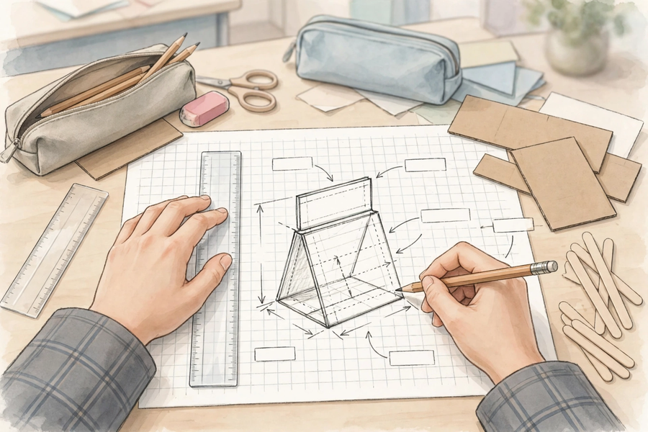
三、例子
3. Examples
例 1：例一（課堂示例：為清潔工設計的反光提示牌）：設計圖標註——牌身 20 cm × 15 cm（卡紙＋反光貼紙）、支架 30 cm（雪條棍）；製作步驟——1. 裁剪卡紙 2. 貼上反光貼紙 3. 裝嵌支架 4. 測試能否穩固豎立 5. 改良；分工——兩人負責實物、兩人負責 AI 生成介紹海報。
Example 1: Example 1 (class example: a reflective warning sign for cleaners): sketch labels – 20 cm × 15 cm board (cardboard + reflective stickers), 30 cm stand (ice-cream sticks); steps – 1. cut the cardboard 2. stick on reflective stickers 3. assemble the stand 4. test whether it stands steadily 5. improve; allocation – two members on the physical part, two on the AI-generated introduction poster.
例 2：例二（成本估算）：卡紙 HK$1.5 × 2 張＝HK$3；反光貼紙 HK$6 × 1 張＝HK$6；雪條棍約 HK$2；膠紙共用約 HK$2；總成本約 HK$13。
Example 2: Example 2 (cost estimation): cardboard HK$1.5 × 2 = HK$3; reflective stickers HK$6 × 1 = HK$6; ice-cream sticks about HK$2; shared tape about HK$2; total about HK$13.
例 3：例三（壞例子 → 好例子）：✘ 只有漂亮圖畫，沒有尺寸和材料標註——別人無法按圖製作。✘ 設計要求「金屬焊接」——中一生做不到、學校也沒有設備。✔ 改用卡紙＋雪條棍＋低溫膠槍，全部做得到。
Example 3: Example 3 (bad → good): ✘ A pretty picture with no dimensions or material labels – nobody can build from it. ✘ A design requiring ‘metal welding’ – impossible for S1 students and unavailable at school. ✔ Use cardboard + ice-cream sticks + a low-temperature glue gun instead – all achievable.
四、課堂小練習
4. Class Practice
與鄰座同學討論後作答，稍後全班一起核對。
Discuss with your neighbour, then check answers with the class.
1. 一份合格的設計圖必須具備哪三要素？
What are the three required elements of a satisfactory design sketch?
＿＿＿＿＿＿＿＿＿＿＿＿＿＿＿＿＿＿＿＿＿＿＿＿＿＿＿＿＿＿＿＿＿＿
＿＿＿＿＿＿＿＿＿＿＿＿＿＿＿＿＿＿＿＿＿＿＿＿＿＿＿＿＿＿＿＿＿＿
2. 以下哪個製作步驟次序正確？(a) 測試 → 裁紙 → 貼上；(b) 裁紙 → 組合 → 測試 → 改良。
Which production sequence is correct? (a) test → cut paper → stick on; (b) cut paper → assemble → test → improve.
＿＿＿＿＿＿＿＿＿＿＿＿＿＿＿＿＿＿＿＿＿＿＿＿＿＿＿＿＿＿＿＿＿＿
＿＿＿＿＿＿＿＿＿＿＿＿＿＿＿＿＿＿＿＿＿＿＿＿＿＿＿＿＿＿＿＿＿＿
3. 小明負責「實物部分」，小美負責「AI 生成部分」。請各舉一個他們具體可以做的工作。
Ming is in charge of the ‘physical part’ and Mei of the ‘AI-generated part’. Give one specific task each of them could do.
＿＿＿＿＿＿＿＿＿＿＿＿＿＿＿＿＿＿＿＿＿＿＿＿＿＿＿＿＿＿＿＿＿＿
＿＿＿＿＿＿＿＿＿＿＿＿＿＿＿＿＿＿＿＿＿＿＿＿＿＿＿＿＿＿＿＿＿＿
五、思考題
5. Thinking Questions
先獨立思考，再與小組分享你的看法。
Think on your own first, then share your views with your group.
1. 為什麼設計圖「清晰、可行」比「美觀」更重要？
Why is it more important for a design sketch to be ‘clear and buildable’ than ‘beautiful’?
＿＿＿＿＿＿＿＿＿＿＿＿＿＿＿＿＿＿＿＿＿＿＿＿＿＿＿＿＿＿＿＿＿＿
＿＿＿＿＿＿＿＿＿＿＿＿＿＿＿＿＿＿＿＿＿＿＿＿＿＿＿＿＿＿＿＿＿＿
＿＿＿＿＿＿＿＿＿＿＿＿＿＿＿＿＿＿＿＿＿＿＿＿＿＿＿＿＿＿＿＿＿＿
2. 如果設計圖需要的材料買不到或太貴，小組可以怎樣應變？
If a material in the design sketch is unavailable or too expensive, how can the group adapt?
＿＿＿＿＿＿＿＿＿＿＿＿＿＿＿＿＿＿＿＿＿＿＿＿＿＿＿＿＿＿＿＿＿＿
＿＿＿＿＿＿＿＿＿＿＿＿＿＿＿＿＿＿＿＿＿＿＿＿＿＿＿＿＿＿＿＿＿＿
＿＿＿＿＿＿＿＿＿＿＿＿＿＿＿＿＿＿＿＿＿＿＿＿＿＿＿＿＿＿＿＿＿＿
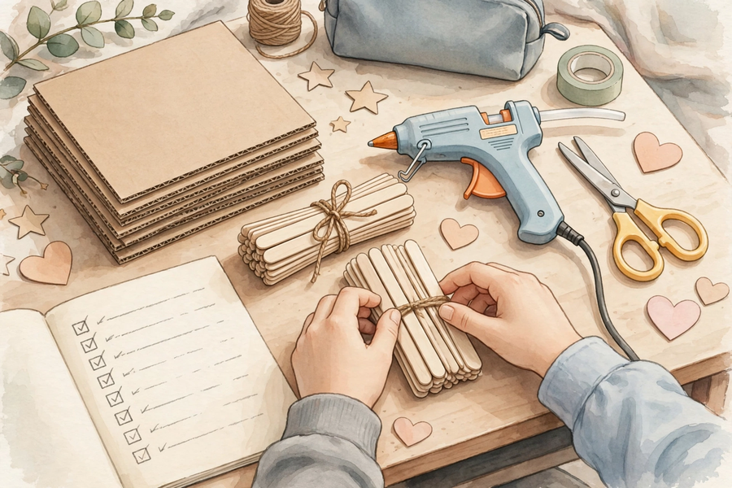
六、分組活動
6. Group Activity
步驟 1：按分工在方格紙上繪製設計圖，必須包含三要素：外形、尺寸標註（寫上單位 cm）、材料標註。
Step 1: Draw the design sketch on grid paper as allocated; it must include all three elements: shape, dimension labels (with the unit cm), and material labels.
步驟 2：填寫「製作計劃表」：至少五個步驟，按先後次序排列，寫明負責人、所需材料、預計完成日期。
Step 2: Complete the ‘production plan’: at least five steps in sequential order, with the person in charge, materials needed, and target completion date.
步驟 3：填寫「分工表」：每位組員的姓名、負責部分（實物／AI 生成）、具體任務；兩部分都要有人負責。
Step 3: Complete the ‘task-allocation table’: each member’s name, part (physical / AI-generated) and specific task; both parts must be covered.
步驟 4：與相鄰組別交換設計圖，用兩句話寫下一個優點和一個建議；然後取回設計圖，教師會收回作下一堂製作之用。
Step 4: Exchange sketches with a neighbouring group; write one strength and one suggestion in two sentences. The teacher will collect the sketches for the next lesson’s making session.
七、總結
7. Summary
- 設計圖三要素：外形、尺寸標註、材料標註；清晰可行比美觀重要。
The three elements of a design sketch: shape, dimension labels, material labels – clear and buildable matters more than beautiful.
- 製作計劃：步驟按先後次序（至少五步），寫明負責人、材料、完成日期。
Production plan: steps in sequential order (at least five), with person in charge, materials and target dates.
- 分工具體到人、到任務；實物部分與 AI 生成部分（海報／故事／音樂／介紹）都要有人負責。
Allocate tasks to named people with specific jobs; both the physical part and the AI-generated part (poster / story / music / introduction) must be covered.
- 估算成本，選用易得、便宜、安全的材料；用三條問題檢查可行性。
Estimate the cost, choose materials that are easy to get, cheap and safe, and run the three-question feasibility check.
八、小測驗
8. Mini Quiz
獨立完成，檢視本課的學習成果。
Complete independently to review what you have learnt.
1. 設計圖三要素不包括以下哪一項？
Which of the following is NOT one of the three elements of a design sketch?
A. 外形
Shape
B. 尺寸標註
Dimension labels
C. 材料標註
Material labels
D. 上色是否美觀
Whether the colouring is beautiful
2. 製作步驟應該怎樣排列？
How should production steps be arranged?
A. 按先後次序排列
In sequential order
B. 隨意排列
In random order
C. 先做最難的
Hardest first
D. 愈少步驟愈好
The fewer steps the better
3. 估算成本時，需要列出什麼？
When estimating costs, what must be listed?
A. 每種材料的品名和數量
Each material’s name and quantity
B. 只寫一個總數
Only a single total
C. 不用理會，隨便寫
Nothing – any number will do
D. 只寫最貴的一項
Only the most expensive item
4. 請寫出「AI 生成部分」可以做的四種作品。
Write down the four kinds of work the ‘AI-generated part’ can be.
＿＿＿＿＿＿＿＿＿＿＿＿＿＿＿＿＿＿＿＿＿＿＿＿＿＿＿＿＿＿＿＿＿＿
＿＿＿＿＿＿＿＿＿＿＿＿＿＿＿＿＿＿＿＿＿＿＿＿＿＿＿＿＿＿＿＿＿＿
＿＿＿＿＿＿＿＿＿＿＿＿＿＿＿＿＿＿＿＿＿＿＿＿＿＿＿＿＿＿＿＿＿＿
5. 你的小組想做一個 30 cm 高的支架，方格紙每格代表 5 cm，應該畫多少格高？
Your group wants a 30 cm tall stand. If each grid square represents 5 cm, how many squares tall should you draw it?
＿＿＿＿＿＿＿＿＿＿＿＿＿＿＿＿＿＿＿＿＿＿＿＿＿＿＿＿＿＿＿＿＿＿
＿＿＿＿＿＿＿＿＿＿＿＿＿＿＿＿＿＿＿＿＿＿＿＿＿＿＿＿＿＿＿＿＿＿
＿＿＿＿＿＿＿＿＿＿＿＿＿＿＿＿＿＿＿＿＿＿＿＿＿＿＿＿＿＿＿＿＿＿

