聖公會呂明才中學 S.K.H. Lui Ming Choi Secondary School
創科班 Little Makers Class ｜ S1 Unit 5：關愛 Project（關愛創科專題）
第 23 堂：動手做（一）：實物原型
Lesson 23: Making the Physical Prototype I
姓名 Name：＿＿＿＿ 班別 Class：＿＿＿＿ 學號 No.：＿＿＿＿ 日期 Date (DD-MM-YYYY)：＿＿＿＿

家課
Homework
得分 Score：＿＿＿＿ / 20 （請把答案寫清楚，問答題須寫出完整句子。）
Write your answers clearly.
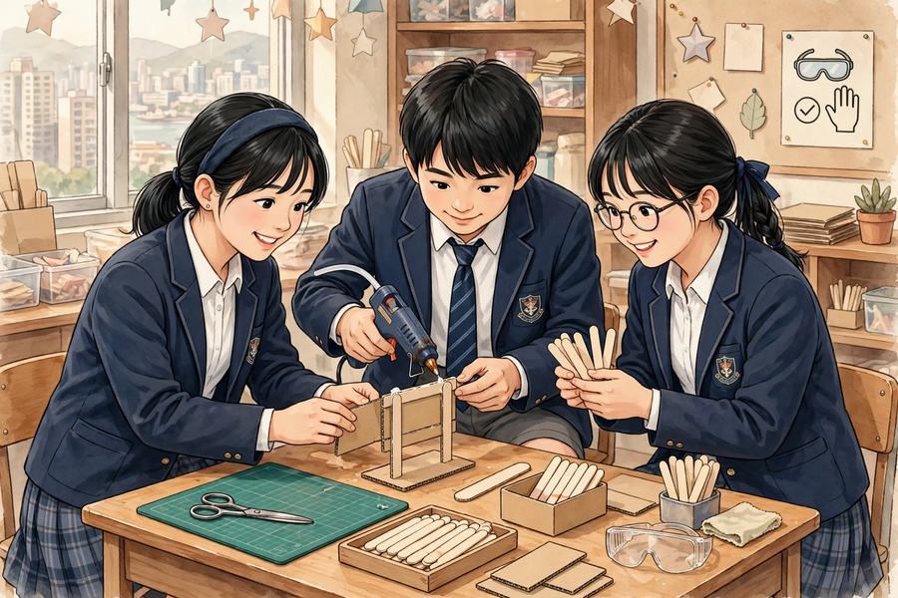
一、甲部：選擇題
Section A: Multiple Choice
1. 傳遞剪刀給同學時，正確的做法是？
What is the correct way to pass scissors to a classmate?
A. 握住尖端、把手向外遞出
Hold the pointed end and offer the handles outward
B. 拋過去
Throw them over
C. 尖端向外遞出
Offer them with the point outward
D. 放在地上踢過去
Put them on the floor and kick them over
2. 製作時發現結構不穩固，以下哪個改良方法最合理？
The structure is found to be unstable during making. Which improvement is most sensible?
A. 改用三角形支架結構，並在底部加闊卡紙座
Switch to a triangular stand structure with a widened cardboard base
B. 用更多膠紙隨意包裹
Wrap it randomly with more tape
C. 把作品壓扁
Flatten the work
D. 放棄不做
Give up
3. 為什麼原型不必一次成功？
Why does a prototype not need to succeed on the first attempt?
A. 因為老師不會檢查
Because the teacher will not check it
B. 因為原型就是用來試錯的，找出問題並改良正是學習
Because prototypes are for trial and error – finding problems and improving is the learning
C. 因為材料不值錢
Because materials are cheap
D. 因為時間太多
Because there is plenty of time
4. 測試原型時，應該針對什麼來測試？
When testing the prototype, what should the test target?
A. 針對問題定義（例如「顯眼」）
The problem definition (e.g. ‘visibility’)
B. 隨便測試
Anything at random
C. 只測試好不好看
Only whether it looks nice
D. 不用測試
No testing needed
5. 在家繼續製作時，以下哪項是安全的？
When continuing the making at home, which of the following is safe?
A. 用剪刀剪貼、繪畫等手工
Handwork such as cutting-and-sticking with scissors and drawing
B. 使用美工刀
Using a craft knife
C. 使用膠槍
Using a glue gun
D. 把半成品放在小孩拿得到的地方
Leaving the work where small children can reach it
二、乙部：問答題
Section B: Short Questions
1. 寫出安全使用低溫膠槍的三項守則。（3 分）
Write down three safety rules for using a low-temperature glue gun. (3 marks)
＿＿＿＿＿＿＿＿＿＿＿＿＿＿＿＿＿＿＿＿＿＿＿＿＿＿＿＿＿＿＿＿＿＿
＿＿＿＿＿＿＿＿＿＿＿＿＿＿＿＿＿＿＿＿＿＿＿＿＿＿＿＿＿＿＿＿＿＿
＿＿＿＿＿＿＿＿＿＿＿＿＿＿＿＿＿＿＿＿＿＿＿＿＿＿＿＿＿＿＿＿＿＿
＿＿＿＿＿＿＿＿＿＿＿＿＿＿＿＿＿＿＿＿＿＿＿＿＿＿＿＿＿＿＿＿＿＿
2. 你的小組在製作時遇到一個問題，請用製作日誌的格式寫下：遇到的問題、解決方法、測試結果。（3 分）
Your group met a problem while making. Using the making-log format, write down: the problem, the solution, and the test result. (3 marks)
＿＿＿＿＿＿＿＿＿＿＿＿＿＿＿＿＿＿＿＿＿＿＿＿＿＿＿＿＿＿＿＿＿＿
＿＿＿＿＿＿＿＿＿＿＿＿＿＿＿＿＿＿＿＿＿＿＿＿＿＿＿＿＿＿＿＿＿＿
＿＿＿＿＿＿＿＿＿＿＿＿＿＿＿＿＿＿＿＿＿＿＿＿＿＿＿＿＿＿＿＿＿＿
＿＿＿＿＿＿＿＿＿＿＿＿＿＿＿＿＿＿＿＿＿＿＿＿＿＿＿＿＿＿＿＿＿＿
3. 解釋：為什麼「記錄失敗」也值得加分？（2 分）
Explain: why does ‘recording failures’ deserve marks too? (2 marks)
＿＿＿＿＿＿＿＿＿＿＿＿＿＿＿＿＿＿＿＿＿＿＿＿＿＿＿＿＿＿＿＿＿＿
＿＿＿＿＿＿＿＿＿＿＿＿＿＿＿＿＿＿＿＿＿＿＿＿＿＿＿＿＿＿＿＿＿＿
＿＿＿＿＿＿＿＿＿＿＿＿＿＿＿＿＿＿＿＿＿＿＿＿＿＿＿＿＿＿＿＿＿＿
＿＿＿＿＿＿＿＿＿＿＿＿＿＿＿＿＿＿＿＿＿＿＿＿＿＿＿＿＿＿＿＿＿＿
三、延伸任務
3. Extension Task
延伸任務：完成實物原型尚未完成的部分（在家只做安全的手工部分，如剪貼、繪畫；不可使用美工刀與膠槍），並在製作日誌補寫「下次要改良的地方」，下一堂帶回課室。
Extension task: finish any incomplete parts of the physical prototype at home (only safe handwork such as cutting-and-sticking with scissors and drawing – do not use craft knives or glue guns), and complete the ‘what to improve next time’ column of the making log. Bring it to the next lesson.

