聖公會呂明才中學 S.K.H. Lui Ming Choi Secondary School
創科班 Little Makers Class ｜ S1 Unit 5：關愛 Project（關愛創科專題）
第 23 堂：動手做（一）：實物原型
Lesson 23: Making the Physical Prototype I
姓名 Name：＿＿＿＿ 班別 Class：＿＿＿＿ 學號 No.：＿＿＿＿ 日期 Date (DD-MM-YYYY)：＿＿＿＿
本堂物資表 Materials List
以下為本堂分組活動所需物資（每組一份）。請在老師派發時核對。
品名 Item | 數量（每組） Quantity (per group) | 安全注意 Safety notes
卡紙（A3，多色） | 每組 4–5 張 | 邊緣或較利，輕放
雪條棍 | 每組約 30 枝 | 斷裂後斷口或尖銳，棄置於廢物箱
低溫膠槍＋膠條 | 每組一部（共用） | 只准低溫型；使用時勿觸碰出膠口；用後即關電源
剪刀 | 每組兩把 | 傳遞時握住刀尖、把手向外遞出
美工刀＋切割墊 | 每組一套（教師監管下使用） | 只准在切割墊上、刀片向外裁切；用後即收刀片
膠紙、雙面膠紙 | 每組各一卷 | —
反光貼紙 | 每組一張（A4） | —
製作日誌（A4） | 每人一張 | —

學生筆記
Student Notes
一、學習目標
1. Learning Objectives
- 1. 學生能按設計圖完成實物原型的至少一半製作進度。
Students can complete at least half of the physical prototype according to the design sketch.
- 2. 學生能在製作日誌中記錄至少一個製作問題及所採用的解決方法。
Students can record at least one making problem and the solution adopted in the making log.
- 3. 學生能正確示範安全使用剪刀、美工刀（或申請教師協助）及低溫膠槍的基本守則。
Students can demonstrate the basic safety rules for scissors, craft knives (or seeking teacher assistance), and low-temperature glue guns.
二、課程內容
2. Lesson Content
甲、什麼是「原型」
A. What is a ‘prototype’?
- 原型（prototype）是產品的初步模型，用來試驗意念是否可行。它不必一次成功——原型就是用來試錯的。
A prototype is a preliminary model of a product, used to test whether the idea works. It need not succeed on the first attempt – prototypes are for trial and error.
- 記錄下「哪裡失敗、怎樣改良」，和成功本身同樣有價值；製作日誌的分數正正來自這些記錄。
Recording ‘what failed and how it was improved’ is as valuable as success itself; the making-log marks come precisely from these records.
乙、安全守則
B. Safety rules
- 剪刀：傳遞時握住尖端、把手向外遞給同學；用後放回原處，不可拋擲或嬉戲。
Scissors: when passing them, hold the pointed end and offer the handles outward; put them back afterwards; never throw or play with them.
- 美工刀：只准在切割墊上、刀片向外裁切；用後即收回刀片；如不確定，申請教師協助，不要勉強。
Craft knives: use only on a cutting mat with the blade facing outward; retract the blade immediately after use; if unsure, ask the teacher for help instead of forcing it.
- 低溫膠槍：只准使用低溫型；切勿觸碰出膠口；用後即關電源；如被燙到，立即舉手通知教師，用清水沖洗。
Low-temperature glue guns: use the low-temperature type only; never touch the nozzle; switch off immediately after use; if burnt, raise your hand at once, inform the teacher and rinse with clean water.
- 受傷即時處理三步：舉手通知教師 → 用清水沖洗 → 由教師決定是否需要進一步處理。
Three steps for injuries: raise your hand and inform the teacher → rinse with clean water → let the teacher decide whether further treatment is needed.
丙、製作技巧
C. Making techniques
- 結構穩固：直立的部件容易搖晃，可改用三角形支架結構，或在底部加闊卡紙座增加穩定。
Stable structures: upright parts wobble easily – switch to a triangular stand structure or widen the cardboard base for stability.
- 量度準確：下刀／下膠前先用間尺量度並做記號；尺寸出錯多數是「目測」造成的。
Measure accurately: measure and mark with a ruler before cutting or gluing; most dimension errors come from ‘eyeballing’.
- 先做核心部件：如果時間緊迫，先完成能展示主要功能的核心部分，裝飾細節留待最後。
Core components first: when time is tight, finish the core parts that show the main function first; leave decorative details for last.
丁、製作日誌
D. The making log
- 製作日誌有五欄：(1) 今日完成的製作部分；(2) 遇到的問題；(3) 嘗試過的解決方法；(4) 測試結果；(5) 下次要改良的地方。
The making log has five columns: (1) part completed today; (2) problem encountered; (3) solutions tried; (4) test result; (5) what to improve next time.
- 寫日誌要具體：寫「支架黏合後搖晃」，不要只寫「失敗了」；寫「改為三角形支架後不再搖晃」，不要只寫「改好了」。
Be specific in the log: write ‘the stand wobbled after gluing’, not just ‘failed’; write ‘it stopped wobbling after switching to a triangular stand’, not just ‘fixed’.
戊、解難策略
E. Problem-solving strategies
- 卡住了，可以試：改用另一種材料、簡化結構、向同伴求助、請教師指導。不要呆等，也不要代做別人的部分。
When stuck, try: switching to another material, simplifying the structure, asking a classmate, or asking the teacher. Do not wait idly, and do not do someone else’s part for them.
- 進度落後時，縮小範圍（先完成核心部件），不要追趕全部細節；半完成的核心部件，勝過什麼都差一點的半成品。
When behind schedule, narrow the scope (finish the core components first) instead of chasing every detail; a half-finished core beats an almost-finished nothing.
- 教師巡視時會問：「這裡卡住了，可以怎樣改設計就做得到？」——引導改良，而不是代做。
When circulating, the teacher will ask: ‘It’s stuck here – how could the design be changed to make it work?’ – guiding improvement, not doing it for you.
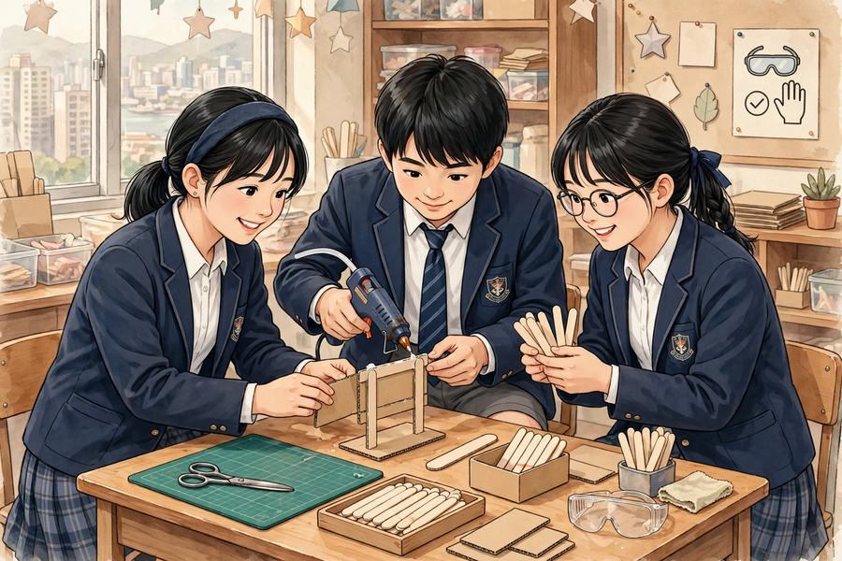
三、例子
3. Examples
例 1：例一（製作日誌示例）：今日完成的製作部分——反光提示牌的牌身與支架黏合；遇到的問題——支架用雪條棍黏合後容易搖晃；嘗試過的解決方法——改為三角形支架結構，並在底部加闊卡紙座；測試結果——輕推後不再搖晃，能穩固豎立；下次要改良的地方——支架與牌身的接合位再加固。
Example 1: Example 1 (sample making-log entry): Part completed today – glued the sign board to the stand of the reflective warning sign; problem – the ice-cream-stick stand wobbled after gluing; solutions tried – changed to a triangular stand structure with a widened cardboard base; test result – no more wobbling when pushed gently, stands steadily; to improve next time – reinforce the joint between the stand and the board.
例 2：例二（測試示例）：把反光牌放在枱上，輕推一下，看它會不會倒下；把牌身拿到較暗的角落，看反光貼紙是否仍然顯眼。測試要針對「問題定義」——我們的問題是「讓清潔工更容易被看見」，所以「顯眼」就是測試重點。
Example 2: Example 2 (sample test): place the sign on the desk and push it gently to see if it topples; take the board to a dim corner to check the reflective stickers still stand out. Tests must target the problem definition – ours is ‘making cleaners more visible’, so ‘visibility’ is the test focus.
四、課堂小練習
4. Class Practice
與鄰座同學討論後作答，稍後全班一起核對。
Discuss with your neighbour, then check answers with the class.
1. 以下哪種做法違反安全守則？
Which of the following breaks the safety rules?
A 用剪刀時把手向外遞給同學；B 在切割墊上、刀片向外裁切；C 用手觸摸膠槍出膠口試溫度；D 用後即關膠槍電源。
A: pass scissors handles-outward; B: cut on the mat with the blade outward; C: touch the glue-gun nozzle to test its temperature; D: switch the glue gun off after use.
＿＿＿＿＿＿＿＿＿＿＿＿＿＿＿＿＿＿＿＿＿＿＿＿＿＿＿＿＿＿＿＿＿＿
＿＿＿＿＿＿＿＿＿＿＿＿＿＿＿＿＿＿＿＿＿＿＿＿＿＿＿＿＿＿＿＿＿＿
2. 製作日誌有哪五欄？
What are the five columns of the making log?
＿＿＿＿＿＿＿＿＿＿＿＿＿＿＿＿＿＿＿＿＿＿＿＿＿＿＿＿＿＿＿＿＿＿
＿＿＿＿＿＿＿＿＿＿＿＿＿＿＿＿＿＿＿＿＿＿＿＿＿＿＿＿＿＿＿＿＿＿
3. 原型第一次測試失敗了，小組應該怎樣做？
The prototype failed its first test. What should the group do?
A 放棄；B 記錄問題、想辦法改良；C 怪責負責的同學；D 照抄別組。
A: give up; B: record the problem and improve; C: blame the member in charge; D: copy another group.
＿＿＿＿＿＿＿＿＿＿＿＿＿＿＿＿＿＿＿＿＿＿＿＿＿＿＿＿＿＿＿＿＿＿
＿＿＿＿＿＿＿＿＿＿＿＿＿＿＿＿＿＿＿＿＿＿＿＿＿＿＿＿＿＿＿＿＿＿
五、思考題
5. Thinking Questions
先獨立思考，再與小組分享你的看法。
Think on your own first, then share your views with your group.
1. 為什麼說「原型就是用來試錯的」？記錄失敗和改良為什麼同樣有分？
Why do we say ‘prototypes are for trial and error’? Why do recorded failures and improvements earn marks too?
＿＿＿＿＿＿＿＿＿＿＿＿＿＿＿＿＿＿＿＿＿＿＿＿＿＿＿＿＿＿＿＿＿＿
＿＿＿＿＿＿＿＿＿＿＿＿＿＿＿＿＿＿＿＿＿＿＿＿＿＿＿＿＿＿＿＿＿＿
＿＿＿＿＿＿＿＿＿＿＿＿＿＿＿＿＿＿＿＿＿＿＿＿＿＿＿＿＿＿＿＿＿＿
2. 製作時間只剩 15 分鐘，但原型只完成一半，小組應該怎樣取捨？
Only 15 minutes of making time remain, but the prototype is only half done. How should the group prioritise?
＿＿＿＿＿＿＿＿＿＿＿＿＿＿＿＿＿＿＿＿＿＿＿＿＿＿＿＿＿＿＿＿＿＿
＿＿＿＿＿＿＿＿＿＿＿＿＿＿＿＿＿＿＿＿＿＿＿＿＿＿＿＿＿＿＿＿＿＿
＿＿＿＿＿＿＿＿＿＿＿＿＿＿＿＿＿＿＿＿＿＿＿＿＿＿＿＿＿＿＿＿＿＿
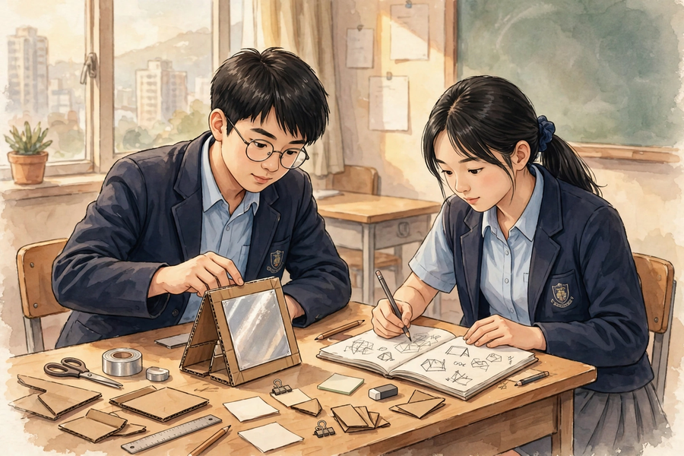
六、分組活動
6. Group Activity
步驟 1：聆聽安全講解，並能覆述三項安全守則（剪刀、美工刀、低溫膠槍）；領取本組材料。
Step 1: Listen to the safety briefing and repeat the three safety rules (scissors, craft knives, low-temperature glue guns); collect your group’s materials.
步驟 2：按設計圖與分工製作實物原型（約 35 分鐘）；遇到困難先試解難策略，再請教師指導。
Step 2: Build the physical prototype from the design sketch and task allocation (about 35 minutes); try the problem-solving strategies first when stuck, then ask the teacher.
步驟 3：初步測試原型（例如反光牌能否穩固豎立、尺寸是否合用），在製作日誌寫下五欄內容。
Step 3: Carry out a preliminary test of the prototype (e.g. whether the sign stands steadily, whether dimensions are suitable) and complete the five columns of the making log.
步驟 4：收拾工具、清理枱面，把半成品妥善存放；聆聽教師總結常見製作問題。
Step 4: Tidy the tools, clean the table and store the work-in-progress safely; listen to the teacher’s summary of common making problems.
七、總結
7. Summary
- 原型是用來試錯的初步模型；記錄問題與改良，和成功同樣有價值。
A prototype is a preliminary model for trial and error; recording problems and improvements is as valuable as success.
- 安全第一：剪刀、美工刀、低溫膠槍各有守則；受傷即舉手通知教師、清水沖洗。
Safety first: scissors, craft knives and glue guns each have their rules; if injured, raise your hand, inform the teacher and rinse with clean water.
- 製作日誌五欄：完成部分、遇到的問題、解決方法、測試結果、下次改良；要寫得具體。
The making log’s five columns – part completed, problem, solution, test result, next improvement – must be written specifically.
- 卡住時：改用材料、簡化結構、向同伴或教師求助；進度落後時縮小範圍，先完成核心部件。
When stuck: change materials, simplify the structure, or ask classmates/the teacher; when behind, narrow the scope and finish the core first.
八、小測驗
8. Mini Quiz
獨立完成，檢視本課的學習成果。
Complete independently to review what you have learnt.
1. 使用美工刀時，正確的做法是？
What is the correct way to use a craft knife?
A. 在手上直接裁切
Cut directly while holding the work in your hand
B. 只在切割墊上、刀片向外裁切，用後即收回刀片
Use only on a cutting mat with the blade outward; retract the blade afterwards
C. 刀片向內，方便施力
Blade facing inward for better force
D. 用完放在枱邊，下次方便拿
Leave it at the table edge for easy access next time
2. 被低溫膠槍燙到，第一時間應該怎樣做？
If burnt by a low-temperature glue gun, what should you do first?
A. 舉手通知教師，用清水沖洗
Raise your hand, inform the teacher and rinse with clean water
B. 用口吹一吹繼續做
Blow on it and carry on
C. 自己塗藥膏
Apply ointment yourself
D. 忍著不說
Say nothing and endure it
3. 以下哪一項不是製作日誌的欄目？
Which of the following is NOT a column of the making log?
A. 今日完成的製作部分
Part completed today
B. 遇到的問題
Problem encountered
C. 嘗試過的解決方法
Solutions tried
D. 組員的午餐吃了什麼
What members had for lunch
4. 原型測試失敗後，小組在日誌寫下「失敗了」三個字。這樣寫有什麼不足？應怎樣寫？
After a failed test, a group wrote only ‘failed’ in the log. What is lacking, and how should it be written?
＿＿＿＿＿＿＿＿＿＿＿＿＿＿＿＿＿＿＿＿＿＿＿＿＿＿＿＿＿＿＿＿＿＿
＿＿＿＿＿＿＿＿＿＿＿＿＿＿＿＿＿＿＿＿＿＿＿＿＿＿＿＿＿＿＿＿＿＿
＿＿＿＿＿＿＿＿＿＿＿＿＿＿＿＿＿＿＿＿＿＿＿＿＿＿＿＿＿＿＿＿＿＿
5. 小組進度落後，只剩很少時間。請寫出一個合理的取捨決定，並說明原因。
A group is behind schedule with little time left. Write down one sensible prioritising decision and explain why.
＿＿＿＿＿＿＿＿＿＿＿＿＿＿＿＿＿＿＿＿＿＿＿＿＿＿＿＿＿＿＿＿＿＿
＿＿＿＿＿＿＿＿＿＿＿＿＿＿＿＿＿＿＿＿＿＿＿＿＿＿＿＿＿＿＿＿＿＿
＿＿＿＿＿＿＿＿＿＿＿＿＿＿＿＿＿＿＿＿＿＿＿＿＿＿＿＿＿＿＿＿＿＿

