聖公會呂明才中學 S.K.H. Lui Ming Choi Secondary School
創科班 Little Makers Class ｜ S1 Unit 5：關愛 Project（關愛創科專題）
第 24 堂：動手做（二）：AI 生成與整合
Lesson 24: AI Generation and Integration
姓名 Name：＿＿＿＿ 班別 Class：＿＿＿＿ 學號 No.：＿＿＿＿ 日期 Date (DD-MM-YYYY)：＿＿＿＿
本堂物資表 Materials List
以下為本堂分組活動所需物資（每組一份）。請在老師派發時核對。
品名 Item | 數量（每組） Quantity (per group) | 安全注意 Safety notes
共用裝置（平板電腦或手提電腦，已連接校園 Wi-Fi） | 每組一部 | 使用時注意螢幕亮度與坐姿；裝置由教師統一保管與充電
AI 使用工作紙＋輪流操作時間表＋整合測試表（A4） | 每組各一張 | —
打印紙（A4） | 每組 2–3 張（列印 AI 海報／故事用） | 列印機高溫部件勿觸碰
展示板／大卡紙 | 每組一塊 | —

學生筆記
Student Notes
一、學習目標
1. Learning Objectives
- 1. 學生能運用 AI 工具，為本組關愛專題生成一件配合主題的作品（海報、故事、音樂或介紹）。
Students can use AI tools to generate one theme-appropriate work (poster, story, music piece, or introduction) for their caring project.
- 2. 學生能在作品上註明「本作品部分內容由 AI 生成」，並說出一項使用 AI 時的道德考慮。
Students can label the work ‘partly generated by AI’ and state one ethical consideration when using AI.
- 3. 學生能把 AI 生成部分與實物原型整合展示，並按測試結果作出至少一項改良。
Students can integrate the AI-generated part with the physical prototype for presentation, and make at least one improvement based on testing.
二、課程內容
2. Lesson Content
甲、AI 生成部分是什麼
A. What is the ‘AI-generated part’?
- 本專題有兩部分：實物原型（上一堂做的）和 AI 生成部分（本堂做的）。AI 生成部分是配合關愛主題的數碼作品：海報、故事、音樂或介紹，四選一。
This project has two parts: the physical prototype (made last lesson) and the AI-generated part (made this lesson). The AI-generated part is a digital work matching the caring theme: a poster, story, music piece or introduction – choose one.
- 例子：為反光提示牌專題生成一張關愛海報，放在展示板上；或生成一段 100 字的介紹，在成果展時配合講解。
Examples: generate a caring poster for the reflective-sign project to mount on the display board; or generate a 100-word introduction to support the showcase presentation.
- 課堂會用 Google Teachable Machine（https://teachablemachine.withgoogle.com/）或 AI 繪圖／文字工具示範；每組一部裝置，輪流操作。
The class will demonstrate with Google Teachable Machine (https://teachablemachine.withgoogle.com/) or AI drawing/text tools; each group shares one device and takes turns.
乙、寫好提示詞
B. Writing good prompts
- 提示詞（prompt）就是你給 AI 的指示。提示詞愈具體，生成結果愈合用。
A prompt is the instruction you give the AI. The more specific the prompt, the more usable the result.
- 好提示詞有四個要領：對象是誰、情境是什麼、想要什麼風格、有什麼具體要求。
A good prompt covers four points: who it is for, what the situation is, what style is wanted, and any specific requirements.
- 比較：✘「畫一張海報」（太空泛） ✔「為清晨工作的清潔工設計一張暖色調、文字簡短的關愛海報」（對象、情境、風格、要求俱備）。
Compare: ✘ ‘Draw a poster’ (too vague) ✔ ‘Design a warm-toned caring poster with short text for cleaners working in the early morning’ (audience, situation, style and requirements all covered).
- 提示詞可以用中文寫；試過不理想就修改再試，多試幾次是正常過程。
Prompts can be written in Chinese; if the result is poor, revise and try again – trying several times is normal.
丙、版本比較與篩選
C. Comparing versions and selecting
- AI 生成一次不算完成。要生成至少三個版本，比較後選出最配合主題的一個，並寫出選擇原因。
One AI generation does not finish the job. Generate at least three versions, compare them, select the one that best matches the theme, and write down why.
- 「篩選與改良」才是人的價值所在：AI 負責生成，人負責判斷、選擇和改良——照單全收不是好方法。
Selecting and refining is where human value lies: AI generates, humans judge, select and refine – accepting everything uncritically is not good practice.
- 比較時看三點：是否配合關愛主題、內容是否恰當、放在實物旁邊是否協調。
When comparing, check three points: does it match the caring theme, is the content appropriate, and does it sit well alongside the physical prototype.
丁、使用 AI 的三項道德守則
D. Three ethical rules for using AI
- 第一，註明出處：在作品上註明「本作品部分內容由 AI 生成」，這是誠信要求，不是扣分項目。
First, give credit: label the work ‘partly generated by AI’. This is a matter of honesty, not a penalty.
- 第二，核實內容：檢查 AI 生成的內容是否真確、恰當；有錯誤或不恰當的地方要修改或棄用。
Second, verify the content: check whether the AI output is accurate and appropriate; correct or discard anything wrong or unsuitable.
- 第三，不冒充：不可以把 AI 作品說成是自己親手繪畫或創作的。
Third, do not pass off: never claim AI-generated work as your own hand-drawn or hand-created work.
戊、輪流操作與角色分工
E. Rotation and role allocation
- 學校裝置有限，每組一部裝置（平板電腦或手提電腦），按「輪流操作時間表」每人操作約 6 分鐘。
Devices are limited: each group shares one device (tablet or laptop) and follows a rotation timetable of about 6 minutes per person.
- 四個角色：操作員（輸入提示詞）、提示詞記錄員（記下用過的提示詞）、作品篩選員（比較各版本、選出最佳）、整合測試員（構思 AI 作品與實物如何結合）。
Four roles: operator (enters prompts), prompt recorder (notes the prompts used), work selector (compares versions and picks the best), integration tester (plans how to combine the AI work with the physical prototype).
- 未能輪到操作的組員不要閒置：同步進行實物原型的最後修飾，或撰寫成果展講稿。
Members waiting for their turn must not sit idle: refine the physical prototype or draft the showcase presentation script.
己、整合測試表
F. The integration test form
- 整合測試表有三欄：(1) AI 作品與實物的結合方式；(2) 測試發現的問題；(3) 作出的改良。
The integration test form has three columns: (1) how the AI work combines with the physical prototype; (2) problem found in testing; (3) improvement made.
- 結合方式例子：把 AI 生成的海報貼於展示板、把 AI 生成的介紹故事印出配合講解、把 AI 生成的音樂在展示時播放。
Example combinations: mount the AI-generated poster on the display board, print the AI-generated introductory story to support the talk, or play the AI-generated music during the presentation.
- 互相測試展示效果：請別組同學看看，問他們「看得明白嗎？有什麼建議？」，然後至少作出一項改良並記錄。
Test the presentation effect on each other: ask another group ‘Is it clear? Any suggestions?’, then make at least one improvement and record it.
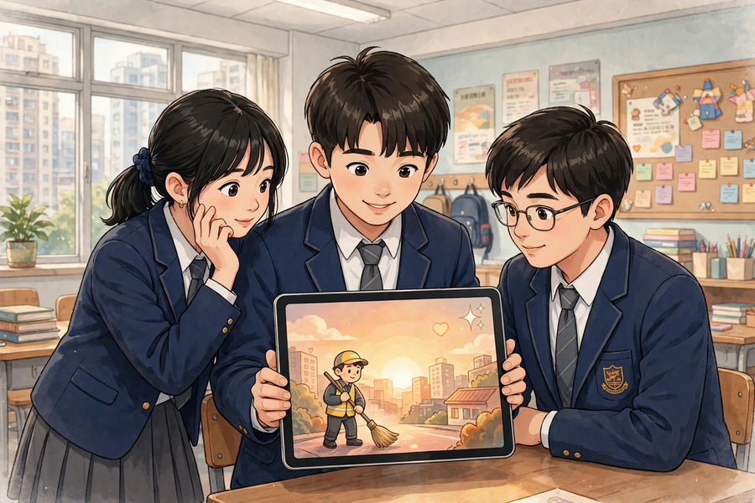
三、例子
3. Examples
例 1：例一（提示詞比較）：✘ 壞提示詞：「畫一張海報」——結果太空泛，不知為誰而畫。✔ 好提示詞：「為清晨工作的清潔工設計一張暖色調、文字簡短的關愛海報」——對象、情境、風格、要求俱備，效果好得多。
Example 1: Example 1 (prompt comparison): ✘ Bad prompt: ‘Draw a poster’ – the result is too vague, with no clear audience. ✔ Good prompt: ‘Design a warm-toned caring poster with short text for cleaners working in the early morning’ – audience, situation, style and requirements all covered, far better results.
例 2：例二（AI 使用工作紙示例）：使用的 AI 工具——AI 繪圖工具；試過的提示詞——(1)「畫一張海報」(2)「為清晨工作的清潔工設計關愛海報」(3)「為清晨工作的清潔工設計一張暖色調、文字簡短的關愛海報」；三個版本比較——版本一太空泛、版本二色調太冷、版本三最配合主題；選定版本及原因——版本三，因為暖色調能傳遞關愛，文字簡短易讀；道德檢查——☑ 已註明 AI 生成 ☑ 內容已核實恰當。
Example 2: Example 2 (sample AI-usage worksheet): AI tool used – AI drawing tool; prompts tried – (1) ‘Draw a poster’ (2) ‘Design a caring poster for cleaners working in the early morning’ (3) ‘Design a warm-toned caring poster with short text for cleaners working in the early morning’; comparison – version 1 too vague, version 2 tones too cold, version 3 matches the theme best; chosen version and reason – version 3, because warm tones convey care and short text is easy to read; ethics check – ☑ AI labelling done ☑ content verified as appropriate.
例 3：例三（整合測試示例）：結合方式——把 AI 生成的海報貼在展示板左邊，實物反光牌放在右邊；測試發現的問題——海報文字太多，觀眾要看很久；作出的改良——把海報文字縮減到三句，並把標題字體放大。
Example 3: Example 3 (sample integration test): combination – the AI-generated poster mounted on the left of the display board, the physical reflective sign on the right; problem found in testing – the poster had too much text and took the audience too long to read; improvement made – cut the poster text to three sentences and enlarged the title font.
四、課堂小練習
4. Class Practice
與鄰座同學討論後作答，稍後全班一起核對。
Discuss with your neighbour, then check answers with the class.
1. 以下哪個提示詞比較有效？為什麼？A「寫個故事」B「為視障人士寫一個 100 字、語氣溫暖的短故事，講述導盲設施如何幫助他們安全過馬路」
Which prompt is more effective, and why? A ‘Write a story’ B ‘Write a 100-word warm-toned short story for visually impaired people about how tactile guide facilities help them cross roads safely’
＿＿＿＿＿＿＿＿＿＿＿＿＿＿＿＿＿＿＿＿＿＿＿＿＿＿＿＿＿＿＿＿＿＿
＿＿＿＿＿＿＿＿＿＿＿＿＿＿＿＿＿＿＿＿＿＿＿＿＿＿＿＿＿＿＿＿＿＿
2. 請說出使用 AI 的三項道德守則。
State the three ethical rules for using AI.
＿＿＿＿＿＿＿＿＿＿＿＿＿＿＿＿＿＿＿＿＿＿＿＿＿＿＿＿＿＿＿＿＿＿
＿＿＿＿＿＿＿＿＿＿＿＿＿＿＿＿＿＿＿＿＿＿＿＿＿＿＿＿＿＿＿＿＿＿
3. 輪流操作時，「提示詞記錄員」負責什麼？「整合測試員」負責什麼？
During rotation, what does the ‘prompt recorder’ do? What does the ‘integration tester’ do?
＿＿＿＿＿＿＿＿＿＿＿＿＿＿＿＿＿＿＿＿＿＿＿＿＿＿＿＿＿＿＿＿＿＿
＿＿＿＿＿＿＿＿＿＿＿＿＿＿＿＿＿＿＿＿＿＿＿＿＿＿＿＿＿＿＿＿＿＿
五、思考題
5. Thinking Questions
先獨立思考，再與小組分享你的看法。
Think on your own first, then share your views with your group.
1. 為什麼 AI 生成一次不算完成？比較多個版本有什麼好處？
Why does one AI generation not finish the job? What are the benefits of comparing multiple versions?
＿＿＿＿＿＿＿＿＿＿＿＿＿＿＿＿＿＿＿＿＿＿＿＿＿＿＿＿＿＿＿＿＿＿
＿＿＿＿＿＿＿＿＿＿＿＿＿＿＿＿＿＿＿＿＿＿＿＿＿＿＿＿＿＿＿＿＿＿
＿＿＿＿＿＿＿＿＿＿＿＿＿＿＿＿＿＿＿＿＿＿＿＿＿＿＿＿＿＿＿＿＿＿
2. 有同學不想註明「AI 生成」，覺得會被扣分。你會怎樣勸他？
A classmate does not want to label the work as ‘AI-generated’, fearing marks will be deducted. How would you persuade them?
＿＿＿＿＿＿＿＿＿＿＿＿＿＿＿＿＿＿＿＿＿＿＿＿＿＿＿＿＿＿＿＿＿＿
＿＿＿＿＿＿＿＿＿＿＿＿＿＿＿＿＿＿＿＿＿＿＿＿＿＿＿＿＿＿＿＿＿＿
＿＿＿＿＿＿＿＿＿＿＿＿＿＿＿＿＿＿＿＿＿＿＿＿＿＿＿＿＿＿＿＿＿＿
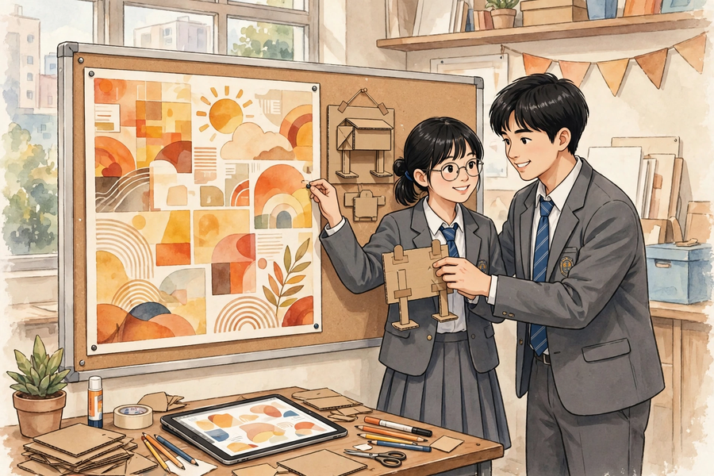
六、分組活動
6. Group Activity
步驟 1：聆聽教師示範：用一部裝置即場為示例專題生成海報初稿，並記下三項道德守則。
Step 1: Watch the teacher’s demonstration: generating a first-draft poster for the sample project on one device; note the three ethical rules.
步驟 2：按「輪流操作時間表」輪流使用裝置（每人約 6 分鐘），擔任分配到的角色；未能輪到的組員同步修飾實物原型或撰寫講稿。
Step 2: Take turns on the device per the rotation timetable (about 6 minutes each) in your assigned role; members waiting refine the physical prototype or draft the presentation script.
步驟 3：填寫「AI 使用工作紙」：使用的 AI 工具、試過的提示詞、三個版本比較、選定版本及原因、道德檢查。
Step 3: Complete the ‘AI usage worksheet’: AI tool used, prompts tried, comparison of three versions, chosen version and reason, ethics check.
步驟 4：填寫「整合測試表」：把 AI 作品與實物原型結合展示，請別組試看，記錄至少一項改良；把選定版本列印或儲存好。
Step 4: Complete the ‘integration test form’: combine the AI work with the physical prototype, invite another group to try it out, and record at least one improvement; print or save the chosen version.
七、總結
7. Summary
- AI 生成部分四選一：海報、故事、音樂、介紹；必須配合關愛主題。
The AI-generated part is one of four: poster, story, music piece, or introduction – and it must match the caring theme.
- 好提示詞四要領：對象是誰、情境是什麼、想要什麼風格、有什麼具體要求；多試幾次是正常過程。
Four essentials of a good prompt: who it is for, the situation, the style wanted, and specific requirements; trying several times is normal.
- 生成至少三個版本，比較後選出最配合主題的一個並寫出原因；照單全收不是好方法。
Generate at least three versions, compare them, and select the best-matching one with reasons; accepting everything uncritically is poor practice.
- 三項道德守則：註明 AI 生成、核實內容真確恰當、不冒充為親手作品。
Three ethical rules: label AI-generated content, verify accuracy and appropriateness, and never pass it off as hand-created.
- 每組一部裝置輪流操作（每人約 6 分鐘），四個角色分工；等待時修飾實物或寫講稿，不要閒置。
Each group shares one device in rotation (about 6 minutes each) with four roles; while waiting, refine the physical work or draft the script – no idling.
- 用整合測試表記錄結合方式、測試發現的問題和至少一項改良。
Use the integration test form to record the combination method, problems found in testing, and at least one improvement.
八、小測驗
8. Mini Quiz
獨立完成，檢視本課的學習成果。
Complete independently to review what you have learnt.
1. 以下哪個是好提示詞？
Which of the following is a good prompt?
A. 畫一張海報
Draw a poster
B. 唱首歌
Sing a song
C. 為清晨工作的清潔工設計一張暖色調、文字簡短的關愛海報
Design a warm-toned caring poster with short text for cleaners working in the early morning
D. 幫我做功課
Do my homework for me
2. 為什麼要在作品上註明「本作品部分內容由 AI 生成」？
Why label the work ‘partly generated by AI’?
A. 因為這是誠信要求
Because it is a honesty requirement
B. 因為會加分
Because it earns bonus marks
C. 因為老師喜歡看
Because the teacher likes to see it
D. 因為 AI 要求
Because the AI requires it
3. 輪流操作時，未能輪到使用裝置的組員應該怎樣做？
During rotation, what should members waiting for the device do?
A. 閒坐等待
Sit idle and wait
B. 修飾實物原型或撰寫展示講稿
Refine the physical prototype or draft the presentation script
C. 玩手機
Play with their phones
D. 離開課室
Leave the classroom
4. 請寫出輪流操作的四個角色及其職責。
Write down the four rotation roles and their duties.
＿＿＿＿＿＿＿＿＿＿＿＿＿＿＿＿＿＿＿＿＿＿＿＿＿＿＿＿＿＿＿＿＿＿
＿＿＿＿＿＿＿＿＿＿＿＿＿＿＿＿＿＿＿＿＿＿＿＿＿＿＿＿＿＿＿＿＿＿
＿＿＿＿＿＿＿＿＿＿＿＿＿＿＿＿＿＿＿＿＿＿＿＿＿＿＿＿＿＿＿＿＿＿
5. 小組只生成了一個版本就決定採用。請指出這樣做的兩個問題。
A group generated only one version and adopted it. Point out two problems with this.
＿＿＿＿＿＿＿＿＿＿＿＿＿＿＿＿＿＿＿＿＿＿＿＿＿＿＿＿＿＿＿＿＿＿
＿＿＿＿＿＿＿＿＿＿＿＿＿＿＿＿＿＿＿＿＿＿＿＿＿＿＿＿＿＿＿＿＿＿
＿＿＿＿＿＿＿＿＿＿＿＿＿＿＿＿＿＿＿＿＿＿＿＿＿＿＿＿＿＿＿＿＿＿

