聖公會呂明才中學 S.K.H. Lui Ming Choi Secondary School
創科班 Little Makers Class ｜ S1 Unit 5：關愛 Project（關愛創科專題）
第 25 堂：成果展
Lesson 25: Showcase and Celebration
姓名 Name：＿＿＿＿ 班別 Class：＿＿＿＿ 學號 No.：＿＿＿＿ 日期 Date (DD-MM-YYYY)：＿＿＿＿
本堂物資表 Materials List
以下為本堂分組活動所需物資（每組一份）。請在老師派發時核對。
品名 Item | 數量（每組） Quantity (per group) | 安全注意 Safety notes
互評表（A4） | 每人一張 | —
反思紙（A5） | 每人一張 | —
展示提示卡 | 每組一張 | —
獎狀 | 每組一張 | —
小獎品（貼紙／文具） | 每組一份 | 選擇無小部件、無尖銳邊緣的獎品
計時器（投影用） | 一個 | —

學生筆記
Student Notes
一、學習目標
1. Learning Objectives
- 1. 學生能在三分鐘內向全班介紹本組作品（包括關愛對象、真實需要、實物設計、AI 生成部分）。
Students can introduce their group’s work to the whole class within three minutes (covering the caring target, real need, physical design, and AI-generated part).
- 2. 學生能按互評表為至少三組作品評分，並為每組寫出至少一項具體讚賞。
Students can score at least three groups’ works using the peer-evaluation form and write at least one specific compliment for each.
- 3. 學生能說出本單元中自己學到的一項與「正能量」相關的體會。
Students can state one takeaway from the unit related to ‘positive energy’.
二、課程內容
2. Lesson Content
甲、展示四要素
A. The four elements of the presentation
- 三分鐘展示必須包括四要素：(1) 關愛對象是誰；(2) 真實需要是什麼；(3) 實物設計是怎樣的；(4) AI 生成部分是什麼。缺一不可。
The three-minute presentation must cover four elements: (1) who the caring target is; (2) what the real need is; (3) what the physical design is like; (4) what the AI-generated part is. None may be missing.
- 展示規則：每組 3 分鐘展示＋1 分鐘問答；教師會用計時器嚴格計時，超時會被叫停。
Presentation rules: 3 minutes per group + 1 minute Q&A; the teacher keeps strict time with a timer – overtime will be stopped.
乙、「1＋1＋1」三分鐘結構
B. The ‘1+1+1’ three-minute structure
- 第 1 分鐘：講關愛對象與真實需要——「我們關心的是誰？他們有什麼困難？」
Minute 1: the caring target and real need – ‘Who do we care about? What difficulty do they face?’
- 第 2 分鐘：講實物設計——展示原型，「我們的設計是怎樣的？怎樣回應這個需要？」
Minute 2: the physical design – show the prototype: ‘What is our design like? How does it address the need?’
- 第 3 分鐘：講 AI 生成部分與分工——「AI 幫我們生成了什麼？組員各自負責了什麼？」
Minute 3: the AI-generated part and task allocation – ‘What did AI generate for us? What did each member do?’
- 每組會獲發一張展示提示卡；上台前小組先分配好每人講哪一分鐘。
Each group receives a presentation prompt card; allocate who speaks in which minute before going on stage.
丙、互評表
C. The peer-evaluation form
- 每位學生為其他組別評分（不評自己組別），每項 1–5 分；評分只作參考，最終獎項由教師綜合決定。
Each student scores other groups (not their own), 1–5 per criterion; scores are advisory and final awards are decided by the teacher overall.
- 互評五項：(1) 關愛對象與需要是否明確；(2) 實物原型是否配合需要、製作認真；(3) AI 生成部分是否配合主題；(4) 介紹是否清晰、有條理；(5) 整體創意。
The five criteria: (1) Is the caring target and need clear? (2) Does the physical prototype address the need, and is it carefully made? (3) Does the AI-generated part match the theme? (4) Is the presentation clear and well organised? (5) Overall creativity.
- 評分要看作品準則，不可只給朋友高分；這是誠實和公平的表現。
Score against the criteria – do not give high marks only to friends; this is a matter of honesty and fairness.
丁、具體讚賞
D. Specific compliments
- 每評一組，須寫出一句具體讚賞。具體讚賞＝指出作品的某個特點＋它好在哪裡。
For each group scored, write one specific compliment. A specific compliment = name a feature of the work + say what is good about it.
- 比較：✘ 空泛：「很好」「很漂亮」「不錯」——沒有指出好在哪裡。✔ 具體：「他們的反光牌支架用了三角形結構，很穩固」「海報用了暖色調和簡短文字，很配合清晨清潔工的主題」。
Compare: ✘ Vague: ‘very good’, ‘very pretty’, ‘not bad’ – none says what is good. ✔ Specific: ‘Their sign stand uses a triangular structure, which is very stable’; ‘The poster uses warm tones and short text, which suits the early-morning cleaners’ theme’.
- 欣賞別人的長處、說出具體原因，是本課要學的「正能量」態度。
Appreciating others’ strengths and stating specific reasons is the ‘positive energy’ attitude this lesson teaches.
戊、獎項與正能量分享
E. Awards and positive-energy sharing
- 獎項類別：最具關愛精神獎、最佳創意獎、最佳 AI 應用獎、最佳演說獎，以及最佳進步獎（肯定起點較低但付出努力的小組）。
Award categories: Most Caring Spirit, Most Creative, Best AI Application, Best Presentation, plus Most Improved (recognising groups that started lower but worked hard).
- 得獎組別分享一句得獎感受；最後全班每人用一句話分享本單元的正能量體會，例如「原來科技可以令清潔工更安全」。
Winning groups share one acceptance sentence; finally, every student shares one positive-energy takeaway in one sentence, e.g. ‘Technology can actually make cleaners safer’.
- 獎項人人有機會；即使沒有得獎，認真完成五堂專題的每一位同學都值得肯定。
Awards are open to all; even without winning, every student who completed the five-lesson project seriously deserves recognition.
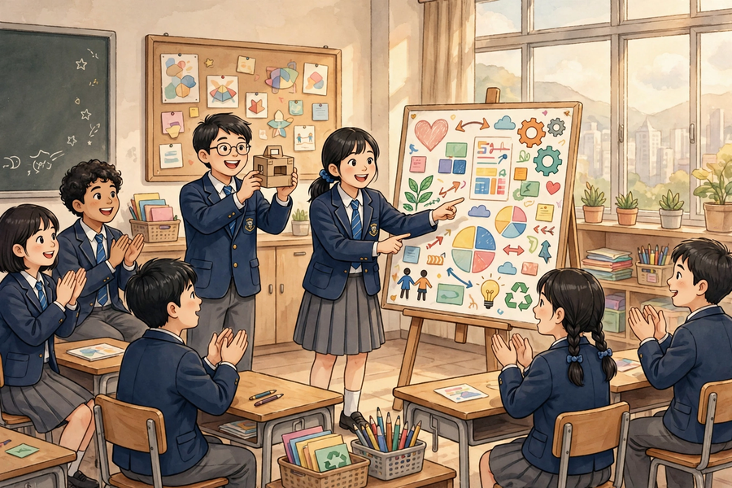
三、例子
3. Examples
例 1：例一（展示講稿開場示例）：「大家好，我們是第 3 組。我們關心的對象是清晨工作的清潔工。他們在光線不足的街道上工作，容易被途人忽視，有一定危險。我們的問題是：如何能讓清晨工作的清潔工更容易被途人看見？」——30 秒內講完對象、需要、問題定義。
Example 1: Example 1 (sample presentation opening): ‘Hello everyone, we are Group 3. Our caring target is cleaners working in the early morning. They work on poorly lit streets and are easily overlooked by passers-by, which is dangerous. Our question is: How might we make cleaners working in the early morning more visible to passers-by?’ – target, need and problem definition covered in 30 seconds.
例 2：例二（互評表填寫示例）：第 2 組——關愛對象與需要是否明確：4 分；實物原型是否配合需要、製作認真：5 分；AI 生成部分是否配合主題：4 分；介紹是否清晰、有條理：4 分；整體創意：5 分。具體讚賞：「他們的反光牌支架用了三角形結構，很穩固，而且海報的標題字很大，遠處也看得見。」
Example 2: Example 2 (sample peer-evaluation entry): Group 2 – Is the caring target and need clear: 4; Does the physical prototype address the need / carefully made: 5; Does the AI-generated part match the theme: 4; Is the presentation clear and well organised: 4; Overall creativity: 5. Specific compliment: ‘Their sign stand uses a triangular structure and is very stable, and the poster title is so large it can be read from far away.’
四、課堂小練習
4. Class Practice
與鄰座同學討論後作答，稍後全班一起核對。
Discuss with your neighbour, then check answers with the class.
1. 以下哪一句是「具體讚賞」？
Which of the following is a ‘specific compliment’?
A「很好」；B「他們的海報用了暖色調和簡短文字，很配合清晨清潔工的主題」；C「很漂亮」；D「不錯」。
A ‘very good’; B ‘Their poster uses warm tones and short text, which suits the early-morning cleaners’ theme’; C ‘very pretty’; D ‘not bad’.
＿＿＿＿＿＿＿＿＿＿＿＿＿＿＿＿＿＿＿＿＿＿＿＿＿＿＿＿＿＿＿＿＿＿
＿＿＿＿＿＿＿＿＿＿＿＿＿＿＿＿＿＿＿＿＿＿＿＿＿＿＿＿＿＿＿＿＿＿
2. 三分鐘展示的「1＋1＋1」結構是怎樣的？
What is the ‘1+1+1’ structure of the three-minute presentation?
＿＿＿＿＿＿＿＿＿＿＿＿＿＿＿＿＿＿＿＿＿＿＿＿＿＿＿＿＿＿＿＿＿＿
＿＿＿＿＿＿＿＿＿＿＿＿＿＿＿＿＿＿＿＿＿＿＿＿＿＿＿＿＿＿＿＿＿＿
3. 互評時可以評自己組別嗎？為什麼？
May you score your own group in peer evaluation? Why?
＿＿＿＿＿＿＿＿＿＿＿＿＿＿＿＿＿＿＿＿＿＿＿＿＿＿＿＿＿＿＿＿＿＿
＿＿＿＿＿＿＿＿＿＿＿＿＿＿＿＿＿＿＿＿＿＿＿＿＿＿＿＿＿＿＿＿＿＿
五、思考題
5. Thinking Questions
先獨立思考，再與小組分享你的看法。
Think on your own first, then share your views with your group.
1. 互評分數只作參考、最終獎項由教師綜合決定，你認為這樣公平嗎？為什麼？
Peer scores are only advisory and the teacher decides the final awards overall. Do you think this is fair? Why?
＿＿＿＿＿＿＿＿＿＿＿＿＿＿＿＿＿＿＿＿＿＿＿＿＿＿＿＿＿＿＿＿＿＿
＿＿＿＿＿＿＿＿＿＿＿＿＿＿＿＿＿＿＿＿＿＿＿＿＿＿＿＿＿＿＿＿＿＿
＿＿＿＿＿＿＿＿＿＿＿＿＿＿＿＿＿＿＿＿＿＿＿＿＿＿＿＿＿＿＿＿＿＿
2. 如果你是台下觀眾，怎樣做才是有禮貌、有幫助的觀眾？
As an audience member, how can you be a polite and helpful audience?
＿＿＿＿＿＿＿＿＿＿＿＿＿＿＿＿＿＿＿＿＿＿＿＿＿＿＿＿＿＿＿＿＿＿
＿＿＿＿＿＿＿＿＿＿＿＿＿＿＿＿＿＿＿＿＿＿＿＿＿＿＿＿＿＿＿＿＿＿
＿＿＿＿＿＿＿＿＿＿＿＿＿＿＿＿＿＿＿＿＿＿＿＿＿＿＿＿＿＿＿＿＿＿
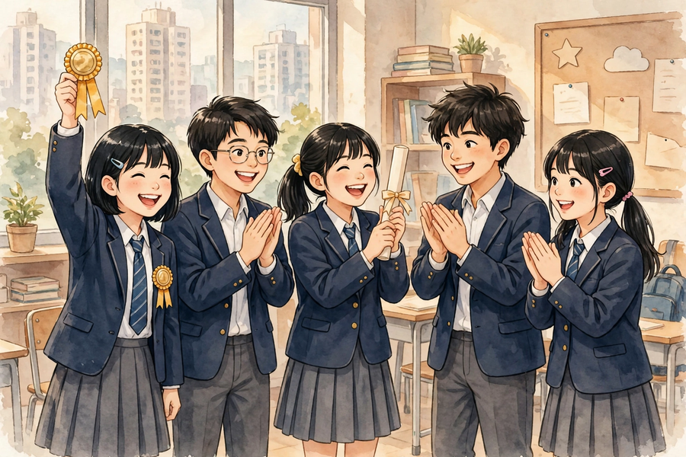
六、分組活動
6. Group Activity
步驟 1：按抽籤次序上台展示（3 分鐘＋1 分鐘問答）：用「1＋1＋1」結構介紹關愛對象、真實需要、實物設計、AI 生成部分與分工。
Step 1: Present on stage in drawn order (3 minutes + 1 minute Q&A): introduce the caring target, real need, physical design, AI-generated part and task allocation using the ‘1+1+1’ structure.
步驟 2：台下即時完成互評表：為至少三組評分（不評自己組別，每項 1–5 分），並為每組寫出一句具體讚賞。
Step 2: Complete the peer-evaluation form in real time: score at least three groups (not your own, 1–5 per criterion) and write one specific compliment for each.
步驟 3：在反思紙上寫下：「我最欣賞的一組是＿＿＿＿，原因是＿＿＿＿。」
Step 3: On the reflection slip, write: ‘The group I admire most is ______, because ______.’
步驟 4：參與頒獎與正能量分享：每人用一句話分享本單元的正能量體會。
Step 4: Join the awards and positive-energy sharing: each person shares one positive-energy takeaway from the unit in one sentence.
七、總結
7. Summary
- 展示四要素：關愛對象、真實需要、實物設計、AI 生成部分；用「1＋1＋1」結構在三分鐘內講完。
The four presentation elements – caring target, real need, physical design, AI-generated part – delivered in three minutes with the ‘1+1+1’ structure.
- 互評五項（每項 1–5 分），不評自己組別；評分看準則、不只給朋友高分；分數只作參考。
Five peer-evaluation criteria (1–5 each); do not score your own group; score against the criteria, not friendships; scores are advisory.
- 每評一組寫一句具體讚賞：指出作品特點＋好在哪裡；空泛的「很好」不算數。
Write one specific compliment per group: name a feature + say what is good about it; vague ‘very good’ does not count.
- 五堂專題歷程：定題 → 設計 → 動手做（一）→ 動手做（二）→ 成果展；正能量不只是一句標語，而是課堂中真實發生的互相肯定。
The five-lesson journey: topic setting → design → making I → making II → showcase; positive energy is not just a slogan but real mutual appreciation happening in class.
八、小測驗
8. Mini Quiz
獨立完成，檢視本課的學習成果。
Complete independently to review what you have learnt.
1. 三分鐘展示必須包括以下哪四要素？
Which four elements must the three-minute presentation include?
A. 關愛對象、真實需要、實物設計、AI 生成部分
Caring target, real need, physical design, AI-generated part
B. 組員名單、日期、地點、天氣
Member list, date, venue, weather
C. 成本、利潤、廣告、銷量
Cost, profit, advertising, sales
D. 老師姓名、課室編號、堂數、功課
Teacher’s name, room number, lesson count, homework
2. 「1＋1＋1」結構中，第 2 分鐘講什麼？
In the ‘1+1+1’ structure, what is covered in minute 2?
A. 關愛對象與真實需要
Caring target and real need
B. 實物設計
Physical design
C. AI 生成部分與分工
AI-generated part and task allocation
D. 得獎感受
Acceptance speech
3. 互評時，以下哪種做法正確？
Which of the following is correct practice in peer evaluation?
A. 只給朋友高分
Give high marks only to friends
B. 按作品準則評分，不評自己組別，並寫出具體讚賞
Score against the criteria, not your own group, and write specific compliments
C. 全部給 1 分
Give 1 mark to everyone
D. 不寫評語
Write no comments
4. 請寫出互評表的五項評分項目。
Write down the five criteria of the peer-evaluation form.
＿＿＿＿＿＿＿＿＿＿＿＿＿＿＿＿＿＿＿＿＿＿＿＿＿＿＿＿＿＿＿＿＿＿
＿＿＿＿＿＿＿＿＿＿＿＿＿＿＿＿＿＿＿＿＿＿＿＿＿＿＿＿＿＿＿＿＿＿
＿＿＿＿＿＿＿＿＿＿＿＿＿＿＿＿＿＿＿＿＿＿＿＿＿＿＿＿＿＿＿＿＿＿
5. 請把以下空泛評語改寫成具體讚賞：「他們的作品很好。」
Rewrite the following vague remark into a specific compliment: ‘Their work is very good.’
＿＿＿＿＿＿＿＿＿＿＿＿＿＿＿＿＿＿＿＿＿＿＿＿＿＿＿＿＿＿＿＿＿＿
＿＿＿＿＿＿＿＿＿＿＿＿＿＿＿＿＿＿＿＿＿＿＿＿＿＿＿＿＿＿＿＿＿＿
＿＿＿＿＿＿＿＿＿＿＿＿＿＿＿＿＿＿＿＿＿＿＿＿＿＿＿＿＿＿＿＿＿＿

