聖公會呂明才中學
S.K.H. Lui Ming Choi Secondary School
創科班 Little Makers Class
第 21 堂 Lesson 21
社區實測：探訪／訪問
Community Fieldwork: Visit and Interview
學生筆記 Student Notes

課堂目標｜Lesson Objectives
- 能按照預先設計的問卷，向用家提出至少五條提問。
Ask users at least five questions following the pre-designed questionnaire.
- 能以文字記錄，準確記下用家回應的重點。
Record the key points of users’ responses accurately in written notes.
- 能從訪談內容中，整理出至少三項針對現有設計的具體回饋。
Extract at least three specific pieces of feedback on the existing design from the interview.

理論內容｜Key Concepts

一、什麼是實地調研｜1. What Is Fieldwork
實地調研是指離開課室，親身到用家生活的真實場景收集資料。本單元的調研對象是真正用家（長者中心長者／校內工友），目的是找出他們使用產品時的真實困難，讓設計改良有根有據，而不是憑空想像。
Fieldwork means leaving the classroom to collect information in users’ real-life settings. In this unit we interview genuine users (elderly people at an elderly centre / school workers) to uncover the real difficulties they face, so that design improvements are evidence-based rather than imagined.
實地調研四個步驟：
The four steps of fieldwork:
- 準備：設計問卷、分派角色（提問員、記錄員）、預約時間地點。
Prepare: design the questionnaire, assign roles (interviewer, note-taker), arrange time and venue.
- 訪問：按問卷提問，並就值得深入之處追問；同時觀察用家的生活情境。
Interview: ask the questionnaire questions, probe further where worthwhile, and observe the user’s everyday context.
- 整理：即日把記錄謄寫清楚，標出重點。
Organise: transcribe the notes clearly on the same day and highlight key points.
- 歸納：把用家原話轉化為具體、可執行的設計回饋。
Summarise: turn users’ words into specific, actionable design feedback.

二、問卷設計三原則｜2. Three Principles of Questionnaire Design
- 以開放式問題為主：讓用家用自己的話回答，例如「你遇到最大的困難是什麼？」；避免只答「是／否」的封閉式問題。
Use mainly open-ended questions so users answer in their own words, e.g. “What is the biggest difficulty you face?” Avoid closed yes/no questions.
- 不問引導式問題：不要把答案暗示給用家。錯誤示範：「你是不是覺得按鈕太小？」正確做法：「你使用按鈕時有什麼感覺？」
Ask no leading questions: never hint at the answer. Wrong: “Don’t you think the buttons are too small?” Right: “How do the buttons feel when you use them?”
- 由淺入深、數量適中：先問簡單的日常問題建立關係，再問產品相關問題；全份問卷五至六條，十五分鐘內完成。
Go from easy to deep, and keep it short: start with simple daily-life questions to build rapport, then move to product questions; five to six questions in total, finished within fifteen minutes.

三、追問技巧｜3. Probing Techniques
當用家的回答值得深入時，用以下句式追問：
When an answer deserves follow-up, probe with these prompts:
- 「可以舉一個具體的例子嗎？」——把抽象感受變成具體事件。
“Could you give a specific example?” — turns vague feelings into concrete events.
- 「這件事通常在什麼情況下出現？」——找出發生的情境。
“In what situations does this usually happen?” — identifies the context.
- 「這件事對你造成多大的不便？」——判斷問題的迫切程度。
“How much inconvenience does this cause you?” — judges how urgent the problem is.

四、分辨客套說話與真實意見｜4. Polite Remarks vs Genuine Opinions
長者或工友有時會出於客氣而讚美（「這個不錯」「幾好呀」）。判斷準則：只有附帶具體事例或困難描述的回應，才是有用的設計依據。聽到讚美時，必須追問「什麼時候」「有多困難」，把客套話挖成真意見。
Elderly users or workers sometimes praise out of politeness (“this is quite good”). Rule of thumb: only responses with concrete examples or descriptions of difficulties count as useful design evidence. When you hear praise, always probe with “when” and “how difficult” to dig beneath the politeness.


例子｜Examples

範例問卷（把橫線填上你的產品名稱）｜Sample Questionnaire (fill in your product name)
- 請問你在使用＿＿＿＿時，遇到最大的困難是什麼？
What is the biggest difficulty you face when using ____?
- 這個困難通常在什麼情況下出現？
In what situations does this difficulty usually arise?
- 你現在用什麼方法應付這個困難？
How do you cope with this difficulty at present?
- 你覺得我們的設計有什麼地方需要改善？
What do you think needs improving in our design?
- 如果只能改善一個地方，你最希望是哪一個？為什麼？
If only one thing could be improved, which would you choose, and why?

追問示範：好與壞｜Probing: Good vs Poor
情境  Situation | 差的追問  Poor probe | 好的追問  Good probe
用家說：「按鈕有啲細。」  User: “The buttons are a bit small.” | 「咁你係咪成日按錯？」（引導式）  “So you often press the wrong one?” (leading) | 「可以舉個例子嗎？上次按錯係幾時？」  “Could you give an example? When did you last press the wrong one?”
用家說：「幾好呀。」（客套）  User: “It’s quite good.” (polite) | 「多謝！」（就此打住）  “Thank you!” (stops there) | 「多謝！如果要你揀一個最想改善嘅地方，會係邊一個？」  “Thanks! If you had to pick one thing to improve, which would it be?”

「原話 → 重點摘要」示範｜Turning Quotes into Key Points
用家原話  User’s words | 重點摘要  Key points | 改良方向  Improvement direction
「按鈕太小，我成日按錯，試過按到隔籬個掣。」  “The buttons are too small; I often press the wrong one.” | 按鈕尺寸太小，長者容易誤觸。  Buttons too small; elderly users mis-press. | 加大按鈕並加強觸感回饋。  Enlarge buttons; add tactile feedback.
「我成日唔記得食藥，試過一日食咗兩次。」  “I often forget my pills; once I took them twice in a day.” | 忘記服藥時間，有重複服藥風險。  Forgets medication times; risk of double dosing. | 加入日期轉盤，每格標示早／午／晚。  Add a date dial marked morning/noon/evening.
「個盒太重，我隻手冇力，拎唔穩。」  “The box is too heavy; my hands are weak and I can’t hold it steady.” | 產品過重，長者手力不足難以拿穩。  Too heavy for elderly users with weak grip. | 改用輕身物料並加防滑手柄。  Use lighter materials; add a non-slip handle.

簡單問答題｜Quick Questions
- 為什麼訪問產品問題之前，要先問一些日常問題？
Why ask some daily-life questions before product questions?
- 什麼是引導式問題？請舉一個例子。
What is a leading question? Give one example.
- 用家說「幾好呀」時，你應該怎樣做？為什麼？
When a user says “it’s quite good”, what should you do, and why?
- 一次訪問應控制在多長時間內？為什麼？
How long should one interview last? Why?

思考題｜Thinking Questions
- 如果受訪長者聽不清楚你的問題，你可以怎樣調整訪問方式？（提示：聲量、語速、用詞、示範）
If an elderly interviewee cannot hear your questions clearly, how could you adjust your approach? (Hint: volume, speed, wording, demonstration)
- 有組員認為「用家讚好就代表設計成功」，你同意嗎？試用本課的判斷準則反駁或支持。
A groupmate claims “user praise means the design is a success”. Do you agree? Argue for or against using this lesson’s criteria.
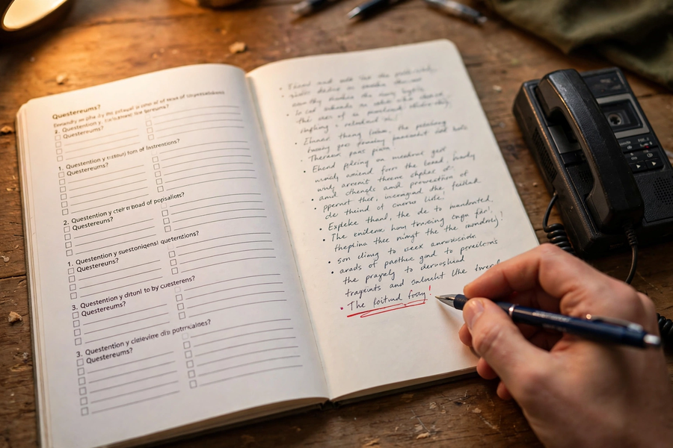

分組活動｜Group Tasks

任務一：角色分配｜Task 1: Role Assignment
- 每組 4–5 人，分派：提問員 1 名、記錄員 1–2 名（即場填寫三欄記錄表：提問／用家回應／重點摘要）、觀察員 1 名（留意用家表情、動作及生活情境）。
In groups of 4–5, assign: 1 interviewer, 1–2 note-takers (complete the 3-column record sheet on the spot: question / user’s response / key points), 1 observer (watching expressions, gestures and living context).
- 把範例問卷的橫線填上你們小組的產品名稱，綵排一次。
Fill in your group’s product name on the sample questionnaire and rehearse once.

任務二：訪問演練｜Task 2: Interview Rehearsal
- 兩人一組，一人扮演長者用家，一人扮演提問員，用五條問卷題目做一次模擬訪問；扮演用家者須至少給一次「客套讚美」，考驗對方追問。
In pairs, role-play: one plays an elderly user, the other the interviewer, running the five questionnaire questions. The “user” must give at least one piece of polite praise to test the interviewer’s probing.
- 完成後互換角色，並互相評分：有沒有問引導式問題？有沒有追問客套話？
Swap roles afterwards and assess each other: any leading questions? Any probing of polite remarks?

總結｜Summary
- 實地調研四步：準備 → 訪問 → 整理 → 歸納；目標是取得真實、具體、可執行的用家回饋。
Fieldwork in four steps: prepare → interview → organise → summarise; the goal is genuine, specific, actionable user feedback.
- 問卷三原則：開放式為主、不問引導式問題、由淺入深五至六條。
Questionnaire principles: mainly open-ended, no leading questions, easy-to-deep, five to six questions.
- 追問三句式：「舉個例子」「什麼情況下」「造成多大不便」。
Three probing prompts: “give an example”, “in what situations”, “how much inconvenience”.
- 只有附帶具體事例的回應，才是可靠的設計依據；第 22 堂將用這些回饋做迭代設計。
Only responses with concrete examples are reliable design evidence; Lesson 22 will use this feedback for iterative design.

小測驗｜Mini Quiz
一、選擇題（每題選一個最佳答案）
Section A: Multiple choice (choose the best answer)
- 以下哪一條是引導式問題？
A. 你使用這個產品時有什麼困難？
B. 你是不是覺得這個產品太重？
C. 你通常在什麼情況下使用它？
D. 你現在用什麼方法應付這個困難？
Which of the following is a leading question?
A. What difficulties do you face when using this product?
B. Don’t you think this product is too heavy?
C. In what situations do you usually use it?
D. How do you cope with this difficulty at present?
- 用家說「幾好呀」時，最恰當的做法是：
A. 記錄為正面回饋，訪問下一題
B. 即場向用家解釋設計意念
C. 追問：「如果只能改善一個地方，你最希望是哪一個？」
D. 結束訪問以節省時間
When a user says “it’s quite good”, the best response is:
A. Record it as positive feedback and move on
B. Explain the design idea on the spot
C. Probe: “If only one thing could be improved, which would you choose?”
D. End the interview to save time
- 訪問記錄表建議分為哪三欄？
A. 提問／用家回應／重點摘要
B. 姓名／年齡／聯絡電話
C. 產品名稱／價錢／購買地點
D. 日期／天氣／訪問地點
The interview record sheet is best divided into which three columns?
A. Question / user’s response / key points
B. Name / age / phone number
C. Product name / price / where bought
D. Date / weather / venue
本堂物資表 Materials List
以下為本堂分組活動所需物資（每組一份）。請在老師派發時核對。
品名 Item | 數量（每組） Quantity (per group) | 安全注意 Safety notes
問卷及記錄表（影印） Questionnaire and record sheets (photocopied) | 每組 6 份 6 copies per group | —
文件夾（可重用） Folder (reusable) | 每組 1 個 1 per group | —
感謝卡 Thank-you cards | 每位受訪者 1 張 1 per interviewee | —
原子筆 Ball pens | 每組 2 枝 2 per group | —
- 一次訪問應控制在多長時間內？
A. 五分鐘內
B. 越長越好
C. 一小時內
D. 十五分鐘內
One interview should be kept within:
A. 5 minutes
B. The longer the better
C. 1 hour
D. 15 minutes

