聖公會呂明才中學
S.K.H. Lui Ming Choi Secondary School
創科班 Little Makers Class
第 22 堂 Lesson 22
進階設計：迭代改良
Advanced Design: Iteration
學生筆記 Student Notes
本堂物資表 Materials List
以下為本堂分組活動所需物資（每組一份）。請在老師派發時核對。
品名 Item | 數量（每組） Quantity (per group) | 安全注意 Safety notes
A3 設計圖紙 A3 drawing paper | 每組 3 張 3 sheets per group | —
鉛筆、擦膠、直尺 Pencils, erasers, rulers | 每組 1 套 1 set per group | —
顏色筆 Colour pens | 每組 1 盒（共用） 1 box per group (shared) | —
製作計劃表及對照表（影印） Production plan and mapping tables (photocopied) | 每組 2 份 2 copies per group | —

課堂目標｜Lesson Objectives
- 能指出原設計中至少兩處需要修改之處，並說明每處修改所依據的用家回饋。
Identify at least two aspects of the original design needing revision, citing the user feedback behind each.
- 能繪出修改後的設計圖，包括正視圖或側視圖、尺寸標註及物料註明。
Draw the revised design with front or side views, dimensions and material specifications.
- 能列出製作工序表，包含至少四個步驟，並清楚列明分工安排。
List a production procedure table with at least four steps and a clear division of labour.

理論內容｜Key Concepts

一、迭代設計｜1. Iterative Design
迭代設計是指「收集回饋 → 修改設計 → 再測試」的循環，而不是一次過定案。真實產品很少一次成功：每次循環都令設計更貼近用家需要。本單元的循環是：第 21 堂收集回饋 → 第 22 堂修改設計 → 第 23–24 堂製作及測試 → 第 25 堂展示再收集意見。
Iterative design is the cycle “gather feedback → revise design → test again”, not a one-shot decision. Real products rarely succeed first time: each cycle brings the design closer to users’ needs. Our cycle: Lesson 21 gathers feedback → Lesson 22 revises the design → Lessons 23–24 build and test → Lesson 25 showcases and gathers more views.

二、決定採納哪些回饋：影響 × 迫切矩陣｜2. Which Feedback to Adopt: Impact × Urgency Matrix
回饋太多不能全做時，用兩個維度排序，先做「高影響＋高迫切」：
When there is too much feedback to act on, rank it on two dimensions and start with “high impact + high urgency”:
 | 迫切（不用會出事／很不方便）  Urgent | 不迫切  Not urgent
影響大  （很多人／核心功能）  High impact | 優先做：例如按鈕太小致誤觸  Do first: e.g. buttons too small causing mis-presses | 排第二：例如外觀顏色不夠吸引  Do second: e.g. colours not attractive enough
影響小  Low impact | 排第三：例如說明書字體稍小  Do third: e.g. manual print slightly small | 可不做／留待日後：例如包裝花紋  Skip / defer: e.g. packaging pattern

- 不採納的回饋也要記錄理由（例如超出成本、技術做不到），在簡介時能向用家交代。
Record reasons for feedback not adopted (e.g. over budget, technically unfeasible) so you can explain to users at the showcase.

三、「回饋 → 改動」對照表｜3. The “Feedback → Change” Mapping Table
動筆改圖之前，先填好對照表，確保每處修改都有用家回饋作依據，避免「為改而改」。表格三欄：
Before redrawing, complete the mapping table so every change is backed by user feedback — no change for change’s sake. Three columns:
- 用家回饋原話：抄下用家的原話（加引號）。
User’s feedback (original words): quote the user, in quotation marks.
- 對應的設計改動：寫出具體改動，連數字（尺寸、數量）。
Corresponding design change: state the concrete change with numbers (sizes, quantities).
- 預期效果：改動後用家會有什麼改善。
Expected effect: how the change helps the user.

四、設計圖規範｜4. Design Drawing Standards
- 視圖：正視圖或側視圖至少一種，線條用直尺繪畫。
Views: at least a front or side view, drawn with a ruler.
- 尺寸：全部標註，單位為厘米（cm）。
Dimensions: mark all of them, in centimetres (cm).
- 物料：每部分註明物料（如瓦楞紙板、雪條棒）。
Materials: label each part (e.g. corrugated cardboard, ice-cream sticks).
- 改動標示：所有改動之處以紅筆圈出並編號，編號對應對照表。
Change marks: circle every change in red and number it, matching the mapping table.

五、製作計劃四要素｜5. Four Elements of a Production Plan
- 工序：按先後列出至少四個步驟（如量度 → 切割 → 黏合 → 加固）。
Procedures: list at least four steps in order (e.g. measure → cut → glue → reinforce).
- 所需物料：每步列出物料及數量。
Materials needed: list materials and quantities per step.
- 負責人：每步寫明由哪位組員負責。
Person in charge: name who does each step.
- 預計時間：每步預計用時，總和不超過兩堂（120 分鐘）。
Estimated time: time per step; total within two lessons (120 minutes).
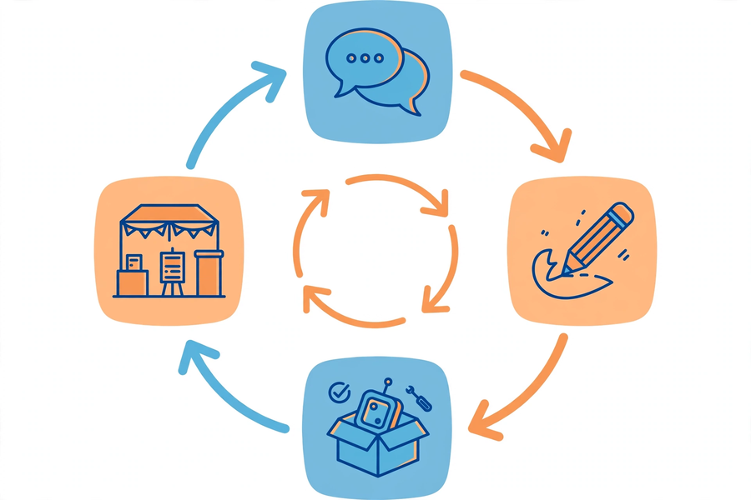

例子｜Examples

「回饋 → 改動」對照表示例｜Sample Mapping Table
編號  No. | 用家回饋原話  User’s feedback | 對應的設計改動  Design change | 預期效果  Expected effect
1  1 | 「按鈕太小，我成日按錯。」  “The buttons are too small; I often press the wrong one.” | 按鈕直徑由 1 厘米加大至 3 厘米，改用高對比顏色。  Button diameter from 1 cm to 3 cm; high-contrast colours. | 長者能準確按下，減少誤觸。  Elderly users press accurately; fewer mis-presses.
2  2 | 「我成日唔記得食藥。」  “I often forget to take my medicine.” | 加入可轉動日期轉盤，每格標示「早／午／晚」。  Add a rotatable date dial marked “morning / noon / evening”. | 用家一眼看到當餐是否已服藥。  Users see at a glance whether a dose was taken.
3  3 | 「個轉盤太緊，我擰唔郁。」  “The dial is too stiff; I can’t turn it.” | 轉盤加裝直徑 4 厘米手柄，改用較鬆的軸心。  Add a 4 cm handle to the dial; use a looser axle. | 手力較弱的長者也能單手轉動。  Elderly users with weak grip can turn it one-handed.

製作計劃表示例｜Sample Production Plan
工序  Procedure | 所需物料  Materials | 負責人  Person in charge | 預計時間  Time
1. 量度並在紙板上標記各部件尺寸  1. Measure and mark part sizes on cardboard | 瓦楞紙板 2 塊、鉛筆、直尺  2 cardboard boards, pencil, ruler | 組員 A  Member A | 20 分鐘  20 min
2. 切割部件（紙板、雪條棒）  2. Cut parts (cardboard, sticks) | 剪刀、美工刀、切割墊  Scissors, craft knife, cutting mat | 組員 B  Member B | 25 分鐘  25 min
3. 黏合組裝主體結構  3. Glue and assemble the main structure | 熱熔膠槍、膠棒 3 枝  Hot glue gun, 3 glue sticks | 組員 C  Member C | 30 分鐘  30 min
4. 安裝轉盤及按鈕，加固結構  4. Fit the dial and buttons; reinforce | 雪條棒 1 包、雙面膠紙  1 pack of sticks, double-sided tape | 組員 A＋D  Members A & D | 25 分鐘  25 min
5. 對照設計圖檢查，修正瑕疵  5. Check against the drawing; fix flaws | 設計圖、顏色筆  Drawing, colour pens | 全組  Whole group | 20 分鐘  20 min

簡單問答題｜Quick Questions
- 什麼是迭代設計？請寫出它的三個步驟。
What is iterative design? State its three steps.
- 為什麼要先填好「回饋 → 改動」對照表，才開始修改設計圖？
Why complete the “feedback → change” table before redrawing the design?
- 用家嫌按鈕太小，有組員建議「加個發聲功能」代替加大按鈕。這做法有什麼問題？
A user finds buttons too small; a groupmate suggests adding sound effects instead of enlarging them. What is wrong with this?
- 製作計劃為什麼要寫明每步的負責人？
Why must the production plan name the person in charge of each step?

思考題｜Thinking Questions
- 兩位用家意見矛盾：一位嫌轉盤太鬆容易移位，一位嫌太緊擰不動。你會怎樣取捨？請用「影響 × 迫切」矩陣說明。
Two users disagree: one finds the dial too loose, another too stiff. How would you decide? Explain with the impact × urgency matrix.
- 有組員想把產品「加多三個功能」令它看來更厲害。試從用家角度反駁這個想法。
A groupmate wants to add three more features to make the product look impressive. Argue against this from the user’s perspective.
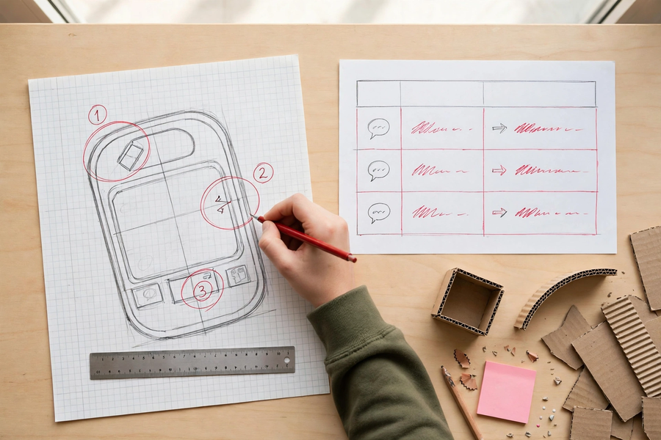

分組活動｜Group Tasks

任務一：填寫對照表｜Task 1: Complete the Mapping Table
- 攤開第 21 堂的「用家回饋摘要」，全組用矩陣排出優先次序，選出至少兩項要採納的回饋。
Spread out the Lesson 21 “user feedback summary”; rank items with the matrix and choose at least two to adopt.
- 填寫「回饋 → 改動」對照表：每項改動必須有具體數字（尺寸、數量）。
Complete the mapping table: every change must carry concrete numbers (sizes, quantities).

任務二：修改設計圖｜Task 2: Revise the Drawing
- 在 A3 圖紙上重繪正視圖／側視圖，標齊尺寸（cm）及物料；所有改動以紅筆圈出並編號。
Redraw the front/side view on A3 paper with all dimensions (cm) and materials; circle every change in red and number it.

任務三：一分鐘簡介綵排｜Task 3: Rehearse the One-Minute Briefing
- 每組派代表用一分鐘簡介：改了哪兩處？依據哪句用家原話？其他組員計時並給意見。
One representative briefs in one minute: which two changes, based on which user quotes? Others time it and give comments.

總結｜Summary
- 迭代＝收集回饋 → 修改設計 → 再測試；每處修改都要有回饋依據。
Iteration = gather feedback → revise → retest; every change needs feedback behind it.
- 用「影響 × 迫切」矩陣決定先做哪項回饋；不採納的也要記錄理由。
Use the impact × urgency matrix to prioritise; record reasons for anything not adopted.
- 設計圖：視圖＋尺寸（cm）＋物料＋紅筆圈改動並編號。
Drawing: views + dimensions (cm) + materials + red-circled numbered changes.
- 製作計劃四要素：工序（≥4 步）＋物料＋負責人＋預計時間（兩堂內完成）。
Plan needs: procedures (≥4 steps) + materials + persons in charge + time (within two lessons).

小測驗｜Mini Quiz
選擇題（每題選一個最佳答案）
Multiple choice (choose the best answer)
- 迭代設計的正確循環是：
A. 設計 → 製作 → 展示
B. 訪問 → 頒獎 → 總結
C. 收集回饋 → 修改設計 → 再測試
D. 繪圖 → 影印 → 存檔
The correct iterative design cycle is:
A. Design → make → showcase
B. Interview → awards → round-up
C. Gather feedback → revise design → test again
D. Draw → photocopy → file away
- 有四項回饋，應優先處理：
A. 影響大＋迫切
B. 影響小＋不迫切
C. 影響小＋迫切
D. 全部同時進行
With four feedback items, prioritise:
A. High impact + urgent
B. Low impact + not urgent
C. Low impact + urgent
D. Do everything at once
- 用家嫌按鈕太小，最恰當的改動是：
A. 加上發聲功能
B. 把按鈕由 1 厘米加大至 3 厘米
C. 把產品改成紅色
D. 加印說明書
A user finds buttons too small. The best change is:
A. Add sound effects
B. Enlarge buttons from 1 cm to 3 cm
C. Repaint the product red
D. Print a thicker manual
- 修改後的設計圖必須包括：
A. 只需美觀的彩圖
B. 只需列出價錢
C. 只需立體圖
D. 視圖、尺寸（cm）、物料註明及紅筆標示改動
A revised design drawing must include:
A. Only a pretty coloured picture
B. Only the price list
C. Only a 3D sketch
D. Views, dimensions (cm), materials and red-marked changes

