聖公會呂明才中學
S.K.H. Lui Ming Choi Secondary School
創科班 Little Makers Class
第 22 堂 Lesson 22
進階設計：迭代改良
Advanced Design: Iteration
教師筆記 Teacher Notes
本堂物資表 Materials List（教師版）
請預早一星期準備所需物資；標示「課室現有」之項目請預先清點。
品名 Item | 數量（每組） Quantity (per group) | 大約成本 Est. cost | 安全注意 Safety notes
A3 設計圖紙 A3 drawing paper | 每組 3 張 3 sheets per group | 約 HK$9 approx. HK$9 | —
鉛筆、擦膠、直尺 Pencils, erasers, rulers | 每組 1 套 1 set per group | 約 HK$12 approx. HK$12 | —
顏色筆 Colour pens | 每組 1 盒（共用） 1 box per group (shared) | 約 HK$15 approx. HK$15 | —
製作計劃表及對照表（影印） Production plan and mapping tables (photocopied) | 每組 2 份 2 copies per group | 約 HK$4 approx. HK$4 | —
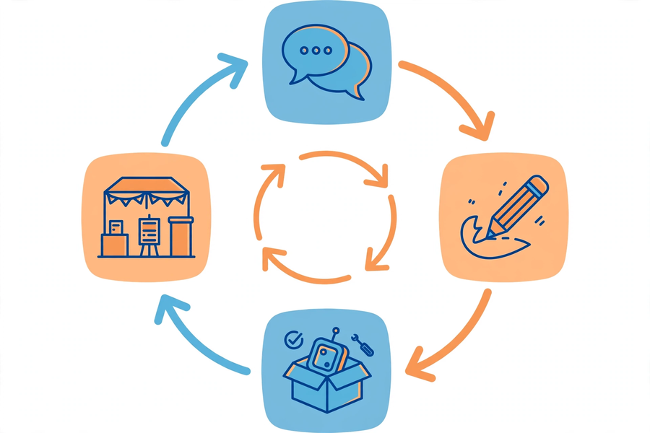

課堂流程撮要｜Lesson Flow Recap
時間  Time | 環節  Stage | 教師重點  Teacher focus
0–10 分鐘  0–10 min | 重溫回饋  Review feedback | 帶領重溫各組回饋摘要，點出常見類型。  Review summaries; highlight common types.
10–25 分鐘  10–25 min | 分析回饋  Analyse feedback | 巡視討論，以提問引導取捨。  Supervise; guide trade-offs with questions.
25–45 分鐘  25–45 min | 修改設計圖  Revise drawing | 指導尺寸標註及視圖畫法。  Guide dimensioning and views.
45–55 分鐘  45–55 min | 訂立製作計劃  Production plan | 派發範本，說明填寫要求。  Distribute template; explain requirements.
55–60 分鐘  55–60 min | 簡介及總結  Briefings & round-up | 主持一分鐘簡介，點評是否扣緊回饋。  Chair briefings; check alignment with feedback.

建議教導方向｜Suggested Teaching Approach
- 硬性規定「先填表、後繪圖」：未交對照表的小組不獲發 A3 圖紙，確保修改有據。
Enforce “table before drawing”: no A3 paper until the mapping table is done, so changes stay evidence-based.
- 巡視時重點抽查紅筆圈改動是否與對照表編號一致，即場糾正「改圖與回饋脫節」。
When supervising, check that red-circled numbers match the table; correct “drawing divorced from feedback” on the spot.
- 一分鐘簡介時追問：「如果用家問你點解唔做第 X 項回饋，你點答？」訓練學生交代取捨。
During briefings ask: “If the user asks why item X wasn’t done, what would you say?” — trains trade-off reasoning.

學生筆記答案｜Answers to Student Notes

簡單問答題答案｜Quick Questions — Answers
- 迭代設計是「收集回饋 → 修改設計 → 再測試」的循環。
Iterative design is the cycle “gather feedback → revise → retest”.
- 確保每處修改都有用家回饋作依據，防止「為改而改」或憑感覺亂改。
It guarantees every change is backed by user feedback, preventing change for change’s sake or random tweaks.
- 問題：沒有回應用家最迫切的需要（按鈕太小），反而堆砌功能；發聲功能不能解決誤觸，屬「加功能代替解痛點」。
It ignores the pressing need (buttons too small) and piles on features; sound does not fix mis-presses — features instead of pain relief.
- 明確責任，避免工作無人認領或重複；出問題時知道找誰跟進。
Clear responsibility avoids orphaned or duplicated work; you know whom to follow up with when problems arise.

思考題參考答案｜Thinking Questions — Reference Answers
- 先追問兩人使用情境：可能一人手大一人手小，或一人單手操作一人雙手。若屬情境差異，考慮可調校設計（如兩檔鬆緊）；若必須二選一，用矩陣判斷哪邊影響大＋迫切，並記錄取捨理由。
Probe both contexts first: different hand sizes or one- vs two-handed use may explain the clash. If so, consider adjustable design (e.g. two tension settings); if a choice is forced, use the matrix and record the rationale.
- 反駁：每加一個功能都增加學習成本、故障點和製作時間；長者要的是「簡單可靠」，不是「厲害」；應把時間花在驗證現有功能是否真正解決痛點。
Counter: each feature adds learning cost, failure points and build time; elderly users want “simple and reliable”, not “impressive”; spend the time verifying existing features truly fix the pain.

小測驗答案｜Mini Quiz — Answers
- C
C
- A
A
- B
B
- D
D

家課答案｜Homework Answers

甲部：選擇題｜Section A: MC
- B
B
- B
B
- B
B
- C
C

乙部：問答題參考答案｜Section B: Reference Answers
- 對照表示例：回饋「個盒太重拎唔穩」→ 改動「改用 3mm 輕身瓦楞紙板，盒身加防滑手柄」→ 預期「長者單手可拿穩」。評分：原話具體、改動有數字、效果對應用家。
Sample: feedback “box too heavy to hold” → change “switch to 3 mm lightweight board; add non-slip handle” → effect “elderly can hold one-handed”. Award for specific quote, numbered change, user-centred effect.
- 驗證方法示例：請 3 位長者試按新舊按鈕各 10 次，記錄誤觸次數；若新按鈕誤觸率明顯下降，即驗證有效。關鍵：要有可量度的比較。
Sample verification: ask 3 elderly users to press old vs new buttons 10 times each; record mis-press counts. A clear drop verifies the change. Key: a measurable comparison.
- 排序示例：(1) 按鈕太小致誤觸（高影響高迫切）(2) 轉盤太緊（高影響中迫切）(3) 顏色不吸引（低影響）(4) 包裝花紋（可不做）。理由須用矩陣語言。
Sample ranking: (1) small buttons causing mis-presses (high/high) (2) stiff dial (high/medium) (3) dull colours (low impact) (4) packaging pattern (skip). Reasons must use matrix language.

附加思考題｜Additional Thinking Questions
- 如果製作時發現某項已採納的改動技術上做不到，你會怎樣處理？參考答案：先嘗試簡化版（如電動轉盤改手動大手柄）；若仍不可行，誠實記錄原因，找最接近的替代方案，並在成果展向用家交代，承諾下一版再試。切忌靜靜刪走不交代。
If an adopted change proves technically unfeasible during making, what would you do? Reference: try a simplified version first (e.g. manual large handle instead of motorised dial); if still impossible, record the reason honestly, find the closest alternative, explain to users at the showcase and promise to try again next version. Never delete it silently.
- 對照表上「預期效果」一欄有什麼用？參考答案：它是第 24 堂用家測試的驗收標準——測試時就驗證這一欄寫的是否成真；若不達標，就要在迭代改良環節再改。
What is the “expected effect” column for? Reference: it becomes the acceptance criterion for Lesson 24 user testing — test whether it comes true; if not, revise again in the improvement slot.

常見迷思｜Common Misconceptions
- 迷思：以「增加功能」代替「針對痛點」。應對：要求每處改動在對照表寫出所回應的用家原話，寫不出的改動一律刪除。
Adding features instead of addressing pain points. Counter: every change must quote the user feedback it answers; changes that cannot do so are deleted.
- 迷思：設計圖只求美觀，不標尺寸。應對：強調沒有尺寸就無法備料、無法製作；教師拒收無尺寸標註的設計圖。
Drawings for looks only, no dimensions. Counter: stress that without dimensions materials cannot be prepared; refuse drawings lacking dimensions.
- 迷思：工序表寫「全組一起做」。應對：要求每步必須有具名負責人，培養問責。
Writing “whole group does everything” in the plan. Counter: require a named person per step to build accountability.

