聖公會呂明才中學
S.K.H. Lui Ming Choi Secondary School
創科班 Little Makers Class
第 23 堂 Lesson 23
動手做（一）：實物原型
Hands-on Making I: Physical Prototype
家課 Homework

姓名：＿＿＿＿ 班別：＿＿＿＿ 學號：＿＿＿＿ 日期：＿＿＿＿
Name: ____ Class: ____ No.: ____ Date: ____
說明：完成甲、乙兩部，於第 24 堂與組員分享乙部第 1 題。
Instructions: complete Sections A and B; share B1 with groupmates in Lesson 24.
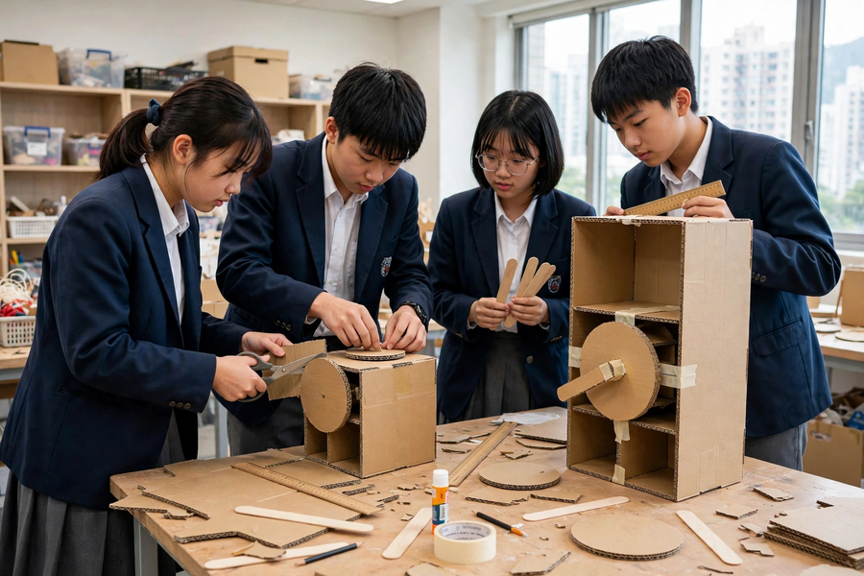

甲部：選擇題（每題 2 分，共 8 分）｜Section A: Multiple Choice (2 marks each; 8 marks)
- 黏合前先「試裝」的主要原因是：
A. 節省時間
B. 檢查尺寸位置是否正確，避免黏死後才發現錯誤
C. 讓膠水預熱
D. 符合課堂儀式
Dry-fitting before gluing mainly:
A. Saves time
B. Checks sizes/positions before they are fixed for good
C. Pre-heats the glue
D. Follows classroom ritual
- 紙板切割時邊緣毛糙，最可能的原因是：
A. 紙板太厚
B. 徒手切割，紙板移位
C. 剪刀太利
D. 燈光太暗
Rough cardboard cut edges are most likely caused by:
A. Board too thick
B. Freehand cutting with the board shifting
C. Scissors too sharp
D. Dim lighting
- 使用熱熔膠槍時，錯誤的做法是：
A. 用後放回支架待冷卻
B. 觸碰槍頭試溫度
C. 膠水適量塗抹
D. 未乾前用膠紙暫時固定
Wrong practice with a hot glue gun:
A. Resting it on the stand to cool
B. Touching the nozzle to test the temperature
C. Applying glue sparingly
D. Taping temporarily before it sets
- 結構搖晃時，最有效的處理是：
A. 加入三角支撐或加厚底座
B. 不斷添加膠水
C. 把產品靠牆擺放
D. 拆掉部分結構減重
For a wobbly structure, the most effective fix is:
A. Add triangular supports or thicken the base
B. Keep adding glue
C. Lean it against a wall
D. Remove parts to reduce weight

乙部：問答題（共 12 分）｜Section B: Structured Questions (12 marks)
- 請用「解難四步」記錄本堂遇到的一個製作問題：寫出問題（具體描述）、分析的原因、嘗試的方法及檢驗結果。（5 分）
Use the four problem-solving steps to log one making problem from this lesson: the problem (precise), its likely cause, the method tried and the verification result. (5 marks)
- 列出使用美工刀的三項安全守則，並解釋每項守則的原因。（4 分）
List three safety rules for craft-knife use and explain the reason for each. (4 marks)
- 你的原型底座需要承托整個盒身。請提出一個加固底座的方案，並說明理由。（3 分）
Your prototype’s base must carry the whole body. Propose one way to reinforce the base and justify it. (3 marks)
____________________________________________________________
____________________________________________________________
____________________________________________________________
____________________________________________________________
____________________________________________________________
____________________________________________________________
____________________________________________________________
____________________________________________________________
____________________________________________________________
____________________________________________________________

