聖公會呂明才中學
S.K.H. Lui Ming Choi Secondary School
創科班 Little Makers Class
第 23 堂 Lesson 23
動手做（一）：實物原型
Hands-on Making I: Physical Prototype
學生筆記 Student Notes
本堂物資表 Materials List
以下為本堂分組活動所需物資（每組一份）。請在老師派發時核對。
品名 Item | 數量（每組） Quantity (per group) | 安全注意 Safety notes
瓦楞紙板 Corrugated cardboard | 每組 4 塊 4 boards per group | 邊緣或較鋒利，拿取時小心 Edges may be sharp; handle with care
熱熔膠槍及膠棒 Hot glue gun and glue sticks | 每組 1 把槍（學校借用）＋ 5 枝棒 1 gun per group (borrowed from school) + 5 sticks | 槍頭高溫，切勿觸碰；用後放回支架 Nozzle is very hot — never touch; rest on stand after use
剪刀 Scissors | 每組 2 把 2 per group | 刀鋒向外，切勿指向他人 Blades facing outward, never towards others
美工刀 Craft knife | 每組 1 把 1 per group | 教師統一派發及收回；在切割墊上使用 Distributed and collected by teacher; use on a cutting mat
雙面膠紙 Double-sided tape | 每組 1 卷 1 roll per group | —
雪條棒 Ice-cream sticks | 每組 1 包 1 pack per group | 如有尖端須先剪去 Trim any pointed ends first
彩紙及裝飾物料 Coloured paper and decorations | 每組 1 份 1 set per group | —

課堂目標｜Lesson Objectives
- 能按照工序表，完成原型的主要結構（完成度達七成或以上）。
Complete the main structure of the prototype (at least 70% complete) following the procedure table.
- 在遇到製作問題時，能提出至少一個解決方案並動手嘗試。
When problems arise, propose at least one solution and try it out.
- 能正確及安全地使用剪刀、美工刀及熱熔膠槍等基本手工工具。
Use basic hand tools — scissors, craft knives and hot glue guns — correctly and safely.

理論內容｜Key Concepts

一、製作五步｜1. Five Making Steps
- 量度並標記：按設計圖尺寸，用直尺和鉛筆在物料上標記；摺合位預留約 0.5 厘米摺邊。
Measure and mark: transfer the drawing’s dimensions onto materials with ruler and pencil; allow about 0.5 cm for folds.
- 切割部件：剪刀剪直線，美工刀切厚紙板；切割時用直尺壓住邊緣，慢慢切。
Cut parts: scissors for straight cuts, craft knife for thick board; press a ruler along the edge and cut slowly.
- 黏合組裝：先試裝（不塗膠水拼一次），確認吻合才上膠水；膠水適量，塗後壓實。
Glue and assemble: dry-fit first (assemble without glue), then apply glue sparingly and press firmly.
- 加固結構：檢查搖晃或受力位，加入三角支撐或加厚底座。
Reinforce: check wobbly or load-bearing joints; add triangular supports or thicken the base.
- 對照驗收：把成品放在設計圖旁邊逐項核對，修正瑕疵。
Check against the drawing: place the product beside the drawing, verify item by item, fix flaws.

二、物料特性｜2. Material Properties
- 瓦楞紙板：順紋方向易彎曲，橫紋方向較硬挺；承重要用橫紋，彎曲造型用順紋。邊緣或較鋒利，拿取小心。
Corrugated cardboard: bends easily along the flutes, stiffer across them; use across-flute for load-bearing, along-flute for curves. Edges may be sharp — handle with care.
- 雪條棒：硬身適合做支架、轉軸；如有尖端先剪去。
Ice-cream sticks: rigid, good for frames and axles; trim any pointed ends first.
- 熱熔膠：擠出後約一分鐘定型；膠水宜少不宜多，溢出反而削弱接合兼影響外觀。未乾前可用膠紙暫時固定位置。
Hot glue: sets in about a minute; use sparingly — overflow weakens joints and spoils appearance. Hold parts temporarily with tape before it sets.
- 雙面膠紙：適合輕身部件的臨時定位，或輔助熱熔膠固定。
Double-sided tape: good for temporarily positioning light parts or assisting hot glue.

三、解難四步｜3. Four Problem-Solving Steps
- 發現問題：具體說出問題（例：「轉盤裝上後擰不動」，而非「整唔到」）。
Identify: state the problem precisely (e.g. “the dial won’t turn after fitting”, not “it doesn’t work”).
- 分析原因：提出可能成因（例：軸心太緊？部件變形？膠水黏住？）。
Analyse: suggest possible causes (axle too tight? part warped? glue seeped in?).
- 試行方案：每次只改一個變量去試（例：先把軸心鑽大 1 毫米）。
Try: change one variable at a time (e.g. widen the axle hole by 1 mm first).
- 檢驗效果：試用並記錄結果；有效就固定做法，無效就回到第二步。
Verify: test and record the result; keep what works, otherwise return to step 2.

四、工具安全守則｜4. Tool Safety Rules
- 美工刀：只由教師指定的組員使用；在切割墊上切割，手指遠離刀鋒；用後立即交還教師。
Craft knife: for the designated member only; cut on a cutting mat, fingers away from the blade; return to the teacher immediately after use.
- 熱熔膠槍：槍頭高溫，切勿觸碰；用後放回支架待冷卻；不使用時關電源。
Hot glue gun: the nozzle is very hot — never touch; rest it on its stand to cool; switch off when not in use.
- 剪刀：刀鋒向外，切勿指向他人；傳遞時握住刀鋒、把手柄遞給對方。
Scissors: blades facing outward, never towards others; pass by holding the blades and offering the handles.
- 受傷處理：立即通知教師，切勿自行包紮了事。
If injured: inform the teacher immediately; do not just bandage it yourself.
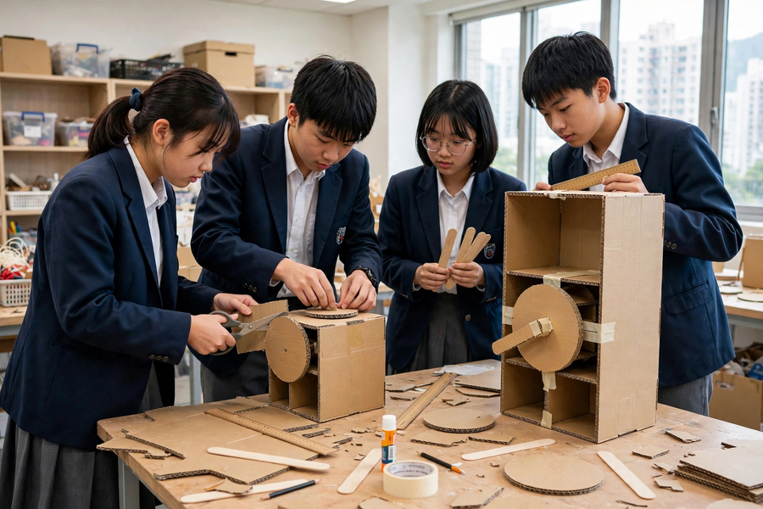

例子｜Examples

常見製作問題對策表｜Common Problems and Fixes
問題  Problem | 可能原因  Likely cause | 對策  Fix
黏合不牢，一碰就散  Joints come apart easily | 膠水太少或未壓實  Too little glue or not pressed firmly | 改用熱熔膠，塗膠後壓實一分鐘，並以膠紙輔助定位  Switch to hot glue; press firmly for a minute; assist with tape
紙板切割邊緣毛糙  Rough cardboard cut edges | 徒手切割，紙板移位  Cut freehand; board shifted | 用直尺壓住邊緣，沿尺慢慢切割  Press a ruler along the edge; cut slowly along it
結構搖晃不穩  Structure wobbles | 接合位太少或底座太輕  Too few joints or base too light | 加入三角支撐，或加厚／加重底座  Add triangular supports; thicken or weight the base
膠水溢出影響外觀  Glue overflow spoils appearance | 一次擠太多膠  Too much glue at once | 膠量減半，分兩次上膠；溢出趁未乾即抹  Halve the amount; apply in two goes; wipe overflow before it sets
部件尺寸不合，裝不上  Parts don’t fit | 量度誤差或沒預留摺邊  Measuring error or no fold allowance | 重做該部件，記得預留 0.5 厘米摺邊；先試裝後上膠  Remake the part with 0.5 cm fold allowance; dry-fit before gluing

試裝的重要性｜Why Dry-Fit
試裝是指正式上膠水之前，先把部件拼合一次，檢查尺寸和位置是否正確。例子：製作藥盒轉盤時，先把轉盤放進盒身試轉，確認轉動順暢才上膠水固定軸心。若跳過試裝，黏死後才發現轉不動，就要整件重做。
Dry-fitting means assembling parts once without glue to check sizes and positions. Example: when making a pill-box dial, place the dial in the body and test the rotation before gluing the axle. Skip this and discover it won’t turn after gluing, and the whole part must be remade.

簡單問答題｜Quick Questions
- 為什麼切割紙板時要用直尺壓住邊緣？
Why press a ruler along the edge when cutting cardboard?
- 熱熔膠未乾時，應該怎樣固定部件？
How should parts be held while hot glue is still wet?
- 結構搖晃不穩時，有哪兩個加固方法？
Name two ways to reinforce a wobbly structure.
- 發現問題時，第一步應該做什麼？請舉例說明「具體說出問題」。
What is the first step when a problem appears? Give an example of stating a problem precisely.

思考題｜Thinking Questions
- 你的原型上，哪一個接合位最脆弱？如果只能用現有物料加強，你會怎樣做？
Which joint on your prototype is the weakest? How would you strengthen it using only the materials at hand?
- 有組員為求快而跳過「試裝」直接上膠水。請預測可能出現的兩個後果，並說服他。
A groupmate skips dry-fitting to save time and glues straight away. Predict two possible consequences and persuade them otherwise.
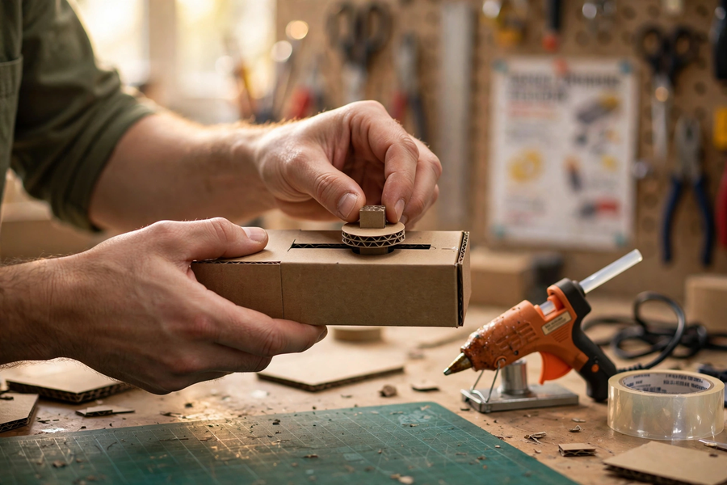

分組活動｜Group Tasks

任務一：分工確認｜Task 1: Confirm Task Allocation
- 攤開第 22 堂的製作計劃表，確認每步負責人；領取工具及物料，填寫「分工確認卡」。
Open the Lesson 22 production plan; confirm who does each step; collect tools and materials; complete the “task confirmation card”.

任務二：分工製作｜Task 2: Build
- 按工序表製作；遇到問題先在組內用「解難四步」商議，記錄在「問題解決記錄表」（問題／嘗試的方法／結果／學到的教訓）。
Build per the procedure table; when stuck, discuss within the group using the four problem-solving steps and log it in the “problem-solving record sheet” (problem / method tried / result / lesson learnt).

任務三：進度檢查｜Task 3: Progress Check
- 對照工序表自評：已完成幾步？主要結構完成度有幾成？把未完成部分寫進下堂計劃。
Self-assess against the procedure table: how many steps done? What percentage of the main structure is complete? Write unfinished parts into next lesson’s plan.

總結｜Summary
- 製作五步：量度 → 切割 → 黏合 → 加固 → 對照驗收；記得先試裝後上膠水。
Five steps: measure → cut → glue → reinforce → verify; dry-fit before gluing.
- 解難四步：發現（具體說出）→ 分析 → 試行（每次改一個變量）→ 檢驗。
Problem-solving: identify (precisely) → analyse → try (one variable at a time) → verify.
- 安全鐵律：美工刀指定人員＋切割墊＋即收回；膠槍頭不觸碰；剪刀刀鋒向外。
Safety: craft knife for designated user + cutting mat + immediate return; never touch the glue-gun nozzle; scissor blades outward.
- 本堂目標：主要結構完成七成；未完成部分留待第 24 堂繼續。
Lesson goal: main structure 70% complete; unfinished parts continue in Lesson 24.

小測驗｜Mini Quiz
選擇題（每題選一個最佳答案）
Multiple choice (choose the best answer)
- 黏合前「試裝」的主要目的是：
A. 檢查尺寸和位置是否正確，避免黏死後才發現錯誤
B. 節省膠水
C. 讓組員休息
D. 拍照留念
The main purpose of dry-fitting before gluing is:
A. To check sizes and positions before they are fixed permanently
B. To save glue
C. To let members rest
D. To take photos
- 熱熔膠的正確用法是：
A. 擠越多越穩固
B. 直接用手按住槍頭加速冷卻
C. 適量塗抹，壓實約一分鐘，未乾前可用膠紙暫時固定
D. 塗在手指上試溫度
Correct use of hot glue:
A. The more the stronger
B. Press the nozzle with your hand to cool it faster
C. Apply sparingly, press for about a minute; tape temporarily before it sets
D. Dab it on your finger to test the temperature
- 結構搖晃不穩，最有效的加固方法是：
A. 不斷加膠水
B. 加入三角支撐或加厚底座
C. 把產品放在牆邊靠住
D. 減少部件數量
For a wobbly structure, the most effective reinforcement is:
A. Keep adding glue
B. Add triangular supports or thicken the base
C. Lean the product against a wall
D. Remove some parts
- 使用美工刀時，正確的做法是：
A. 任何組員都可隨意使用
B. 刀鋒指向自己較易控制
C. 徒手切割較快，不用切割墊
D. 只由指定組員在切割墊上使用，用後立即交還教師
When using a craft knife:
A. Any member may use it freely
B. Point the blade towards yourself for control
C. Freehand cutting is faster; skip the mat
D. Only the designated member uses it on a cutting mat; return it to the teacher immediately after

