聖公會呂明才中學
S.K.H. Lui Ming Choi Secondary School
創科班 Little Makers Class
第 23 堂 Lesson 23
動手做（一）：實物原型
Hands-on Making I: Physical Prototype
教師筆記 Teacher Notes
本堂物資表 Materials List（教師版）
請預早一星期準備所需物資；標示「課室現有」之項目請預先清點。
品名 Item | 數量（每組） Quantity (per group) | 大約成本 Est. cost | 安全注意 Safety notes
瓦楞紙板 Corrugated cardboard | 每組 4 塊 4 boards per group | 約 HK$12 approx. HK$12 | 邊緣或較鋒利，拿取時小心 Edges may be sharp; handle with care
熱熔膠槍及膠棒 Hot glue gun and glue sticks | 每組 1 把槍（學校借用）＋ 5 枝棒 1 gun per group (borrowed from school) + 5 sticks | 膠棒約 HK$10 sticks approx. HK$10 | 槍頭高溫，切勿觸碰；用後放回支架 Nozzle is very hot — never touch; rest on stand after use
剪刀 Scissors | 每組 2 把 2 per group | 約 HK$12 approx. HK$12 | 刀鋒向外，切勿指向他人 Blades facing outward, never towards others
美工刀 Craft knife | 每組 1 把 1 per group | 約 HK$8 approx. HK$8 | 教師統一派發及收回；在切割墊上使用 Distributed and collected by teacher; use on a cutting mat
雙面膠紙 Double-sided tape | 每組 1 卷 1 roll per group | 約 HK$8 approx. HK$8 | —
雪條棒 Ice-cream sticks | 每組 1 包 1 pack per group | 約 HK$10 approx. HK$10 | 如有尖端須先剪去 Trim any pointed ends first
彩紙及裝飾物料 Coloured paper and decorations | 每組 1 份 1 set per group | 約 HK$10 approx. HK$10 | —
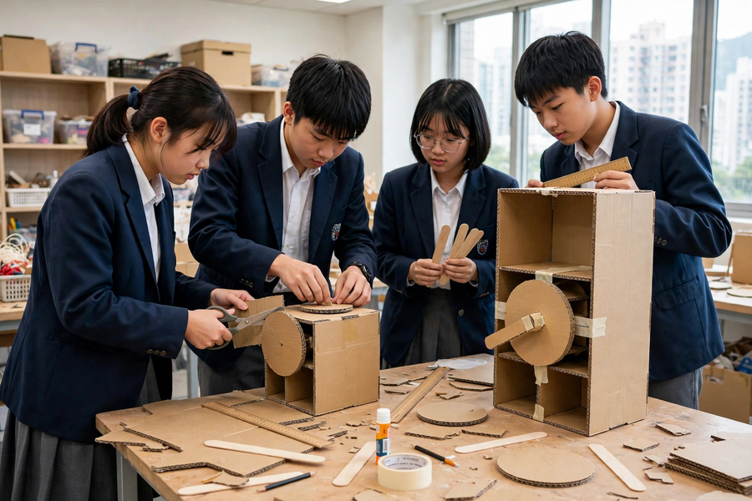

課堂流程撮要｜Lesson Flow Recap
時間  Time | 環節  Stage | 教師重點  Teacher focus
0–5 分鐘  0–5 min | 安全講解  Safety briefing | 示範三種工具的安全用法。  Demo safe use of the three tools.
5–10 分鐘  5–10 min | 確認分工  Confirm roles | 協助各組確認分工及本堂目標。  Help groups confirm roles and goals.
10–45 分鐘  10–45 min | 分工製作  Group making | 巡視；以提問引導解難，不直接給答案。  Supervise; guide with questions, not answers.
45–55 分鐘  45–55 min | 進度檢查  Progress check | 帶領對照工序表檢查進度。  Check progress against the table.
55–60 分鐘  55–60 min | 收拾及預告  Tidy & preview | 監督收拾；預告第 24 堂 AI＋用家測試。  Supervise tidy-up; preview L24 AI + testing.

建議教導方向｜Suggested Teaching Approach
- 美工刀實行「一組一把、即派即收」：課初點名派發指定學生，課尾逐把點收；遺失即全班停工尋回，立下規矩。
One craft knife per group, issued and collected by name: issue to designated students at the start, count every knife back at the end; if one is missing, all work stops until found.
- 學生求助時先反問：「你覺得問題出在哪裡？」「除了這個方法，還可以怎樣試？」迫他們走完解難四步，教師只在安全或僵持超過五分鐘時介入。
When students ask for help, first ask back: “Where do you think the problem is?” “What else could you try?” Force them through the four steps; intervene only for safety or deadlocks over five minutes.
- 中段（約 30 分鐘）叫停全班 2 分鐘，每組用一句話報告「最大進展＋最大困難」，讓各組互相借鏡解法。
Halfway (~30 min), pause the class for 2 minutes: each group reports in one sentence its “biggest progress + biggest difficulty” so groups borrow fixes from each other.

學生筆記答案｜Answers to Student Notes

簡單問答題答案｜Quick Questions — Answers
- 防止紙板在切割時移位，確保切線筆直，邊緣平滑；同時保護手指。
Prevents the board shifting so cuts are straight and edges smooth; also protects fingers.
- 用膠紙暫時固定位置，待膠水冷卻定型後再除去；切勿用手長時間按住槍頭附近。
Hold temporarily with tape until the glue sets; never press near the nozzle with your hand.
- 加入三角支撐；加厚或加重底座。
Add triangular supports; thicken or weight the base.
- 第一步是「發現問題」，要具體說出問題，例如「轉盤裝上後擰不動」而不是「整唔到」，具體描述才能對症分析。
First step: identify — state precisely, e.g. “the dial won’t turn after fitting” rather than “it doesn’t work”; only precise descriptions allow targeted analysis.

思考題參考答案｜Thinking Questions — Reference Answers
- 先找出受力最大的接合位（通常是底座與主體的連接處）。加強法：加三角支撐、用雪條棒做骨架、雙層紙板加厚。評分看是否針對受力點而非盲目加料。
Find the most-loaded joint (usually base-to-body). Strengthen with triangular supports, stick skeletons or double-layer board. Award for targeting load points, not blindly adding material.
- 後果一：尺寸不合被黏死，整件報廢重做，更浪費時間；後果二：位置偏了影響功能（如轉盤卡住）。說服點：試裝只需一分鐘，重做卻要半小時。
Consequence 1: mis-sized parts glued permanently — remake wastes more time. Consequence 2: misaligned parts impair function (e.g. jammed dial). Persuasion: dry-fitting takes one minute; remaking takes half an hour.

小測驗答案｜Mini Quiz — Answers
- A
A
- C
C
- B
B
- D
D

家課答案｜Homework Answers

甲部：選擇題｜Section A: MC
- B
B
- B
B
- B
B
- A
A

乙部：問答題參考答案｜Section B: Reference Answers
- 示例：問題「轉盤軸心太緊，轉不動」→ 分析「軸孔直徑比軸心小 1 毫米」→ 試行「把軸孔擴大 1 毫米」→ 檢驗「轉動順暢」。評分：四步齊備且具體。
Sample: problem “axle too tight, dial won’t turn” → analyse “hole 1 mm smaller than axle” → try “widen hole by 1 mm” → verify “turns smoothly”. Award for all four steps done concretely.
- 示例：美工刀只可由指定組員在切割墊上使用，手指遠離刀鋒，用後立即交還教師。另須提及熱熔膠槍頭不觸碰。
Sample: craft knife for the designated member only, on a cutting mat, fingers away, returned immediately after use. Must also mention never touching the glue-gun nozzle.
- 示例：底座加厚一層紙板並在四角加三角支撐；理由：底座承托整個盒身重量，四角最易變形。可用簡單草圖輔助說明。
Sample: add one more board layer to the base plus triangular supports at four corners; reason: the base carries the whole body and corners deform most easily. A simple sketch may support the answer.

附加思考題｜Additional Thinking Questions
- 如果第 24 堂要用這個原型做用家測試，現在這個半成品還缺少什麼才「測得到」？參考答案：至少要有可操作的核心功能（如可轉動的轉盤、可按的按鈕），外觀未完成不要緊；測試測的是功能是否解決痛點，不是美觀。
If this prototype must undergo user testing in Lesson 24, what is still missing for it to be testable? Reference: at minimum a working core function (a turnable dial, pressable buttons); unfinished looks don’t matter. Testing checks whether functions fix pain points, not appearance.
- 物料有限（每組只有四塊紙板），你會如何分配物料給「結構」和「外觀」？參考答案：結構優先，保證七成完成度；外觀用彩紙等輕身物料點綴；切下的邊角料先留起作加固之用，不要即棄。
Materials are limited (four boards per group). How would you split them between structure and appearance? Reference: structure first to secure 70% completion; decorate lightly with coloured paper; keep offcuts for reinforcement instead of discarding them.

常見迷思｜Common Misconceptions
- 迷思：「黏得越多膠水越穩固」。應對：示範適量上膠＋壓實一分鐘的接合，對比溢膠接合的強度；立下「膠水適量」規矩。
“More glue = stronger”. Counter: demo a sparing-glued, well-pressed joint vs an overflowed one; set the “glue sparingly” rule.
- 迷思：跳過試裝直接上膠。應對：要求每組在上膠前舉手示意，教師抽查試裝情況。
Skipping dry-fitting. Counter: require groups to signal before gluing so the teacher can spot-check dry-fits.
- 迷思：遇到問題即舉手等教師給答案。應對：教師一律先反問引導，培養解難習慣。
Raising hands for answers at the first snag. Counter: the teacher always questions back first, building problem-solving habits.

