聖公會呂明才中學
S.K.H. Lui Ming Choi Secondary School
創科班 Little Makers Class
第 24 堂 Lesson 24
動手做（二）：人工智能＋用家測試
Hands-on Making II: AI and User Testing
家課 Homework

姓名：＿＿＿＿ 班別：＿＿＿＿ 學號：＿＿＿＿ 日期：＿＿＿＿
Name: ____ Class: ____ No.: ____ Date: ____
說明：完成甲、乙兩部；乙部第 3 題 100–150 字，須於第 25 堂前交。
Instructions: complete Sections A and B; B3 (100–150 words) due before Lesson 25.
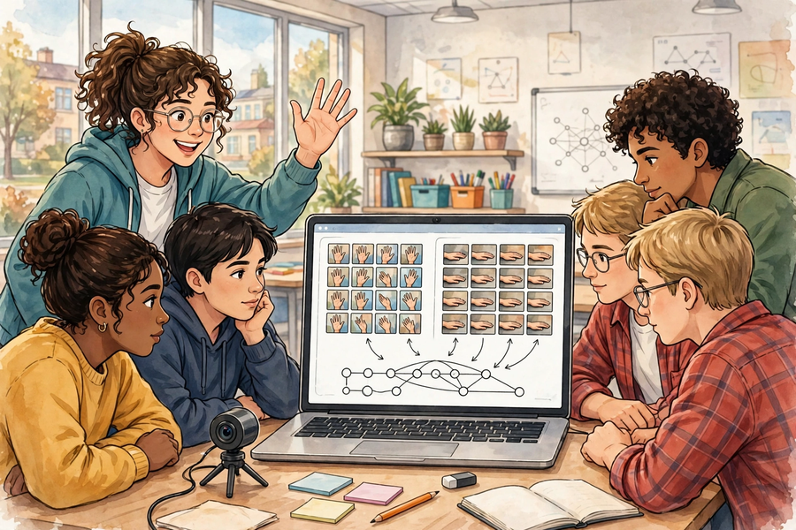

甲部：選擇題（每題 2 分，共 8 分）｜Section A: Multiple Choice (2 marks each; 8 marks)
- Teachable Machine「影像專案」的第一步是：
A. 直接按「訓練模型」
B. 開新專案並為類別命名
C. 上載樣本到社交平台
D. 刪除所有樣本
The first step of a Teachable Machine Image Project is:
A. Click “Train Model” straight away
B. Create a project and name the classes
C. Upload samples to social media
D. Delete all samples
- 每個類別收集樣本時，最重要的是：
A. 樣本數量剛好二十張
B. 樣本具多樣性（角度、光線、背景、人物有變化）
C. 全部由同一人拍攝
D. 全部在同一背景拍攝
When collecting samples per class, the most important thing is:
A. Exactly twenty samples
B. Diversity (varied angle, lighting, background, people)
C. All photographed by the same person
D. All against the same background
- 測試 10 次，答對 7 次，準確率是：
A. 70%
B. 30%
C. 17%
D. 107%
Ten tests, seven correct. The accuracy is:
A. 70%
B. 30%
C. 17%
D. 107%
- 小組共用裝置時，最恰當的安排是：
A. 由最懂電腦的組員全程操作
B. 分工為操作員、樣本收集員、記錄員、測試員，每十分鐘輪換
C. 輪流每人玩五分鐘手機
D. 把裝置放在一邊，先聊天
When sharing one device in a group, the best arrangement is:
A. The most computer-savvy member operates throughout
B. Roles of operator, sample collector, recorder and tester, rotating every ten minutes
C. Each person plays on their phone for five minutes in turn
D. Put the device aside and chat first

乙部：問答題（共 12 分）｜Section B: Structured Questions (12 marks)
- 你的小組測試 8 次，答對 5 次。請計算準確率，判斷是否達標（以 80% 為可用標準），並提出一項針對性的改良。（4 分）
Your group tested 8 times with 5 correct. Calculate the accuracy, judge whether it meets the bar (80% = usable), and propose one targeted improvement. (4 marks)
- 請提出兩項「增加樣本」以外的改良方法，並說明每項針對什麼測試證據。（4 分）
Propose two improvements other than “adding samples”, stating the test evidence each addresses. (4 marks)
- 反思（100–150 字）：人工智能部分最困難的步驟是什麼？你是如何解決的？（4 分）
Reflection (100–150 words): what was the most difficult step in the AI component, and how did you solve it? (4 marks)
____________________________________________________________
____________________________________________________________
____________________________________________________________
____________________________________________________________
____________________________________________________________
____________________________________________________________
____________________________________________________________
____________________________________________________________
____________________________________________________________
____________________________________________________________

