聖公會呂明才中學
S.K.H. Lui Ming Choi Secondary School
創科班 Little Makers Class
第 24 堂 Lesson 24
動手做（二）：人工智能＋用家測試
Hands-on Making II: AI and User Testing
學生筆記 Student Notes
本堂物資表 Materials List
以下為本堂分組活動所需物資（每組一份）。請在老師派發時核對。
品名 Item | 數量（每組） Quantity (per group) | 安全注意 Safety notes
共用裝置（平板電腦或手提電腦） Shared device (tablet or laptop) | 每組 1 部，輪流使用 1 per group, used in turn | 教師統一借出及收回；小心輕放 Issued and collected by teacher; handle with care
第 23 堂製成品 Prototype from Lesson 23 | 每組 1 件 1 per group | —
測試記錄表及工作紙（影印） Test record sheets and worksheets (photocopied) | 每組 2 份 2 copies per group | —

課堂目標｜Lesson Objectives
- 能在 Teachable Machine 上完成一個可運作的辨識模型，包含至少兩個類別，每個類別不少於二十個訓練樣本。
Build a working recognition model on Teachable Machine with at least two classes and ≥20 training samples per class.
- 能進行至少三次測試，並準確記錄每次的測試結果。
Conduct at least three tests and record each result accurately.
- 能按測試結果提出至少一項改良，並動手執行。
Propose at least one improvement based on test results and carry it out.

理論內容｜Key Concepts

一、人工智能影像辨識三要素｜1. Three Elements of AI Image Recognition
- 類別（Class）：你要模型分辨的種類，例如「揮手求助」和「手放下安好」。類別名稱要具體，一看就明。
Classes: the categories the model must tell apart, e.g. “waving for help” vs “hand down, all well”. Name them concretely.
- 訓練樣本（Training samples）：給模型學習的例子相片。每個類別至少二十張，越多樣越準。
Training samples: example photos for the model to learn from. At least twenty per class — the more varied, the more accurate.
- 準確率（Accuracy）：模型猜中的比率。公式：準確率＝答對次數 ÷ 測試總次數 × 100%。例如測試 10 次答對 8 次，準確率就是 80%。
Accuracy: the proportion the model gets right. Formula: accuracy = correct ÷ total tests × 100%. E.g. 8 correct out of 10 = 80%.

二、Teachable Machine 操作五步｜2. Teachable Machine in Five Steps
- 開啟網站（https://teachablemachine.withgoogle.com/），新增「影像專案」（Image Project）。
Open the site (https://teachablemachine.withgoogle.com/) and create a new “Image Project”.
- 為兩個類別命名（例如「揮手求助」「手放下」）。
Name the two classes (e.g. “waving for help”, “hand down”).
- 每類收集至少二十個樣本：變換角度、距離、光線及背景來拍攝。
Collect at least twenty samples per class, varying angle, distance, lighting and background.
- 按「訓練模型」（Train Model），等候訓練完成。
Click “Train Model” and wait for training to finish.
- 即時測試：做出手勢，看模型判斷是否正確，並記錄。
Test instantly: perform the gestures, check the model’s judgement, and record.

三、樣本多樣性：準確率的關鍵｜3. Sample Diversity: The Key to Accuracy
如果二十張樣本全在同一背景、同一角度拍攝，模型只學會了「認背景」，換個環境即失效，測試時的高準確率是「虛高」。正確做法：每類樣本要混合不同角度（正面／側面）、不同光線（光亮／陰暗）、不同背景、不同人物（組員輪流做手勢）。
If all twenty samples share one background and angle, the model only learns the background and fails elsewhere — the high test accuracy is inflated. Do it right: mix angles (front/side), lighting (bright/dim), backgrounds and people (members take turns gesturing) within each class.

四、分工與輪換（小組共用裝置）｜4. Roles and Rotation (Shared Devices)
4–5 人一組共用一部裝置，每十分鐘輪換一次，確保人人有操作機會：
Groups of 4–5 share one device, rotating every ten minutes so everyone gets hands-on time:
- 操作員：按步驟在 Teachable Machine 建立模型。
Operator: builds the model step by step in Teachable Machine.
- 樣本收集員：準備及拍攝訓練樣本（注意多樣性）。
Sample collector: prepares and photographs training samples (minding diversity).
- 記錄員：填寫工作紙及測試記錄表。
Recorder: completes the worksheet and test record sheet.
- 測試員：草擬測試計劃，測試時扮演用家操作。
Tester: drafts the test plan and role-plays the user during testing.
- 等候的組別：先準備訓練樣本及撰寫測試計劃，不呆等。
Waiting groups: prepare samples and write the test plan first — no idle waiting.

五、用家測試｜5. User Testing
模型完成後，同學互相扮演用家，按測試計劃試用至少三次：
After the model is built, classmates role-play as users and trial it at least three times per the test plan:
- 測試前寫好測試計劃：測什麼手勢、做幾次、怎樣算「正確」。
Write the test plan first: which gestures, how many trials, what counts as “correct”.
- 每次記錄：測試次數、輸入情況、模型判斷、是否正確、改良建議。
Record each trial: test no., input, model’s judgement, correct or not, suggested improvement.
- 測試後計算準確率，按結果即場改良（例如增加樣本、調整類別定義），再快速複測一次。
Calculate accuracy, improve on the spot (e.g. add samples, adjust class definitions), then re-test quickly.

六、數據私隱三守則｜6. Three Data-Privacy Rules
- 訓練樣本只拍攝手勢或物件，絕不拍攝任何人樣貌。
Training samples may show gestures or objects only — never anyone’s face.
- 課後立即刪除所有樣本相片。
Delete all sample photos immediately after class.
- 使用學校網絡須遵守資訊科技使用守則。
School network use must comply with the IT usage policy.
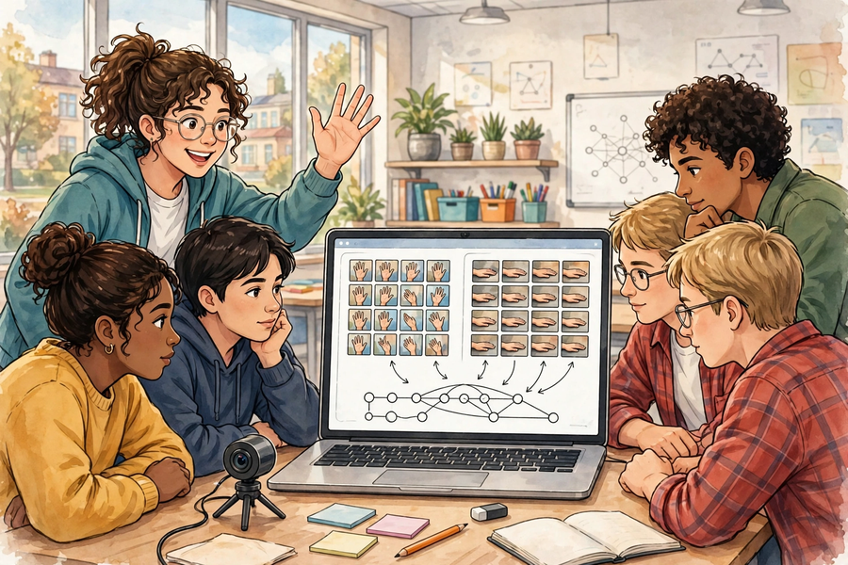

例子｜Examples

例子一：長者求助提示裝置｜Example 1: Elderly Help-Alert Device
- 類別一「揮手求助」：手舉起揮動的相片 25 張（正面 10、側面 8、陰暗光線 7）。
Class 1 “waving for help”: 25 photos of a raised waving hand (10 front, 8 side, 7 dim light).
- 類別二「手放下安好」：手自然放下的相片 25 張（不同背景 3 種）。
Class 2 “hand down, all well”: 25 photos of a lowered hand (3 different backgrounds).
- 用途：模型判斷為「揮手求助」時，觸發提示（響聲／亮燈），通知家人或職員。
Use: when the model judges “waving for help”, trigger an alert (sound/light) to notify family or staff.

例子二：用家測試記錄｜Example 2: User-Testing Record
測試次數  Test no. | 輸入情況  Input | 模型判斷  Model’s judgement | 是否正確  Correct? | 改良建議  Improvement
1  1 | 正面揮手，光線充足  Front wave, bright light | 揮手求助  Waving for help | ✓  ✓ | —  —
2  2 | 側面揮手，背景雜亂  Side wave, cluttered background | 手放下安好  Hand down, all well | ✘  ✘ | 增加側面＋雜亂背景樣本  Add side-angle, cluttered-background samples
3  3 | 手放下，光線陰暗  Hand down, dim light | 手放下安好  Hand down, all well | ✓  ✓ | —  —

三次測試答對兩次，準確率＝2 ÷ 3 × 100% ≈ 67%。改良：補拍 10 張側面揮手樣本後複測，準確率升至 100%。
Two correct out of three: accuracy = 2 ÷ 3 × 100% ≈ 67%. Improvement: add 10 side-wave samples; re-test accuracy rises to 100%.

簡單問答題｜Quick Questions
- 什麼是「類別」？請為你的小組產品舉出兩個類別名稱。
What is a “class”? Name two classes for your group’s product.
- 為什麼每個類別至少要二十個訓練樣本？
Why does each class need at least twenty training samples?
- 測試 5 次，答對 4 次，準確率是多少？請寫出計算過程。
Five tests, four correct: what is the accuracy? Show your working.
- 為什麼訓練樣本不能拍攝人臉？
Why must training samples never show faces?

思考題｜Thinking Questions
- 你的模型在課室測試準確率達 100%，但拿到走廊測試卻只有 50%。最可能的原因是什麼？你會怎樣改良？
Your model scores 100% in the classroom but only 50% in the corridor. What is the most likely cause, and how would you improve it?
- 除了影像辨識，你的小組產品還可以怎樣運用人工智能？（提示：聲音辨識）請舉一個具體例子。
Besides image recognition, how else could your product use AI? (Hint: sound recognition) Give one concrete example.
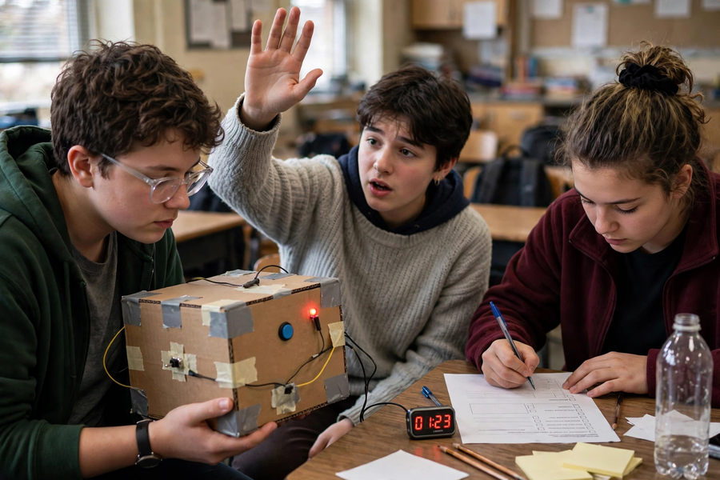

分組活動｜Group Tasks

任務一：建立模型（輪流操作）｜Task 1: Build the Model (Taking Turns)
- 按角色卡分工，每十分鐘輪換：操作員建模型、樣本收集員拍樣本、記錄員填工作紙、測試員寫測試計劃。
Work by role cards, rotating every ten minutes: operator builds, collector photographs, recorder writes, tester plans.
- 樣本檢查點：每類 ≥20 張；角度、光線、背景、人物四項至少各有兩種變化。
Sample checkpoint: ≥20 per class; at least two variations each of angle, lighting, background and person.

任務二：用家測試＋迭代改良｜Task 2: User Testing + Iteration
- 按測試計劃試用至少三次，填寫測試記錄表並計算準確率。
Trial at least three times per the plan; complete the record sheet and calculate accuracy.
- 按結果即場改良（加樣本／調類別），再快速複測一次，記錄前後準確率對比。
Improve on the spot (add samples / adjust classes), re-test quickly, and record the before/after accuracy.
- 課後：刪除所有樣本相片；簽署私隱承諾。
After class: delete all sample photos; sign the privacy pledge.

總結｜Summary
- 三要素：類別、訓練樣本（每類 ≥20）、準確率＝答對 ÷ 總次數 × 100%。
Three elements: classes, training samples (≥20 per class), accuracy = correct ÷ total × 100%.
- 樣本多樣性決定真實準確率：角度、光線、背景、人物都要變。
Diversity decides real accuracy: vary angle, lighting, background and people.
- 測試 ≥3 次 → 計算準確率 → 即場改良 → 複測；「訓練完成」不等於「產品完成」。
Test ≥3 times → calculate → improve on the spot → re-test. “Training done” ≠ “product done”.
- 私隱：只拍手勢／物件，不拍人臉，課後刪除。
Privacy: gestures/objects only, never faces; delete after class.

小測驗｜Mini Quiz
選擇題（每題選一個最佳答案）
Multiple choice (choose the best answer)
- 在 Teachable Machine 中，「類別」是指：
A. 學生的分組類別
B. 要模型分辨的種類，例如「揮手」和「手放下」
C. 相片的檔案大小分類
D. 電腦的型號分類
In Teachable Machine, a “class” is:
A. Students’ group categories
B. The kinds the model must tell apart, e.g. “waving” vs “hand down”
C. Photo file-size categories
D. Computer model categories
- 以下哪種樣本收集方法最恰當？
A. 混合不同角度、光線、背景及人物拍攝
B. 二十張全在同一白牆前、同一角度拍攝
C. 全部下載網上圖片，不用自己拍攝
D. 只拍攝一張，然後複製十九次
Which sampling method is best?
A. Mixed angles, lighting, backgrounds and people
B. All 20 against the same white wall, same angle
C. Download all images online instead of photographing
D. Photograph once and duplicate it nineteen times
- 測試 8 次，答對 6 次，準確率是：
A. 60%
B. 80%
C. 75%
D. 133%
Eight tests, six correct. The accuracy is:
A. 60%
B. 80%
C. 75%
D. 133%
- 關於數據私隱，正確的做法是：
A. 拍攝同學樣貌作訓練樣本，效果較好
B. 只拍攝手勢或物件，課後立即刪除所有樣本相片
C. 把樣本相片上載到社交平台分享
D. 保留樣本相片，方便下次使用
On data privacy, the correct practice is:
A. Photograph classmates’ faces as samples for better results
B. Photograph gestures/objects only; delete all samples after class
C. Upload sample photos to social media
D. Keep sample photos for next time

