聖公會呂明才中學
S.K.H. Lui Ming Choi Secondary School
創科班 Little Makers Class
第 24 堂 Lesson 24
動手做（二）：人工智能＋用家測試
Hands-on Making II: AI and User Testing
教師筆記 Teacher Notes
本堂物資表 Materials List（教師版）
請預早一星期準備所需物資；標示「課室現有」之項目請預先清點。
品名 Item | 數量（每組） Quantity (per group) | 大約成本 Est. cost | 安全注意 Safety notes
共用裝置（平板電腦或手提電腦） Shared device (tablet or laptop) | 每組 1 部，輪流使用 1 per group, used in turn | 學校借用（HK$0） Borrowed from school (HK$0) | 教師統一借出及收回；小心輕放 Issued and collected by teacher; handle with care
第 23 堂製成品 Prototype from Lesson 23 | 每組 1 件 1 per group | HK$0 | —
測試記錄表及工作紙（影印） Test record sheets and worksheets (photocopied) | 每組 2 份 2 copies per group | 約 HK$4 approx. HK$4 | —
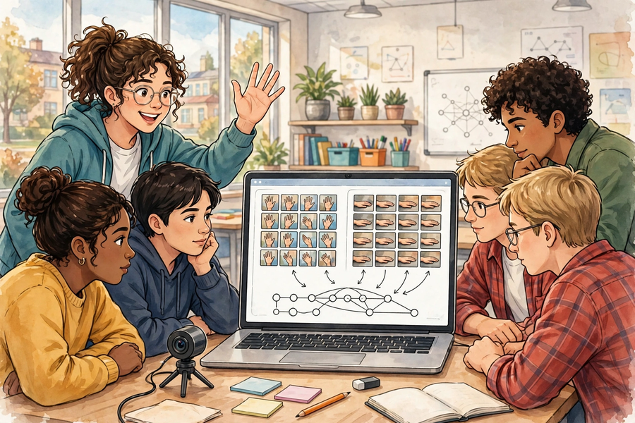

課堂流程撮要｜Lesson Flow Recap
時間  Time | 環節  Stage | 教師重點  Teacher focus
0–10 分鐘  0–10 min | 示範  Demonstration | 示範五步流程；重申只拍手勢／物件。  Demo the five steps; stress gestures/objects only.
10–35 分鐘  10–35 min | 製作 AI 模型  Build AI model | 派發管理裝置；指導樣本多樣性；管理輪換。  Manage devices; guide sample diversity; manage rotation.
35–50 分鐘  35–50 min | 用家測試  User testing | 指導按測試計劃試用及記錄。  Guide trials per plan and recording.
50–58 分鐘  50–58 min | 迭代改良  Iteration | 協助分析結果，以提問引導改良。  Help analyse; question-guide improvements.
58–60 分鐘  58–60 min | 總結  Round-up | 收回裝置；點評常見問題；預告成果展。  Collect devices; comment on issues; preview showcase.

建議教導方向｜Suggested Teaching Approach
- 示範時故意用「單一背景樣本」訓練一個反面教材模型，即場換背景測試讓學生親眼看到準確率崩潰，多樣性概念即刻入腦。
Demo a bad model trained on single-background samples, then test against a new background live — watching accuracy collapse teaches diversity instantly.
- 輪換用計時器嚴格執行：每 10 分鐘響鈴換人；教師手持「輪換表」點名，確保無人全程旁觀。
Enforce rotation strictly with a timer: bell every 10 minutes; keep a rotation checklist so nobody spectates the whole lesson.
- 改良環節要求每組先說出「數據證據」（哪幾次測試錯、錯在哪類），才准動手加樣本，防止盲目加相。
In the improvement slot, require each group to state the data evidence (which trials failed, in which class) before adding samples — no blind photo-adding.
- 課尾親自檢查每部裝置的相簿已清空，才准交還；把私隱守則變成可檢查的動作。
Before devices are returned, personally verify photo albums are empty — turn privacy into a checkable action.

學生筆記答案｜Answers to Student Notes

簡單問答題答案｜Quick Questions — Answers
- 類別是模型要分辨的種類；例如求助裝置的「揮手求助」和「手放下安好」；藥盒提示的「已服藥」和「未服藥」。
Classes are the kinds the model tells apart, e.g. “waving for help” vs “hand down, all well”; or “taken” vs “not taken” for a pill reminder.
- 樣本太少，模型學不到該類別的變化，容易把偶然特徵（如背景）當成判斷依據，導致過度擬合。
Too few samples and the model cannot learn the class’s variations; it latches onto accidental features (like the background) — overfitting.
- 準確率＝4 ÷ 5 × 100%＝80%。
Accuracy = 4 ÷ 5 × 100% = 80%.
- 拍攝人臉涉及個人私隱，且本課只需要手勢或物件作辨識；保護私隱是合乎道德使用 AI 的基本要求。
Faces involve personal privacy, and this lesson only needs gestures or objects; protecting privacy is fundamental to ethical AI use.

思考題參考答案｜Thinking Questions — Reference Answers
- 最可能原因：訓練樣本全在課室背景拍攝，模型學會認背景而非手勢（準確率虛高）。改良：補拍走廊背景、不同光線的樣本，每類加至少 10 張，再訓練及複測。
Most likely: all training samples were shot against the classroom background, so the model learnt the background, not the gesture (inflated accuracy). Fix: add corridor-background and varied-lighting samples, ≥10 per class, retrain and re-test.
- 示例：聲音辨識——訓練模型分辨「呼叫聲」和「環境雜音」，長者大叫「救命」時觸發提示；或分辨「跌倒撞擊聲」。注意同樣要收集多樣化聲音樣本。
Example: sound recognition — train a model to distinguish “calls for help” from ambient noise, triggering an alert; or detect fall-impact sounds. Diverse sound samples are equally needed.

小測驗答案｜Mini Quiz — Answers
- B
B
- A
A
- C
C
- B
B

家課答案｜Homework Answers

甲部：選擇題｜Section A: MC
- B
B
- B
B
- A
A
- B
B

乙部：問答題參考答案｜Section B: Reference Answers
- 計算：準確率＝5 ÷ 8 × 100%＝62.5%。判斷：未達標（一般要求 ≥80% 才算可用）。改良：檢查哪類別出錯較多，針對該類補拍多樣化樣本 10–15 張，再訓練及複測。
Accuracy = 5 ÷ 8 × 100% = 62.5%. Judgement: below par (usually ≥80% counts as usable). Improvement: find which class errs most, add 10–15 diverse samples to it, retrain and re-test.
- 兩項不同做法示例：(1) 樣本多樣性——原來只在白牆前拍攝，改為混合三種背景及兩種光線；(2) 類別定義——把容易混淆的「手舉起」和「揮手」合併或重新命名，減少模型混淆。須說明每項針對的測試證據。
Two distinct improvements, e.g. (1) diversity — from white-wall-only to three backgrounds and two lightings; (2) class definitions — merge/rename confusable “hand raised” vs “waving”. Each must cite the test evidence it addresses.
- 示例：測試員按計劃做出 3 種手勢各 2 次，記錄員即時填寫「輸入／判斷／是否正確」；發現側面手勢全錯 → 判定為樣本多樣性不足。關鍵：有計劃、有分工、有記錄。
Sample: the tester performs 3 gestures × 2 trials per the plan while the recorder logs “input / judgement / correct?” live; all side-gesture trials fail → diagnosed as insufficient sample diversity. Key: planned, role-based, recorded.

附加思考題｜Additional Thinking Questions
- 如果組內有組員堅持「樣本夠 20 張就行，唔使咁麻煩轉背景」，你會用什麼證據說服他？參考答案：用教師示範的反面教材數據（課室 100% → 走廊 50%）；或即場做對比實驗：同一模型測舊背景 vs 新背景，把數字攤出來。
If a groupmate insists “20 samples is enough, no need to bother with backgrounds”, what evidence would persuade them? Reference: the teacher’s bad-model demo data (100% classroom → 50% corridor); or run a live contrast test of old vs new backgrounds and show the numbers.
- Teachable Machine 的模型只認得它學過的東西。這對「關愛產品」有什麼啟示？參考答案：產品只能處理訓練範圍內的情況，推出前必須想清楚邊界（如只認得兩種手勢，第三種手勢會被誤判），並誠實告訴用家限制，而非誇大 AI 能力。
A Teachable Machine model only recognises what it was taught. What does this imply for a caring product? Reference: the product only handles its trained scope; before release, define its limits (a third gesture will be misclassified) and tell users honestly instead of overselling the AI.

常見迷思｜Common Misconceptions
- 迷思：單一背景收集樣本，測試準確率高就等於模型好。應對：硬性規定樣本檢查點（四項變化各 ≥2 種），教師抽查相簿。
Single-background samples with high test accuracy = good model. Counter: enforce the diversity checkpoint (≥2 variations of each of the four factors); spot-check albums.
- 迷思：「訓練完成等於產品完成」。應對：強調測試與迭代才是產品可靠的關鍵；把「複測準確率」列為評分項。
“Training done = product done”. Counter: stress that testing and iteration make products reliable; score the re-test accuracy.
- 迷思：樣本越多越好，盲目狂拍。應對：要求先分析錯誤集中在哪類，再針對性補拍；重質（多樣）不重量。
More samples always better — shoot blindly. Counter: require error analysis first, then targeted top-ups; diversity over volume.

