聖公會呂明才中學
S.K.H. Lui Ming Choi Secondary School
創科班 Little Makers Class
第 25 堂 Lesson 25
社區成果展
Community Showcase
學生筆記 Student Notes
本堂物資表 Materials List
以下為本堂分組活動所需物資（每組一份）。請在老師派發時核對。
品名 Item | 數量（每組） Quantity (per group) | 安全注意 Safety notes
互評表（A4，影印） Peer assessment forms (A4, photocopied) | 每人 1 張 1 per student | —
獎狀 Certificates | 每組 1 張 1 per group | —
展位名牌及枱布 Booth name cards and tablecloths | 每組 1 套 1 set per group | —
嘉賓感謝卡 Guest thank-you cards | 每位嘉賓 1 張 1 per guest | —
單元反思工作紙（影印） Unit reflection worksheets (photocopied) | 每人 1 張 1 per student | —

課堂目標｜Lesson Objectives
- 能以三分鐘口頭報告介紹作品，內容涵蓋設計意念、用家回饋及改良之處。
Present the product in a three-minute talk covering the design idea, user feedback and improvements.
- 能按互評表為至少兩個組別評分，並寫出具體評語。
Score at least two groups with the peer assessment form and write specific comments.
- 能說出本單元中最重要的一個學習得著。
State the single most important takeaway from this unit.

理論內容｜Key Concepts

一、三分鐘報告四部曲｜1. The Three-Minute Talk in Four Parts
部分  Part | 時間  Time | 內容  Content
1. 設計意念  1. Design idea | 約 40 秒  approx. 40 s | 我們為誰設計？解決什麼問題？  Who did we design for? What problem does it solve?
2. 用家回饋  2. User feedback | 約 40 秒  approx. 40 s | 用家說了什麼？引用一句原話。  What did users say? Quote one line.
3. 改良之處  3. Improvements | 約 50 秒  approx. 50 s | 我們改了什麼？為什麼這樣改？  What did we change, and why?
4. 實物示範  4. Live demo | 約 50 秒  approx. 50 s | 即場示範產品運作。  Demonstrate the product on the spot.

- 時間控制：中文每分鐘約講 160–180 字，三分鐘講稿約 500 字；分段綵排計時，超時刪例子、不刪結構。
Timing: about 160–180 Chinese characters per minute, so ~500 characters for three minutes; rehearse each part with a timer — cut examples, never structure, when overtime.

二、回應提問三步｜2. Handling Questions in Three Steps
- 複述：先重複／確認問題（「你的問題是……，對嗎？」），爭取思考時間。
Repeat: restate the question (“Your question is…, right?”) to buy thinking time.
- 簡答：直接回答核心，最多兩句。
Answer: address the core in at most two sentences.
- 舉例：用一個具體例子或數據支持。
Illustrate: back it with one concrete example or figure.
- 遇到不懂的問題，誠實說：「這個我們未試過，展示後我們會再試，多謝你的建議。」切忌亂編答案。
If you don’t know, be honest: “We haven’t tried that; we’ll test it after the showcase. Thank you for the suggestion.” Never invent answers.

三、互評方法｜3. Peer Assessment Method
- 四個評分準則（每項 1–5 分）：關愛切合度、創意、製作質素、表達清晰度。
Four criteria (1–5 each): care relevance, creativity, craftsmanship, presentation clarity.
- 不評自己組別；為至少兩個其他組別評分。
Do not score your own group; score at least two other groups.
- 每份互評表必須包括：具體評語＋一項改善建議。
Every form must include specific comments + one improvement suggestion.
- 評分只作參考，最終獎項由教師綜合互評結果決定。
Scores are for reference; the teacher decides final awards from the overall results.

四、具體評語 vs 空泛讚美｜4. Specific Comments vs Vague Praise
空泛讚美（避免）  Vague praise (avoid) | 具體評語（學習）  Specific comment (aim for)
「做得很好。」  “Well done.” | 「按鈕加大到 3 厘米後，長者用家能單手準確按下。」  “After enlarging buttons to 3 cm, elderly users press accurately one-handed.”
「好有創意。」  “Very creative.” | 「用轉盤代替電子顯示，唔用電都睇到服藥紀錄，適合長者。」  “Using a dial instead of a screen shows medication history without power — suits elderly users.”
「加油！」  “Keep it up!” | 「建議把手柄再加粗 1 厘米，手掌較大的用家會更易握。」  “Suggest thickening the handle by 1 cm for users with larger hands.”

五、展位佈置與嘉賓接待｜5. Booth Setup and Guest Reception
- 展位：枱布鋪平、名牌放正；作品放中央，設計圖立起展示；危險尖角以膠紙包裹。
Booth: tablecloth flat, name card upright; product centre-stage, drawings propped up; cover sharp corners with tape.
- 接待：課前確認嘉賓名單；安排同學於門口迎接並引領入座；展示後致送感謝卡並合照。
Reception: confirm the guest list beforehand; station students at the entrance to greet and seat guests; present thank-you cards and take a group photo afterwards.
- 全程保持展位整潔，示範後把物品放回原位。
Keep the booth tidy throughout; return items to place after demos.


例子｜Examples

三分鐘講稿示例（節錄，服藥提示盒為例）｜Sample Talk Excerpt (Pill Reminder Box)
我們為記性轉差的長者設計服藥提示盒，解決「忘記服藥、重複服藥」的問題。
陳婆婆說：「我成日唔記得食藥，試過一日食咗兩次。」我們發現，問題不在記性，而在沒有一眼可見的紀錄。
因此我們加入可轉動日期轉盤，每格標示早／午／晚；按鈕由 1 厘米加大到 3 厘米，方便手力弱的長者按壓。
現在示範：轉動轉盤到「午」，按下按鈕，提示燈亮起……
[Design idea · 40s] We designed a pill reminder box for elderly users with fading memory, solving missed and double doses.
[User feedback · 40s] Mrs Chan said: “I often forget my pills; once I took them twice in a day.” The problem isn’t memory — it’s the lack of an at-a-glance record.
[Improvements · 50s] So we added a rotatable date dial marked morning/noon/evening, and enlarged buttons from 1 cm to 3 cm for weak grips.
[Live demo · 50s] Demonstration: turn the dial to “noon”, press the button, the indicator lights up…

頒獎安排｜Awards Arrangement
- 獎項：最佳關愛設計、最佳迭代改良、最佳表達，以及「嘉賓之選」（由嘉賓投票選出最關愛設計）。
Awards: Best Caring Design, Best Iterative Improvement, Best Presentation, and “Guests’ Choice” (voted by guests).
- 每組至少獲一個獎項，讓每位學生的努力都得到肯定。
Every group receives at least one award so every student’s effort is recognised.

簡單問答題｜Quick Questions
- 三分鐘報告的四個部分是什麼？各佔多少時間？
What are the four parts of the three-minute talk, and how long is each?
- 為什麼互評時不能評自己組別？
Why must you not score your own group in peer assessment?
- 什麼是「嘉賓之選」？由誰投票選出？
What is “Guests’ Choice”? Who votes for it?
- 嘉賓問了一個你答不上的問題，你應該怎樣回應？
A guest asks something you cannot answer. How should you respond?

思考題｜Thinking Questions
- 如果實物示範即場失敗（例如轉盤卡住），你會怎樣處理，才不影響報告的專業形象？
If the live demo fails on the spot (e.g. the dial jams), how would you handle it without harming your professional image?
- 除了作品本身，你還可以怎樣令嘉賓感受到你們的關愛？（提示：接待、聆聽、跟進）
Beyond the product itself, how else could guests feel your care? (Hint: reception, listening, follow-up)
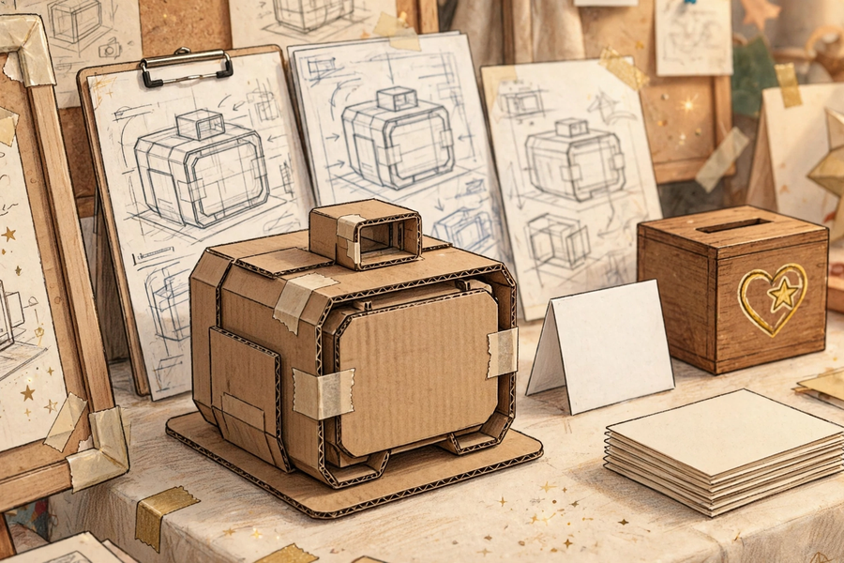

分組活動｜Group Tasks

任務一：綵排計時｜Task 1: Timed Rehearsal
- 按四部曲寫好講稿（約 500 字），組內綵排並分段計時；超時就刪例子，不刪結構。
Write the talk (~500 characters) in four parts; rehearse in-group with per-part timing; cut examples, not structure, when overtime.
- 推選報告代表及示範助手；預演一次「示範失敗」的應變。
Choose a presenter and a demo assistant; rehearse once what to do if the demo fails.

任務二：互評演練｜Task 2: Peer-Assessment Practice
- 用課堂示例作品練習填寫互評表：四項評分＋具體評語＋一項改善建議；同組互相檢查評語是否具體。
Practise on the sample product: four scores + specific comments + one suggestion; check each other’s comments for specificity.

任務三：展位佈置｜Task 3: Booth Setup
- 佈置展位：名牌、作品、設計圖；檢查尖角已包裹；接待組到門口就位。
Set up the booth: name card, product, drawings; check sharp corners are covered; reception team to the entrance.

總結｜Summary
- 報告四部曲：意念 40 秒 → 回饋 40 秒 → 改良 50 秒 → 示範 50 秒。
Four parts: idea 40s → feedback 40s → improvements 50s → demo 50s.
- 回應提問：複述 → 簡答 → 舉例；不懂就誠實承認，承諾會後再試。
Q&A: repeat → answer briefly → illustrate; admit honestly what you don’t know.
- 互評：四準則 1–5 分，不評自己組，具體評語＋一項改善建議。
Peer assessment: four criteria 1–5, not your own group, specific comments + one suggestion.
- 本單元由真實用家開始，以向關愛對象負責作結——這就是「用創科關愛弱勢社群」。
This unit began with real users and ends by answering to them — that is “caring for the underprivileged through innovation and technology”.

小測驗｜Mini Quiz
選擇題（每題選一個最佳答案）
Multiple choice (choose the best answer)
- 三分鐘報告中，「改良之處」部分應佔多少時間？
A. 約 40 秒
B. 越長越好
C. 約 90 秒
D. 約 50 秒
In the three-minute talk, the “improvements” part should take:
A. approx. 40 seconds
B. as long as possible
C. approx. 90 seconds
D. approx. 50 seconds
- 回應提問時，最恰當的次序是：
A. 複述 → 簡答 → 舉例
B. 舉例 → 簡答 → 複述
C. 簡答 → 離題 → 結束
D. 即時反問嘉賓
The best order for handling questions is:
A. Repeat → answer briefly → illustrate
B. Illustrate → answer → repeat
C. Answer → digress → end
D. Question the guest back at once
- 以下哪一句是「具體評語」？
A. 做得很好
B. 按鈕加大到 3 厘米後，長者能單手準確按下
C. 好有創意
D. 加油
Which is a specific comment?
A. Well done
B. After enlarging buttons to 3 cm, elderly users press accurately one-handed
C. Very creative
D. Keep it up
- 互評時正確的做法是：
A. 只評自己組別，給滿分
B. 全部組別給同一分數，省時
C. 為至少兩個其他組別評分，並寫具體評語及一項改善建議
D. 不用寫評語，只填分數
Correct peer-assessment practice:
A. Score only your own group with full marks
B. Give every group the same score to save time
C. Score at least two other groups with specific comments and one suggestion
D. Fill in scores only, no comments

