S2 Little Makers Class ｜ 中二創科班
S2 Little Makers Class
Unit 2 Lesson 8
Unit 2: Advanced Hands-on STEAM
進階電路：串聯並聯
Series and Parallel Circuits
學生筆記 ｜ Student Notes
姓名 Name：__________ 班別 Class：______ 學號 No.：______ 日期 Date：__________
本堂物資表 Materials List
以下為本堂分組活動所需物資（每組一份）。請在老師派發時核對。
品名 Item | 數量（每組） Quantity (per group) | 安全注意 Safety notes
AA 電池及電池盒 AA batteries with holders | 2 套 | 只准使用低壓電池；嚴禁短路（不可把電線直接接電池兩極）。
小燈泡及燈座 Small bulbs with holders | 3 個 | 燈泡發熱，小心觸摸。
電線（連鱷魚夾） Wires with crocodile clips | 6 條 | 接線前先畫電路圖。
開關掣 Switches | 2 個 | —
工作紙 Worksheet | 每人 1 張 | —
一、課堂目標 ｜ Lesson Objectives
- 正確連接串聯及並聯電路，並以電路圖記錄接法。 Connect series and parallel circuits correctly and record them with circuit diagrams.
- 說出串聯與並聯在電流路徑、燈泡光暗及開關控制方面的分別。 State the differences in current paths, bulb brightness and switch control.
- 解釋為何並聯較適合家居及課室照明。 Explain why parallel connection suits home and classroom lighting.
- 為課室設計一款節能小夜燈方案，並說明其省電之處。 Design an energy-saving night light for the classroom and explain its energy-saving features.
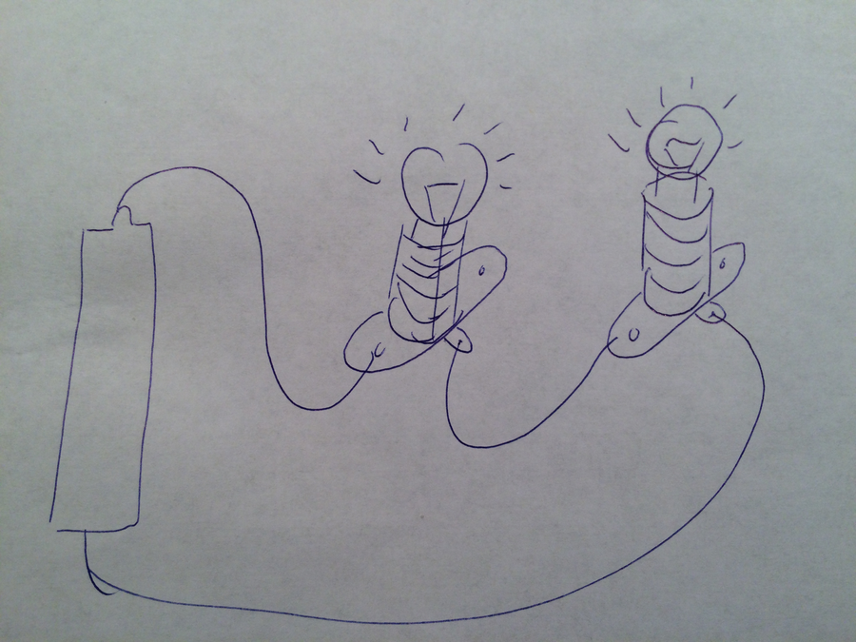
二、理論：串聯 ｜ Theory: Series Connection
串聯（series）：所有元件首尾相接，排成一條單一路徑，電流只有一條路可走。電池的電壓由各燈泡「攤分」：燈泡愈多，每個分得的電壓愈少，因此每個燈泡愈暗。開關無論接在哪個位置，都控制整個電路。只要其中一個燈泡損壞（斷路），整條路徑中斷，全部燈泡熄滅。
Series: components joined end to end in a single path — current has only one route. The battery's voltage is shared among the bulbs: more bulbs means less voltage each, so each bulb is dimmer. A switch anywhere controls the whole circuit. If one bulb fails (open circuit), the path breaks and all bulbs go out.
三、理論：並聯 ｜ Theory: Parallel Connection
並聯（parallel）：每個燈泡各自連接電池兩極，形成多條分支路徑。每個燈泡都得到電池的全部電壓，因此燈泡光暗不受燈泡數量影響 —— 加燈泡不會令原有燈泡變暗。接在總線上的開關控制全部燈泡，接在分支上的開關只控制該分支。個別燈泡損壞時，其餘分支仍有電流，繼續發光。
Parallel: each bulb connects across the battery terminals, forming multiple branch paths. Every bulb gets the full battery voltage, so brightness is unaffected by the number of bulbs — adding bulbs does not dim the others. A switch on the main line controls all bulbs; a switch on a branch controls only that branch. If one bulb fails, the other branches still carry current and stay lit.
四、串聯與並聯比較表 ｜ Series vs Parallel Comparison
比較項目 Aspect | 串聯 Series | 並聯 Parallel
電流路徑 Current path | 只有一條路徑 One single path | 多條分支路徑 Multiple branch paths
燈泡光暗 Bulb brightness | 燈泡愈多，每個愈暗 More bulbs → each dimmer（分壓） | 光暗不受燈泡數量影響 Unaffected by number of bulbs
開關控制 Switch control | 開關控制整個電路 Controls the whole circuit | 總開關控制全部；分支開關只控制該分支 Main switch: all; branch switch: that branch only
一個燈泡損壞 One bulb fails | 全部熄滅 All go out | 其餘照常發光 Others stay lit
適合用途 Suitable use | 小裝飾燈串等 Decorative light strings | 家居、課室照明 Homes, classrooms
五、簡單問答題 ｜ Short Questions
1. 畫出兩個燈泡串聯及兩個燈泡並聯的電路圖（標示電池、開關）。 Draw circuit diagrams for two bulbs in series and two bulbs in parallel (label battery and switch).
2. 為甚麼串聯的燈泡愈多，每個愈暗？ Why does each bulb get dimmer as more bulbs are added in series?
3. 並聯電路中，擰走一個燈泡，其餘燈泡為何仍會發光？ In a parallel circuit, why do the remaining bulbs stay lit when one is removed?
4. 開關在串聯和並聯（分支）中的控制範圍有何不同？ How does a switch's control range differ between series and a parallel branch?
六、思考題 ｜ Thinking Questions
1. 家居的電燈、插座全部採用並聯。試從「個別電器損壞」及「電壓」兩個角度，解釋為甚麼不能用串聯。 Home lighting and sockets all use parallel wiring. Explain, from the angles of "one appliance failing" and "voltage", why series cannot be used.
2. 有同學說「並聯燈泡數量不限，加得愈多愈好」。這個說法有何問題？（提示：電池的電量。） A classmate says "there is no limit to parallel bulbs — the more the better". What is wrong with this? (Hint: the battery's capacity.)
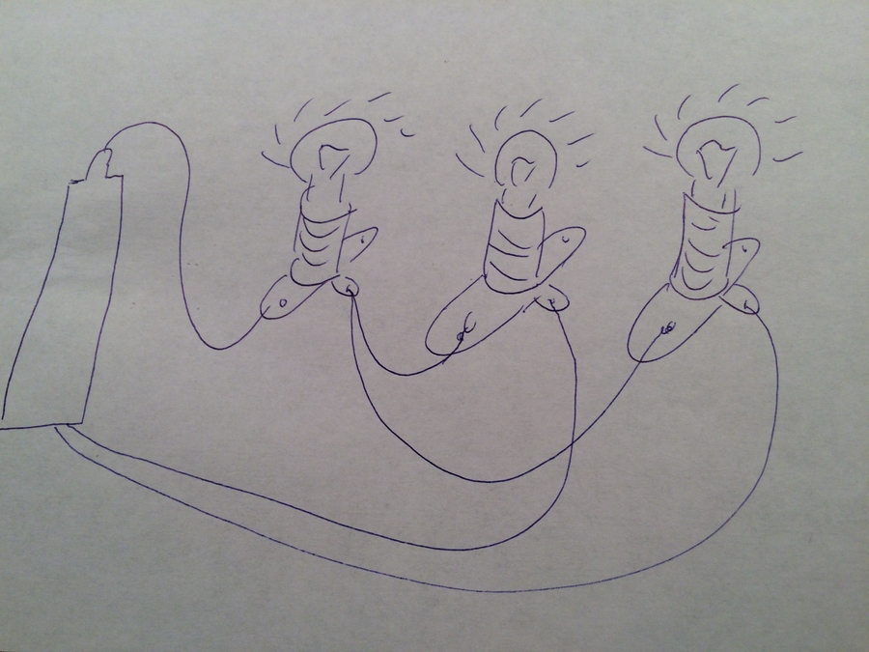
七、分組活動：實驗與節能小夜燈設計 ｜ Group Activity: Experiments and Night-light Design
- 實驗一（串聯）：連接兩個燈泡串聯，觀察光暗；擰走一個燈泡，記錄現象；繪畫電路圖。 Experiment 1 (series): connect two bulbs in series, observe brightness; remove one bulb and record; draw the circuit diagram.
- 實驗二（並聯）：改接為並聯（用同一組電池），比較光暗；測試開關在不同位置的控制範圍；擰走一個燈泡，記錄現象。 Experiment 2 (parallel): rewire in parallel (same batteries), compare brightness; test switch positions; remove one bulb and record.
- 設計任務：為課室設計節能小夜燈 —— 選用接法、燈泡數量、開關位置，繪畫電路圖，並寫出省電之處。 Design task: an energy-saving night light for the classroom — choose connection type, number of bulbs and switch positions; draw the circuit diagram and state the energy-saving features.
- 先畫電路圖，後接線，可減少接錯及短路。 Draw the diagram before wiring to reduce errors and short circuits.
八、安全須知及物料 ｜ Safety Notes and Materials
- 只准使用低壓電池；嚴禁把電線直接接電池兩極造成短路。 Low-voltage batteries only; never connect a wire directly across the battery terminals (short circuit).
- 小燈泡使用時會發熱，小心觸摸。 Bulbs get hot in use — touch with care.
- 接線前先畫電路圖；如電線或電池異常發熱，立即斷開並通知教師。 Draw the diagram before wiring; if any wire or battery heats up abnormally, disconnect at once and tell the teacher.
物料（每組，大約成本，僅供參考）：AA 電池及電池盒 2 套約 HK$12；小燈泡及燈座 3 個約 HK$9；電線（連鱷魚夾）6 條約 HK$12（可重用）；開關掣 2 個約 HK$6。
Materials (per group, approximate costs for reference only): 2 sets of AA batteries with holders ≈ HK$12; 3 small bulbs with holders ≈ HK$9; 6 wires with crocodile clips ≈ HK$12 (reusable); 2 switches ≈ HK$6.
九、總結 ｜ Summary
- 串聯：單一路徑、分壓（燈泡多則暗）、一壞全滅。 Series: single path, voltage shared (more bulbs → dimmer), one fails → all out.
- 並聯：多分支、各得全電壓（光暗不變）、個別損壞不影響其餘。 Parallel: branches, full voltage each (brightness unchanged), one fails → rest stay lit.
- 家居及課室照明用並聯；節約能源應由設計做起。 Homes and classrooms use parallel; energy saving starts with design.
- 電流在電路中循環，不是「用完就沒有」。 Current circulates in the circuit — it is not "used up".
十、小測驗 ｜ Mini Quiz
（一）選擇題 Multiple choice（每題 2 分）
1. 串聯電路的特徵是：(A) 有多條電流路徑 (B) 只有一條電流路徑 (C) 每個燈泡電壓不變 (D) 開關只控制一個燈泡。 A series circuit features: (A) multiple current paths (B) a single current path (C) unchanged voltage per bulb (D) a switch controlling one bulb only.
2. 兩個相同的燈泡由串聯改為並聯（用同一電池），燈泡會：(A) 變暗 (B) 光暗不變 (C) 變光 (D) 燒毀。 Two identical bulbs rewired from series to parallel (same battery) will: (A) dim (B) stay the same (C) brighten (D) burn out.
3. 並聯電路中，擰走一個燈泡：(A) 全部熄滅 (B) 其餘更光 (C) 其餘照常發光 (D) 電池爆炸。 In a parallel circuit, removing one bulb: (A) all go out (B) others brighten (C) others stay lit (D) the battery explodes.
（二）問答題 Short questions（每題 2 分）
1. 解釋為何課室照明宜用並聯而不用串聯。 Explain why classroom lighting should use parallel rather than series connection.
2. 為需要夜晚上洗手間的長者設計夜燈時，應選用哪種接法？為甚麼？（關愛反思） When designing a night light for elderly people who use the toilet at night, which connection type should be used? Why? (Caring reflection)

