S2 Little Makers Class ｜ 中二創科班
S2 Little Makers Class
Unit 2 Lesson 9
Unit 2: Advanced Hands-on STEAM
太陽能小車
Solar Car
學生筆記 ｜ Student Notes
姓名 Name：__________ 班別 Class：______ 學號 No.：______ 日期 Date：__________
本堂物資表 Materials List
以下為本堂分組活動所需物資（每組一份）。請在老師派發時核對。
品名 Item | 數量（每組） Quantity (per group) | 安全注意 Safety notes
太陽能小車套件（太陽能板＋摩打＋車架） Solar car kit (panel + motor + chassis) | 1 套 | 太陽能板小心輕放，避免壓裂；戶外使用後抹乾淨。
計時器（教師提供，全班共用） Timers (provided by teacher, shared) | 每班 2–3 個 | —
鉛筆芯粉／潤滑用具（共用，可選） Pencil lead powder for lubrication (shared, optional) | 共用 | 避免吸入粉末。
工作紙 Worksheet | 每人 1 張 | —
一、課堂目標 ｜ Lesson Objectives
- 說出太陽能轉換為電能再轉為動能的能量轉換過程。 Describe the energy conversion from solar to electrical to kinetic energy.
- 組裝一台可正常行走的太陽能小車。 Assemble a solar car that runs properly.
- 透過最少一項調校提升小車的速度或穩定性，並記錄調校前後的表現。 Improve speed or stability through at least one tuning adjustment, recording before-and-after performance.
- 說出最少兩個使用再生能源的好處。 State at least two benefits of renewable energy.
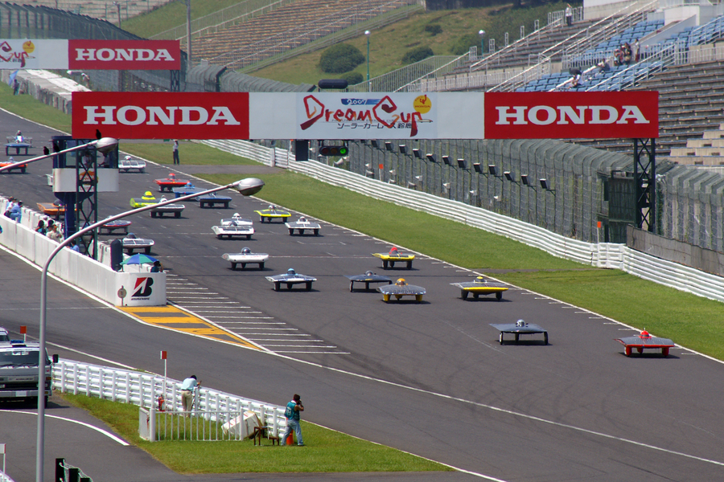
二、理論：能量轉換鏈 ｜ Theory: The Energy Conversion Chain
太陽能板（solar panel）把光能（light energy）轉換為電能（electrical energy）；摩打（motor）再把電能轉換為動能（kinetic energy），推動小車前進。整條能量轉換鏈是：光能 → 電能 → 動能。
The solar panel converts light energy into electrical energy; the motor then converts electrical energy into kinetic energy, driving the car forward. The full chain is: light energy → electrical energy → kinetic energy.
太陽能板發電的關鍵是光照：光線愈強、照射角度愈正對面板（入射角接近垂直），產生的電流愈大，小車跑得愈快。陰天時光線較弱，小車仍可緩慢行走，但速度明顯下降。
The key is light: stronger light and a more direct angle (near-perpendicular incidence) generate more current and a faster car. On cloudy days the car can still crawl, but much more slowly.
三、理論：影響速度的三個因素 ｜ Theory: Three Factors Affecting Speed
- 太陽能板角度：正對陽光時發電效能最高；角度偏差愈大，效能愈低。 Panel angle: facing the sun directly gives maximum output; the greater the deviation, the lower the output.
- 車身重量：車身愈輕，摩打負擔愈小，加速愈快。 Body weight: a lighter car loads the motor less and accelerates faster.
- 車軸摩擦：車軸愈順滑，阻力愈小；可用鉛筆芯粉潤滑。 Axle friction: smoother axles mean less resistance; lubricate with pencil lead (graphite) powder.
四、再生能源的好處與限制 ｜ Benefits and Limitations of Renewable Energy
好處 Benefits | 限制 Limitations
清潔：使用時不排放廢氣 Clean: no emissions in use | 受天氣影響：陰天、夜晚發電大減 Weather-dependent: poor output on cloudy days and at night
可再生：陽光取之不盡 Renewable: sunlight is inexhaustible | 能量密度較低：需要較大面積收集 Lower energy density: needs a large collection area
運作成本低：陽光免費 Low running cost: sunlight is free | 初期設備成本較高 Higher initial equipment cost
五、簡單問答題 ｜ Short Questions
1. 寫出太陽能小車的能量轉換鏈，並標示每一步的能量形式。 State the solar car's energy conversion chain, labelling the energy form at each step.
2. 為甚麼太陽能板正對陽光時，小車跑得最快？ Why does the car run fastest when the panel faces the sun directly?
3. 減輕車身重量及潤滑車軸分別如何提升速度？ How do reducing body weight and lubricating the axles each improve speed?
4. 舉出兩個使用再生能源的好處及一個限制。 Give two benefits and one limitation of renewable energy.
六、思考題 ｜ Thinking Questions
1. 有同學想換一塊更大的太陽能板，認為「板愈大一定愈快」。這個想法有何問題？ A classmate wants a bigger solar panel, thinking "bigger is always faster". What is wrong with this idea?
2. 陰天時小車仍可緩慢行走，這說明了甚麼？這對「太陽能完全靠天吃飯」的說法有何修正？ The car can still crawl on cloudy days. What does this show, and how does it refine the claim that "solar power is entirely at the mercy of weather"?
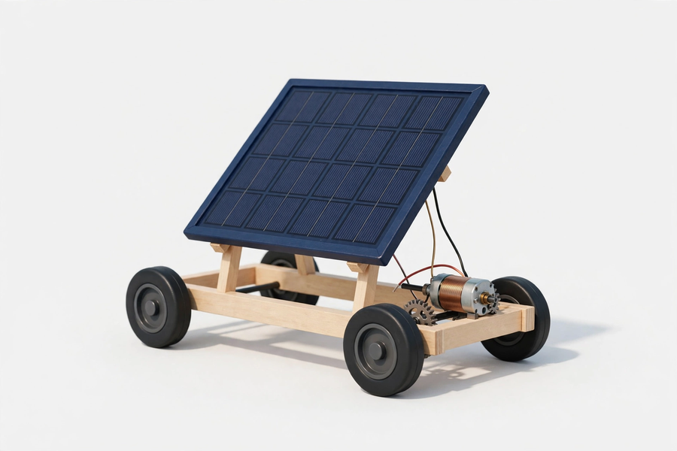
七、分組活動：組裝、調校與競速 ｜ Group Activity: Assembly, Tuning and Racing
- 按說明書分工組裝小車；完成後作初步試跑。 Assemble the car following the instructions; run an initial trial.
- 調校方向：太陽能板角度（正對陽光）、減輕車身（拆除多餘裝飾）、車軸潤滑（鉛筆芯粉）。記錄每次調校項目及試跑時間，比較成效。 Tuning: panel angle (face the sun), reduce weight (remove decorations), lubricate axles. Record each tuning item and trial time.
- 比賽規則：戶外直線競速，每組兩次，取最佳成績。 Race: outdoor straight-line sprint, two runs per group, best result counts.
- 陰天後備方案：以強光電筒或射燈代替陽光，在室內試跑。 Wet-weather backup: use strong torches or spotlights indoors.
八、安全須知及物料 ｜ Safety Notes and Materials
- 太陽能板小心輕放，避免壓裂；戶外使用後抹乾淨。 Handle the solar panel gently to avoid cracking; wipe clean after outdoor use.
- 鉛筆芯粉避免吸入粉末。 Avoid inhaling pencil lead (graphite) powder.
- 戶外比賽時遵守教師指示，不可離開指定範圍。 Follow teacher instructions outdoors; stay within the designated area.
物料（每組，大約成本，僅供參考）：太陽能小車套件（太陽能板＋摩打＋車架）1 套約 HK$20–30；計時器（教師提供，全班共用）；鉛筆芯粉（共用，可選）約 HK$5。
Materials (per group, approximate costs for reference only): 1 solar car kit (panel + motor + chassis) ≈ HK$20–30; timers (teacher-provided, shared); pencil lead powder (shared, optional) ≈ HK$5.
九、總結 ｜ Summary
- 能量轉換鏈：光能 →（太陽能板）→ 電能 →（摩打）→ 動能。 Energy chain: light → (panel) → electrical → (motor) → kinetic.
- 調校三方向：面板角度、車身重量、車軸摩擦。 Three tuning directions: panel angle, body weight, axle friction.
- 再生能源：清潔、可再生，但受天氣影響、能量密度較低。 Renewable energy: clean and renewable, but weather-dependent with lower energy density.
- 以數據比較調校前後，是工程師的探究方法。 Comparing before-and-after data is the engineer's method of inquiry.
十、小測驗 ｜ Mini Quiz
（一）選擇題 Multiple choice（每題 2 分）
1. 太陽能小車的能量轉換鏈是：(A) 電能→光能→動能 (B) 光能→電能→動能 (C) 動能→電能→光能 (D) 光能→動能→電能。 The solar car's energy chain is: (A) electrical→light→kinetic (B) light→electrical→kinetic (C) kinetic→electrical→light (D) light→kinetic→electrical.
2. 下列哪項調校最可能提升小車速度？(A) 在車身加上裝飾 (B) 把太陽能板轉至正對陽光 (C) 把車軸弄緊 (D) 在陰影下試跑。 Which tuning most likely improves speed? (A) adding decorations (B) tilting the panel to face the sun (C) tightening the axles (D) trial runs in shade.
3. 下列哪項是使用再生能源的限制？(A) 使用時排放廢氣 (B) 陽光會用完 (C) 受天氣影響 (D) 運作成本極高。 Which is a limitation of renewable energy? (A) emits exhaust in use (B) sunlight runs out (C) weather-dependent (D) extremely high running cost.
（二）問答題 Short questions（每題 2 分）
1. 記錄一項你的調校及試跑成績的變化，並解釋為何有效。 Record one tuning adjustment and the change in trial results, and explain why it worked.
2. 太陽能等再生能源如何幫助偏遠或資源匱乏的社群獲得電力？（關愛反思，50 字內） How can renewable energy such as solar power help remote or resource-scarce communities gain electricity? (Caring reflection, within 50 Chinese characters)

