第 11 堂：流程圖 —— 教師筆記
Lesson 11: Flowcharts — Teacher's Notes
本堂物資表 Materials List（教師版）
請預早一星期準備所需物資；標示「課室現有」之項目請預先清點。
品名 Item | 數量（每組） Quantity (per group) | 大約成本 Est. cost | 安全注意 Safety notes
A4 白紙 A4 paper | 每人 2 張 2 sheets per student | 約 HK$0.2／人 approx. HK$0.2 per student | — —
流程圖符號配對卡（預先列印及裁剪） Flowchart symbol matching cards (pre-printed and cut) | 每組 1 套 1 set per group | 約 HK$1／組 approx. HK$1 per group | 卡紙邊緣較利，小心輕放 Handle card edges with care
顏色筆 Colour pens | 每組 1 盒（課室常用，可重用） 1 box per group (reusable classroom stock) | HK$0（重用） HK$0 (reused) | 避免弄污衣物 Avoid staining clothes
藍丁膠 Blu-Tack | 每組少許 a small amount per group | 約 HK$1／組 approx. HK$1 per group | — —
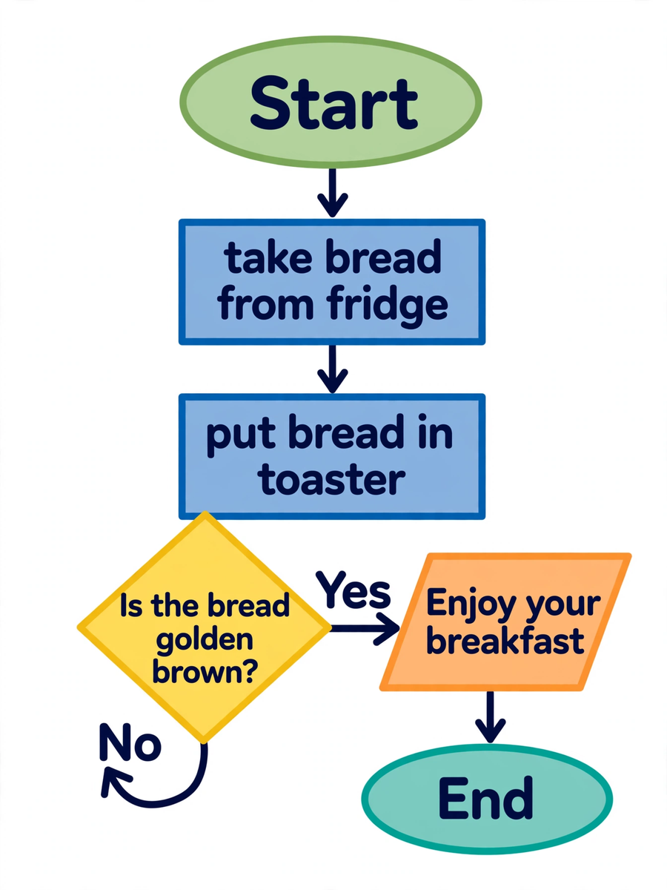
中二創科班｜Unit 3 進階編程思維｜只供教師參閱
S2 Little Makers Class | Unit 3 Advanced Programming Thinking | For teachers only
一、學生筆記答案 Answers to student notes
簡單問答題答案 Quick questions — answers
- 橢圓形：開始／結束，標示流程的起點或終點；菱形：判斷，提出是非問題並分出「是／否」兩條路。 / Oval: terminator, marks the start/end. Diamond: decision, asks a yes/no question and branches.
- 是非問題（只可用「是／否」回答），例如「帶齊功課了嗎？」。 / A yes/no question, e.g. "Have I packed all my homework?"
- 因為一個長方形代表一個處理步驟；多個步驟塞在一起會令流程含糊不清，難以檢查和修正。 / One rectangle is one process step; cramming steps together makes the flow vague and hard to check or fix.
- 從多士爐取出多士。 / Take the toast out of the toaster.
思考題參考答案 Thinking questions — model answers
- 沒有「否」的出路，流程便不完整：當答案為「否」時，使用者不知道下一步該做什麼，流程會卡住。例如判斷「帶齊功課了嗎？」若只有「是→出門」，答「否」的學生便無所適從；應補上「否→回房間拿取功課」。 / Without a "no" exit the flow is incomplete: a "no" answer leaves the user stuck. E.g. "Have I packed my homework?" with only "yes → leave" strands anyone answering "no"; add "no → go back and fetch it".
- 開放式，合理即可。例子：食譜步驟圖（按部就班煮食不出錯）、學校火警疏散程序（每一步指示清晰）。評分着重例子是否包含「有序步驟」。 / Open-ended. Examples: a recipe flowchart (cook step by step without mistakes); the school fire drill procedure (every step clearly directed). Credit examples that involve ordered steps.
分組題指導 Group task — guidance
參考流程：開始 → 在床邊坐一分鐘 → 起床 → 判斷「頭暈嗎？」（是：坐下休息再試／否：繼續）→ 判斷「地面有水漬嗎？」（是：抹乾／否：繼續）→ 檢查大門已鎖好 → 輸出：安心出門 → 結束。
Model flow: start → sit on the bedside for one minute → get up → decision "Dizzy?" (yes: sit and rest, try again / no: continue) → decision "Water on the floor?" (yes: wipe it dry / no: continue) → check the door is locked → output: leave home safely → end.
- 巡視重點：菱形有否兩條出路；箭頭是否單向；有否把多個動作塞進同一個長方形。
- While circulating, check: does each diamond branch? Are arrows single-headed? Is any rectangle overloaded?
- 展示點評：先讚賞切合長者需要的內容，再指出符號使用的問題。
- When commenting: praise caring content first, then correct symbol use.
小測驗答案及評分 Quiz — answers and marking
- B（2 分） / B (2 marks)
- B（2 分） / B (2 marks)
- 錯（2 分） / False (2 marks)
- 不正確（1 分）；一個長方形只做一件事（1 分）；三個步驟應分開畫成三個長方形（1 分）。 / Incorrect (1 mark); one rectangle does one thing (1 mark); the three steps need three separate rectangles (1 mark).
- 問題合理（1 分）；「是」與「否」的後續各 1 分。合理例子：「帶齊功課了嗎？」是→出門上學；否→回房間拿取功課。 / Sensible question (1 mark); 1 mark for each follow-up. E.g. "Packed all homework?" yes → leave for school; no → go back and fetch it.
二、家課答案 Homework — answers
甲部：1. C 2. C 3. B 4. B 5. A
Section A: 1. C 2. C 3. B 4. B 5. A
- 箭頭指示流程的進行方向（1 分）；若畫成雙向，使用者便不知道先做哪一步（1 分），順序含糊，流程圖失去指導作用（1 分）。 / Arrows show the direction of flow (1 mark); double-headed arrows leave the order ambiguous (1 mark), so the chart cannot guide the user (1 mark).
- 小明漏了「否」的出路（1 分）；當答案為「否」時沒有任何指示（1 分）；改正：加上「否 → 回房間拿取功課，然後再檢查一次」（2 分）。 / Ming omitted the "no" exit (1 mark), leaving no instruction for a "no" answer (1 mark). Fix: add "no → fetch the homework and check again" (2 marks).
- 實踐題按隨附的《評分準則》評分。 / Mark the practical task with the accompanying rubric.
三、附加思考題 Extra thinking questions
- 試把「為家人沖一杯熱飲」畫成流程圖：當中哪一步最適合用判斷符號？為什麼？ / Draw a flowchart for "making a hot drink for a family member": which step best suits a decision symbol, and why?
- 如果流程圖中出現兩個連續的判斷（例如先判斷「有麵包嗎？」再判斷「有果醬嗎？」），可以合併成一個判斷嗎？為什麼？ / If a flowchart has two decisions in a row (e.g. "Is there bread?" then "Is there jam?"), can they be merged into one? Why?
附加思考題參考答案 Extra questions — model answers
- 「水滾了嗎？」最適合，因為水滾與否決定能否沖調，有明確的是非分支；評分着重學生能否指出「具分支需要」的步驟。 / "Has the water boiled?" fits best, because it determines whether brewing can start — a genuine branch. Credit students who identify a step that truly needs branching.
- 不可以直接合併。兩個獨立問題共有四種答案組合（是是、是否、否是、否否），合併會遺漏分支；正確做法是保留兩個菱形，先後判斷。 / No. Two independent questions give four answer combinations (yes-yes, yes-no, no-yes, no-no); merging loses branches. Keep two diamonds in sequence.
四、建議教導方向 Teaching suggestions
- 從學生最熟悉的早餐入手，降低入門門檻；先讓全班說出步驟，再由教師示範繪圖。
- Start with the familiar breakfast example; let the class call out the steps before you draw.
- 判斷符號是本堂難點：反覆強調每個菱形必須有「是」與「否」兩條出路，可故意畫一個漏分支的版本讓學生找錯。
- The decision symbol is the crux: stress repeatedly that every diamond needs "yes" and "no" exits — try showing a faulty version for students to spot.
- 長者情境要具體：起床後先在床邊坐片刻（防止暈眩）、檢查地面有否水漬、確認大門已鎖好。
- Keep the elderly scenario concrete: sit on the bedside after waking, check the floor for water, confirm the door is locked.
- 邀請兩組展示作品，先讚賞切合長者需要的內容，再點評符號使用的準確性；總結三要素：順序、分支、完整。
- Invite two groups to present; praise caring content first, then comment on symbol accuracy. Close with the three essentials: sequence, branching, completeness.
五、常見迷思 Common misconceptions
- 把箭頭畫成雙向 → 強調流程圖箭頭只指向單一方向。
- Double-headed arrows → stress one direction only.
- 把多個步驟塞進同一個長方形 → 一個長方形只做一件事。
- Several steps in one rectangle → one rectangle does one thing.
- 判斷只寫問題而不畫分支 → 必須畫出兩條出路及各自的後續步驟。
- Question in the diamond but no branches drawn → both exits and their follow-up steps must be drawn.
- 把輸入／輸出與處理混淆 → 輸入／輸出是資料進出，處理是實際動作。
- Confusing input/output with process → input/output is data in or out; process is an action.

