品名 Item | 數量（每組） Quantity (per group) | 安全注意 Safety notes
指令卡、條件卡、重複卡（預先列印） Instruction, condition and repeat cards (pre-printed) | 每組 1 套 1 set per group | 卡紙邊緣較利，小心輕放 Handle card edges with care
A4 白紙 A4 paper | 每人 1 張 1 sheet per student | — —
顏色筆 Colour pens | 每組 1 盒（課室常用，可重用） 1 box per group (reusable classroom stock) | 避免弄污衣物 Avoid staining clothes
計時器 Timer | 教師共用 1 個（可用課室時鐘） 1 shared by the teacher (classroom clock may be used) | — —
以下為本堂分組活動所需物資（每組一份）。請在老師派發時核對。
本堂物資表 Materials List
第 12 堂：條件與迴圈
Lesson 12: Conditions and Loops
中二創科班｜Unit 3 進階編程思維｜不插電課堂
S2 Little Makers Class | Unit 3 Advanced Programming Thinking | Unplugged Lesson
一、課程內容理論 Theory
條件讓程式懂得「作決定」：符合條件時做一件事，不符合時做另一件事。迴圈讓程式懂得「重複做」：把相同的步驟重複執行。這是編程的兩大核心機制——上一堂的判斷符號（菱形），其實就是條件的一種。
A condition lets a program "make decisions": do one thing when the condition is met, another when it is not. A loop lets a program "repeat": run the same steps over and over. These are the two core mechanisms of programming — last lesson's decision symbol (the diamond) is actually a condition in disguise.
條件句式 Condition sentence patterns
- 如果……，就……。
- If …, then ….
- 如果……，就……；否則，……。
- If …, then …; otherwise (else), ….
- 「否則」分支可以省略：只寫符合條件時要做的事也可以。
- The "else" branch may be omitted.
例子：商場自動門 —— 如果感應到有人，就開啟；否則，保持關閉。
Example: a shopping-mall automatic door — if someone is detected, open; otherwise, stay closed.
迴圈句式 Loop sentence patterns
- 重複 N 次：……
- Repeat N times: …
- 重複……，直至……。
- Repeat …, until ….
- 每個迴圈都必須有「終止條件」——讓迴圈停下來的條件。
- Every loop must have a "termination condition" — the condition that stops the loop.
例子：重複 4 次：畫一個星形 → 畫出 ★★★★。沒有終止條件的迴圈會無限重複下去，成為「無限迴圈」——就像一個永遠響不停的鬧鐘。
Example: Repeat 4 times: draw a star → ★★★★. A loop with no termination condition repeats forever — an "infinite loop", like an alarm clock that never stops ringing.
生活中的條件與迴圈 Conditions and loops in daily life
例子  Example | 屬於  Type | 說明  Explanation
交通燈按時序循環轉換  Traffic lights changing in sequence | 迴圈  Loop | 紅 → 綠 → 黃 → 紅，不斷重複  Red → green → amber → red, repeating
商場自動門  Automatic doors | 條件  Condition | 如果感應到有人，就開啟  If someone is detected, open
洗衣機  Washing machine | 條件＋迴圈  Condition + loop | 重複清洗，直至衣服乾淨；如果水位不足，就加水  Repeat washing until clothes are clean; if water is low, add water

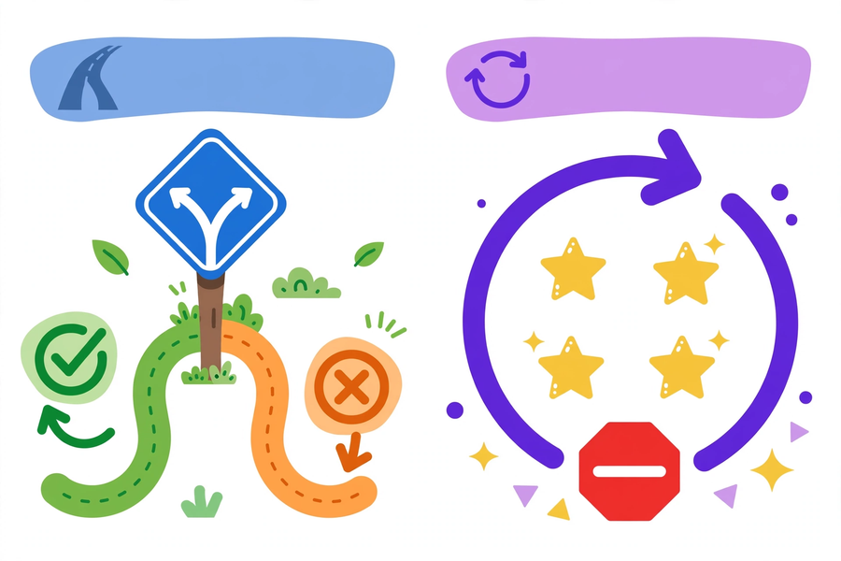
二、例子：長者服藥提醒演算法 Example: medication reminder algorithm
以下演算法同時運用條件和迴圈，為長者設計定時服藥提醒：
The algorithm below uses both a condition and a loop — a scheduled medication reminder for the elderly:
- 重複每一天，直至一星期結束：
- Repeat each day, until the week ends:
- 如果早上，就提醒服白色藥丸；
- If it is morning, remind them to take the white pill;
- 否則如果晚上，就提醒服黃色藥丸。
- Else, if it is evening, remind them to take the yellow pill.
執行追蹤 Trace
日子  Day | 時段  Time | 執行的動作  Action taken
第 1 天  Day 1 | 早上  Morning | 提醒服白色藥丸  Remind: white pill
第 1 天  Day 1 | 晚上  Evening | 提醒服黃色藥丸  Remind: yellow pill
第 2 天  Day 2 | 下午  Afternoon | 什麼都不做（既非早上亦非晚上）  Nothing (neither morning nor evening)
第 7 天結束後  After day 7 | —  — | 停止（終止條件成立）  Stop (termination condition met)

留意：如果刪去「直至一星期結束」，這個迴圈便沒有終止條件，會無限重複下去。
Note: without "until the week ends", this loop would have no termination condition and would repeat forever.
三、簡單問答題 Quick questions
- 用自己的話解釋「條件」和「迴圈」有什麼分別。 / In your own words, explain the difference between a condition and a loop.
- 執行「重複 5 次：拍手」，會拍手幾下？ / Execute "Repeat 5 times: clap". How many claps?
- 執行：重複 3 天 —— 如果下雨，就帶雨傘；否則如果天晴，就戴帽子。三天分別是「雨、晴、陰」，每天各做什麼？ / Execute: repeat for 3 days — if it rains, bring an umbrella; else if it is sunny, wear a cap. The three days are rainy, sunny, cloudy. What happens each day?
- 什麼是「終止條件」？為什麼迴圈需要它？ / What is a "termination condition"? Why does a loop need one?
四、思考題 Thinking questions
- 沒有終止條件的迴圈，在現實生活中可能有什麼例子？（除了永遠響不停的鬧鐘）會造成什麼問題？ / What real-life examples of loops without termination conditions can you think of (besides the never-ending alarm clock)? What problems would they cause?
- 「如果……就……」和「重複……直至……」有什麼本質分別？試各舉一個生活例子。 / What is the essential difference between "if…then…" and "repeat…until…"? Give one real-life example of each.

五、分組題 Group task
小組任務：為長者設計「定時服藥提醒演算法」，寫在設計紙上，並在組內試演一次，檢查邏輯是否通順。
Group task: design a "scheduled medication reminder algorithm" for the elderly. Write it on the design sheet and rehearse it once in your group to check the logic flows.
- 必須包含至少一個條件。
- Include at least one condition.
- 必須包含一個迴圈，而且迴圈要有明確的終止條件。
- Include one loop with a clear termination condition.
- 例子：早上服白色藥丸、晚上服黃色藥丸；想一想：若長者漏服一次，應如何處理？
- E.g. white pills in the morning, yellow pills at night. Also consider: what if a dose is missed?
- 完成後一組上台示範，全班一起驗證邏輯。
- One group demonstrates; the whole class verifies the logic.
完成檢查清單 Self-check list
- 演算法中有條件嗎？
- Does the algorithm contain a condition?
- 演算法中有迴圈嗎？
- Does it contain a loop?
- 迴圈有明確的終止條件嗎？（沒有的話會變成無限迴圈！）
- Does the loop have a clear termination condition? (Otherwise it becomes an infinite loop!)
六、總結 Summary
- 條件等於作決定：如果……就……，否則……。
- A condition means making a decision: if…then…else….
- 迴圈等於重複做：重複 N 次，或重複……直至……。
- A loop means repeating: repeat N times, or repeat…until….
- 每個迴圈都必須有終止條件，否則會變成無限迴圈。
- Every loop must terminate — otherwise it becomes an infinite loop.
七、小測驗 Quiz
（滿分 12 分）
(Total: 12 marks)
- 下列哪一項是迴圈必須具備的？ A. 顏色 B. 終止條件 C. 紙牌 D. 骰子（2 分） / Which must every loop have? A. Colour B. Termination condition C. Cards D. Dice (2 marks)
- 「如果感應到有人，就開啟自動門」這句中，條件是？ A. 開啟自動門 B. 感應到有人 C. 有人走過 D. 關閉自動門（2 分） / In "If someone is detected, open the automatic door", the condition is? A. Open the door B. Someone is detected C. Someone walks past D. Close the door (2 marks)
- 執行指令「重複 4 次：向前走一步」，共走幾步？（2 分） / Execute "Repeat 4 times: step forward". How many steps in total? (2 marks)
- 判斷對錯：「否則」分支在條件句中必須出現。（圈出：對／錯）（2 分） / True or false: the "else" branch must always appear in a condition. (Circle: True / False) (2 marks)
- 用條件／迴圈句式，寫出一個包含一個條件和一個具終止條件的迴圈的日常生活演算法。（4 分） / Using condition/loop sentences, write an everyday algorithm containing one condition and one loop with a termination condition. (4 marks)

