第 12 堂：條件與迴圈 —— 教師筆記
Lesson 12: Conditions and Loops — Teacher's Notes
本堂物資表 Materials List（教師版）
請預早一星期準備所需物資；標示「課室現有」之項目請預先清點。
品名 Item | 數量（每組） Quantity (per group) | 大約成本 Est. cost | 安全注意 Safety notes
指令卡、條件卡、重複卡（預先列印） Instruction, condition and repeat cards (pre-printed) | 每組 1 套 1 set per group | 約 HK$4／組 approx. HK$4 per group | 卡紙邊緣較利，小心輕放 Handle card edges with care
A4 白紙 A4 paper | 每人 1 張 1 sheet per student | 約 HK$0.1／人 approx. HK$0.1 per student | — —
顏色筆 Colour pens | 每組 1 盒（課室常用，可重用） 1 box per group (reusable classroom stock) | HK$0（重用） HK$0 (reused) | 避免弄污衣物 Avoid staining clothes
計時器 Timer | 教師共用 1 個（可用課室時鐘） 1 shared by the teacher (classroom clock may be used) | HK$0 HK$0 | — —
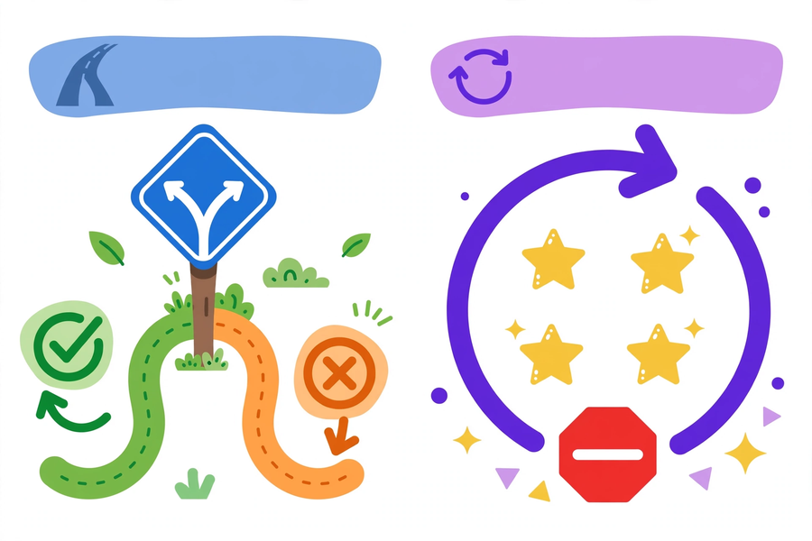
中二創科班｜Unit 3 進階編程思維｜只供教師參閱
S2 Little Makers Class | Unit 3 Advanced Programming Thinking | For teachers only
一、學生筆記答案 Answers to student notes
簡單問答題答案 Quick questions — answers
- 條件是「作決定」：二選一，符合條件做一件事、不符合做另一件；迴圈是「重複做」：把相同步驟重複執行。 / A condition "makes a decision" (choose between alternatives); a loop "repeats" the same steps.
- 5 下。 / 5 claps.
- 第一天（雨）：帶雨傘；第二天（晴）：戴帽子；第三天（陰）：什麼都不做（既非下雨亦非天晴）。 / Day 1 (rain): bring an umbrella; day 2 (sunny): wear a cap; day 3 (cloudy): nothing (neither condition met).
- 終止條件是讓迴圈停下來的條件；沒有它，迴圈會無限重複下去，變成無限迴圈。 / The termination condition stops the loop; without it the loop repeats forever — an infinite loop.
思考題參考答案 Thinking questions — model answers
- 合理例子：卡住的影印機不停吐出白紙、不斷重播的廣告。問題：浪費資源（紙張、電力）、工作永遠做不完、程式「當機」。 / Examples: a jammed printer endlessly spitting out blank pages; an advert replaying forever. Problems: wasted resources, the job never finishes, the program hangs.
- 本質分別：條件是二選一的決定，迴圈是重複執行。條件例子：如果遲到，就跑步回校；迴圈例子：重複刷牙，直至牙齒乾淨。 / A condition chooses between alternatives; a loop repeats. Condition e.g.: if late, run to school. Loop e.g.: keep brushing until teeth are clean.
分組題指導 Group task — guidance
參考版本：重複每一天，直至一星期結束：如果早上，提醒服白色藥丸；否則如果晚上，提醒服黃色藥丸。
Model answer: repeat each day, until the week ends: if morning, remind them to take the white pill; else if evening, remind them to take the yellow pill.
- 漏服處理可作延伸：加入判斷「忘記服藥嗎？」—— 是：立即補服並記錄；否：繼續。
- Extension for missed doses: add a decision "Dose missed?" — yes: take it now and record it; no: continue.
- 試演時請一組員讀出演算法，一組員按指令做動作，全班檢查有否矛盾或遺漏終止條件。
- For the rehearsal, one member reads the algorithm while another acts it out; the class checks for contradictions or a missing termination condition.
小測驗答案及評分 Quiz — answers and marking
- B（2 分） / B (2 marks)
- B（2 分） / B (2 marks)
- 4 步（2 分） / 4 steps (2 marks)
- 錯（2 分） / False (2 marks)
- 包含一個條件（1 分）、一個迴圈（1 分）、終止條件明確（1 分）、邏輯通順可執行（1 分）。 / One condition (1 mark), one loop (1 mark), clear termination condition (1 mark), logic flows and is executable (1 mark).
二、家課答案 Homework — answers
甲部：1. B 2. B 3. B 4. B 5. C
Section A: 1. B 2. B 3. B 4. B 5. C
- 三次動作：舉手、拍手、舉手（每次 1 分）。2 是雙數→舉手；5 是單數→拍手；4 是雙數→舉手。 / Actions: raise hand, clap, raise hand (1 mark each). 2 is even → hand; 5 is odd → clap; 4 is even → hand.
- 這個迴圈沒有終止條件（2 分），會無限重複下去（1 分）。修改：加上終止條件，例如「重複：每天做運動，直至連續做滿 30 天」（1 分）。 / The loop has no termination condition (2 marks) and would repeat forever (1 mark). Fix: add one, e.g. "Repeat: exercise every day, until 30 consecutive days are done" (1 mark).
- 電器運作邏輯按隨附的《評分準則》評分。 / Mark the appliance logic with the accompanying rubric.
三、附加思考題 Extra thinking questions
- 「重複 N 次」和「重複……直至……」兩種迴圈寫法，各有什麼好處？試各舉一個適用例子。 / What are the strengths of "repeat N times" versus "repeat…until…"? Give one suitable example of each.
- 電腦程式可否只有迴圈、沒有條件？可否只有條件、沒有迴圈？試舉例說明。 / Can a program have loops but no conditions, or conditions but no loops? Illustrate with examples.
附加思考題參考答案 Extra questions — model answers
- 「重複 N 次」適用於次數已知的情況，例如每天服藥 2 次；「重複……直至……」適用於次數未知、只知停止條件的情況，例如煲水直至水滾。 / "Repeat N times" suits a known count, e.g. taking medicine twice a day; "repeat…until…" suits an unknown count with a known stopping condition, e.g. boiling water until it boils.
- 可以。純迴圈例子：時鐘每秒滴答一次（重複直至電池耗盡）；純條件例子：自動門感應（沒有重複）。兩者結合威力更大。 / Yes. Loop-only e.g.: a clock ticking every second (repeat until the battery dies). Condition-only e.g.: an automatic door sensor (no repetition). Combined, they are more powerful.
四、建議教導方向 Teaching suggestions
- 先用身體動作體驗抽象概念，再落到紙牌操作：由具體到抽象，符合學習次序。
- Experience the concepts through body movement first, then card operations — concrete before abstract.
- 條件動作遊戲由淺入深：先玩「如果……就……」，熟習後再加入「否則」分支。
- Build the action game up gradually: "if…then…" first, then add the "else" branch.
- 引入迴圈時舉行計數挑戰，再提問：「若沒有說明重複多少次，會發生什麼事？」從而引出終止條件。
- When introducing loops, hold a counting challenge, then ask: "What if no number of repeats is given?" — leading to termination conditions.
- 服藥例子要貼近真實：早上服白色藥丸、晚上服黃色藥丸，以及漏服的處理。
- Keep the medication example realistic: white pills in the morning, yellow pills at night, and what to do about a missed dose.
- 邀請一組上台示範演算法，全班一起驗證邏輯；總結：條件等於作決定，迴圈等於重複做，迴圈必須有終止。
- Invite one group to demonstrate; the class verifies the logic together. Close: conditions decide, loops repeat, and every loop must terminate.
五、常見迷思 Common misconceptions
- 以為「否則」分支必須出現 → 其實可以省略，只寫符合條件時要做的事也可以。
- Thinking "else" must always appear → it may be omitted.
- 以為迴圈只是「做很多次」→ 忽略計數或終止條件，須強調「重複幾次」和「何時停止」。
- Thinking a loop is just "doing something many times" → stress the counter and when it stops.
- 把條件與迴圈混淆 → 條件是二選一，迴圈是重複執行；可用「作決定 vs 重複做」幫助分辨。
- Confusing conditions with loops → a condition chooses, a loop repeats ("decide vs repeat").

