品名 Item | 數量（每組） Quantity (per group) | 安全注意 Safety notes
密碼輪紙模（預先列印） Cipher wheel template (pre-printed) | 每人 1 份 1 per student | — —
開口釘 Split pins | 每人 1 枚 1 per student | 釘尖較利，小心使用，勿拋擲，用後統一收回 The pins are sharp; handle with care, do not throw them, and return them after use
A4 白紙 A4 paper | 每人 1 張 1 sheet per student | — —
顏色筆 Colour pens | 每組 1 盒（課室常用，可重用） 1 box per group (reusable classroom stock) | 避免弄污衣物 Avoid staining clothes
以下為本堂分組活動所需物資（每組一份）。請在老師派發時核對。
本堂物資表 Materials List
第 13 堂：密碼學
Lesson 13: Cryptography
中二創科班｜Unit 3 進階編程思維｜不插電課堂
S2 Little Makers Class | Unit 3 Advanced Programming Thinking | Unplugged Lesson
一、課程內容理論 Theory
三個基本概念 Three basic concepts
- 加密：把可讀的訊息（明文）變成看不懂的密文。
- Encryption: turning a readable message (plaintext) into an unreadable cipher text.
- 解密：用正確方法把密文還原為明文。
- Decryption: restoring the cipher text to plaintext by the correct method.
- 密鑰：加密與解密所用的秘密資訊，收發雙方須事先約定。
- Key: the secret information used to encrypt and decrypt, agreed in advance by sender and receiver.
凱撒密碼 The Caesar cipher
凱撒密碼是最古老的加密法之一：把每個字母按固定的位移量推移。例如位移 3，A 變成 D，B 變成 E……位移量就是密鑰。字母移到 Z 之後要「環繞」回到 A：位移 3 時，X→A、Y→B、Z→C。
The Caesar cipher is one of the oldest encryption methods: shift every letter by a fixed amount. With a shift of 3, A becomes D, B becomes E, and so on. The shift amount is the key. After Z, letters "wrap around" to A: with a shift of 3, X→A, Y→B, Z→C.
密碼輪：把內圈的 A 對準外圈的 A，然後把內圈轉動位移量，對齊後即可逐字母查表編碼或解碼。
The cipher wheel: align the inner A with the outer A, then rotate the inner disc by the shift amount; each letter can then be encoded or decoded by lookup.
頻率分析 Frequency analysis
英文中出現頻率最高的字母是 E，其次是 T、A 等。數一數密文裡各字母出現的次數，出現最多的密文字母很可能就是 E，由此便可推測位移量。四個步驟：
In English, the most frequent letter is E, followed by T, A and others. Count how often each letter appears in the cipher text — the most frequent cipher letter is probably E, revealing the shift. Four steps:
- 數頻率：數出密文各字母的出現次數。 / Count frequencies: count each letter in the cipher text.
- 找最高：找出出現次數最高的字母。 / Find the highest: pick the most frequent letter.
- 推測位移：假設該字母是 E，推算位移量。 / Infer the shift: assume that letter is E and work out the shift.
- 驗證：用推測的位移量試解整段密文。 / Verify: decode the whole text with the guessed shift.
資訊安全 Information security
密碼與加密保護我們的對話、相片與個人資料。長者較易成為電話騙案的目標，學懂保護個人資料本身就是關愛的一種：不隨便透露密碼、不把個人資料告訴陌生人。
Passwords and encryption protect our messages, photos and personal data. Elderly people are frequent targets of phone scams — learning to protect personal data is itself a form of care: never reveal passwords, and never give personal details to strangers.
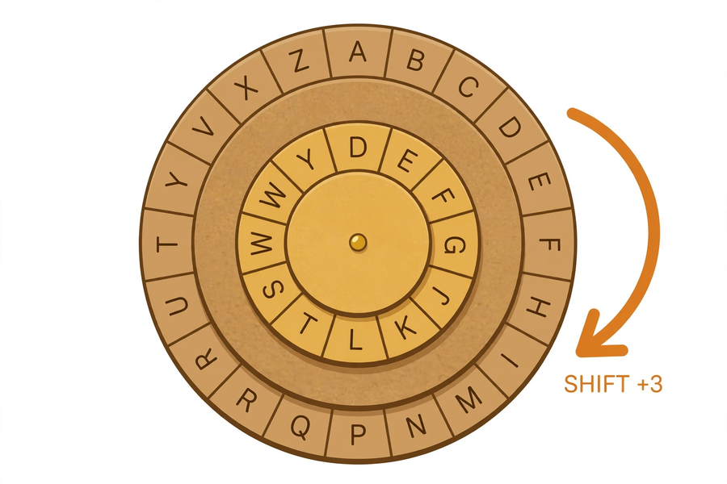
二、例子 Examples
例一：編碼 Example 1: Encoding
把 "CARE" 以位移 3 編碼：
Encode "CARE" with a shift of 3:
明文字母  Plain letter | C | A | R | E
位移 3 後  After shift 3 | F | D | U | H

所以 "CARE" 的密文是 "FDUH"。
So the cipher text of "CARE" is "FDUH".
例二：為句子編碼 Example 2: Encoding a sentence
把 "CARE FOR THE ELDERLY" 以位移 3 編碼（空格不變）：
Encode "CARE FOR THE ELDERLY" with a shift of 3 (spaces unchanged):
密文：FDUH IRU WKH HOGHUOB
Cipher text: FDUH IRU WKH HOGHUOB
例三：解碼 Example 3: Decoding
把 "FDUH" 以位移 3 解碼（把字母往相反方向移 3 位）：C←F、A←D、R←U、E←H，得原文 "CARE"。
Decode "FDUH" with a shift of 3 (move each letter 3 places back): F→C, D→A, U→R, H→E, giving "CARE".
例四：頻率分析破解 Example 4: Cracking by frequency analysis
密文（位移 7）：
Cipher text (shift 7):
DL JHYL MVY AOL LSKLYSF LCLYF ZPUNSL KHF
第一步——數頻率（出現次數最多的幾個字母）：
Step 1 — count frequencies (most frequent letters):
字母  Letter | L | Y | S | F | H | K
出現次數  Count | 8 | 4 | 3 | 3 | 2 | 2

- 第二步——找最高：L 出現 8 次，明顯最多。
- Step 2 — the highest: L appears 8 times, clearly the most.
- 第三步——推測位移：假設 L 就是 E。L 往回移 7 位是 E，所以位移量很可能是 7。
- Step 3 — infer the shift: assume L is E. Moving L back 7 places gives E, so the shift is probably 7.
- 第四步——驗證：把整段密文往回移 7 位，得到 "WE CARE FOR THE ELDERLY EVERY SINGLE DAY"，意思通順，破解成功！
- Step 4 — verify: shifting the whole text back by 7 gives "WE CARE FOR THE ELDERLY EVERY SINGLE DAY". It makes sense — cracked!
三、簡單問答題 Quick questions
- 在凱撒密碼中，「密鑰」是指什麼？ / In the Caesar cipher, what is the "key"?
- 位移 3 時，字母 Y 編碼後變成什麼？（留意環繞） / With a shift of 3, what does the letter Y become? (Watch the wrap-around.)
- 解碼時，應該把字母往哪個方向移？移多少？ / When decoding, which direction should letters move, and by how much?
- 頻率分析的第一步和第二步是什麼？ / What are the first two steps of frequency analysis?
四、思考題 Thinking questions
- 有人說：「位移量越大，密碼越安全。」你同意嗎？為什麼？ / Someone says: "The larger the shift, the safer the cipher." Do you agree? Why?
- 頻率分析為什麼只適用於簡單替代密碼？試想一個令頻率分析失效的方法。 / Why does frequency analysis only work on simple substitution ciphers? Suggest one way to defeat it.

五、分組題 Group task
分組編碼挑戰：每組用自選位移量，把一句關愛訊息（例如 HELP THE ELDERLY）加密，交給別組限時破解。
Group encoding challenge: each group encrypts a caring message (e.g. HELP THE ELDERLY) with a chosen shift, then passes it to another group to crack against the clock.
- 用密碼輪編碼，確保內圈 A 對準外圈 A。
- Encode with the cipher wheel; make sure inner A aligns with outer A.
- 記下所用的位移量（先保密），並記錄別組破解所用的時間。
- Note your shift (keep it secret for now) and record how long the other group takes to crack it.
- 破解時可嘗試：逐一轉動密碼輪試誤，或數字母頻率。
- To crack: try each wheel position in turn, or count letter frequencies.
六、總結 Summary
- 凱撒密碼：每個字母按固定位移量推移；位移量就是密鑰。
- Caesar cipher: shift every letter by a fixed amount; the shift is the key.
- 頻率分析四步：數頻率、找最高、推測位移、驗證。
- Frequency analysis in four steps: count, find the highest, infer the shift, verify.
- 凱撒密碼只有 25 種可能，逐一試誤即可破解，非常不安全。
- There are only 25 possible shifts — brute-force trial breaks it easily. It is very insecure.
- 加密保護個人資料；教導長者保護資料，就是關愛。
- Encryption protects personal data; teaching the elderly to protect theirs is care in action.
七、小測驗 Quiz
（滿分 12 分）
(Total: 12 marks)
- 凱撒密碼位移 3，「HELLO」編碼後是？ A. KHOOR B. HELLO C. EBIIL D. GDKKN（2 分） / With a Caesar shift of 3, "HELLO" becomes? A. KHOOR B. HELLO C. EBIIL D. GDKKN (2 marks)
- 把 "FDUH" 以位移 3 解碼，結果是？ A. CARE B. FDUH C. DARE D. CGTF（2 分） / Decoding "FDUH" with a shift of 3 gives? A. CARE B. FDUH C. DARE D. CGTF (2 marks)
- 英文中出現頻率最高的字母是？ A. Z B. E C. Q D. X（2 分） / The most frequent letter in English is? A. Z B. E C. Q D. X (2 marks)
- 「MJQU」是以位移 5 編碼的密文，原文是什麼？（2 分） / "MJQU" was encoded with a shift of 5. What is the plaintext? (2 marks)
- 用文字解釋：頻率分析是如何破解凱撒密碼的？（4 分） / Explain in words: how does frequency analysis break a Caesar cipher? (4 marks)

