John Benedict Z. Damalerio

G1-BSIT

1. Refer to the attached pdf NOTES Science Technology & Nation Building and make a collage of at least ten (10) inventions or discovery of 10 Filipino scientists. Indicate the name of the scientist within each invention and the year of discovery (20 points).

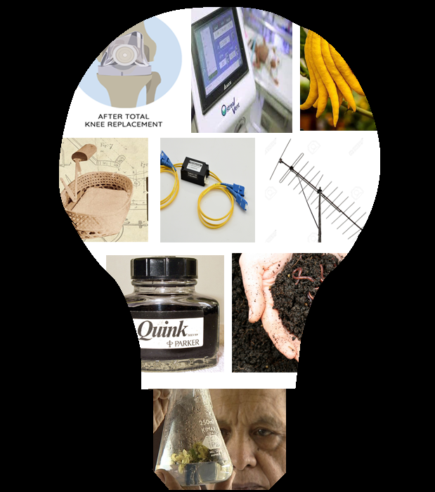

**Invention**

1. Method of promoting flowering of plants using potassium nitrate - Ramon Barba
2. meconium drug test - Enrique M. Ostrea Jr -
3. Discovered breeds of lime - Lilian F. Patena
4. Bamboo Incubator – Fe Del Mundo
5. All optical switch module – Gregory L. Tangonan
6. Analog Antenna - Gregory L. Tangonan -
7. Quink Ink – Fransico Quisumbing –
8. Vermicomposting – Rafael D. Guerrero
9. Different hip replacement system – Ramon Gustilo

2) Make another collage of at least (10) inventions or discovery of 10 foreign scientists. Indicate the name of the scientist within each invention and the year of discovery. (20 points)

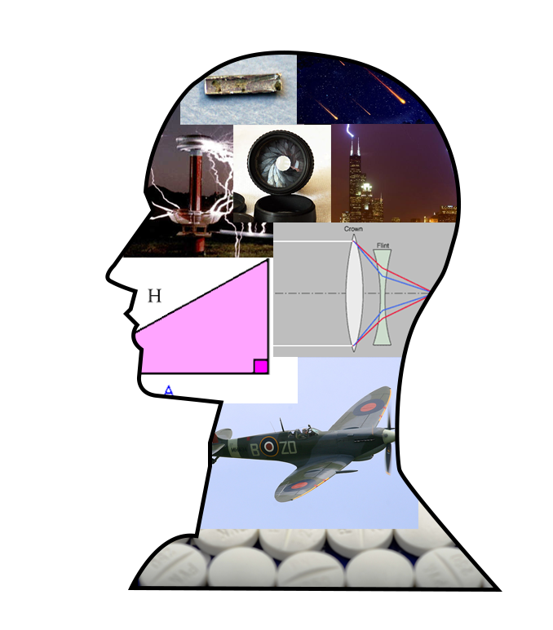

1. Lever – Archimedes – 5000 BC
2. Trigonometry – Hipparchus – 190 – 120 BCE
3. Iris diaphragm in cameras – Robert Hooke -
4. Monoplanes – Louis Bleriot -
5. Lightning Rod – Benjamin Franklin - 1752
6. apochromatic lens of the microscope – Carl Zeiss - 1729
7. Meteors – Frederick Denning -1920
8. Magnetism and Electricity – Andre Marie Ampere - 1820
9. Radium – Marie Curie - 1902
10. Penicillin – Alexander Fleming - 1928