John Benedict Z. Damalerio

BSIT-2

Activity 1

1. A picture of the DOS Command Window that displays the phrase “Hello World”

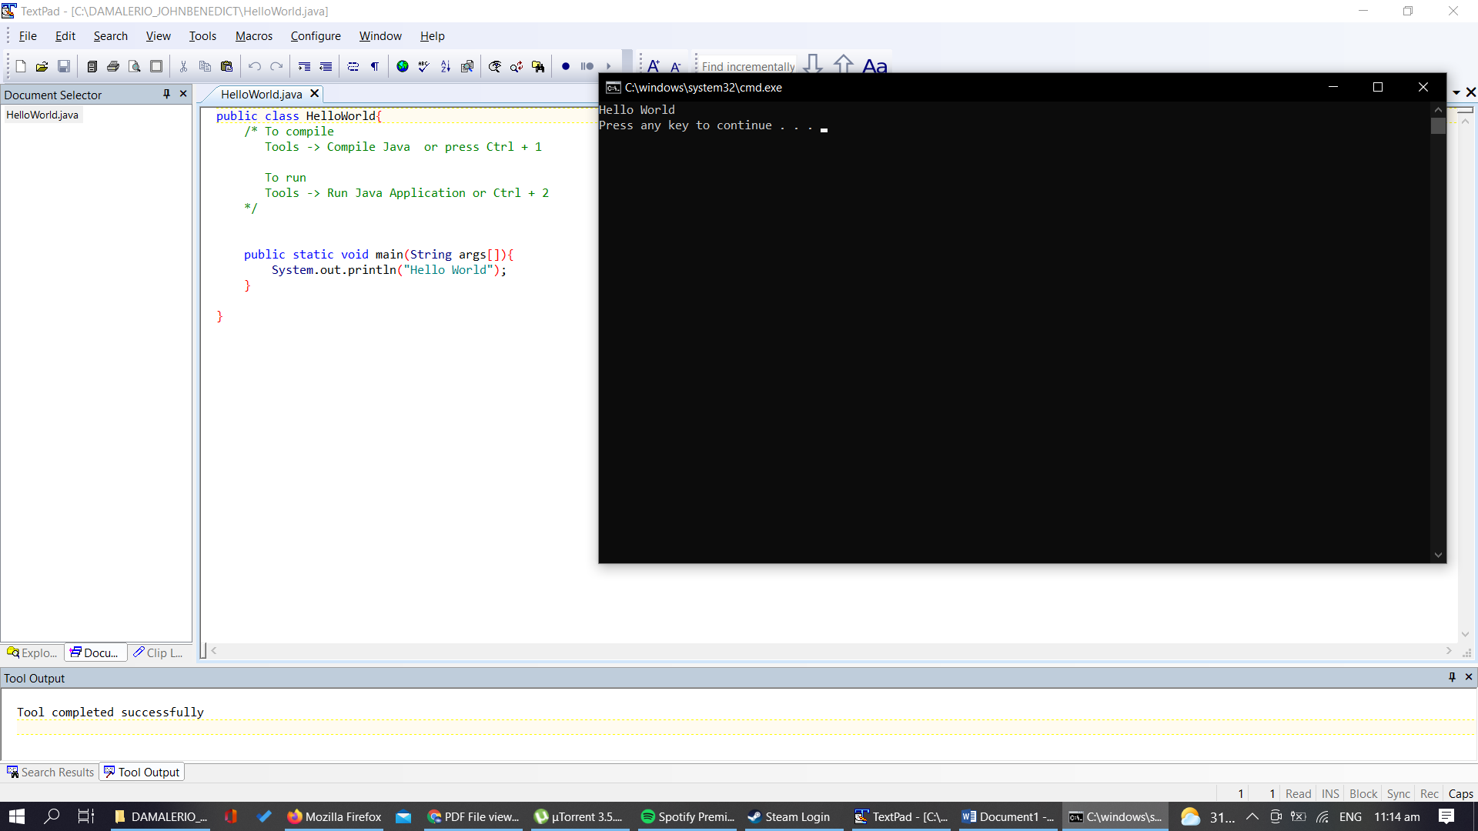

2. A picture of your directory file(showing your folder, HelloWorld.class and HelloWorld.java)

