

# On-the-Job-Training Weekly Journal Form

Name: Cardano, Hart C.

Inclusive Dates: September 25,27,28,29 2023 Company/Client Company: The Umonics Method Supervisor/Client’s Name Mr. Sancy Suraj

| **Day** | **Date** | **Work Description** | **Remarks** |
| --- | --- | --- | --- |
| Mon | 9/25/2023 | Book Chapters Creation | In progress |
| Tue | 9/26/2023 | School Day |  |
| Wed | 9/27/2023 | Book Chapters Creation | In progress |
| Thur | 9/28/2023 | Book Chapters Creation | In progress |
| Fri | 9/29/2023 | Book Chapters Creation | In progress |

POINT OF LEARNING: I’ve gained a knowledge about creating books chapters.

**This Journal must be accomplished and has to be submitted every Week in your portal.**

**Supervisor:**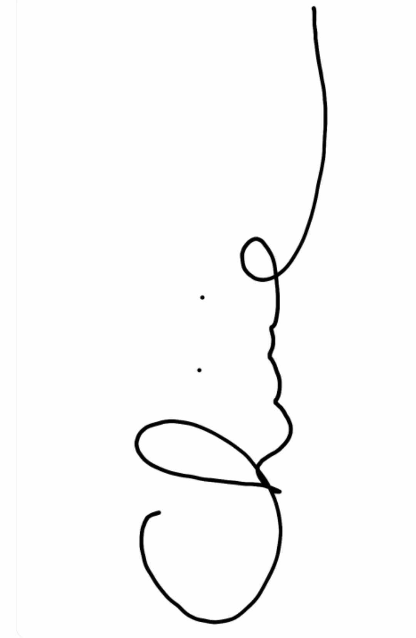

**CHINIE C. CAYANAN**

**Signature over printed name**

Prepared by: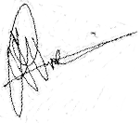

**MR. PAULO A. VICTORIA**

Program Head

On-the-Job Training Daily Journal and Accomplishment Report Page **1** of **1**