John Benedict Z. Damalerio

BSIT-4

PRELIM REQUIREMENT

MAVEN QUIZ 1



MAVEN QUIZ 2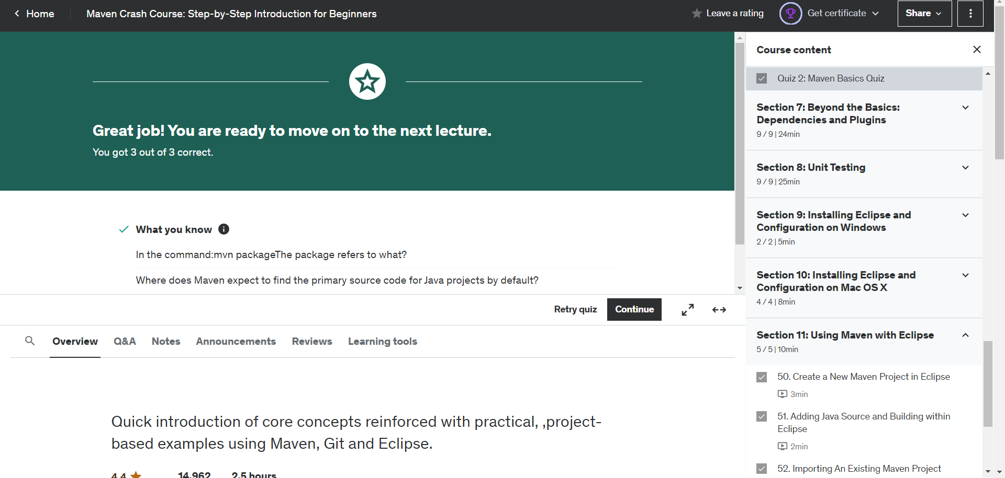MM

MAVEN QUIZ 3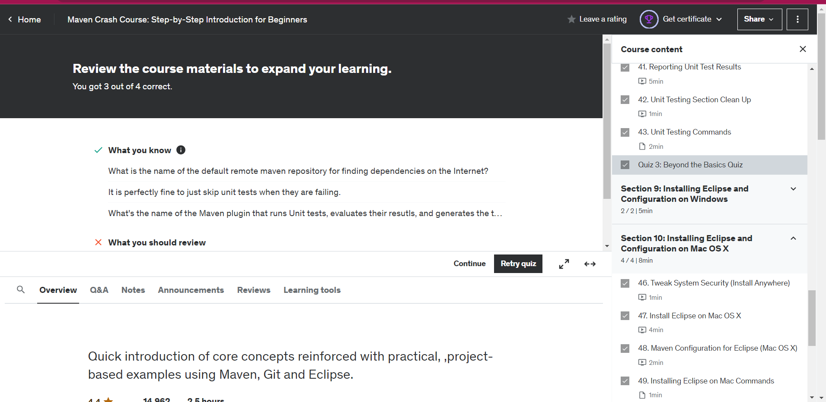

MAVEN QUIZ 4

