**CSIT385 Information Assurance and Security**

**Basic Linux Commands Exercise**

**Name: John Benedict Z. Damalerio_ Section:G1**

Secure a terminal of your choice. May it be an online tool, e.g. cocalc.com, or your own pc/desktop. Perform every steps and make a screenshot to be attached in the space provided.

Upon entering your terminal:

1. Check the directory name in which you are now by typing *pwd*.

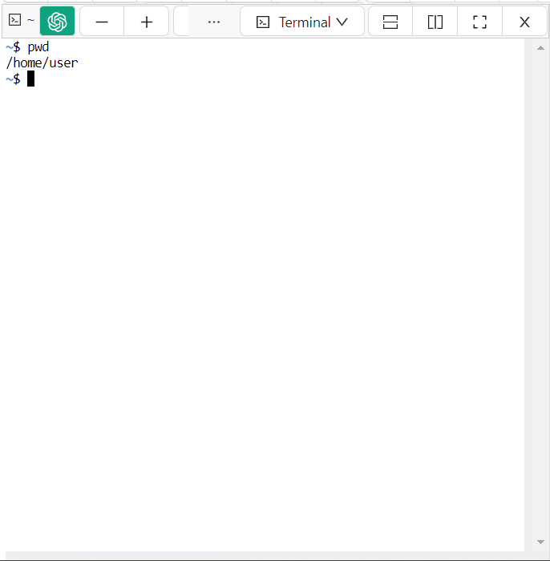

1. Check the contents of your current directory with *ls*.



1. Create directory with a name “Lastname-Date”. Example “Busico-07-09-2020” by typing *mkdir Busico-07-09-2020*.

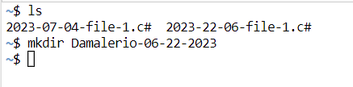

1. Check the information of the directory created in #3 by typing *ls –ld*. Example *ls –ld Busico-07-09-2020*.

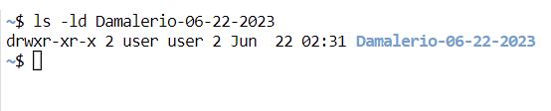

1. Recheck the contents of your current directory.



1. Change the current directory to the directory created in #3 with *cd*. Example *cd Busico-07-09-2020*.



1. Check the directory name in which you are now.

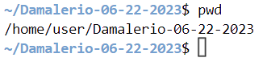

1. Create a file named *Me.txt* by typing *touch Me.txt.*



1. Recheck the contents of your current directory.

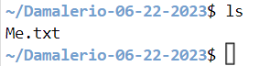

1. Check the size of the file created in #8.

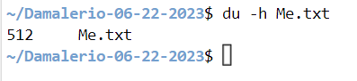

1. Modify the contents of the *Me.txt* and add basic information about yourself by typing *nano Me.txt.*Note: check other text editor of your machine is *nano* is unrecognized.

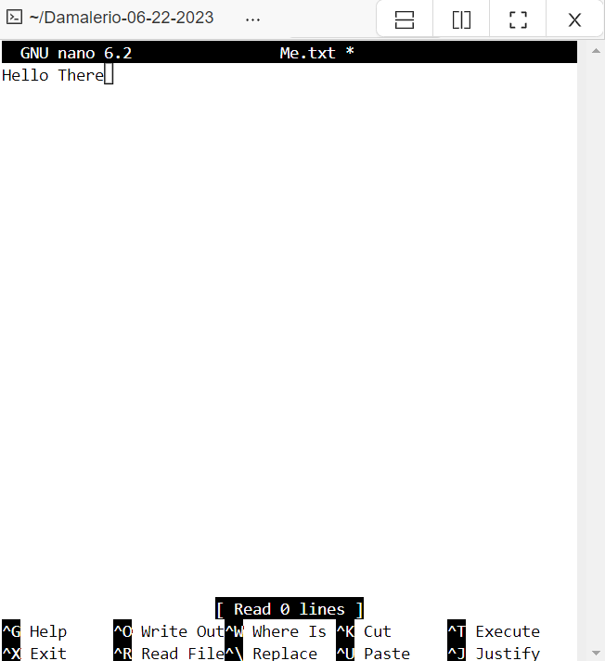



1. Create another file named “*YourFavoriteFood.txt”*. Example “Lumpia.txt”



1. Recheck the contents of your current directory with *ls*.

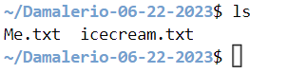

1. Delete the file created in #12 by typing *rm [FileName]*. Example *rm Lumpia.txt.*



1. Recheck the contents of your current directory with *ls*.

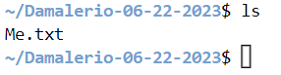

1. Recheck the size of the file created in #8 for changes in its size.

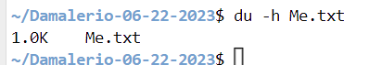

1. Create two more directories under the directory created in #3, namely *MyCourses and MySchedule.* Add dummy file in each directory created with a file name *Dummy.txt* and add the line, “Silence is Golden”.

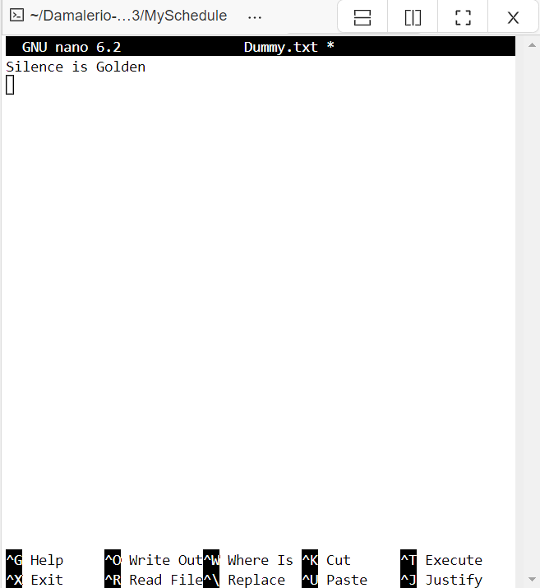

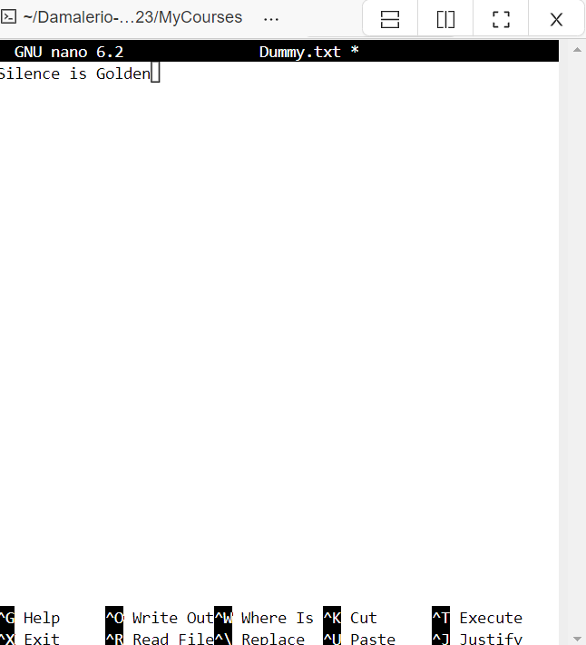

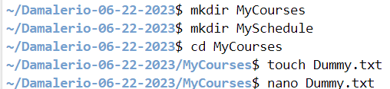

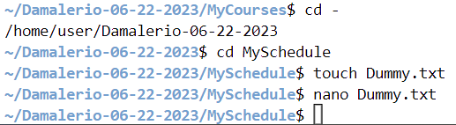

**Thank You and Have a Great Day!**

***-hyeumine***