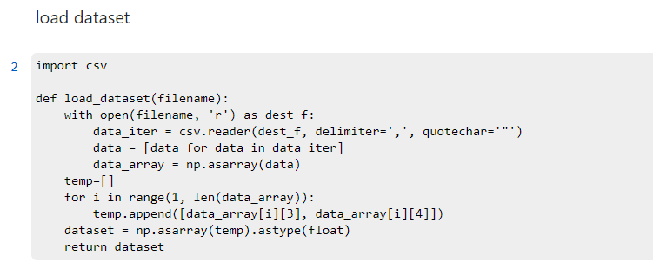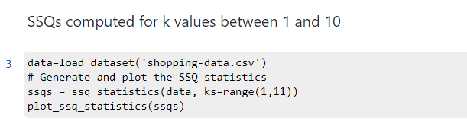

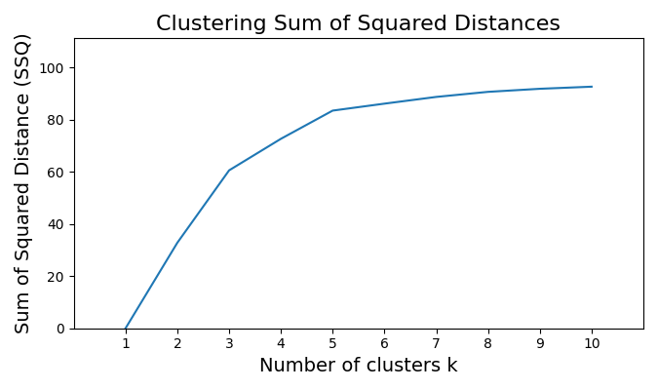

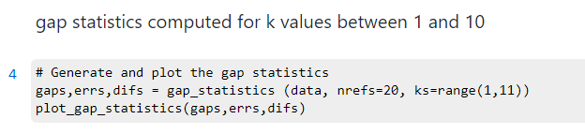

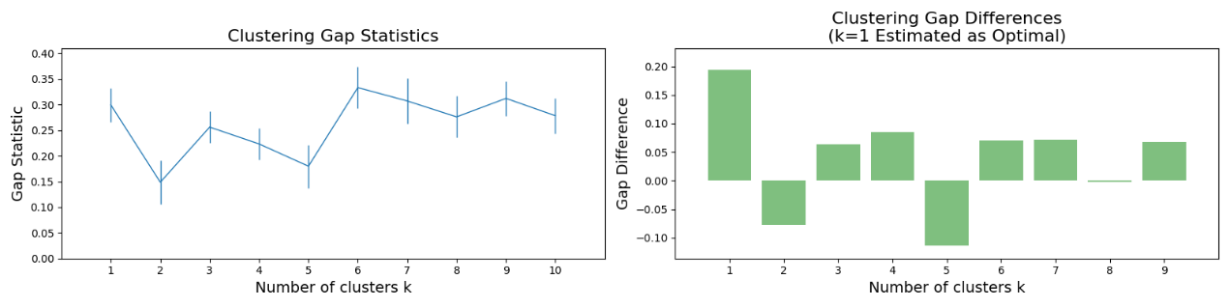

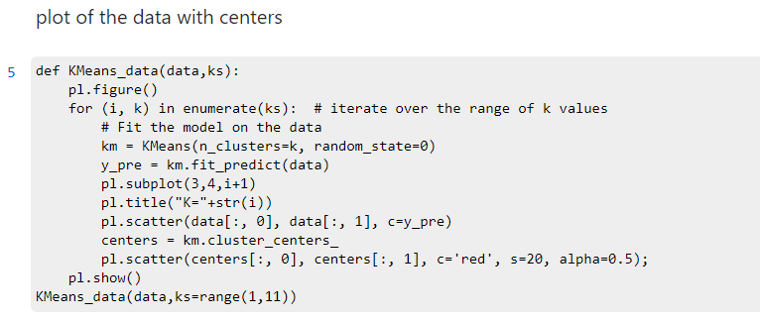

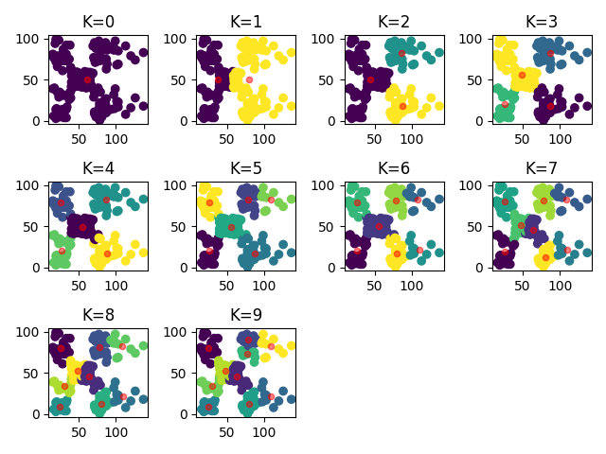

  
elbow point: k=3

gap statistic estimated: k=1



File a large amount of data into different categories, and then formulate different processing methods for each type of data, because each type of data is significantly different



Gap Statistics

Its advantage is that we no longer need to judge with the naked eye, only need to find the K corresponding to the largest Gap Statistic. The physical meaning of gap loss function is the difference between the loss of a random sample and the loss of an actual sample. The larger the gap, the better the clustering effect. An extreme case is that as K changes, the gap almost maintains a straight line. It shows that there is no obvious category relationship among these samples, and the data distribution is almost consistent with the uniform distribution, which is approximately random. There is no point in clustering at this time.