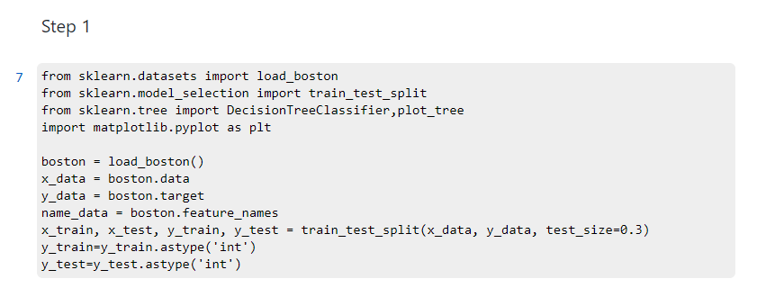

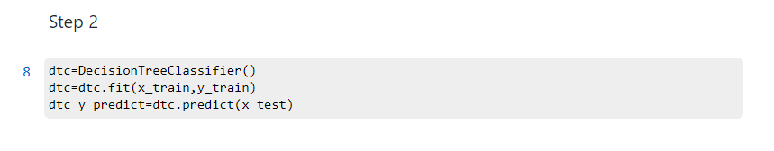

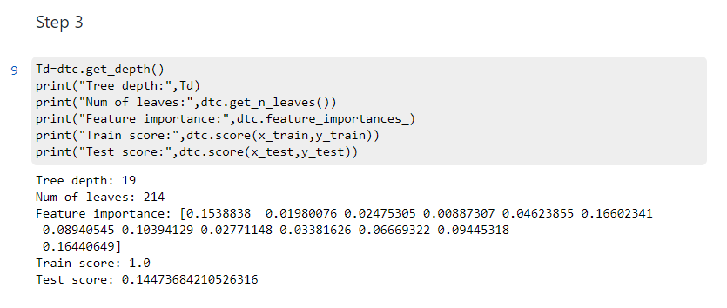

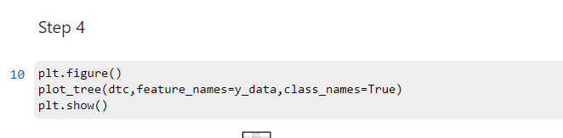

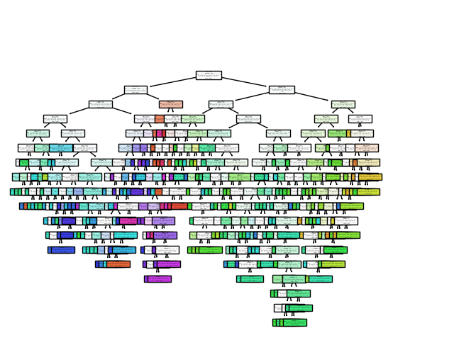

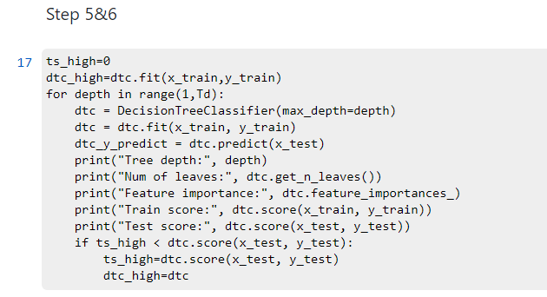

Tree depth: 1

Num of leaves: 2

Feature importance: [0. 0. 0. 0. 0. 0. 0. 0. 0. 0. 0. 0. 1.]

Train score: 0.11864406779661017

Test score: 0.09868421052631579

Tree depth: 2

Num of leaves: 4

Feature importance: [0.16769637 0. 0. 0. 0. 0.38854089

0. 0. 0. 0. 0. 0.

0.44376273]

Train score: 0.1553672316384181

Test score: 0.09868421052631579

Tree depth: 3

Num of leaves: 8

Feature importance: [0.24328957 0. 0. 0. 0. 0.38001023

0. 0. 0. 0. 0. 0.

0.3767002 ]

Train score: 0.2062146892655367

Test score: 0.14473684210526316

Tree depth: 4

Num of leaves: 16

Feature importance: [0.14452064 0. 0. 0. 0. 0.3202346

0. 0.10070509 0. 0.06000593 0.11528403 0.

0.25924971]

Train score: 0.2824858757062147

Test score: 0.11842105263157894

Tree depth: 5

Num of leaves: 31

Feature importance: [0.12159521 0.03205957 0.02391494 0.03308323 0. 0.24379498

0. 0.10648295 0.02066878 0. 0.09126891 0.0954126

0.23171884]

Train score: 0.3898305084745763

Test score: 0.1118421052631579

Tree depth: 6

Num of leaves: 58

Feature importance: [0.10860821 0.02058967 0.01535893 0.0212471 0. 0.22684156

0.06474341 0.06525252 0. 0.02096332 0.12928016 0.06894651

0.25816861]

Train score: 0.5112994350282486

Test score: 0.09868421052631579

Tree depth: 7

Num of leaves: 91

Feature importance: [0.11616543 0.01504035 0.03428698 0.02112301 0.03516188 0.20278985

0.09563693 0.08698452 0. 0.03188046 0.08289099 0.08528584

0.19275376]

Train score: 0.6271186440677966

Test score: 0.09868421052631579

Tree depth: 8

Num of leaves: 126

Feature importance: [0.13349056 0.01632072 0.05161766 0.01670041 0.02858032 0.20189482

0.10242865 0.08907376 0.00442942 0.02225258 0.08217074 0.07270041

0.17833994]

Train score: 0.7344632768361582

Test score: 0.10526315789473684

Tree depth: 9

Num of leaves: 153

Feature importance: [0.11500299 0.01794159 0.03974347 0.01061009 0.03253891 0.18944888

0.09298944 0.1012738 0.01174501 0.01732572 0.08151721 0.09503144

0.19483146]

Train score: 0.8107344632768362

Test score: 0.13157894736842105

Tree depth: 10

Num of leaves: 172

Feature importance: [0.1129328 0.0175051 0.03799804 0.02143501 0.05089916 0.17664736

0.11637146 0.09046687 0.02153919 0.02876352 0.07544962 0.07660366

0.17338822]

Train score: 0.8700564971751412

Test score: 0.13157894736842105

Tree depth: 11

Num of leaves: 183

Feature importance: [0.08569351 0.01911764 0.0444596 0.00931677 0.05041637 0.19323632

0.10866162 0.08765313 0.01762907 0.02137938 0.08234398 0.09622714

0.18386546]

Train score: 0.9011299435028248

Test score: 0.11842105263157894

Tree depth: 12

Num of leaves: 195

Feature importance: [0.08231419 0.01180507 0.04641366 0.01207971 0.04616896 0.17666851

0.08389129 0.115424 0.02138696 0.03595977 0.08250505 0.10299329

0.18238955]

Train score: 0.9350282485875706

Test score: 0.11842105263157894

Tree depth: 13

Num of leaves: 202

Feature importance: [0.10249275 0.01728385 0.04834249 0.00857392 0.0401527 0.1524569

0.08812657 0.12870902 0.01876782 0.03099325 0.08435746 0.08989582

0.18984746]

Train score: 0.963276836158192

Test score: 0.1513157894736842

Tree depth: 14

Num of leaves: 206

Feature importance: [0.11759584 0.01113281 0.04913719 0.01441324 0.06465864 0.15445527

0.07445231 0.110365 0.01913573 0.0359982 0.073449 0.10344438

0.17176238]

Train score: 0.9830508474576272

Test score: 0.09868421052631579

Tree depth: 15

Num of leaves: 213

Feature importance: [0.09025385 0.01388162 0.05307304 0.01117239 0.03158903 0.1647459

0.08779213 0.12074364 0.0162978 0.03236982 0.09086101 0.11350243

0.17371733]

Train score: 0.9971751412429378

Test score: 0.13157894736842105

