Jesse Wynn
MeEn 537 Robotics
Homework 7
December 13, 2017

Problem 1

PD control code:
function tau = torque_pd_condrol(q_des, q, q_dot)

% q_desired_1 = [pi, pi/2, pi/3, pi/4, pi/5, pi/6];
% q_desired_2 = [pi/6, pi/5, pi/4, pi/3, pi/2, pi];

% kp = 10;
% kd = 2;

kp = [10, 30, 20, 10, 10, 10];
kd = [2, 5, 2, 2, 2, 2];

tau1 = kp(1)*(q_des(1) - q(1)) - kd(1)*(q_dot(1));
tau2 = kp(2)*(q_des(2) - q(2)) - kd(2)*(q_dot(2));
tau3 = kp(3)*(q_des(3) - q(3)) - kd(3)*(q_dot(3));
tau4 = kp(4)*(q_des(4) - q(4)) - kd(4)*(q_dot(4));
tau5 = kp(5)*(q_des(5) - q(5)) - kd(5)*(q_dot(5));
tau6 = kp(6)*(q_des(6) - q(6)) - kd(6)*(q_dot(6));

tau = [tau1, tau2, tau3, tau4, tau5, tau6];
end

Simulink Block Diagram:
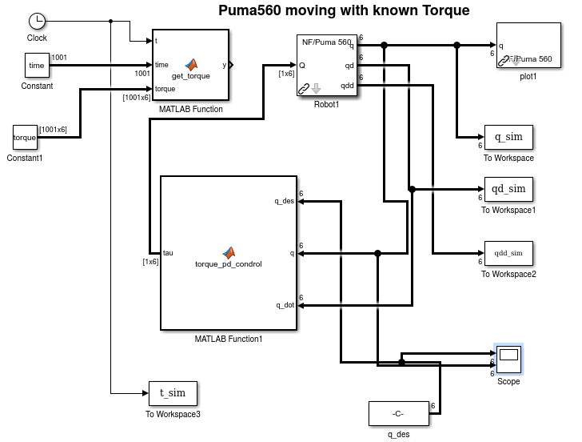

Problem 1 cont.

Plots q-desired and q-actual vs time:
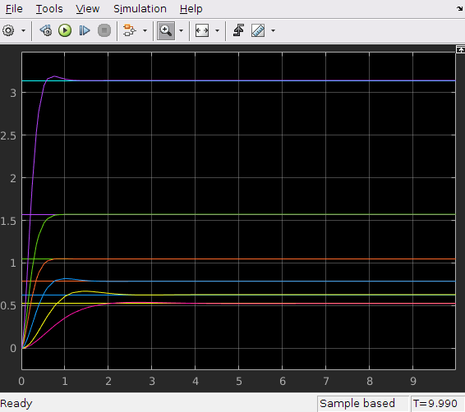

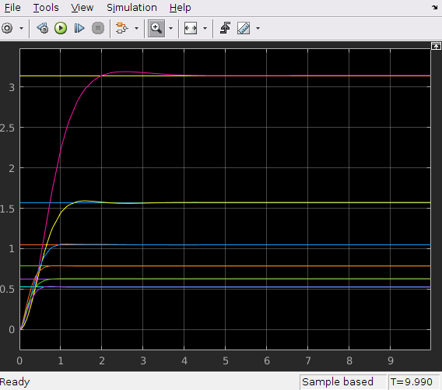

Problem 2
(a) Done.
(b) See plots below

sl ctorque plots (correct params and then perturbed params):
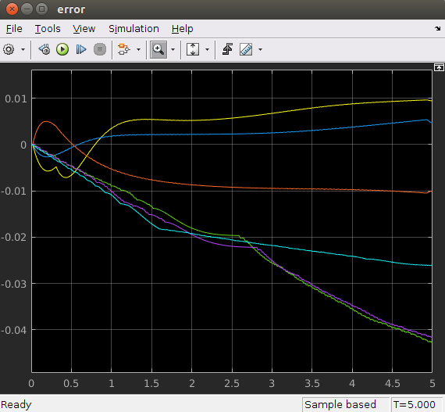
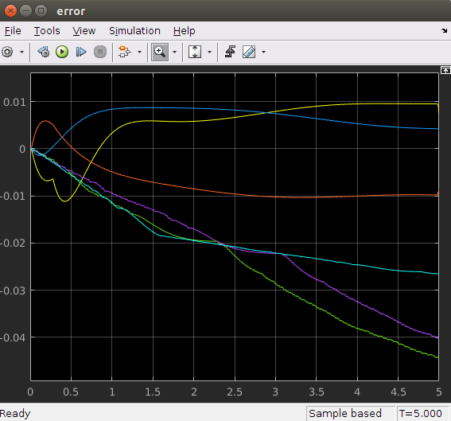

For the sl_ctorque controller simulation, the results were pretty similar using the real robot parameters and the perturbed parameters. This tells us that this particular controller does a pretty good job.

sl fforward plots (correct params and then perturbed params):
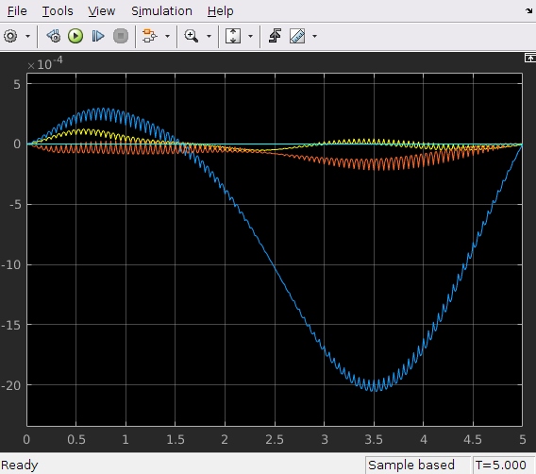
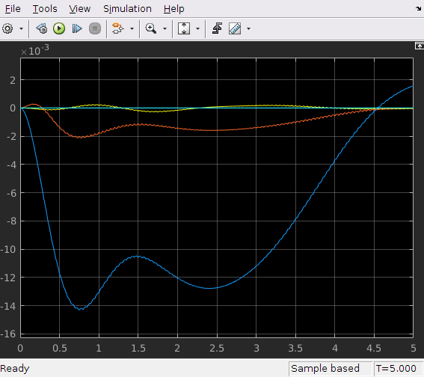

In the case of the feed-forward controller, the error with the perturbed parameters was an order of magnitude larger than it was with perfect parameters but the overall performance is still very good. In both cases the error is very small.

Problem 3

