Midterm Problem 1b Plots for the Full Nonlinear system from t = 0 to t = 100
solution trajectories
‘o’ starting point
‘*’ ending point
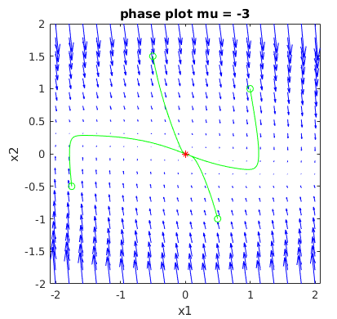
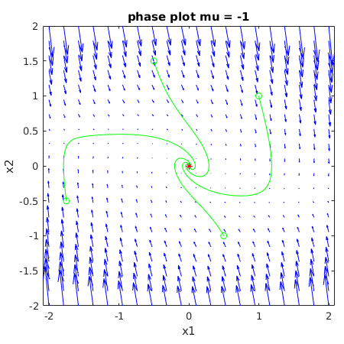
mu < 0 :

mu = 0 :

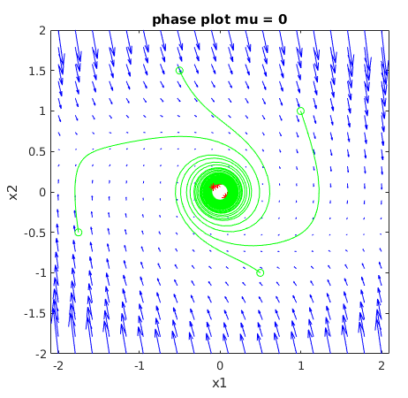

mu > 0:

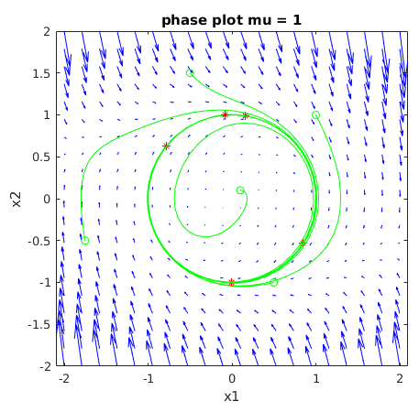

Conclusions:

Changing mu has a large impact on the behavior of the system (both the full nonlinear system and the linearized systems). With mu < 0 we have stable behavior with possibilities of a stable node or a stable focus. With mu = 0 we have centers, and with mu > 0 we have unstable behavior from the equilibrium. Interestingly it with mu > 0 we also have a limit cycles.

