Jesse Wynn
Nonlinear Systems Theory
Application Homework

Differential Flatness Control of a Planar VTOL

VIDEO: https://youtu.be/o8jLKYmxDmM (see 2nd half of video for fast performance)

Q1: Why is this control strategy a good choice for this system?

Differential Flatness (DF) is a good choice for systems which will be following predetermined trajectories that are several times differentiable. Since the planar quad usually flies in a small simulation space, a differential path such as an ellipse or figure-8 is a good path for it to fly. Additionally, the VTOL is a good candidate for DF because the mapping from accelerations outputted by DF to forces and torques inputted to the system dynamics is fairly straightforward.

There are however some drawbacks to DF on the planar VTOL that make it less well suited for DF than a regular quadrotor. A quadrotor can fly interesting paths while maintaining constant altitude (E.g. a roll-pitch actuated horizontal figure 8) while the VTOL has to fly up and down. I found that oftentimes due to the VTOL’s mass and the force of gravity, the VTOL had a hard time raising and lowering itself as quickly as trajectories wanted it to do so (see second plot below). In the case of a quadrotor, it’s much less demanding and much more physically feasible to execute aggressive roll and pitch maneuvers. Rolling and pitching torques can also be positive or negative in sign and thus can be fully actuated in both directions. In the case of the planar VTOL, thrust is only positive and can only force the VTOL up an cannot force the VTOL down. Thus at any instance, the VTOL is limited in how quickly it can accelerate downwards and can only fall as fast as gravity allows.

Q2: What are the strengths/weaknesses of the control strategy

The main weakness of DF is that it assumes instantaneous accelerations. Because this is not actually possible on physical systems this can cause lag and slow initial convergence to the desired trajectory. Additionally, if your physical system can’t keep up with the commanded trajectory, then the system and the command can get out of phase with each other—leading to poor performance. I had this problem with the planar VTOL especially in the vertical (hight) axis (see plots below).

Good ans here about instant accel

Q3: How does the cost of implementation compare with the benefits of results to that of a linear control strategy? What are the trade-offs?

The cost of implementation for simple DF trajectories is fairly low and seems well worth the effort if you are applying it to an ideal system (such as the quadrotor) in a very controlled environment (such as a motion-capture room). Performance in flying aggressive maneuvers is far superior to that of linear or PID control. If your trajectories are slow or more step-like in nature, then I believe that a linear controls approach is much more appropriate. In the first plot below, you can see that PID performed just as well while flying a slow trajectory. In the second plot you can see that although not perfect (largely due to the reasons discussed in answer to question 1), DF performed much better than PID on a fast trajectory.
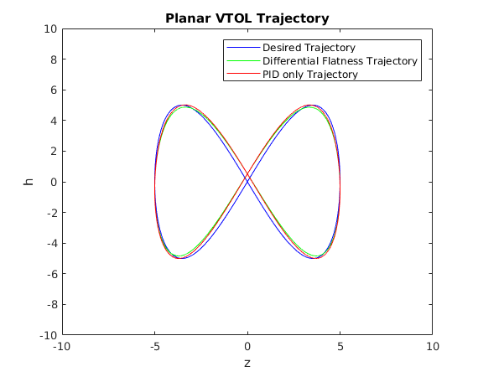
Results from a slow trajectory:

Note that performance is about the same as PID alone.

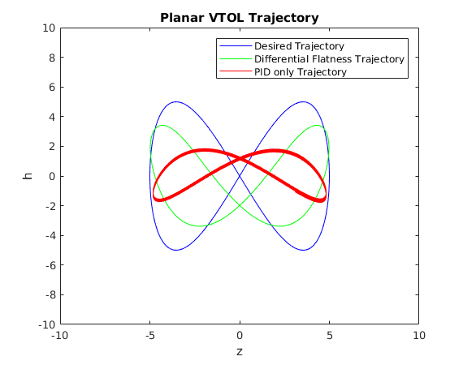

Results from a fast trajectory:

While performance isn’t perfect, DF matches the desired trajectory much better than PID and it follows the exact same path over and over again whereas PID has some variation (hense the thick red lines).

