Jesse Wynn
ME 575
February 17, 2018
Design Project 1

Ground Target Interception Optimization

Section I. Title Page

Problem Statement:
Maximize the field-of-view (FOV) from a downward-facing camera on a quadrotor while keeping the relative size of a ground target (in the image frame) large enough such that all target features are guaranteed to be distinguishable to a computer vision algorithm. Design variables for this problem are image sensor width (pixels), square target width (meters), height above ground (meters), and camera focal length (meters).

Main Results:
sensor_width = 1114.29 (pixels)
target_size = 1.49 (meters)
height = 29.99 (meters)
focal_length = 4.29e-3 (meters)
fov = 1746.05 (meters^2)

Note: The result above was found to be a local maximum (discussed further in Section III).

Section II. Procedure

Model Development:

Model development was based off of well-known mathematical models, as well as results from actual experiments that were conducted as part of this project. The fundamental set of equations used in the model stem from projective geometry relationships and the pinhole camera model. The other relationships such as computational cost and image processing requirements (required number of pixels to adequately represent target features) are approximations based on experiments conducted as part of my research. The overall geometry of the problem is described in Figure 1.

Key Assumptions:
- Square image sensor
- Square pixels
- Pinhole camera model is sufficient

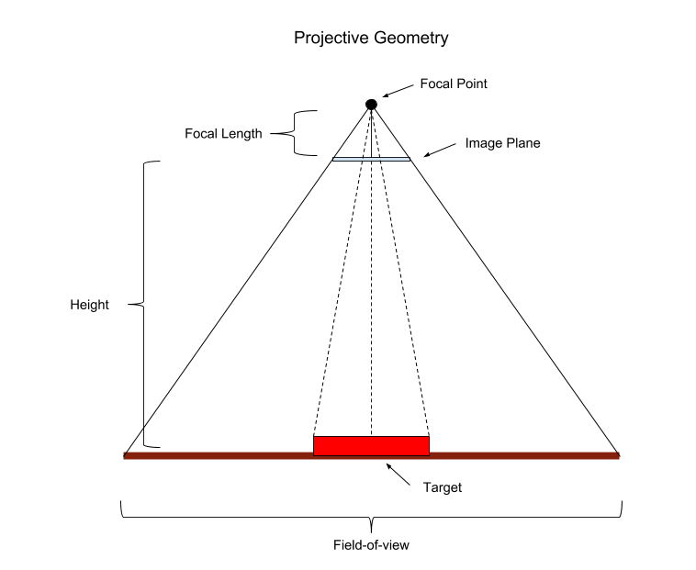
Figure 1.

Model Robustness and Testing

Robustness of the model was insured by removing any opportunities for the model to 'blow up' to infinity or 'NaN'. Since the tangent function is used in the model, and tangent is undefined for multiples of pi/2, a simple check with an 'if' statement makes sure that the value passed to tangent is less than pi/2. If the value equals or exceeds pi/2, a value of 0.99*pi/2 is passed to the function instead. Based on several tests of using the model in the optimizer, robustness has been verified through having no model failures.

Optimization Problem Functions and Equations:

Design Variables:
- Height, h (meters)
- Focal length, fl (meters)
- Sensor width, ss_pix (pixels)
- Target size, ts (meters)
Design Functions (in-loop sequence): Compute...
- Angular field of view of the camera, v (radians)
- Field-of-view of the downward-facing camera, fov (square meters)
- Size of target in the image plane, uv_target (square meters)
- Pixel size (meters)
- Size of the target in the image plane, uv_pix (pixels)
- Time to process the image, t_proc (seconds)
- Image processing rate, rate_proc (1/seconds)

Model Constraints:

- 0.3mm <= Focal length <= 25 mm
- Image processing rate >= 10
- 0.5 m <= Target Size <= 1.5 m
- Target area (pixels) >= 1600
- Height <= 30 m

Section III. Results and Discussion of Results

Table 1: Optimum values of variables and functions
Design Variable / Function | Optimal Value | Constraint Status
Height | 29.99 meters | At constraint (binding)
Focal length | 4.29 millimeters | Within constraint bounds
Sensor width | 1114.29 pixels | Within constraint bounds
Target Size | 1.499 meters | At constraint (binding)
Angular field of view | 1.217 radians | -
Field-of-view (objective) | 1746.05 square meters | -
Target area (image plane) | 1.155e-08 square meters | -
Pixel size | 5.373e-06 meters | -
Target area (image plane--pixels) | 1600 pixels | At constraint (binding)
Time to process image | 0.01 seconds | -
Image processing rate | 10.0 | At constraint (binding)
**After optimization, objective value increased from starting value of 195 to 1746 square meters

Contour Plots
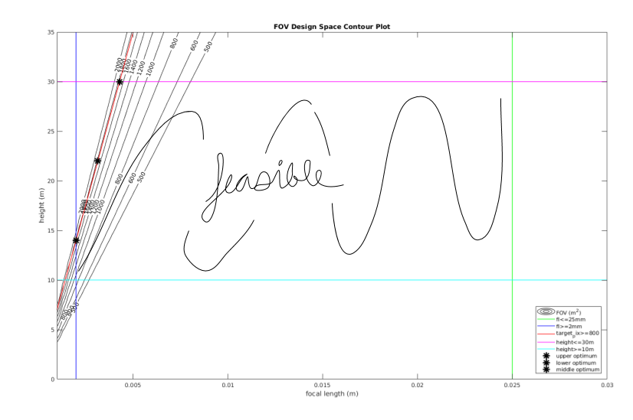
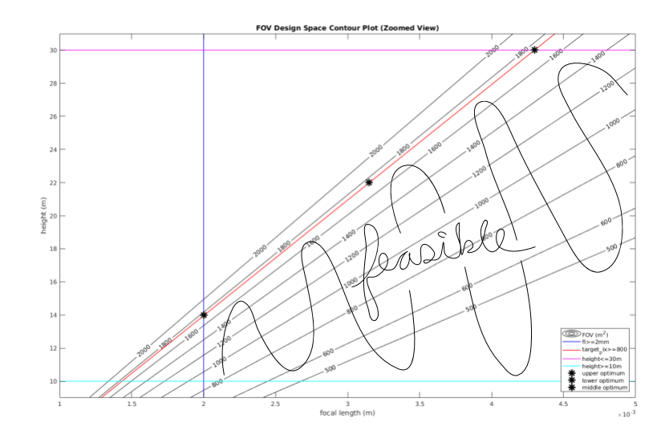
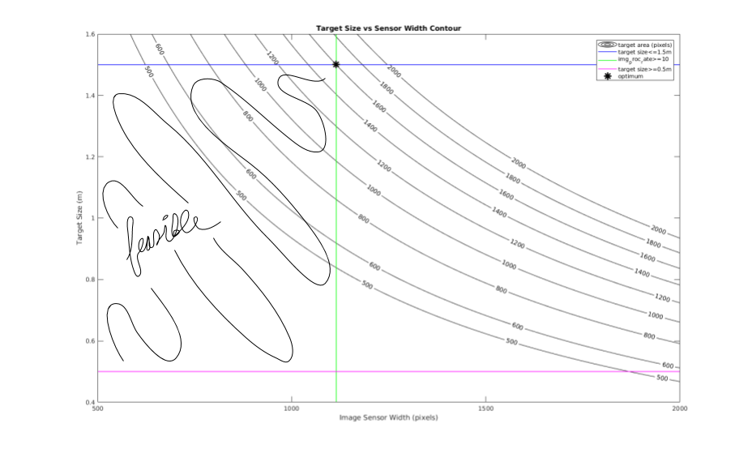
Discussion and Observations

As can be seen from the contour plots, the design space for this problem includes a linear region along which many equally-optimal combinations of height and focal length exist. Thus for this problem there is an infinite number of local optimums. After a closer inspection of the problem, this outcomes makes sense. Even though there are four design variables, the variables of focal length and height are correlated and both change how the target is perceived in the image plane. For example, the target in the image plane may appear the same with a shorter focal length at lower height as it does with a longer focal length from a greater height. The root of this correlation is because of the similar triangle relationships in the model geometry. If the variable of height or focal length is changed from a design variable to a fixed variable, then a single optimal value can be found. Although initially disappointing that the problem as posed contains no single optimum set of design variables, the results are still very useful. For most fixed-lens cameras, lenses can be purchased in only a select number of focal lengths. The results of this project allow one to select a lens between 2 and 4.3 mm, and then directly look up the optimal height for that lens. As for the two other design parameters, the optimal value for the sensor width in pixels is at the maximum that it can be while respecting the image processing rate constraint, and the physical target size is also at the maximum constraint. Both of these results make sense.

Section IV. Appendix

Fmincon optimization MATLAB script:

function [xopt, fopt, exitflag, output] = fov_optimizer()

% ------------Starting point and bounds------------
% design variables: height, focal length, sensor size, target size
x0 = [14, 0.006, 1260, 0.707]; % starting point
ub = [100, 0.015, 2000, 5.0]; % upper bound
lb = [1, 0.001, 300, 0.25]; % lower bound

% ------------Linear constraints------------
A = [];
b = [];
Aeq = [];
beq = [];

% ------------Objective and Non-linear Constraints------------
function [f, c, ceq] = objcon(x)

% set objective/constraints here

% design variables (things we'll adjust to find optimum)
h = x(1); % approach height or distance to target (m)
fl = x(2); % camera focal lenght (m)
ss_pix = x(3); % sensor size (width of square pixel array in pixels)
ts = x(4); % target_size (width of square target) (m)

% other analysis variables (constants that the optimization won't touch)
ss_physical = 1/3; % physical sensor size in inches (diagonal)
min_target_pixels = 800; % minimum number of pixels that can
% represent the target and still have
% the target's features be
% distinguishable.
F_safe = 2; % safety factor min_target_pixels;

% analysis functions
ss_w = ss_physical * sqrt(2)/2; % physical sensor width (inches)
ss_w = ss_w * 0.0254; % convert sensor width to meters
v = 2 * atan(ss_w/(2*fl)); % angular field of view of the camera

% here we don't let tan(x) blow up to infinity
if (v/2) < 0.99*pi/2
fov_w = 2 * (h * tan(v/2)); % width of rectangular region camera can see
else
fov_w = 2 * (h * tan(0.99*v/2));
end

fov_h = fov_w; % height of rectangular region camera can see

u_target = (fl/h) * (ts/2); % projection of the target onto the image plane (meters)
v_target = u_target; % same as above since target is square (meters)
pix_size = ss_w/ss_pix; % pixel size (meters)
target_area_pix = (2 * u_target/pix_size) * (2 * v_target/pix_size); % area of target in pixels

% rate at which images can be processed is directly proportional to
% the area (in pixels) of the sensor
tpp = 8.0539e-8; % time it takes to process each pixel (found from experimentation)
t_proc = tpp * ss_pix^2; % time to process the image
rate_proc = 1/t_proc; % rate at which images can be processed

% what we're optimizing
fov = fov_w * fov_h % area in square meters that camera can see

% objective function (what we're trying to optimize)
f = -fov; % maximize Field-of-view (m^2)

% inequality constraints (c<=0)
c = zeros(7,1);
c(1) = (fl - 0.025)*1; % focal length <= 25 mm
c(2) = (-fl + 0.002)*1; % focal length >= 2 mm
c(3) = -rate_proc + 10; % image processing rate >= 10 hz
c(4) = ts - 1.5; % target size (width) <= 1.5 meters
c(5) = -ts + 0.5; % target size (width) >= 0.3 meters
c(6) = -target_area_pix + F_safe * min_target_pixels; % target's area in pixels >= safety_factor * 800
c(7) = h - 30; % height <= 30 meters

% equality constraints (ceq=0)
ceq = []; % empty when we have none

end

% ------------Call fmincon------------
options = optimoptions(@fmincon, 'display', 'iter-detailed');
options.StepTolerance = 1e-20;
options.MaxFunctionEvaluations = 60000;
[xopt, fopt, exitflag, output] = fmincon(@obj, x0, A, b, Aeq, beq, lb, ub, @con, options);

% ------------Separate obj/con (do not change)------------
function [f] = obj(x)
[f, ~, ~] = objcon(x);
end
function [c, ceq] = con(x)
[~, c, ceq] = objcon(x);
end
end

Contour plot scripts:
% This script constructs a contour plot for the fov optimization
clc
clear
close all

% height vs. focal length
res = 100;

% limits for zoomed out view
fl_min = 0.001;
fl_max = 0.03;
h_min = 0.0;
h_max = 35.0;

[fl,height] = meshgrid(fl_min:(fl_max - fl_min)/res:fl_max, h_min:(h_max - h_min)/res:h_max);

% limits for zoomed in view
fl_min = 0.001;
fl_max = 0.005;
h_min = 9.0;
h_max = 31.0;

[fl_zoom,height_zoom] = meshgrid(fl_min:(fl_max - fl_min)/res:fl_max, h_min:(h_max - h_min)/res:h_max);

res = 100;

fov = zeros(res+1);
target_area_pix = zeros(res+1);
target_area_pix_zoom = zeros(res+1);

% constants
ss_physical = 1/3;
F_safe = 2;
min_target_pixels = 800;

% optimums for the variables (from optimization)
ss_pix = 1114.286537365992; % optimal pixel size
ts = 1.499999999828; % optimal target size

h_opt_up = 29.999;
fl_opt_up = 0.004297954694;
h_opt_low = 13.99;
fl_opt_low = 0.002;
h_opt_mid = 22;
fl_opt_mid = 0.003148862;

% design variables at mesh points
% [fl,height] = meshgrid(fl_min:(fl_max - fl_min)/res:fl_max, h_min:(h_max - h_min)/res:h_max);

% equations
ss_w = ss_physical * sqrt(2)/2; % physical sensor width (inches)
ss_w = ss_w * 0.0254; % convert sensor width to meters
for i=1:length(fl)
for j=1:length(fl)
v = 2 * atan(ss_w/(2*fl(i,j))); % angular field of view of the camera
fov_w = 2 * (height(i,j) * tan(v/2)); % width of rectangular region camera can see
fov_h = fov_w; % height of rectangular region camera can see
fov(i,j) = (fov_w * fov_h); % area in square meters that camera can see

u_target = (fl(i,j)/height(i,j)) * (ts/2); % projection of the target onto the image plane (meters)
v_target = u_target; % same as above since target is square (meters)
pix_size = ss_w/ss_pix; % pixel size (meters)
target_area_pix(i,j) = (2 * u_target/pix_size) * (2 * v_target/pix_size); % area of target in pixels
end
end

for i=1:length(fl_zoom)
for j=1:length(fl_zoom)
v = 2 * atan(ss_w/(2*fl_zoom(i,j))); % angular field of view of the camera
fov_w = 2 * (height_zoom(i,j) * tan(v/2)); % width of rectangular region camera can see
fov_h = fov_w; % height of rectangular region camera can see
fov_zoom(i,j) = (fov_w * fov_h); % area in square meters that camera can see

u_target = (fl_zoom(i,j)/height_zoom(i,j)) * (ts/2); % projection of the target onto the image plane (meters)
v_target = u_target; % same as above since target is square (meters)
pix_size = ss_w/ss_pix; % pixel size (meters)
target_area_pix_zoom(i,j) = (2 * u_target/pix_size) * (2 * v_target/pix_size); % area of target in pixels
end
end

figure(1)
% [C,h] = contour(fl,height,fov,[500:100:2000],'k');
[C1,h1] = contour(fl,height,fov,[500, 600, 800, 1000, 1200, 1400, 1600, 1800, 2000],'k');
clabel(C1,h1,'Labelspacing',250);
title('FOV Design Space Contour Plot');
xlabel('focal length (m)');
ylabel('height (m)');
hold on;
% solid lines to show constraint boundaries
contour(fl,height,(fl - 0.025),[0.0,0.0],'g-','LineWidth',1);
contour(fl,height,(-fl + 0.002),[0.0,0.0],'b-','LineWidth',1);
contour(fl,height,(-target_area_pix + F_safe * min_target_pixels),[0.0,0.0],'r-','LineWidth',1);
contour(fl,height,(height - 30),[0.0,0.0],'m-','LineWidth',1);
contour(fl,height,(height - 10),[0.0,0.0],'c-','LineWidth',1);
plot(fl_opt_up,h_opt_up,'k*','MarkerSize',12,'LineWidth',2)
plot(fl_opt_low,h_opt_low,'k*','MarkerSize',12,'LineWidth',2)
plot(fl_opt_mid,h_opt_mid,'k*','MarkerSize',12,'LineWidth',2)
% show a legend
legend('FOV (m^2)','fl<=25mm','fl>=2mm','target_pix>=800','height<=30m', ...
'height>=10m','upper optimum','lower optimum','middle optimum', 'Location','SouthEast')

figure(2)
% [C,h] = contour(fl,height,fov,[500:100:2000],'k');
[C2,h2] = contour(fl_zoom,height_zoom,fov_zoom,[500, 600, 800, 1000, 1200, 1400, 1600, 1800, 2000],'k');
clabel(C2,h2,'Labelspacing',250);
title('FOV Design Space Contour Plot (Zoomed View)');
xlabel('focal length (m)');
ylabel('height (m)');
hold on;
% solid lines to show constraint boundaries
%contour(fl,height,(fl - 0.025),[0.0,0.0],'g-','LineWidth',1);
contour(fl_zoom,height_zoom,(-fl_zoom + 0.002),[0.0,0.0],'b-','LineWidth',1);
contour(fl_zoom,height_zoom,(-target_area_pix_zoom + F_safe * min_target_pixels),[0.0,0.0],'r-','LineWidth',1);
contour(fl_zoom,height_zoom,(height_zoom - 30),[0.0,0.0],'m-','LineWidth',1);
contour(fl_zoom,height_zoom,(height_zoom - 10),[0.0,0.0],'c-','LineWidth',1);
plot(fl_opt_up,h_opt_up,'k*','MarkerSize',12,'LineWidth',2)
plot(fl_opt_low,h_opt_low,'k*','MarkerSize',12,'LineWidth',2)
plot(fl_opt_mid,h_opt_mid,'k*','MarkerSize',12,'LineWidth',2)
% show a legend
legend('FOV (m^2)','fl>=2mm','target_pix>=800','height<=30m', ...
'height>=10m','upper optimum','lower optimum','middle optimum', 'Location','SouthEast')

