Jesse Wynn
ME EN 575 Optimization
Homework 1
Spring Design
Jan 19, 2018

Report

Objective
Maximize the force of a spring at its preloaded height, h0 by varying design parameters wire diameter, coil diameter, number of coils, and free height (d, D, n, hf respectively).

I. Main Optimization Results
d = 0.0724
D = 0.6776
n = 7.5928
hf = 1.3691

F = 6.4541
k = 17.4854
K = 1.1561
hs = 0.55
Tau_m = 5.2224e+04
Tau_a = 1.8353e+04
Tau_hs = 7.5165e+04
Sy = 1.0586e+05

Constraints (c <= 0)
c(1) = Tau_hs – Sy – binding
c(2) = Tau_a – Se/Sf
c(3) = Tau_a + Tau_m – Sy/Sf – binding
c(4) = (D/d) – 16 – binding
c(5) = -(D/d) + 4
c(6) = d - 0.2
c(7) = -d + 0.01
c(8) = D + d – 0.75 – binding
c(9) = -hdef + hs + 0.05 – binding

II. Optimization Setup
Table 1 Variable and Function Mappings
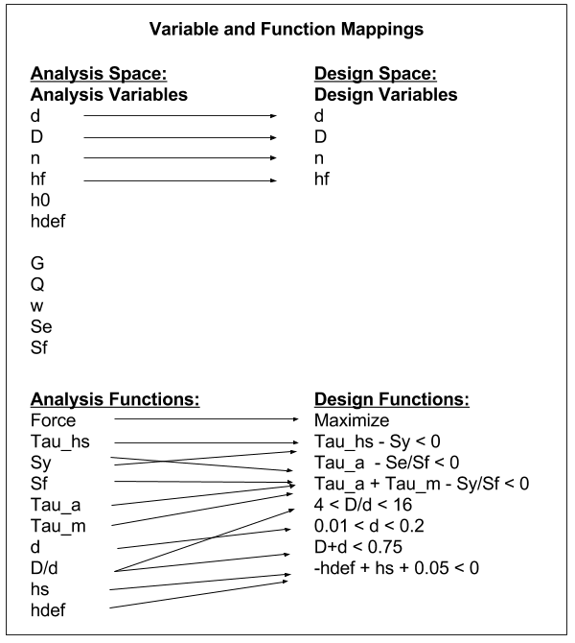

III. Results
Table 2 Optimum Values (variables and functions)
Variables | Value
d | 0.0724
D | 0.6776
n | 7.5928
hf | 1.3691
Functions | Value
F | 6.4541
k | 17.4854
K | 1.1561
hs | 0.5500
Tau_m | 5.2224e+04
Tau_a | 1.8353e+04
Tau_hs | 7.5165e+04
Sy | 1.0586e+05
Table 3 Starting Points & Results
Starting Points |  |  |  | Optimized Results
d | D | n | hf | d | D | n | hf
0.015 | 0.5 | 10.0 | 1.5 | 0.0724 | 0.6776 | 7.5928 | 1.3691
0.15 | 1.0 | 1.0 | 7.0 | 0.0724 | 0.6776 | 7.5928 | 1.3691
0.08 | 0.75 | 3.0 | 0.9 | 0.0724 | 0.6776 | 7.5928 | 1.3691
0.01 | 0.2 | 9.0 | 5.0 | 0.0724 | 0.6776 | 7.5928 | 1.3691
0.2 | 0.9 | 4.0 | 1.0 | 0.0724 | 0.6776 | 7.5928 | 1.3691

Zoomed Out Contour Plot of Design Space

Zoomed In Contour Plot of Design Space

IV. Discussion
Using MatLab’s ‘fmincon’ funtion, an optimal design that meets all requirements and constraints was found. By starting the optimization at several different points in the design space, and arriving at the same result each time (see Table 3), there is high confidence that the optimum found represents the true optimum. By the same argument there is also evidence that this is both a local and a global optimum. As can be seen clearly by the plots, there are five bounding constraints. Since we are trying to maximize force, and force increases as we move to the right within the design space, we see that the optimum lies near the right-most corner of the feasible design space.

V. Appendix

Matlab Script:

function [xopt, fopt, exitflag, output] = spring_design()

% ------------Starting point and bounds------------
% design variables: d D n hf
x0 = [0.015, 0.5, 10.0, 1.5]; % starting point
% x0 = [0.15, 1.0, 1, 7.0]; % starting point
% x0 = [0.08, 0.75, 3, 0.9]; % starting point
% x0 = [0.01, 0.2, 9, 5.0]; % starting point
% x0 = [0.2, 0.9, 4, 1.0]; % starting point
ub = [0.2, 1.0, 50.0, 10.0]; % upper bound
lb = [0.01, 0.1, 1.0, 1.0]; % lower bound

% ------------Linear constraints------------
A = [];
b = [];
Aeq = [];
beq = [];

% ------------Objective and Non-linear Constraints------------
function [f, c, ceq] = objcon(x)

% set objective/constraints here

% design variables (things we'll adjust to find optimum)
d = x(1); % wire dia (in)
D = x(2); % coil dia (in)
n = x(3); % num coils
hf = x(4); % free height (no load) (in)

% other analysis variables (constants that the optimization won't touch)
h0 = 1.0; % preloaded height (in)
delta0 = 0.4; % deflection (in)
hdef = h0 - delta0; % deflected spring height (in)
G = 12e6;
Q = 150e3;
w = 0.18;
Se = 45e3;
Sf = 1.5;

% delta_x = 0.4; % not sure if this is right??
delta_x = (hf - h0); % maybe this instead???

% analysis functions
k = G*d^4/(8*D^3*n)
F = k*delta_x
K = ((4*D-d)/(4*(D-d)))+0.62*(d/D)
% Tau = (8*F*D/pi*d^3)*K;
hs = n*d
F_min = k*(hf - h0);
% F_max = F_min + delta0*k;
F_max = k*(hf - (h0 - delta0));
F_hs = k*(hf - hs);
Tau_min = 8*F_min*D*K/(pi*(d^3));
Tau_max = 8*F_max*D*K/(pi*(d^3));
Tau_m = (Tau_max + Tau_min)/2
Tau_a = (Tau_max - Tau_min)/2
Tau_hs = 8*F_hs*D*K/(pi*(d^3))
Sy = 0.44*(Q/d^w)

% objective function (what we're trying to optimize)
f = -F; % maximize Force

% inequality constraints (c<=0)
c = zeros(5,1);
c(1) = Tau_hs - Sy;
c(2) = Tau_a - Se/Sf;
c(3) = Tau_a + Tau_m - Sy/Sf;
c(4) = (D/d) - 16;
c(5) = -(D/d) + 4;
c(6) = d - 0.2;
c(7) = -d + 0.01;
c(8) = D + d - 0.75;
c(9) = -hdef + hs + 0.05;

% equality constraints (ceq=0)
ceq = []; % empty when we have none

end

% ------------Call fmincon------------
options = optimoptions(@fmincon, 'display', 'iter-detailed');
[xopt, fopt, exitflag, output] = fmincon(@obj, x0, A, b, Aeq, beq, lb, ub, @con, options);

% ------------Separate obj/con (do not change)------------
function [f] = obj(x)
[f, ~, ~] = objcon(x);
end
function [c, ceq] = con(x)
[~, c, ceq] = objcon(x);
end
end

