**SPONSOR CHALLENGE**

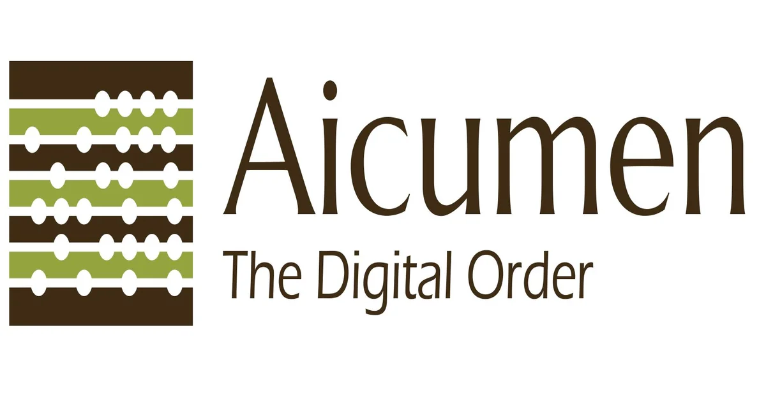

$1500 for best app built using the MoiBit API for decentralized off-chain storage

**1.** Build a dApp that leverages MoiBit for storing data.

**2.** The dApp can be built and deployed on any blockchain or DLT platform (Ethereum, Hyperledger, Corda, Hashgraph, etc.)

**3.** 2gb of Storage will be provided for free to all the challenge participants.

**4.** The information persisted in MoiBit needs to be recorded in the form of hashes on the respective blockchain or DLT platforms.

**5.** Everyone who signs up and registers gets 2 gb of space for 1 year.

*Things To Keep In Mind*

Applicants will be judged based on:

1. Novelty of the use-case,

2. Technical exploitation of KFS features,

3. Completeness,

4. Demo with appealing presentation.

**Prizes**

$1000 for 1st place, $300 for 2nd place, $200 for 3rd place

**Judges**

Anantha, Karthik, Peter