**SPONSOR CHALLENGE**

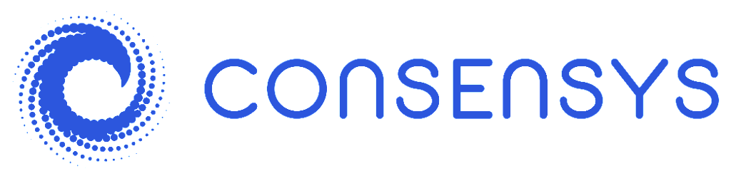

**Non-fungible Tokens (NFTs) $5,000**

NFT tokens offer up unique ways to interact with the Ethereum ecosystem and the wider world. Build the most impressive NFT-based submission supported by the criteria outlined.

Requirements: (1) Link to open-source code; (2) Submission must be directly affiliated to NFT usage/creation/interaction; (3) 3-5 minute presentation describing project vision, submission and demo.

*Things To Keep In Mind*

Specific tools or tech stack required or favor over other solutions to accomplish the challenge: Ethereum.

Submission will be judged according to the following criteria:

**1.** Creativity. How unique is your submission? NFTs allow users to create limited, rich assets and/or services which more traditional fungible tokens do not. Got a crazy idea? We want to see it.

**2.** User Experience. The blockchain industry is in desperate need of easy-to-use tools/services/products. We want to see not only how creative your idea is but how easy you make it for others to use.

**3.** Efficiency. Lots of code doesn’t necessarily mean good code. Submissions will be judged on how much resource-requirements it demands for its set of functions.

**4.** Stability. Is your submission ready to handle consistent usage?

**5.** Interface design. Sometimes you’ve got to judge a book by its cover! Show us how your submission can be distinguished from current products / services.

**Prizes**

1st: $3000; 2 x Runners-Up: $1000

**Appointed Judges**

Ejaaz Ahamadeen